Brief | First impressions are very important. SMSA’s Dress Code, Uniform and Appearance Policy offers employees flexibility of personal choice within a framework which upholds the professional standards expected in a dynamic working environment.  The appearance of employees reflects the image of our company and has a significant impact on the way we are viewed by customers, employees, visitors and the general public.  We encourage smart, stylish dress which promotes self-confidence, commitment, and pride, projecting good and positive image to all stakeholders.
Purpose | The purpose of this policy is to establish consistent and comprehensive guideline on the appropriate attire and appearance of SMSA employees in the workplace. It outlines the minimum acceptable standard for dress, uniform and appearance.
Persons Affected | All SMSA employees are covered by this policy.
Responsibilities | Uniforms will be supplied to relevant staff and will remain the property SMSA, however full responsibility for care and maintenance will remain with the employee, including replacement of damaged uniforms.  Managers and supervisors are responsible for ensuring that the guidelines set forth are adopted and implemented consistently. Non-compliance with this policy may result in counseling or appropriate progressive disciplinary action.  Human Resource Department is responsible for determining when and in what quantities replacement uniforms are to be issued to employees based on wear and tear.  Human Resources will make the final decision if there is any question or dispute regarding the provisions of this policy.
Guidelines | SMSA requires a high standard of personal presentation and grooming. Employees should always be dressed neatly and appropriately for the type of work they perform. The company will provide comfortable and professional uniforms to all front-line staff and must be worn at all times during actual work hours, each working day (including weekends) and in accordance with the following policy and procedure.

Guidelines | Identification Badge  All SMSA employees are required to wear the identification badge conspicuously at all times during work hours and/or while inside the company premises.  ID Badges will feature the employee’s legal name as it is documented in the Human Resource system, the employee’s position/designation, photograph, employee number, and expiration date.  Please refer to GUIDE Doc. No. 83 - Identification of Personnel Policy for more details.  Business Attire  All employees, other than those wearing the Omani traditional male dress and those issued with uniforms, are required to wear any of the following attire as maybe required by the business:  - FORMAL BUSINESS ATTIRE - Formal business attire includes business suits and dress shirts for men. Dress shoes are required, and men should wear ties when formal business attire is required.  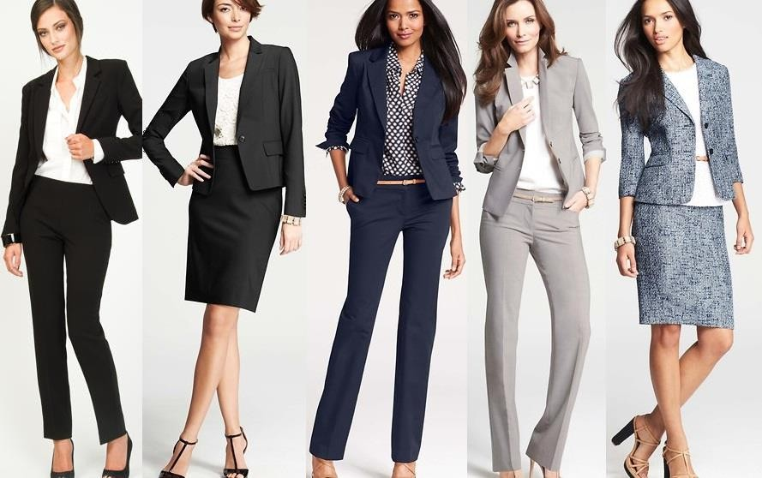

Guidelines | 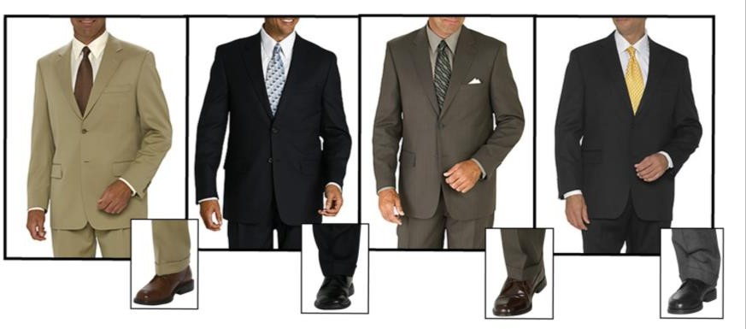  - GENERAL BUSINESS ATTIRE - General business attire is only slightly less formal than formal business attire and tends to include the same things, including suits, dress shirts and ties. However, general business attire also allows men to wear less formal coats, like sports coats or a structured jacket instead of a suit jacket. General business attire is the most common form of business attire required on the job.  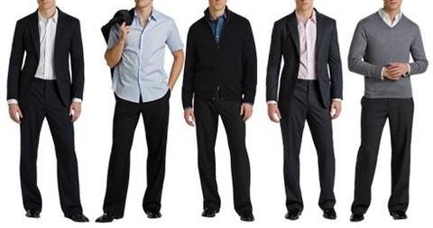

Guidelines | 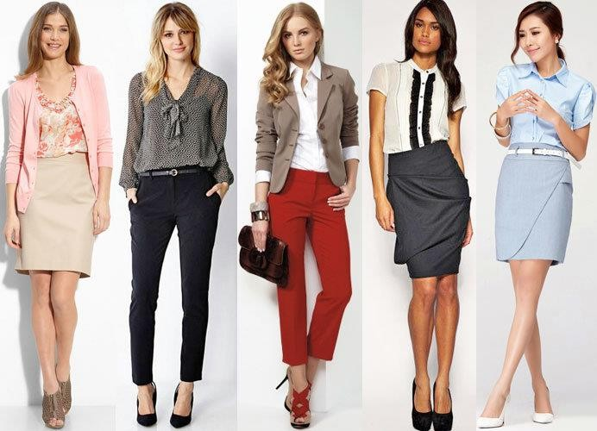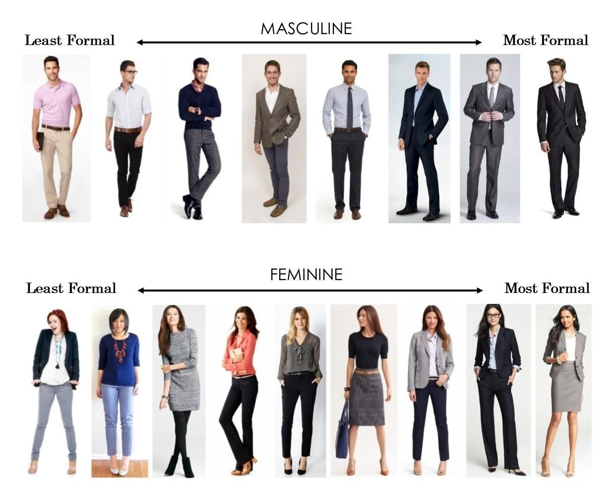  - BUSINESS CASUAL ATTIRE - Business casual attire for men is more relaxed and includes items like chinos, khakis, knit polo shirts and sweaters. True business casual attire does not require men to wear ties, and nice, clean sneakers are usually considered to be fine, although dress shoes are still preferred.  Omani Traditional Male Dress  The religion and customs of the Sultanate of Oman dictate conservative dressing for both men and women. Omani Nationals prefer traditional clothes over Western styles of dress, and generally wear modern adaptations of age-old designs. The loose, flowing traditional garments are practical for the location’s hot, windswept climate, and in keeping with the Islamic ideal of modesty.  - THOBE/ DISHDASHA: The traditional clothing for men is the Thobe, a loose, long-sleeved, ankle-length garment. Thobes worn in summer are generally white and made of cotton. Thobes worn in winter are generally darker in color and made of wool.

Guidelines | - KUMMAH: An embroidered brimless cap.  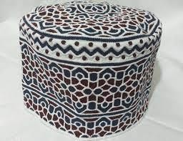  - NA'AL: Na’al is the traditional sandals worn by men. It is made of leather material which may have a variety of patterns. However, European-style shoes are common.  The Omani traditional female/ male dress may be worn by employees during work hours provided the following conditions are complied with:  - Dress is worn with the full and complete head gear  - Identification badge is worn conspicuously at all times  - The dress does not restrict movement and/or compromise safety of the employee  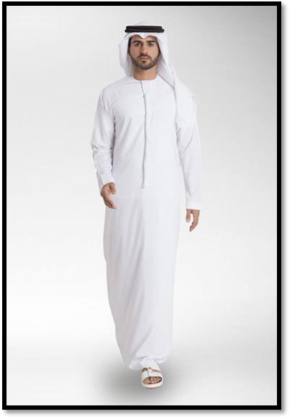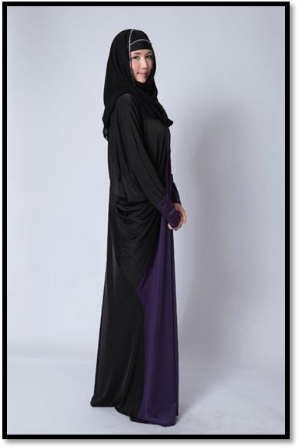

Guidelines | Uniforms  SMSA will issue comfortable and professional uniforms to employees according to the work they perform. These must be worn neatly and appropriately at all times during actual work hours, each working day (including weekends).  Wearing the Uniforms  Employees must wear the uniforms issued to them with pride and confidence as they represent the company to our customers. Uniforms must be worn in FULL, and not to be matched with any unofficial or unauthorized garment.  SMSA uniforms must be worn only when an employee is on duty or while officially representing the company in business-related activities.  Employees are discouraged from wearing the SMSA uniforms outside of work and non-business related activities.  - The Basic Uniform issued to employees consists of the following:  SMSA Shirt – black and purple short sleeved knitted shirt made from 62% cotton and 38% polyester, with embroidered SMSA logo on the left chest pocket; comes in different sizes  Trousers/Pants – navy long pants made from 65% Polyester and 35% Cotton, with six (6) pockets, belt loops and reflectorized lining on the side pockets; comes in different sizes  Safety Shoes – black low-cut reinforced steel-toe shoes for added protection, safety and durability. Issued only to employees working in a potentially hazardous environment.  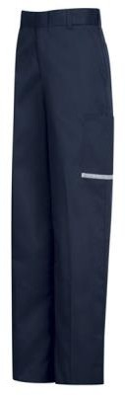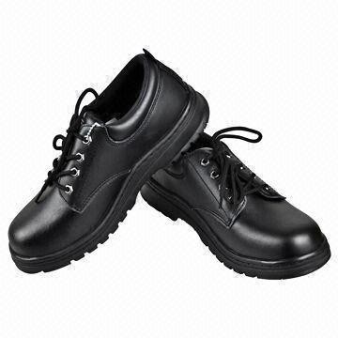

Guidelines | - Cleaners Uniform – Khaki shirt and trousers with black shoes  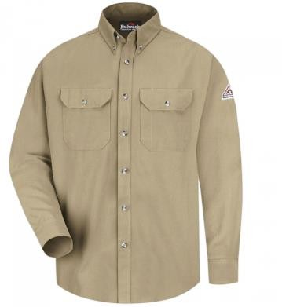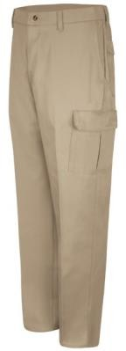  - Tea Boy Uniform - Black vest with white long sleeved shirt, black trousers and black shoes  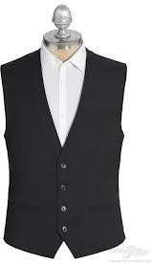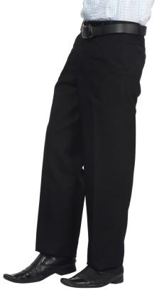  Ordering & Issuance of Uniforms  Department heads are responsible for placing the purchase request of uniforms required in their respective departments.  New hired employee will be provided with new uniform prior to their date of joining.  Direct managers or supervisors must keep a record of the uniforms issued to each employee.

Guidelines | Care & Maintenance of Uniforms  Employees are responsible for the care and maintenance of the uniforms issued to them. Cleaning instructions must be followed to ensure that the garments maintain its appearance.  Alteration & Adjustments of Uniforms  Hemming to appropriate length is the only change allowed on the uniforms issued to the employees.  Replacement, Return & Disposal of Uniforms  Department Head is responsible for determining when and in what quantities replacement uniforms are to be issued to employees as deemed necessary due to normal wear and tear.  The uniform may be replaced as follows:  - 3 Trousers yearly (to be distribute on January - 1 Trouser for every 4 month)  - 1 Shoes yearly (to be distribute on January)  - 1 Jacket every two years (to be distribute on January)  - 6 Shirts yearly (3 Shirts to be distribute on January & 3 on July - (1 Shirt for every 2 months)  Employees, transferring to any position which does not require uniforms, must return all issued uniforms to his immediate manager or supervisor.  Employees leaving the company must surrender all uniforms issued to him before securing final clearance from his immediate manager or supervisor.  Used uniforms must be destroyed prior to disposal. This is to ensure and prevent unauthorized use of the uniforms.  Head Gear  The Kummah must be worn together with the traditional Omani male dress.  Caps may be worn for protection from the heat of the sun, but is not issued as part of the basic uniform. Only plain caps in corporate colors i.e. black or purple.

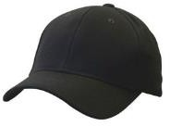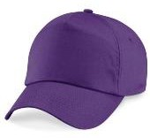
No other headgear may be worn during work hours aside from those mentioned above.
Footwear
Employees working in a potentially hazardous environment will be issued with safety shoes and must wear this while at work. Maintenance and repair of shoes is the employee’s responsibility.

All other employees who are not required to wear uniform must wear comfortable leather shoes with fresh pair of socks. Make sure shoes are always clean, well polished and in good condition.

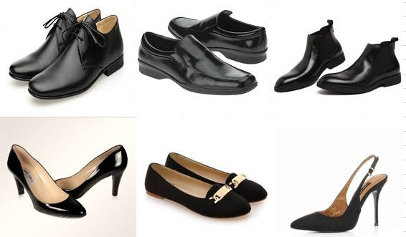

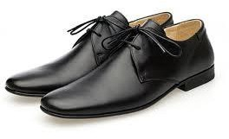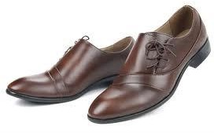

Flip-flops, slippers, clogs, sneakers and rubber shoes are not allowed at work.

Good Grooming & Personal Hygiene

Hair Style/Color – The most conservative hairstyle for male employees in a conservative environment is to have a short and textured haircut that will look both professional and less potentially distracting to others. Dyeing hair using henna is acceptable. Only natural hair colors are allowed, generally black or brown.
Facial Hair - Good grooming is important for everyone – and facial hair maintenance is no exception. Keeping the facial hair neatly trimmed and clean is essential to all employees.
Nails - Nails should be neatly trimmed and clean at all times. Colored nail polish is prohibited for men.
Perfumes/Scent – All employees must observe good habits of grooming and personal hygiene. Body odor, from any cause, should not create distractions. To accommodate sensitive individuals, employees are discouraged from wearing or applying excessive amounts of perfume, cologne, scented lotions, or body washes in the workplace; using hairsprays, air freshener, or other scented products in the workplace; and eating or keeping fragrant foods or items at your desk.
Jewelry - Jewelry must be kept to a minimum. If any employee desires to wear jewelry, it must be limited to a ring and a wristwatch at the most. Remove bracelets, earrings and facial piercings or any jewelry that is prohibited by Omani Law, as these can be offensive to the Muslim religion and culture, besides that it lessens your overall professional look.
Piercings & Tattoos – Tattoos and piercings, if any, must be kept concealed under your clothes.

Dress Down/ Casual Day

SMSA adopts the practice of having casual Saturday for office-based staff only who are not directly in contact with customers, where instead of wearing business attire, employees are allowed to dress down a bit.
Business casual or smart casual means not having to wear a tie and/or a coat. The safest choice is usually an open-collared button-down shirt, sleeves rolled up, and nice casual pants, like khakis. Black or brown casual shoes are usually the most appropriate choice for casual Saturday. Athletic shoes are not allowed; however, canvas sneakers might be permissible. No matter the shoe choice, socks should always be worn.

This provision is applicable only to employees who were not issued with uniforms, working in the headquarters/ regional offices, and does not have direct contact with customers.
Even though employees can relax a bit on casual Saturdays, they should still be well dressed and serve as good representatives of the company they work for.

Inappropriate Attire
Any clothing that exposes too much skin of the employee, in state of disrepair, contains obscene or offensive image and foul language, or are too casual are considered to be unprofessional and should not be worn in a business environment. Examples of unacceptable attire include:
- Tank tops, halter tops, or muscle shirts that expose the shoulders
- Bare navel or see-through shirts
- Torn clothing or clothing with holes
- Sweat pants, sweat suits, jogging pants
- Jeans, athletic shorts
- Sandals, flip flops, slippers, rubber shoes
General | Any exception to this policy must be approved by the Managing Director.

