Standard Operating Procedure “SOP” Procurement & Purchasing Operating Standards

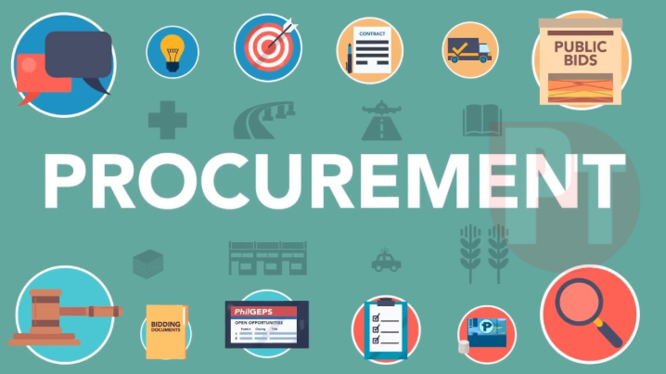

Table of Contents
Section 1:Overview 3
Section 2: End-to-End Procurement Flow 3
Section 3: Detailed Stages 3
Section 4: Summary Table of Required Documents 7
Section 5: Mandatory Policy Rules & Compliance Requirements 7

Section 1: Overview

The SMSA Procurement Process is designed to provide a structured, transparent, and efficient methodology for the acquisition of goods and services. By standardizing the flow from initial requisition to final payment, the organization ensures that all operational needs are met while maintaining strict financial controls and accountability across all departments and branches.

Section 2: End-to-End Procurement Flow
The procurement lifecycle at SMSA follows a specific sequential workflow to ensure compliance and budgetary oversight:
- Purchase Requisition (PR): Identification of need and submission of request, All Purchase Requisitions (PRs) shall be raised and submitted through Oracle ERP.
- Approval: Verification of necessity and budget.
- RFQ Process: Solicitation of quotes from qualified suppliers.
- Quotation Evaluation: Technical and commercial assessment of bids.
- Vendor/supplier Selection: Determination of the most suitable vendor.
- PO Issuance: Formalizing the commitment via Purchase Order.
- Delivery & Receiving: Physical receipt and quality inspection.
- GRN & Invoice Verification: Matching documentation (3-way match).
- Payment: Final processing of funds to the vendor/supplier.
Section 3: Detailed Stages
1. Purchase Requisition Stage (PR)
- Responsible Department: Requesting Department (All Departments / Branches), Initiate PR form with Approval from Dept. Manager & submit to Purchasing via email to create the PR via Oracle system
- Responsibilities:
  - Identify operational need (goods/services)
  - Confirm specifications (technical + commercial)
  - Ensure correct quantity and delivery requirements
  - Check internal budget availability (if applicable locally)
  - Submit formal Purchase Requisition in the system
- Required Documents:
  - Purchase Requisition (PR) system entry (mandatory)
  - Technical specifications sheet (if applicable)

  - Justification notes for urgent or non-budgeted requests
  - Internal approvals as per Delegation of Authority (DOA)
2. PR Review & Approval Stage
- Responsible Departments: Approvals shall be routed through Oracle Workflow in accordance with the approved financial authorization matrix.
- Responsibilities:
  - Verify necessity of request
  - Confirm budget availability
  - Ensure compliance with company policies
  - Approve or reject PR based on authority limits
  - All approvals shall be processed through Oracle Workflow.
  - Approval routing shall follow the approved Delegation of Authority (DOA) and financial approval matrix.
- Required Documents:
  - Approved Purchase Requisition (PR)
  - Budget confirmation (if required)
  - Approval workflow record (Oracle system-generated)
3. Procurement Sourcing Stage (RFQ Process)
- Responsible Department: Procurement Department
- Responsibilities:
  - Validate PR details with requesting department
  - Identify qualified suppliers (approved vendor list preferred)
  - Issue Request for Quotation (RFQ)
  - Receive and evaluate quotations
  - Conduct price and technical comparison
  - Negotiate prices, delivery terms, and payment terms
  - Obtain a minimum of three quotations whenever applicable.
- Required Documents:
  - RFQ documents sent to suppliers
  - Vendor/supplier quotations (minimum 3 where possible)
  - Technical & Commercial comparison sheet
  - Vendor/supplier evaluation form (if applicable)
4. Vendor/supplier Selection & Approval Stage
- Responsible Departments: Procurement + Finance + Top Management (depending on value)

- Responsibilities:
  - Review evaluation results
  - Ensure vendor/supplier compliance (quality, price, delivery, payment terms)
  - Select most suitable supplier
  - Obtain final approval before issuing PO
- Required Documents:
  - Bid comparison sheet
  - Vendor/supplier evaluation report
  - Approval for Vendor/supplier selection (DOA-based)
5. Purchase Order (PO) Issuance
- Responsible Department: Procurement Department
- Responsibilities:
  - Generate official Purchase Order through Oracle ERP to selected vendor/supplier
  - Ensure PO matches approved PR and quotation
  - Include terms & conditions clearly
  - Send PO to vendor/supplier and confirm acceptance
- Required Documents:
  - Approved Purchase Requisition (PR)
  - Selected vendor/supplier quotation
  - Oracle-approved Purchase Order (PO)
  - Vendor/supplier PO acknowledgment (if required)
6. Delivery & Receiving Stage
- Responsible Department: Warehouse / Store / Receiving Department
- Responsibilities:
  - Verify received goods/services against the approved PR and PO before acceptance. Inspect quantity and quality upon receipt
  - Verify compliance with specifications
  - Report any damages or shortages immediately
  - Hand over the received items/services to the requesting department after verification.
  - Update inventory system
- Required Documents:
  - Purchase Order (PO)
  - Delivery Note (from supplier)
  - Goods Receipt Note (GRN)

  - Inspection/Quality Report (if applicable)
  - Discrepancy Report (if any issues found)
7. Invoice Verification & Payment Stage
- Responsible Departments: Finance Department
- Responsibilities:
  - Confirm completion of goods/service receipt verification before processing payment.
  - Match invoice with PO and GRN (3-way matching)
  - Verify pricing, quantities, and tax compliance
  - Ensure proper approvals before payment
  - Process vendor/supplier payment within agreed terms
- Required Documents:
  - Vendor/supplier Invoice
  - Purchase Order (PO)
  - Goods Receipt Note (GRN)
  - Payment approval workflow
  - Tax documents (if applicable)
8. Internal Audit & Compliance (Post-Process Review)
- Responsible Department: Internal Audit / Compliance
- Responsibilities:
  - Ensure procurement procedures are followed correctly
  - Review documentation completeness
  - Detect and report any non-compliance
  - Recommend process improvements
- Required Documents:
  - PR, RFQ, Quotations, PO, GRN, Invoice (full procurement file)
  - Audit checklist/report

Section 4: Summary Table of Required Documents
Stage | Key Required Documents
1. Requisition | PR Form, Technical Specifications, Justification Notes
2. Approval | Approved PR, Budget Confirmation, Approval Record
3. Sourcing | RFQ, 3 vendor/supplier Quotations, Comparison Sheet
4. Selection | Bid Comparison, vendor/supplier Evaluation Report, Selection Approval
5. PO Issuance | Approved PO, vendor/supplier Acknowledgment
6. Receiving | Delivery Note, Goods Receipt Note (GRN), Inspection Report
7. Payment | Vendor/supplier Invoice, 3-Way Match (PO/GRN/Invoice), Tax Docs
8. Audit | Full Procurement File, Audit Checklist/Report

Section 5: Important Policy Rules & Notes
- Mandatory Authorization: No purchase should proceed without an approved Purchase Requisition (PR) and Purchase Order (PO).
- Vendor Prequalification: All suppliers must be approved or pre-qualified where applicable to ensure service standards and reliability.
- Exception Handling: Any deviation from this standard process requires explicit written justification and formal management approval.
- Traceability: All documents related to the procurement lifecycle must be stored within the system to ensure complete audit traceability.
- Compliance Requirement: Strict adherence to the above process across all departments and branches is required to maintain internal control, financial transparency, and operational efficiency.

