Brief | Special Delivery Channel uses Special Delivery Management System for its Operations.
Purpose | To provide guidelines on SDM scans
Person Affected | All Staffs using SDM
Instruction | Refer below

POD Process:

- Shipment Dispatch to Ops
- Operations In
- Sort shipments at operations
- OFD
- POD Capture
- Outbound (Same Day of Operations In)
- Create Outbound Manifests
- Destination Inbound
- OFD
- POD Capture

Return Process:

- 1st Day OFD
- Exception registered (Requested Future Delivery/Mobile No response/Switched Off)
- 2nd Day OFD
- Exception registered (Requested Future Delivery/Mobile No response/Switched Off)
- 3rd Day OFD
- Exception registered (Requested Future Delivery/Mobile No response/Switched Off)
- Delivery attempt over (RETURN PROCES STARTED)
- Apply return scan and Create Return Manifest for the Client.

Dispatch Process:

- Print Validated shipments manifest
- Print Manifested AWB labels
- Shipment dispatch to Ops

SDM menus explained:

- Reports

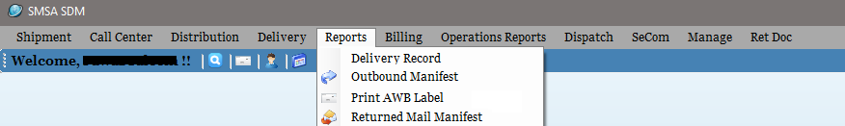
Reports | Print AWB label | To print a duplicate copy of Validated AWB
Reports | Delivery Record | To reprint Delivery Record
Reports | Outbound Manifest | To reprint Outbound Manifest
Reports | Returned Manifest | To reprint Returned Manifest

- Delivery

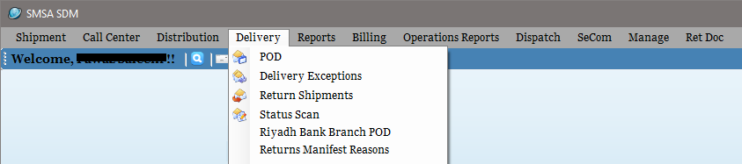
Delivery | Delivery Exceptions | Apply DEX scans
Delivery | POD | Apply POD Scan
Delivery | Return Manifest Reasons | Get undelivered reason of returned shipments
Delivery | Return Shipments | Apply Returned to client scan
Delivery | Branch POD | Apply POD of shipments delivered to branch
Delivery | Status Scan | Apply Future Delivery/HAL/DEX with comments

- Distribution
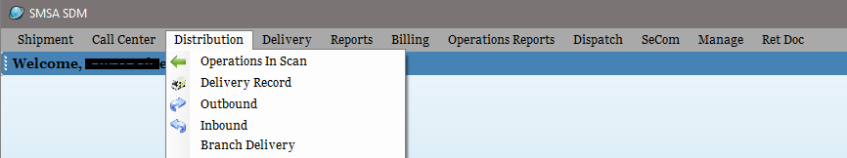

Distribution | Branch Delivery | To print Branch Delivery Records
Distribution | Delivery Record | To print Delivery Records
Distribution | Inbound | Applied on shipments received from other destination
Distribution | Operations In | Applied on shipments received from dispatch at origin
Distribution | Outbound | Applied on shipments send to other destination

- Operations Reports

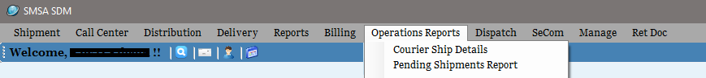
Operations Reports | Courier Shipment Details | Provides summary of shipments processed for delivery
Operations Reports | Pending Shipments Report | Provides number of pending shipments available at each region

- Dispatch

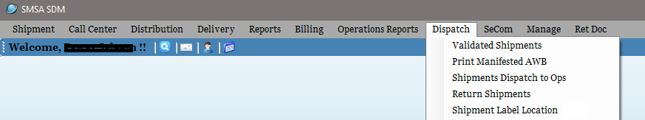
Dispatch | Validated Shipments | Check and print Validated shipment’s Manifest
Dispatch | Print Manifested AWB | Print Manifested AWBs
Dispatch | Return Shipments | Print unvalidated shipments
Dispatch | Shipment Dispatch to Ops | Transit scan, Dispatch to OPS
Dispatch | Shipment Label Location | To print label location barcode on new shipments

- Ret Doc

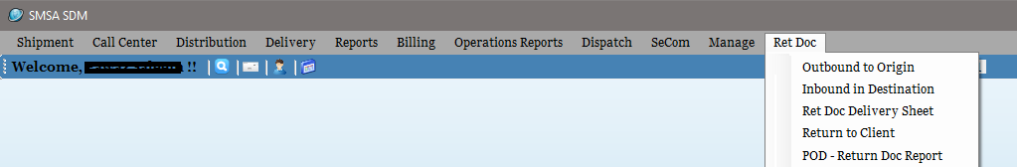
Ret Doc | Inbound in Destination | Ret Doc received at destination scan
Ret Doc | Outbound to Origin | Ret Doc forwarded to origin scan
Ret Doc | POD - Ret Doc Report | To get list of Ret Doc pending for return to shipper
Ret Doc | Return to Client | To return the Ret Doc back to shipper
Ret Doc | Ret Doc Delivery Sheet | To reprint Ret Doc Delivery record

