Brief | SMSA Express reserves the right to refuse any package that in the judgment of the carrier may:  - Soil, taint, damage, or delay other merchandise.  - Damage the carrier’s equipment or facilities.  - Inflict injury.
Purpose | SMSA Express refuses some of customer’s packaging to protect other shipments from damage, leakage, etc, also to protect its employees from injury.
Responsibilities | RD Executive is responsible to refuse customer’s packaging if he judges that it may affect other shipments or personal injury.
Guidelines | SMSA Express provides free packaging to its customers to assist them in shipping their packages.  SMSA Express packaging, size and weight guidelines:  refer to Marketing Policy  For international shipments SMSA used or Customers’.  When a shipment was accepted in the customer’s own packaging, the packaging must meet SMSA Express standards.  Customer packaging general guidelines:  Procedure  RD Executive must not accept shipment that meet any of the description below:  SMSA Express Packaging  - SMSA Envelope  - SMSA PAK Large & Extra Large  - SMSA High –Value Pak 1, 2, & 3  - SMSA Small Box  - SMSA Medium Box  - SMSA Large Box  - SMSA 5 Kg (Printed)  - SMSA 10 Kg (Printed & Unprinted)  - SMSA 25 Kg (Printed & Unprinted)  - SMSA 1 Kg Honey Box  - SMSA 5 Kg Honey Box  - SMSA Olive Oil Box  - SMSA XL Box  - SMSA 2 Kg Box (with optional Gift Sleeve)  - SMSA High Value Box  - SMSA Fresh Box  International Shipment Packaging  The following descriptions of packaging options available through SMSA/ to find what customer may need.  Express Packaging Supplies  Express packaging comes in several sizes.  Envelope  For documents up to 500 grams  Inside dimensions: 34 cm x 25 cm  Made of 100% recycled paperboard, with at least 35% post-consumer content  Not meant for fragile contents, instead use a Box  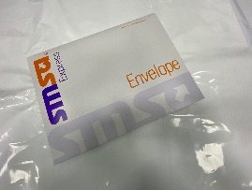  Pak (Large & Extra Large)  Expands to fit various shipment sizes  Inside dimensions: Large - 46 cm x 31 cm Extra Large 51 cm X 36 cm  Not meant for fragile contents - instead use a Box  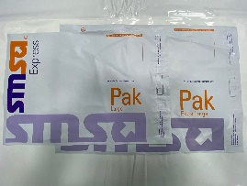  High-Value Pak (HV1, HV2, HV3)  Tamper-resistant Paks with tag number to be used for high-value items.  Inside dimensions:HV1 - 60 cm x 32 cm ,HV2 - 82 cm x 49 cm ,HV3 - 100 cm x 76 cm  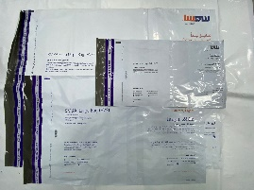  Box – Small  For binders and other small sizable shipments  Inside dimensions: 31.5 cm x 28.8 cm x 4.5 cm  May not be used to ship laptop or desktop computers  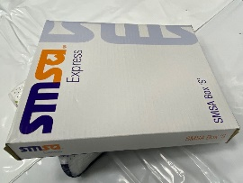  Box - Medium  For binders and other sizable shipments  Inside dimensions: 33.5 cm x 29 cm x 6.5 cm  May not be used to ship laptop or desktop computers  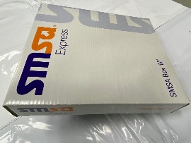  Box - Large  For small parts or computer printouts  Inside dimensions: 44 cm x 31 cm x 8 cm  May not be used to ship laptop or desktop computers  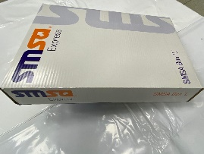  5 Kg Box  Convenient flat-priced service solution using International Priority Promo and Domestic Promo Services  Inside dimensions: 34 cm x 26 cm x 21 cm  One price for all shipments weighing up to 5 kg  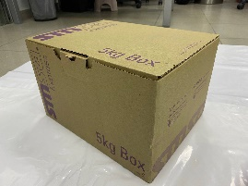  10 Kg Box  Convenient flat-priced service solution using International Priority Promo and Domestic Promo Services  Inside dimensions: 41 cm x 34 cm x 26 cm  One price for all shipments weighing up to 10 kg  Also comes in an unprinted form that is used for SPO-P Services.  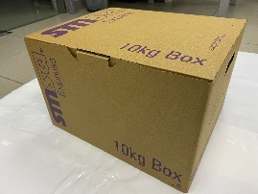  25 Kg Box  Convenient flat-priced service solution using International Priority Promo and Domestic Promo Services  Inside dimensions: 55 cm x 43 cm x 34 cm  One price for all shipments weighing up to 25 kg  Also comes in an unprinted form that is used for SPO-P Services.  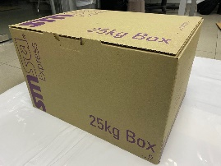  1 Kg Honey Box  Specialized box to fit 1 Kg of Honey jar shipment for SPO Services. Available only in selected cities throughout KSA.  Inside dimensions: 13 cm x 13 cm x 18 cm  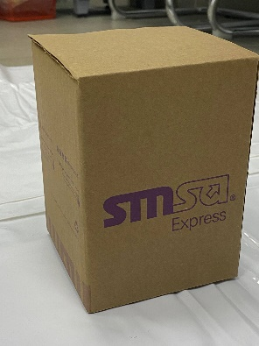  5 Kg Honey Box  Specialized box to fit 5 Kg of Honey jar shipment for SPO Services. Available only in selected cities throughout KSA.  Inside dimensions: 20 cm x 14.5 cm x 30 cm  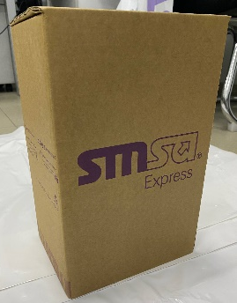  Olive Oil Box  Specialized box to be used for SMSA Olive Oil Service (SOOS) exclusively available in selected Northern Region cities.  Inside dimensions: 25 cm x 25 cm x 37 cm  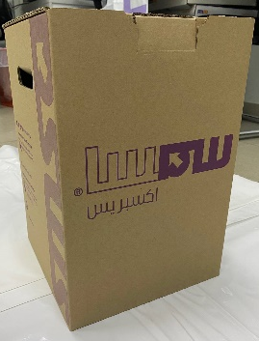
  Type | Size  (cm) | Weight  (Kg) | Used to ship | Max DV
  Material | Recommended Packaging | Check points
  Outer protection | Corrugated carton in good, rigid condition that are large enough to allow cushioning, or contents on top, bottom, and sides. | - The package is structurally sound.  - The package is dry.  - All flaps on the carton are intact.  - The carton has no punctures, tears, or damage corners.
  Inner protection | Bubble wrap, shredded materials, expanded polystyrene pellets, or properly designed cushioning pads. | - No contents are loose when the package is shaken.  - The bottom of the package is layered with a few centimeters of cushioning material.  - All items are wrapped separately.  - Items are centered in the carton.  - Protection is provided between items to prevent heavier items from crushing lighter items.  - Protection is provided to prevent the contents from being crushed by heavier packages.
  Tape | Pressure-sensitive tape applied in at least 3 strips to both the top and bottom flaps of the carton. | - Package is sufficiently taped.
  String/  Rope | No string or rope of any type is accepted. | - All string or rope must be removed.
  Description | Action
  Two or more packages taped on banded together | Split them into pieces and repackage them if needed
  Packages secured with loose bands | re-tape it
  Cartons that are damaged | Do not accept, ask the sender to change the carton.
  Fragile items that are not in approved packaging | Do not accept
  Heavy metal items in a single-wall corrugated box. | Ask the sender to pack them properly
  Delicate items that are not packaged (for example, furniture) | accept if it cannot packed under sender responsibility (see the indemnity letter)
  Packages that are wet or highly suspected of leaking | Do not accept
  Packages with odors | Do not accept
  Package taped with household cellophane tape or masking tape | Ask the sender to remove the tape and re-tape it with plastic tape, if he did not agree do not accept
  Package sealed with string or rope | Ask the sender to remove the string/rope and tape it with plastic tape, if he did not agree do not accept
  Package with loose contents inside | Ask the sender to repack in smaller package of to fill the gaps, if he did not agree do not accept
  Package when flaps are not intact | Repack it properly and accept, tape it if necessary
  Unsealed liquid containers | Ask the sender to seal it, if he did not agree do not accept

