PLAN OVERVIEW 2
I. BCM Structure 7
II. Roles, Responsibilities & Authorities 8
III. Business Impact Analysis & Risk Assessment 9
IV. Business Continuity & Recovery Plan 14
V. Activation Criteria & Procedure 16
VI. Communication & Response Structure 16
VII. Evaluation 17
VIII. Distribution List 17

PLAN OVERVIEW

Scope
Business Continuity Plans (BCPs) outline the activities and information necessary to recover operations following a disaster or crisis, while minimizing additional service disruptions and financial losses. BCPs are designed to address geographical diversity requirements, workplace recovery, workaround procedures, and other strategies to maximize the continuity of business operations in the event of a disruption. Additionally, these plans must align with the criticality ratings identified in the Business Impact Assessment (BIA) results.
Guiding Principles
The following principles will serve as a comprehensive guide for managing incidents associated with significant adverse events:
- First Priority: The safety and security of employees, contractors, customers, clients, their families, and the communities we serve. It is essential to address not only physical security and safety but also the psychological well-being of everyone affected during an incident.
- Second Priority: Ensuring the continuity of business operations and preserving our brands. This includes all business assets, whether financial, physical, or knowledge-based—that are owned or entrusted to us.
- Third Priority: The restoration and/or replacement of business operations and assets lost or damaged during an incident.
Objectives
The objective of the Business Continuity Plan (BCP) is to provide direction and guidance for implementing effective actions that ensure the continued operation of core business functions and activities. It aims to facilitate an orderly recovery from a wide range of potential emergencies or threats, including natural disasters, accidents, technological failures, and attack-related incidents.
The objectives of a BCP plan include:
- Identify and document recovery procedures to be implemented in the event of a business disruption.
- Ensure the continuation of critical business processes for a specified period (as determined by Business Impact Analysis results), while maintaining an acceptable level of service for users of those processes.
- Identify and safeguard essential equipment, records, and assets.
- Assess and minimize potential damage and losses.
- Foster organizational and operational stability.
- Facilitate effective decision-making during emergencies.
- Achieve a structured recovery from emergency operations.
Assumptions
The Business Continuity Plan (BCP) has been developed with the understanding that a worst-case interruption could render facilities entirely unusable, resulting in no salvageable materials. In such a scenario, individual business units would be equipped to recover from less severe interruptions.
It is assumed that sufficient staff would be available to implement the recovery plan, and all data files/vital business records are backed up on a regular basis.
For the purposes of this plan, a disaster is defined as “any situation requiring possible relocation or the use of alternate external resources,” whereas an emergency situation typically involves less severe impacts, allowing recovery to be carried out on-site using alternate internal resources.
Since documentation describing the specific nature of the recovery from all potential emergencies/disasters would yield an impractical and unwieldy plan, the plan will assume full relocation/replacement is required for each element described. Anything less than full relocation replacement will be handled using the same guidelines but with efforts and activities on a proportionally reduced scale.
Planning Assumptions
- Assume a complete loss of a single facility during peak processing periods, with the exception of buildings that are structurally interconnected.
- Personnel with general knowledge of the critical business and technical functions will be available following a disaster.
- The Recovery Time Objective (RTO) begins from time of disaster, not from the time of declaration. The RTO is defined as “the maximum acceptable length of time that can elapse before the interruption of a business function severely impacts the business.”
- An RTO is based on the level of projected financial exposure over time that is deemed acceptable to senior management.
- The Recovery Point Objective (RPO) refers to the specific point in time prior to the interruption at which data must be available and accurate for business functions to resume operations. Typically, the RPO is determined by the point at which synchronized backup data is accessible. The objective is to minimize the amount of data and/or the number of transactions lost due to the interruption. Hence, the recovery point objective should aim to resume processing at, or as close as possible to, the moment of interruption.
- RTOs vary depending on specific business and system requirements.
- Plans reflect high-level business functions but may also refer to detailed processes.
- Vital Business Records are those containing information essential to a firm’s success or survival, whereby their loss or inaccessibility could result in significant business disruption and/or financial exposure. Vital records may include computer data as well as non-computer related records, such as paper documents, forms, microfilm, and fiche.
- File Backup ensures that all data files essential for recovering computer operations are backed up regularly and stored offsite.

Policy
To establish a strong foundation for preparedness against a full spectrum of potential emergencies, all departments within SMSA ZAF are required to develop and maintain a viable Business Continuity Plan (BCP) capability. This capability ensures the uninterrupted performance of essential functions during any emergency or situation that may disrupt normal operations. A viable BCP encompasses the identification of essential functions, the formulation of plans and procedures, the provision of alternate facilities, and the implementation of alternate interoperable communication and data support systems. These components are further strengthened by comprehensive training, orientation, and exercise programs.

BCP capabilities must be sustained at a high level of readiness, able to be activated with or without warning. They should achieve operational status within 2 to 24 hours of activation and maintain sustained operations for up to 30 days, or until the situation is resolved.

SMSA ZAF is committed to responding promptly at all levels in the event of an emergency or threat, which may include human, natural, technological, and other crises. This response aims to continue essential internal operations and provide support to client and external organizations.

BCPs must be reviewed and updated in accordance with policy requirements or when significant changes occur. Business process owners and managers must possess a thorough understanding of their specific responsibilities related to the mitigation, preparedness, response, and recovery activities outlined in their plans.
BUSINESS CONTINUITY POLICY STATEMENT
SMSA ZAF (ZAF) recognizes its obligation to establish and uphold a comprehensive business continuity program, both within our facilities and at external locations where we conduct operational activities, and therefore the policy is also reviewed on a regular basis.
- We evaluate the risks to our operations and understand their potential impacts.
- Manage the identified risks by applying appropriate controls.
- Recognize, communicate and respond to incidents in an effective and appropriate manner to minimize impact.
- Should an incident occur, business facilities must be recovered as swiftly as possible.
All employees of SMSA ZAF are committed to the business continuity programs for its continual development and improvement.

___________________________
Dirk Uys
Managing Director
(Original Signed)

BCM Structure

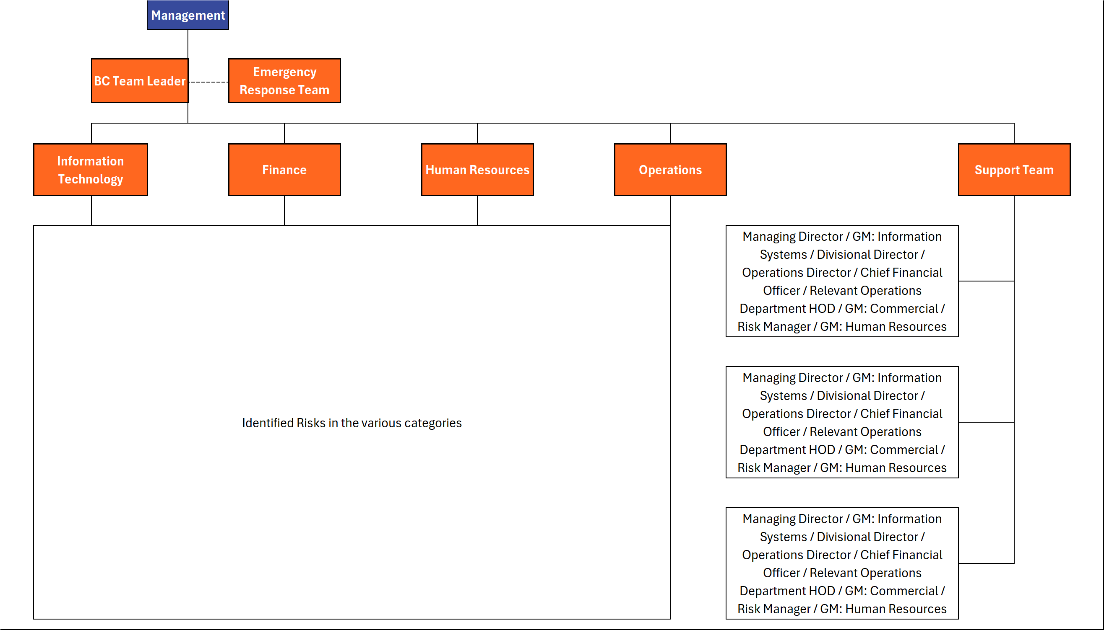

Refer to SMSA ZAF ZAF GUIDE Database

Roles, Responsibilities & Authorities
Below table shows all the roles and responsibilities for all staff who will be involved in the Business continuity plan when an incident happens:
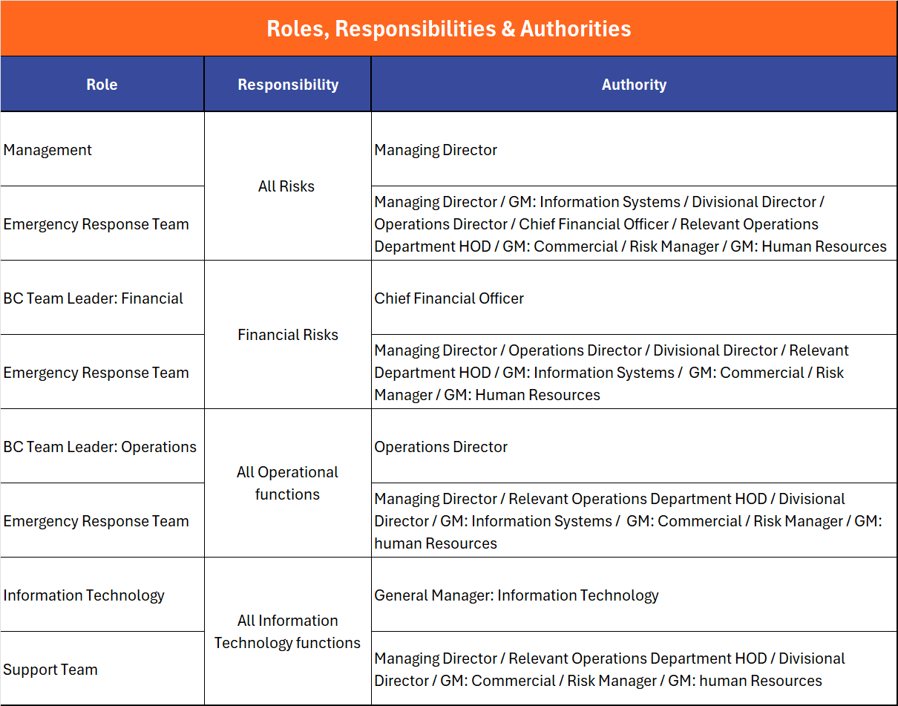

Business Impact Analysis & Risk Assessment
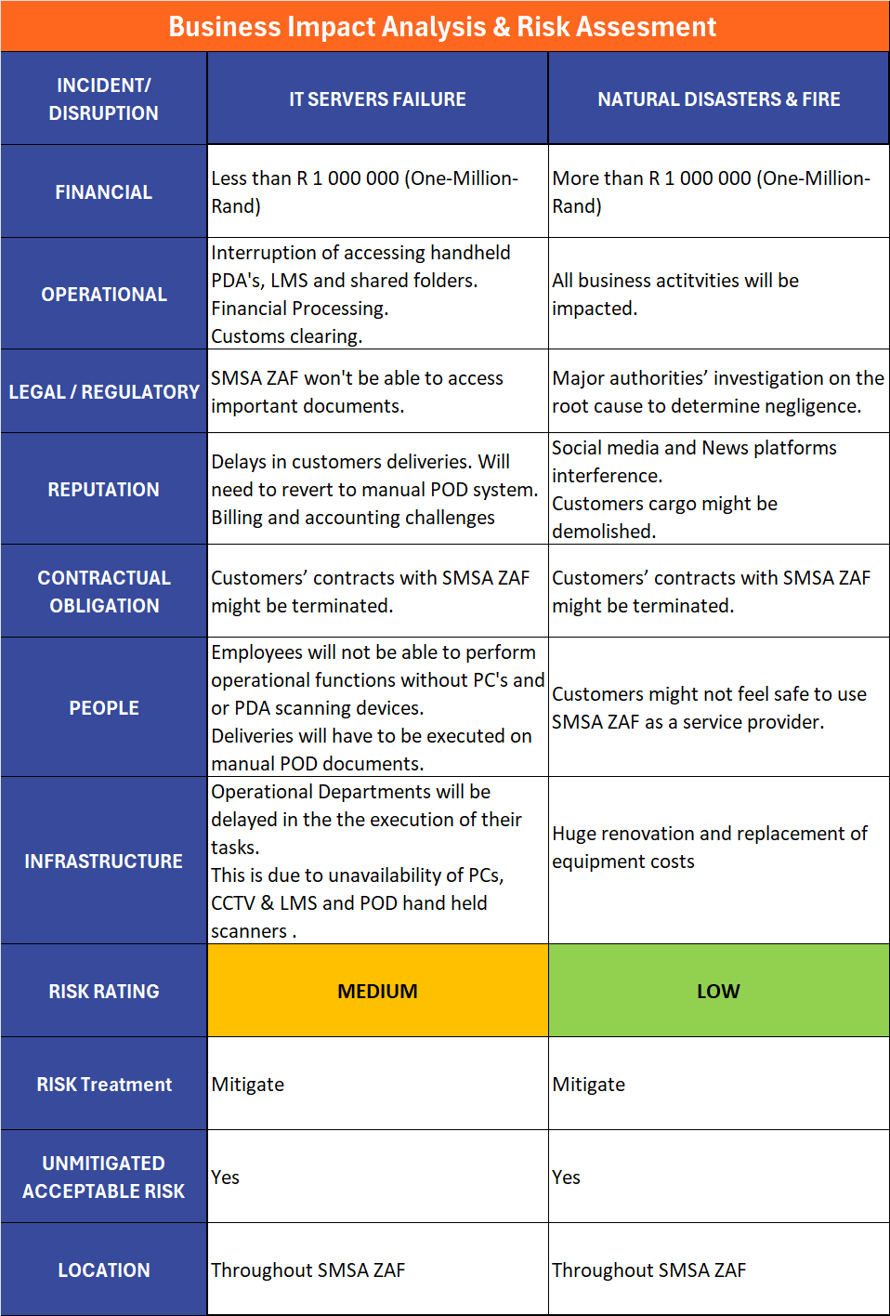
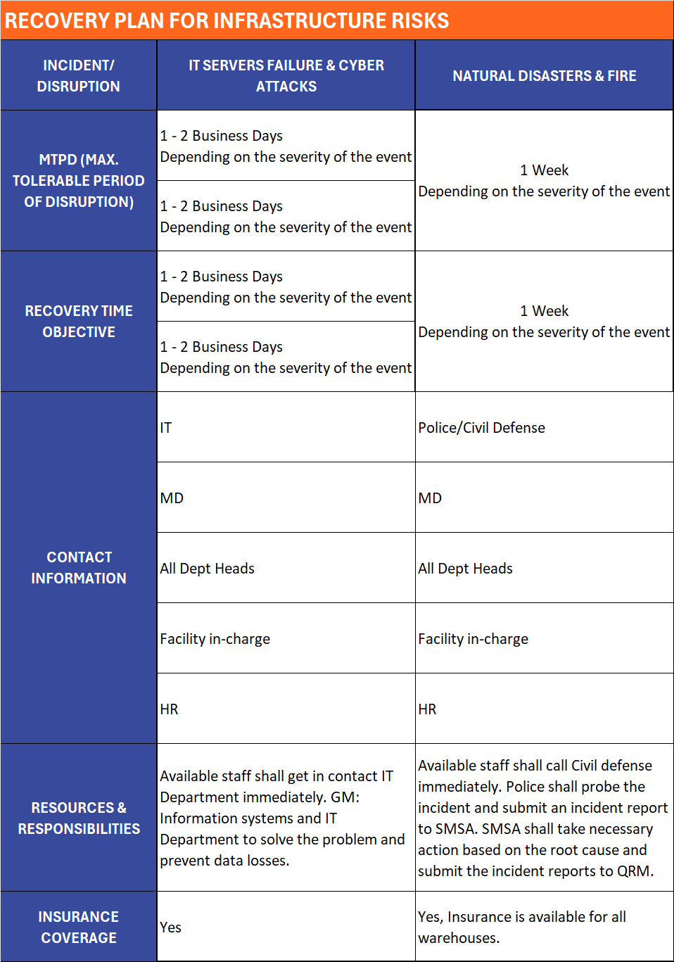
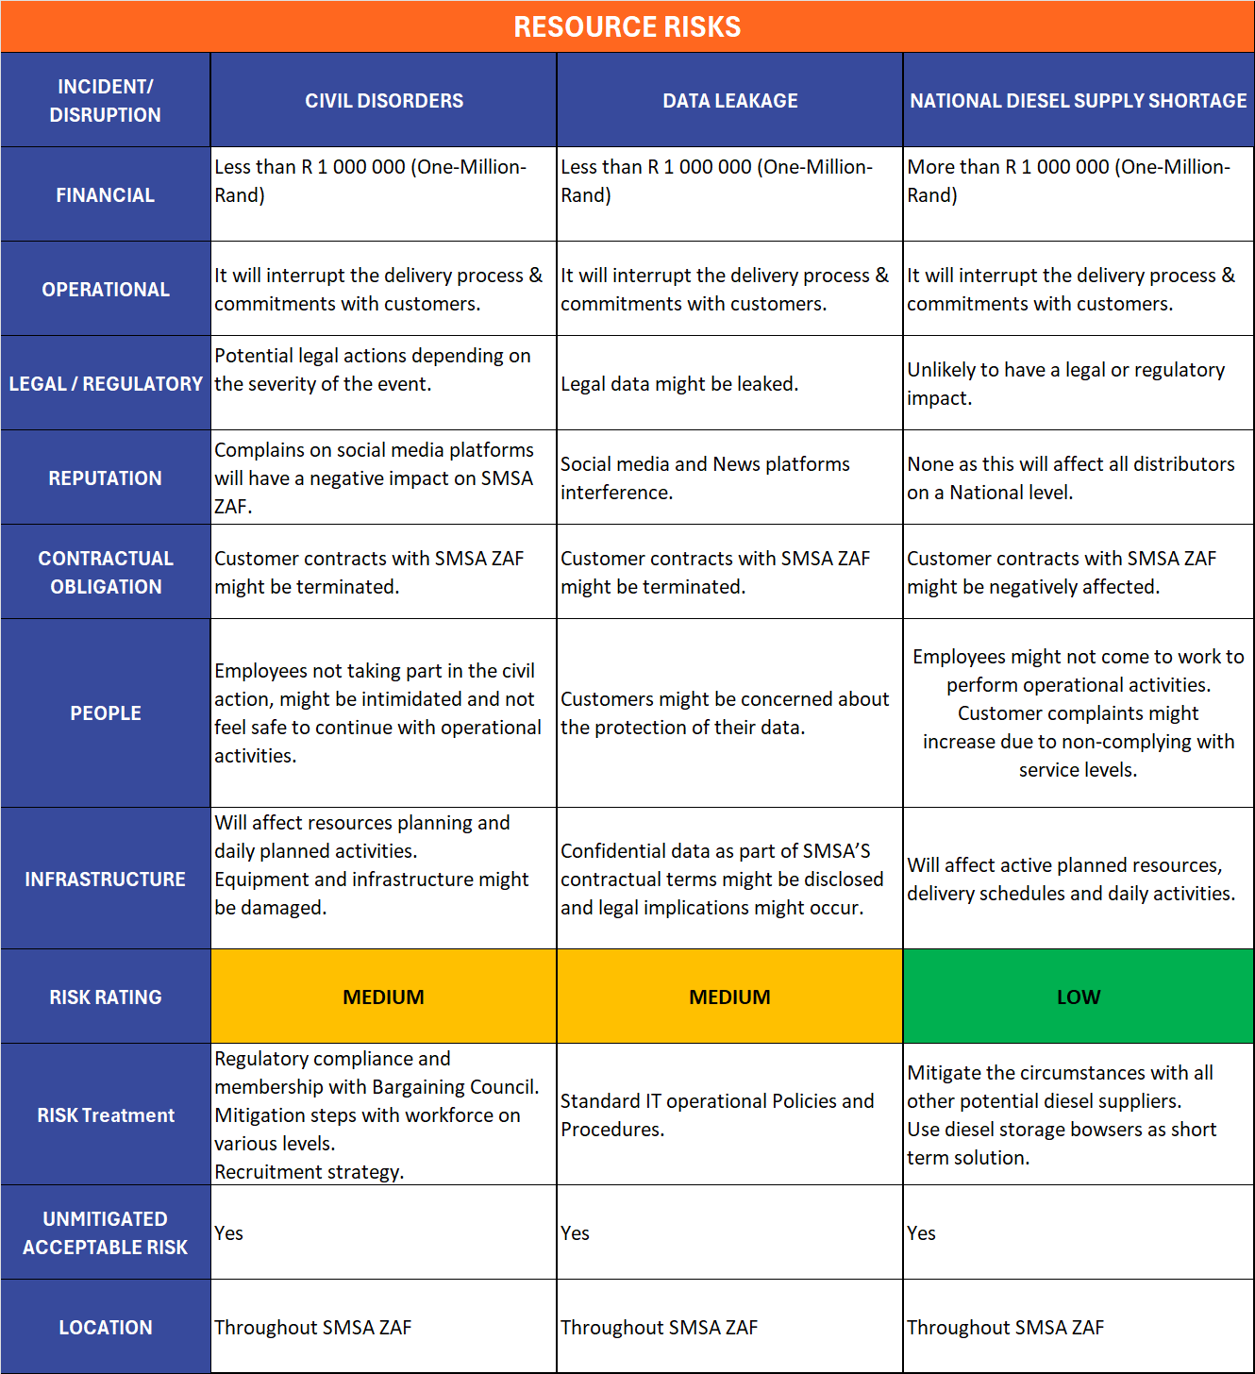
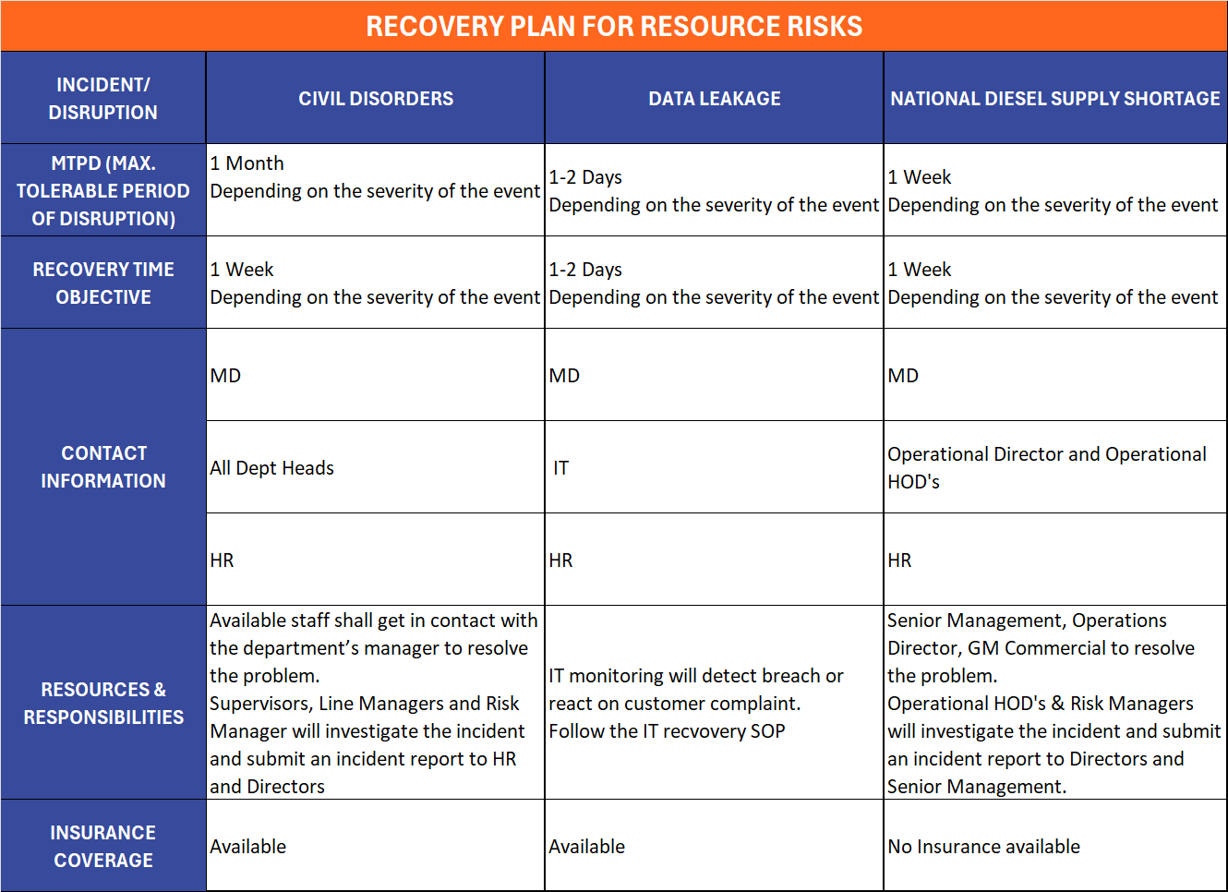
Risk – Impact Matrix

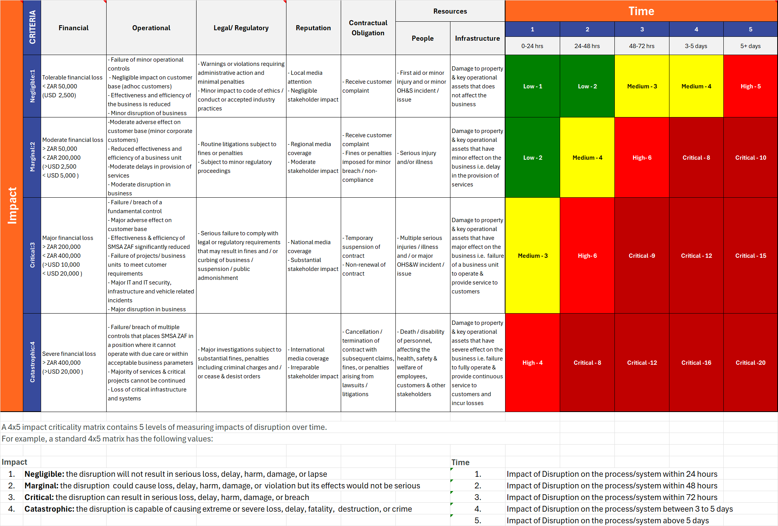

*Refer to SMSA ZAF ZAF GUIDE Database
Business Continuity & Recovery Plan

- Incident: IT Servers Failures and Cyber Attacks
Business Continuity Action:
- As per IT Backup and Disaster Recovery Standard Operating Procedures and Policies. (Document number tbc)

Recovery Plan:
- As per IT Backup and Disaster Recovery Standard Operating Procedures and Policies. (Document number tbc)

- Incident: Data Leakage
Business Continuity Action:
- As per IT Backup and Disaster Recovery Standard Operating Procedures and Policies. (Document number tbc)

Recovery Plan:
- As per IT Backup and Disaster Recovery Standard Operating Procedures and Policies. (Document number tbc)

- Incident: Natural Disasters and Fire
Business Continuity Action:
- List the potential natural disasters with a rating of the likelihood of event occurrence.
- Namlog Directors and Senior Management will have a crisis meeting to prepare a immediate response action plan with Operations Division.
- Based on response action plan decide to continue operational activities in current facility or to relocate all operational activities to the nearest similar-in size warehouse.
Recovery Plan:
- Incident report documentation.
- Employees’ awareness of the incident, its root cause and its impact to the company.
- Preparation of corrective and preventive action plans.
- Maintain the Safety of the warehouse with the proper equipment, systems & extinguishers locations.

- Incident: Unauthorised Industrial Action
Business Continuity Action:
- Suspend all staff involved.
- Launch an investigation and perform root cause analysis by Risk Manager.
- Conduct hearings and take the necessary disciplinary action as per the outcome of the hearings.

Recovery Plan:
- Incident report documentation.
- Replacement of staff based on the outcome of investigations and disciplinary actions.

- Incident: National Diesel Supply Shortage
Business Continuity Action:
- Namlog Directors and Senior Management to contact all potential diesel suppliers for alternative diesel supply.
- Fleet planning prioritize deliveries for bigger customers.
- Changes in delivery frequencies.
- Assess the situation, inform all customers and continue to update customers on the situation.

Recovery Plan:
- During the event or shortly thereafter consider to increase diesel stock storage.
- Equip key personnel to work from home if required.
- Alternative transport options for blue collar workers to continue with operational activities.

Activation Criteria & Procedure
When an incident occurs, the BC team leader shall coordinate with emergency response team to contact all the concerned staff through direct calls, emails or WhatsApp messages.

Communication & Response Structure
SMSA ZAF shall handle and carry-out all internal and external communications relevant to the Business Continuity Management System, whilst ensuring the continuance of operations during a disruption.

Internal Communications
A documented procedure shall be available for all communication, including what, when, with whom, and how to communicate with employees and their emergency contacts.

Emergency Contacts
The various departments or team leaders will be primary contacts. It will be their responsibility to communicate with all other personnel.

External Communications
All external communications relevant to BCMS shall be in accordance to the Media and Public Relations Policy of SMSA ZAF. Including receiving, documenting, and responding to communications to and from interested parties, such as media and government authorities.

Exercise Program
SMSA ZAF shall implement and maintain an exercise and test program annually to validate over time the effectiveness of the business continuity strategies and solutions, or when there are significant changes within SMSA ZAF or the context in which it operates.
After the exercise, a formal report is published, that contains the outcomes, recommendations, and actions to implement improvements.

Evaluation
SMSA ZAF shall evaluate the suitability, adequacy and effectiveness of the Business Impact Analysis, Risk Assessment, Plans and Procedures, and all relevant documents to the Business Continuity Management System at least once a year, after an incident or activation, and when significant changes occur. All documentations and procedures shall be updated accordingly.
SMSA ZAF shall also conduct evaluations of relevant partners and suppliers’ business continuity capabilities, and compliance with applicable legal and regulatory requirements, industry best practices, and conformity to the business continuity policy and objectives of the company.
The evaluations may be carried-out through reviews, analysis, exercises, tests, post-incident reports and performance evaluations.

Distribution List
A digital copy of this Business Continuity Plan is available in SMSA ZAF’s Quality Management System, GUIDE. Access to this document is limited to the system administrators, authors, plan owners, BCP teams, and Quality & Risk Management group. All printed copies of this document are considered uncontrolled copies.

