Purpose: To ensure that the pre-invoice send to the Debtors Clerk for invoicing is accurate

- Login to LMS from your desktop.IT will supply you with the login details

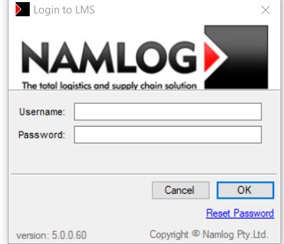

- Pull a report to see which waybills are billable (Have a POD image)

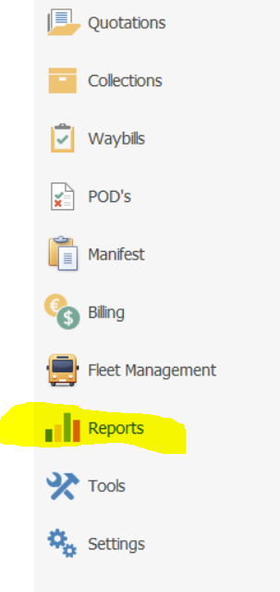

- Selecting profit centre you want to bill from and customers you want to bill

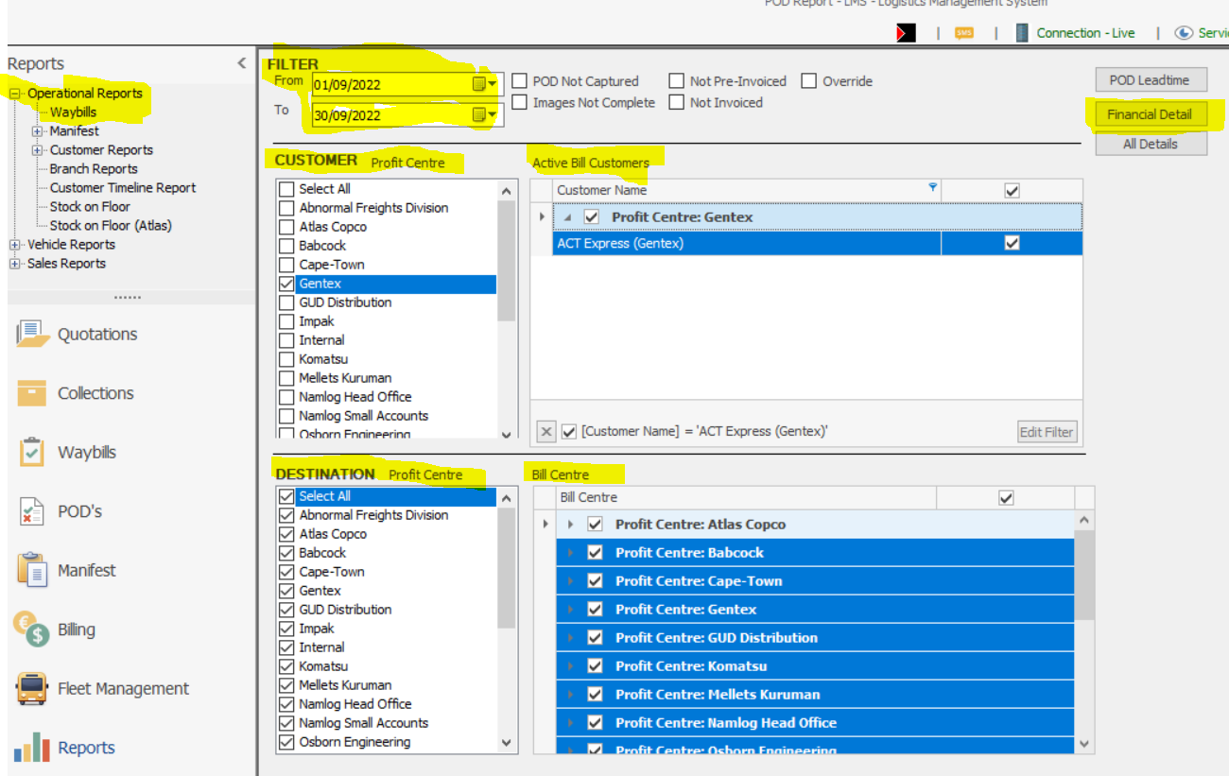
- Operationsl Reports – Select waybills
- Filter – Select your date range
- Customer Profit Centre – Profit Centre you will be billing from
- Active Bill Customer – The customer you want to bill
- Destination – Based on profit centre
- Bill Centre – Based on Profit Centre you will be billing from
- Financial Details

4. Check which waybills can be billed based on POD Image being uploaded or not – Filter the POD Image column to only show ‘Image Complete waybills’

ONLY BILL WAYBILLS THAT ARE IMAGE COMPLETE

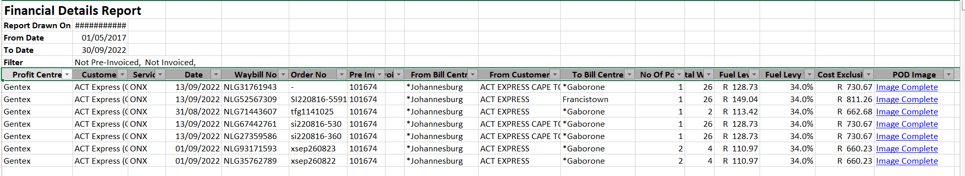

5. Preparing a pre-invoice for billing in LMS – Click on Billing the Check Billing

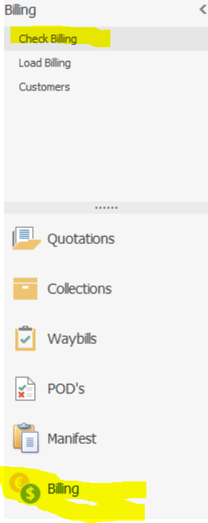

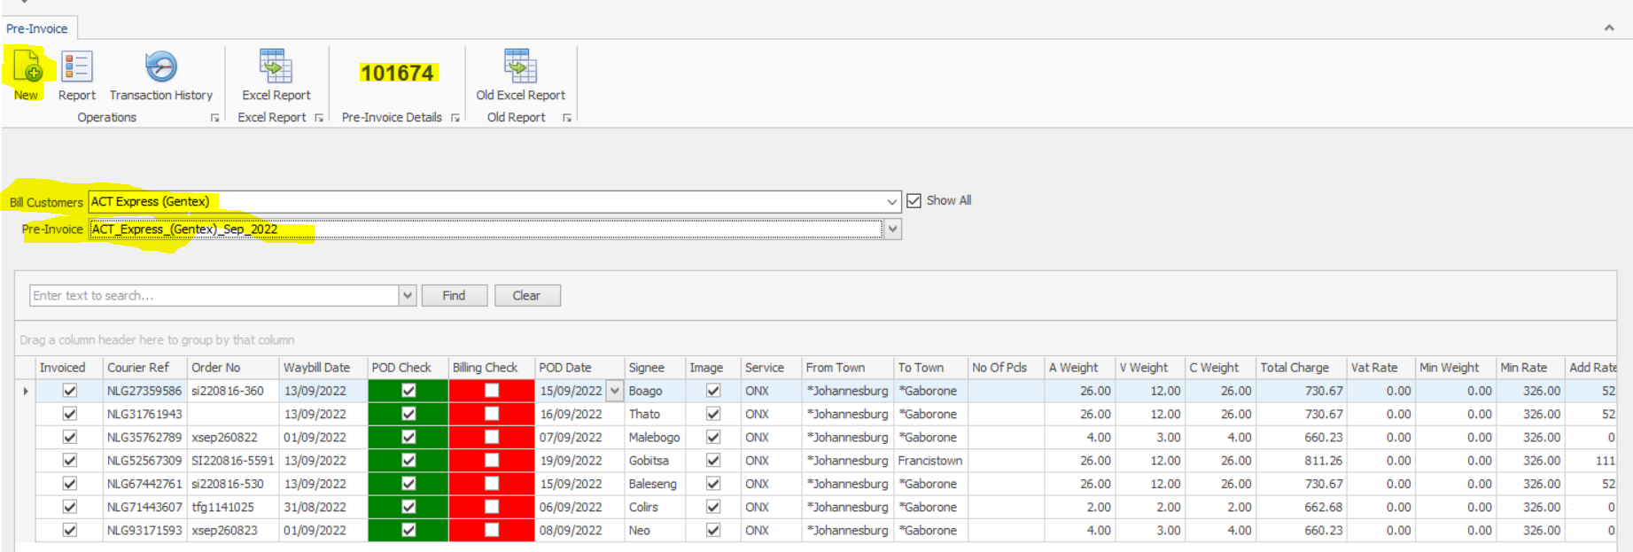

- New – Create and name your pre-invoice
- Bill Customer – On drop down select customer you want to bill
- Pre-Invoice – The name of the pre-invoice you created
- All waybills that needs to be billed will pop up
- Right click on the waybill then click edit waybill

6. Confirm if what’s on the waybill mirrors what’s captured on LMS
- Confirm if the service is correct
- Check if route is correct
- Address of sending customer and the receiving customer.
- Check if the dimension on the waybill matches the dimensions captured on LMS
- Confirm if the correct documents are uploaded – By clicking Image
- Confirm the correct rates are used and the correctly fuel levy for the month is used
- We bill on the highest of the total weight and the volumetric weight
- If all the checks have been done
- Click on save to save all changes made

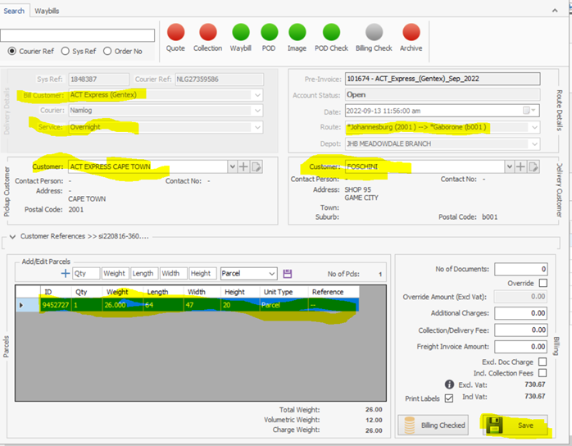

7. Close the waybill screen and return to Pre-Invoice tab

- Click on Excel report to create the pre-invoice and send to Debtors Clerk for invoicing

8. Once invoice has been processed the INV invoice processed on Evolution needs to be linked to the pre-invoice created on LMS to avoid it appearing on the unbilled report
- Capture in the invoice number and amount invoiced then click save

