Purpose: To ensure that the correct steps are followed when processing an invoice on Evolution

1. Find the Evolution app on your desktop screen
Login to Evolution (IT or Lauren Rogers will supply the Evolution login details)

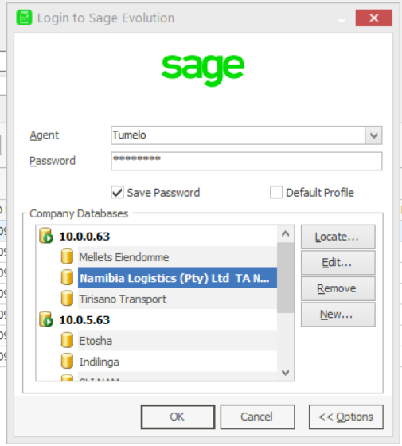

2. Where to process an invoice on Evolution
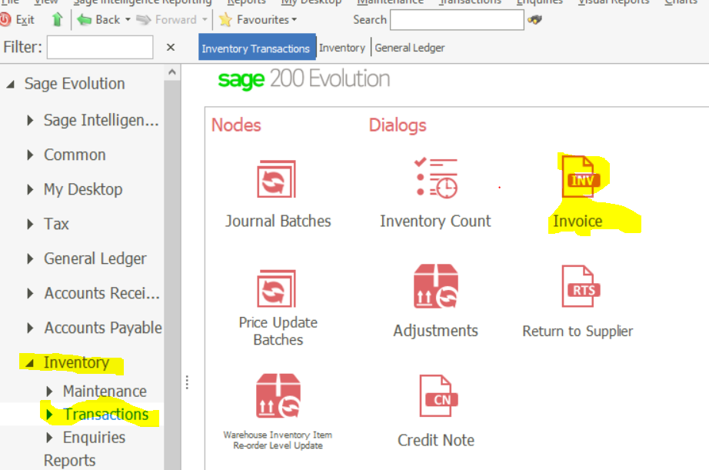
Inventory – Transactions – Invoice

3. Processing a customer’s invoice
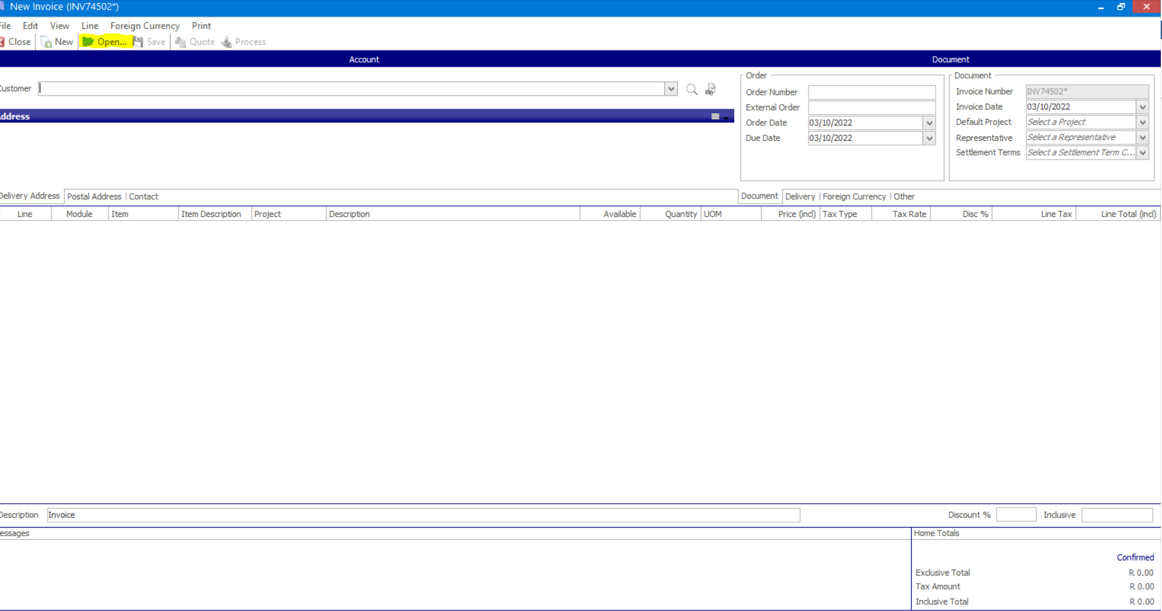
- Click on open

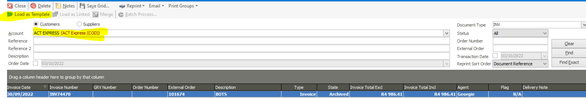
- Account – Select customer’s account number
- Choose the latest invoice processed
- Then click on load as template

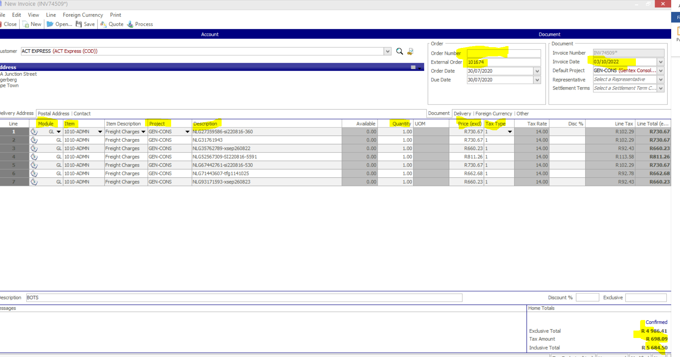
- Customer - Customer name
- Order number –Normally sent to us by the customer
- External order – Pre-invoice number
- Make sure that the date captures is correct before invoicing
- Module – Always (GL)
- Item – General ledger account
1010 - ADMN (Normal freight)
1010 - SPEC (Special freight)
1010 - DEDI (Dedicated freight)
1900 - ADMN (Disbursement and Service Fees)
8250 - ADMN (VAT advances recoveries)
- Projects
GEN-CONS (Botswana shipments)
STR-OTHR (Namibia shipments)
LES-OTHR (Lesotho shipments)
SWZ-OTHR (Swaziland shipments)
ATL-OTHR (Epiroc/Atlas Shipments)
FTL-OTHR (Full Truck loads)
MEL-OTHR (Mellets Shipments)
SPR-OTHR (Springbok Shipments)
- Quantity – Will always be 1
- Price excl – Amount to be invoiced without VAT
- Tax Type – Make sure the correct tax type is selected
6 – All cross-border shipment (Zero VAT)
01 – Local shipments (Attracts VAT)
7 – non-VATABLE items
- Confirm if the amount including VAT matches what the amount you are about to process.
- Click Process at the top.

