LOGIN
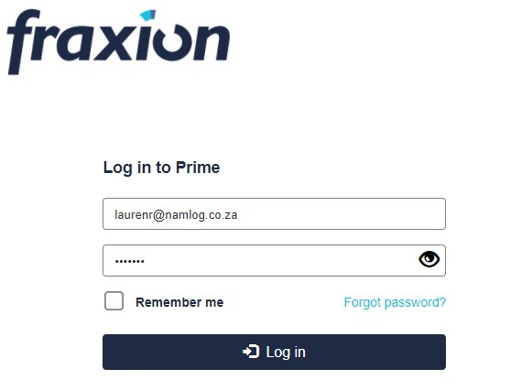
Select Request – Purchase

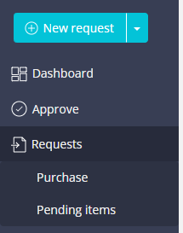

Select CREATE
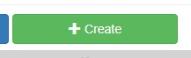

Complete ALL fields
- Title : enter description
- Request owner – you
- Company – select which company the PO needs to be issued in
- Enter vehicle reg no
- Enter vehicle km’s
- Enter brief description
- Select YES/No for AOD
- Select YES/NO for COD

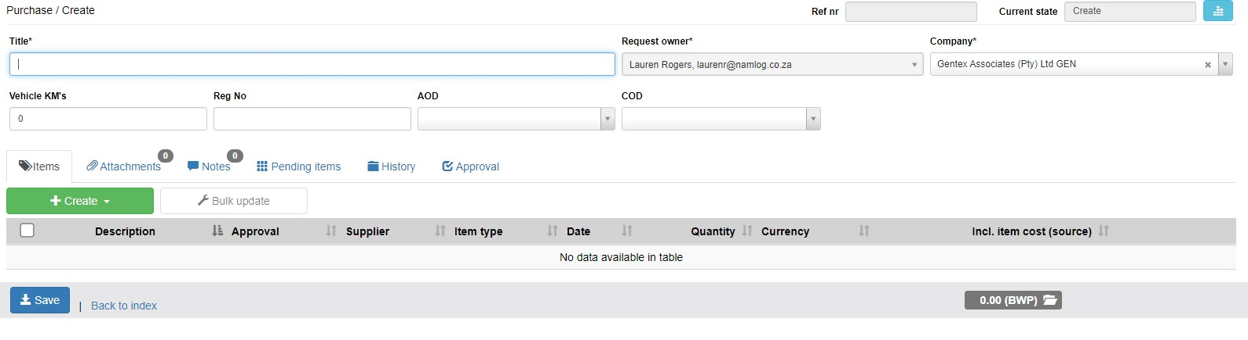

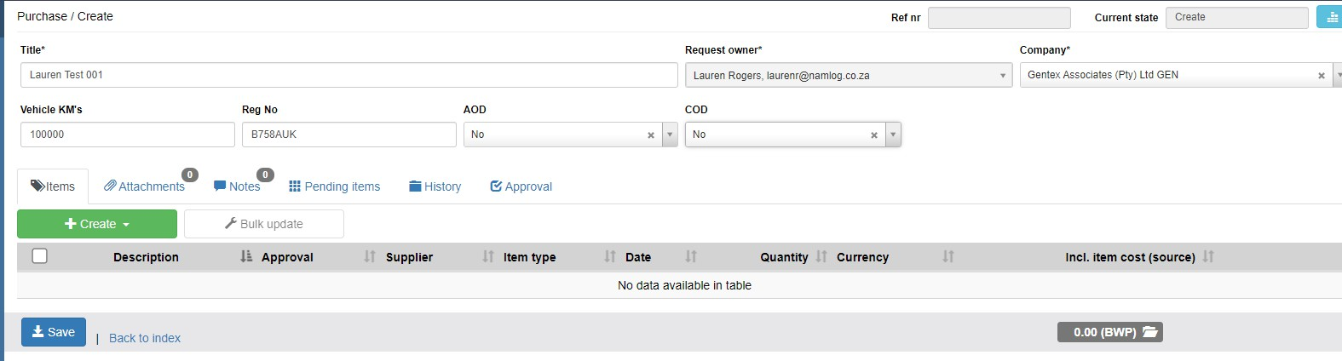

Select CREATE

- Select GOODS/SERVICES
- Complete all fields

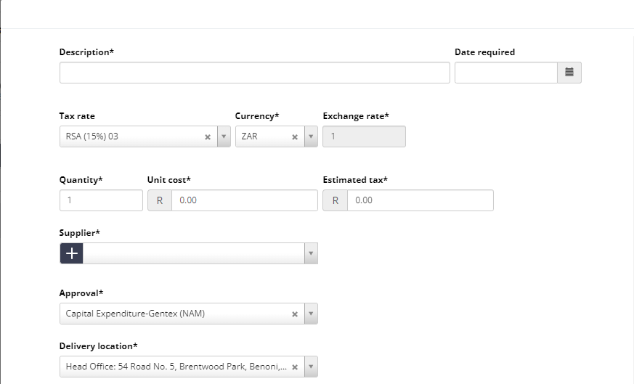

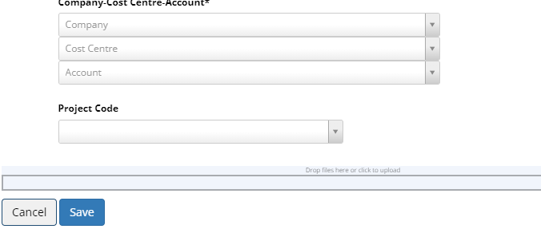

- Description – explain what is required ie repairs to brakes, stationery etc. ALSO add in vehicle km’s &
Reg No – THIS LINE EXPORTS TO EVOLUTION
- Date required
- Tax rate
- Quantity
- Cost
- Supplier
- Approval (this field is VERY important) and will be explained further in training – this will select the approvers of this request

- 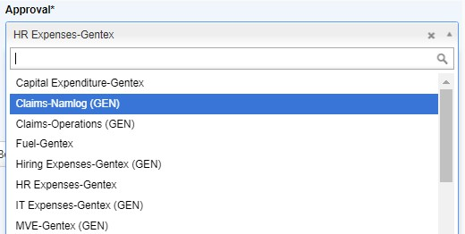
-

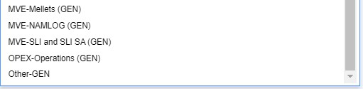
-
- Delivery Location

- Company cost centre account :
- Company
- Cost Centre
- Account
- Project code

- You must add a copy of the quote and any other supporting documentation.
- Notes – must enter a note with a further/detailed description


- Once saved you can click on edit or delete

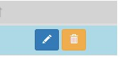

- Once all information has been added and the quote is attached you can submit for approval


Once request has been approved by all relevant managers, you need to “flip” to a PO

