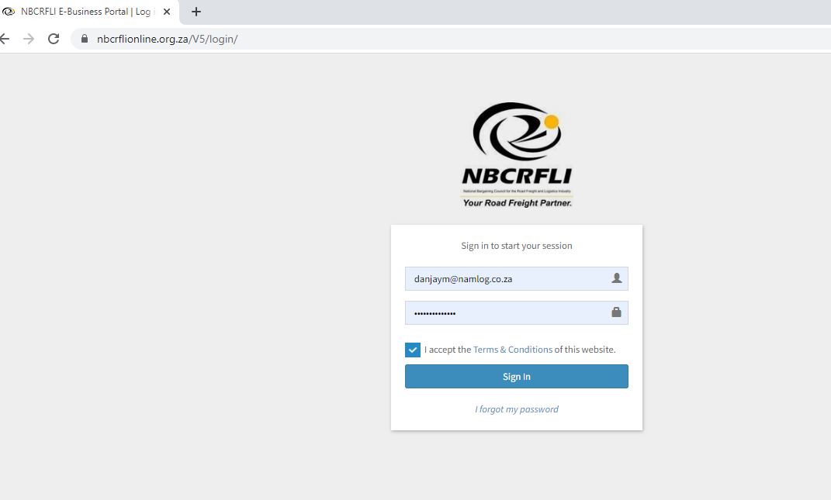

1. Log in on NBC https://nbcrflionline.org.za/V5/login/
2. Choose the Company
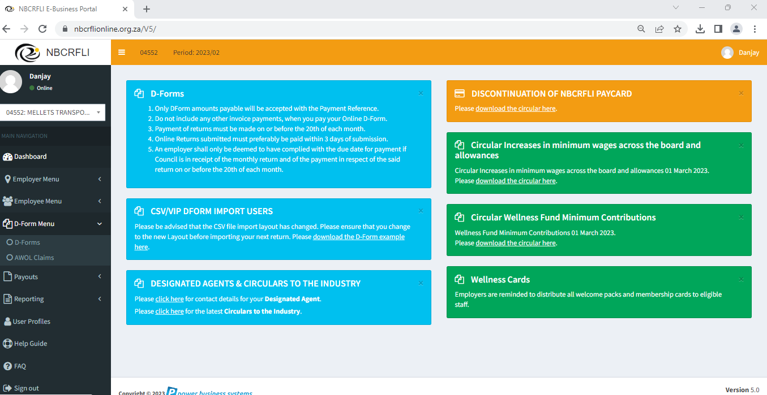

3. Click on the D Form Tab

4. Click on the Create New D Form (+) button

5.1. Add New Employees
5.2 Termination to be done.
5.3 Unions to be added
5.4 Increase to be completed.

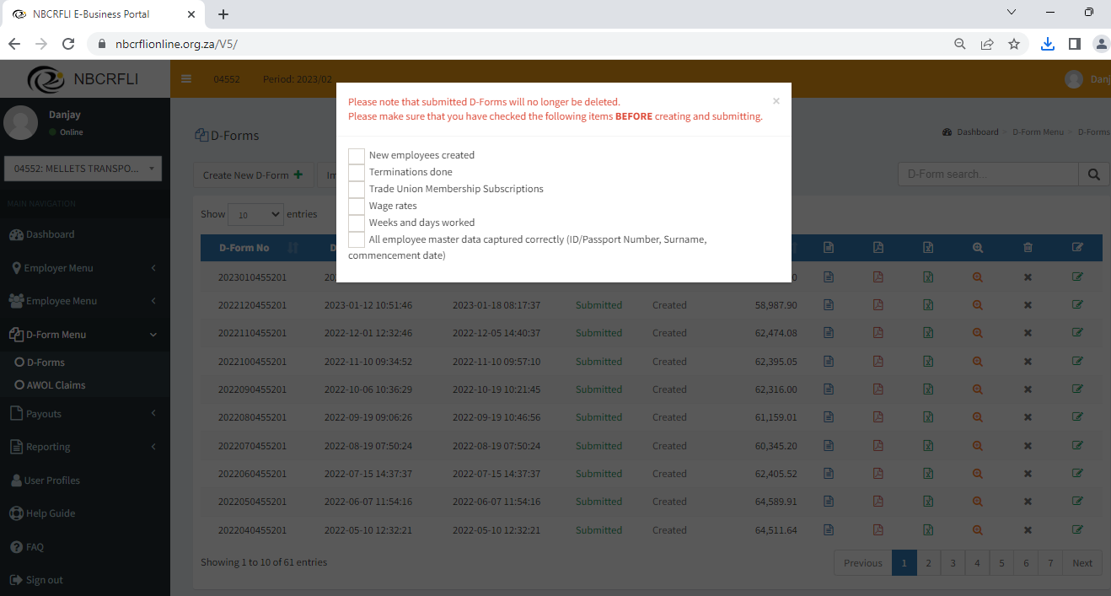

6. Once the checklist is done, Click on Create D Form .

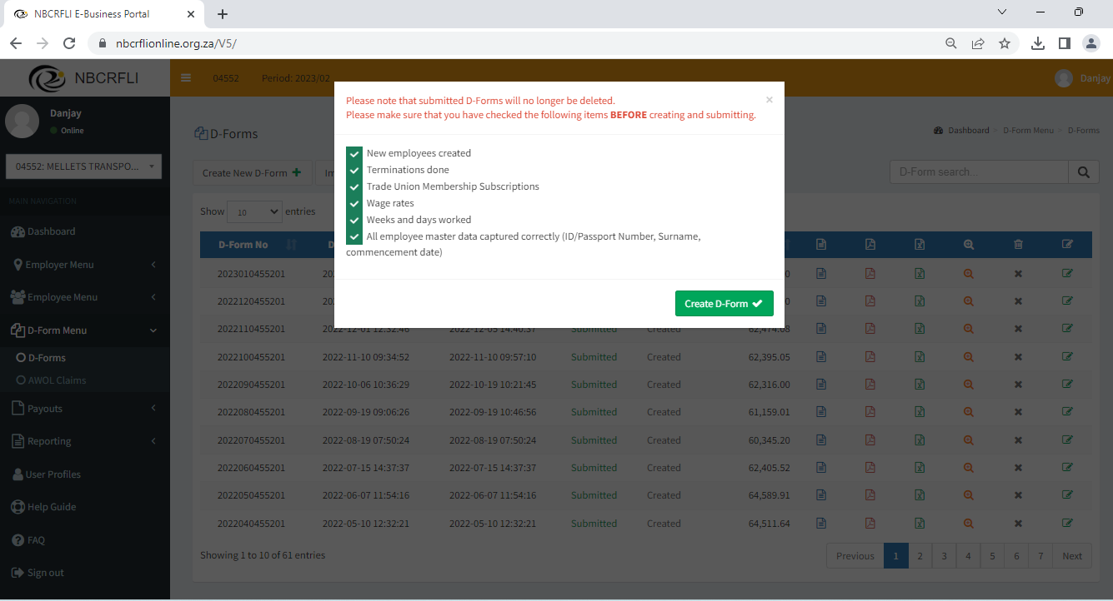

7. D Form is created .

