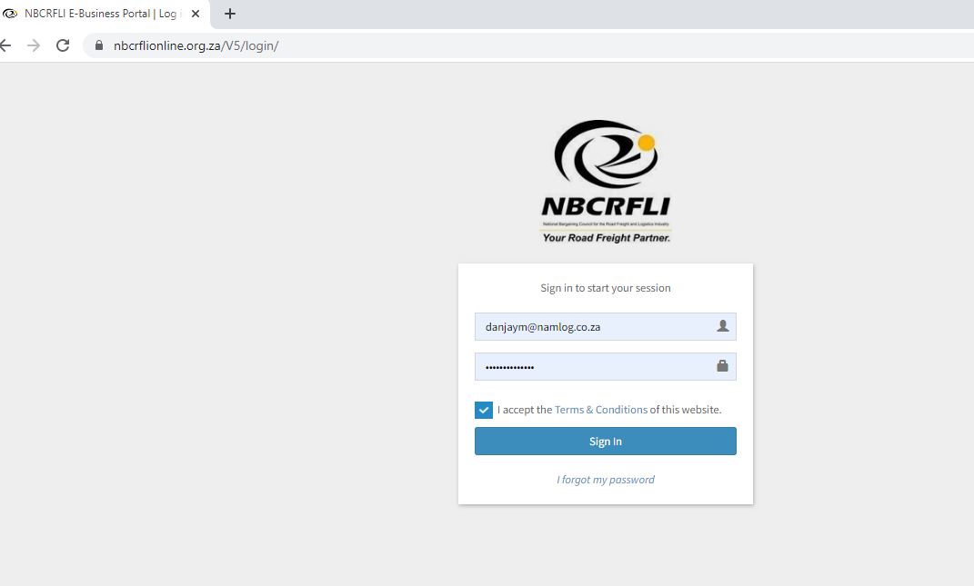

1. Log in on NBC ONLINE https://nbcrflionline.org.za/V5/login/
2. Choose the Company
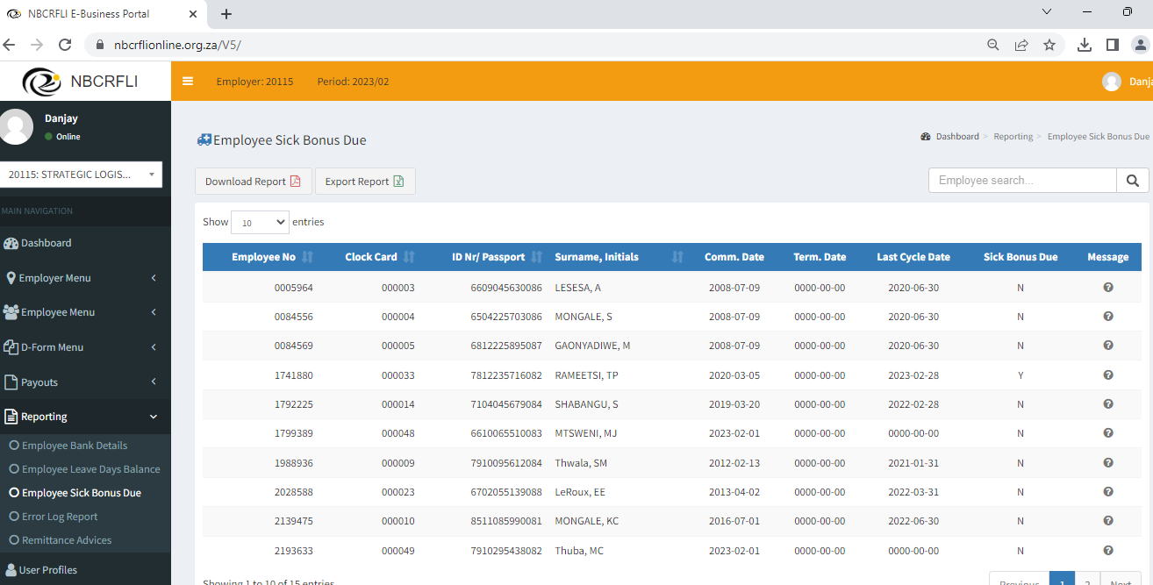
3. Click on the Reporting tab
3.1. Click on the Employee Sick Bonus Due.
3.2 Export report into Excel

3.3 Sort Excel sheet by those that qualify for Sick Bonus Due (- Y) 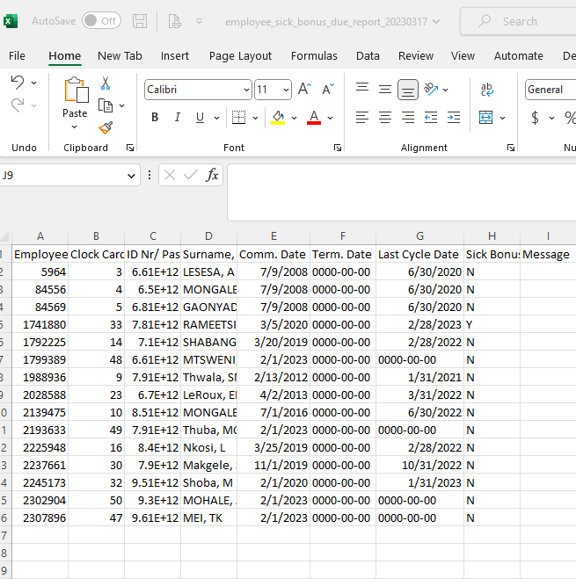

4. Click on the Payouts
4.1 Click on Employee Payouts
4.2 Click on Create on New Payouts
4.3 Search for employee who qualifies for sick leave bonus.

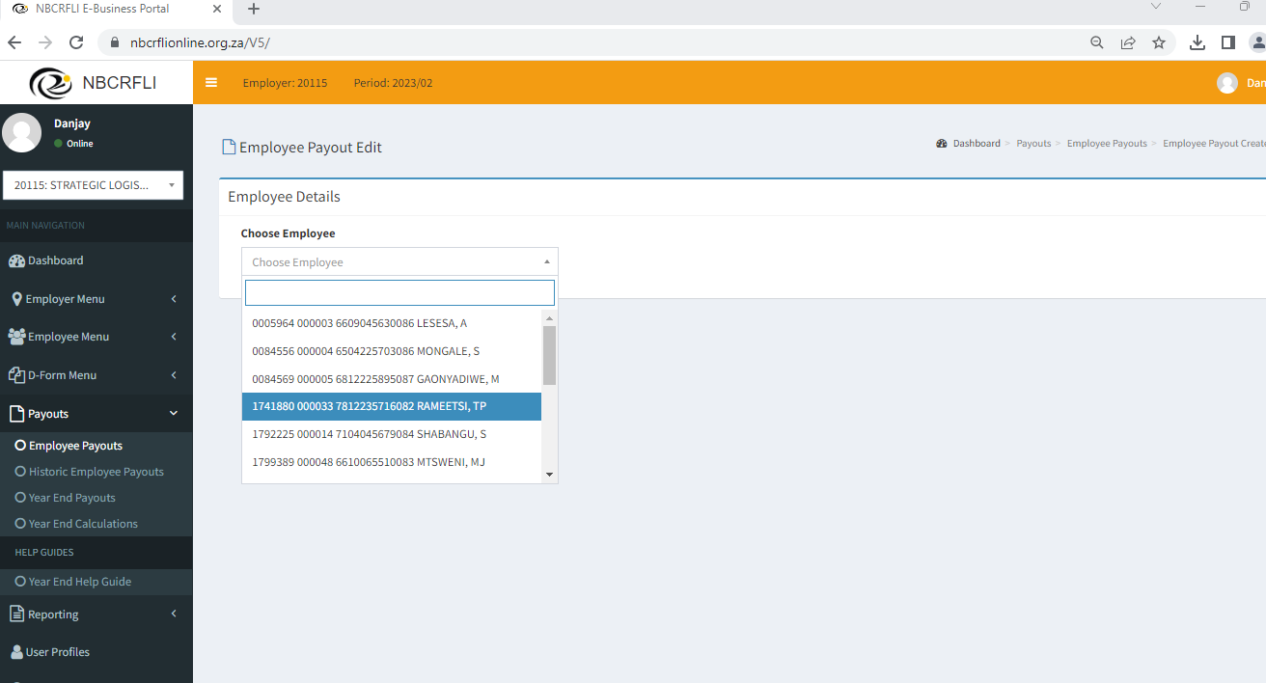

4.4 Click on Create on Payout Application
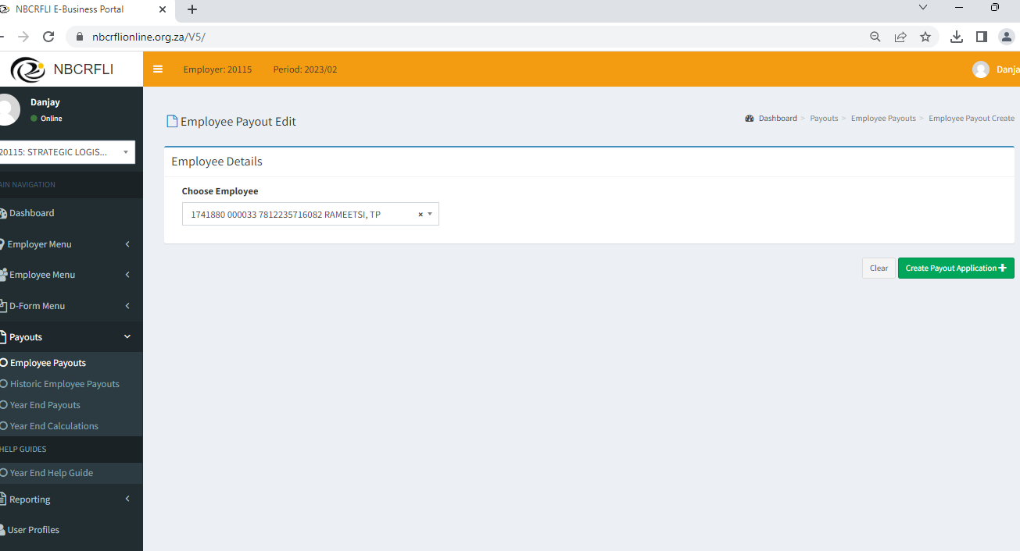

4.5 Choose Application Type A Voucher

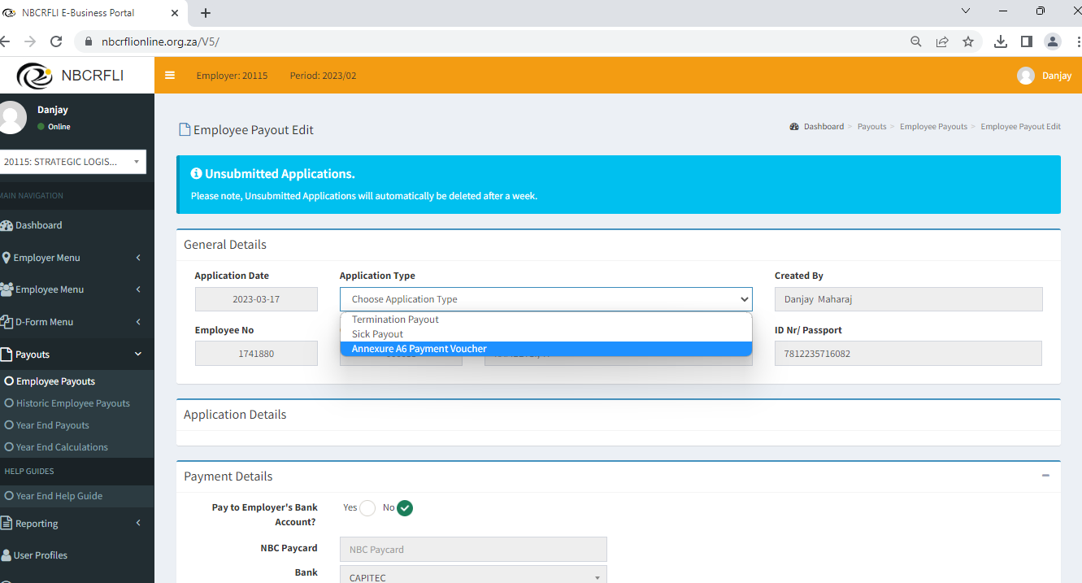

4.6 Click on SICK LEAVE BONUS

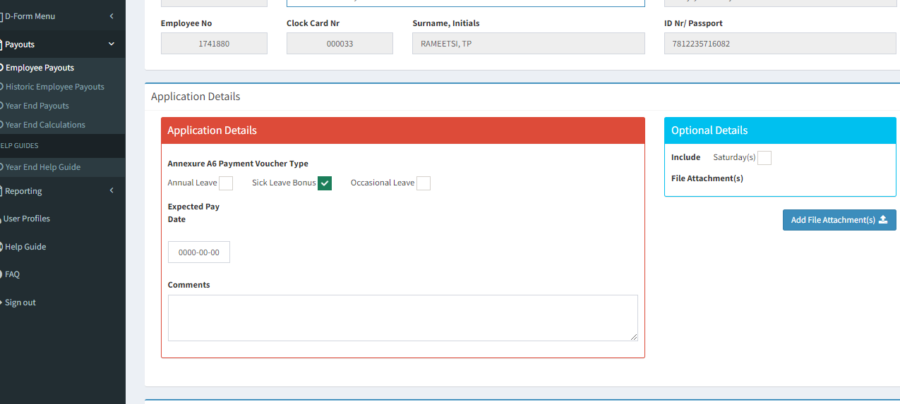

4.7 Click on the Green button - Submit Application

