Double Click on icon on desktop:
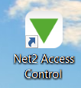
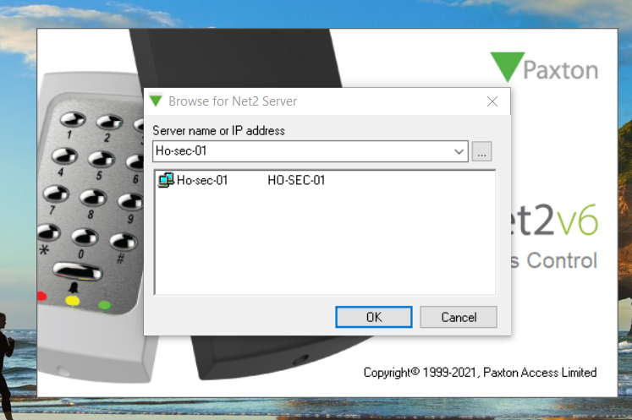
Click OK
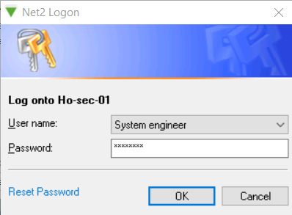
Insert Password – 143Jesus
Click OK
Click on reports
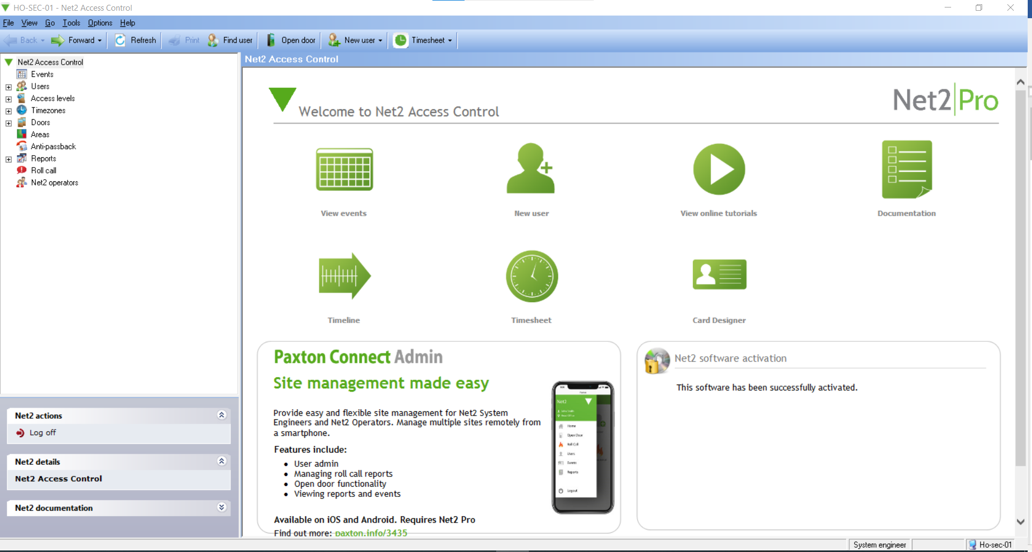
Click on New Report:
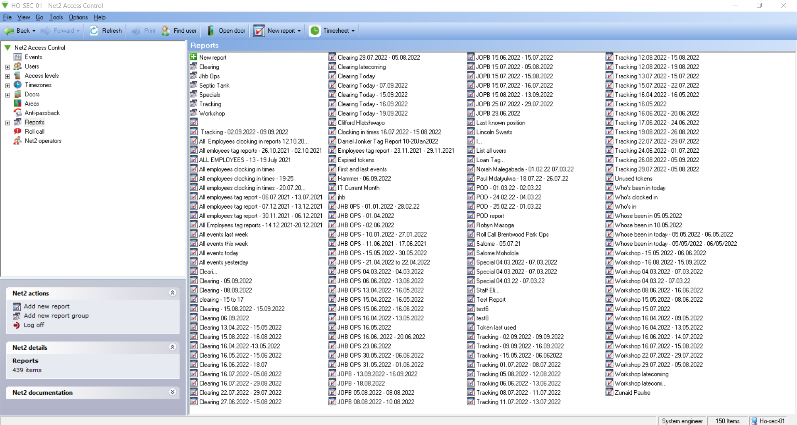
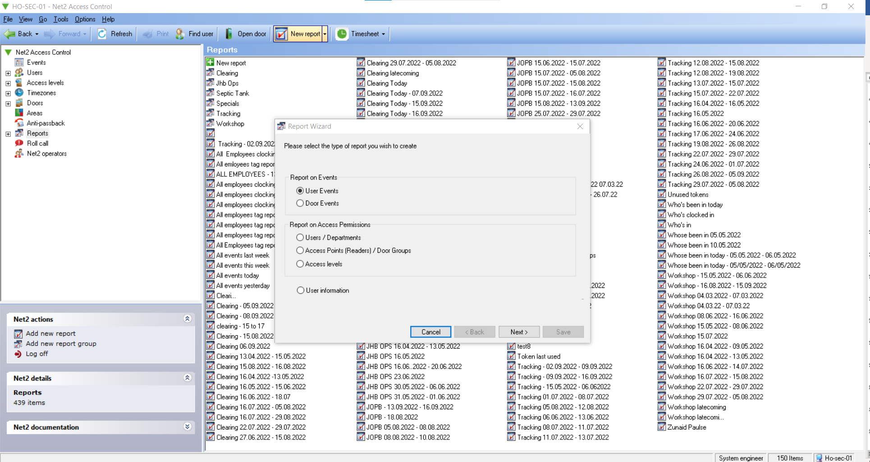
Click on Next
Highlight All Departments except Kathu Staff.
Do not include individual employee Names.
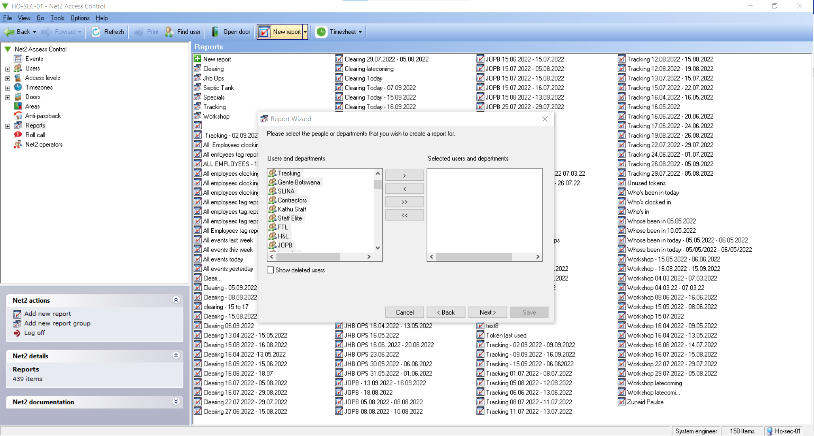
Click on >.
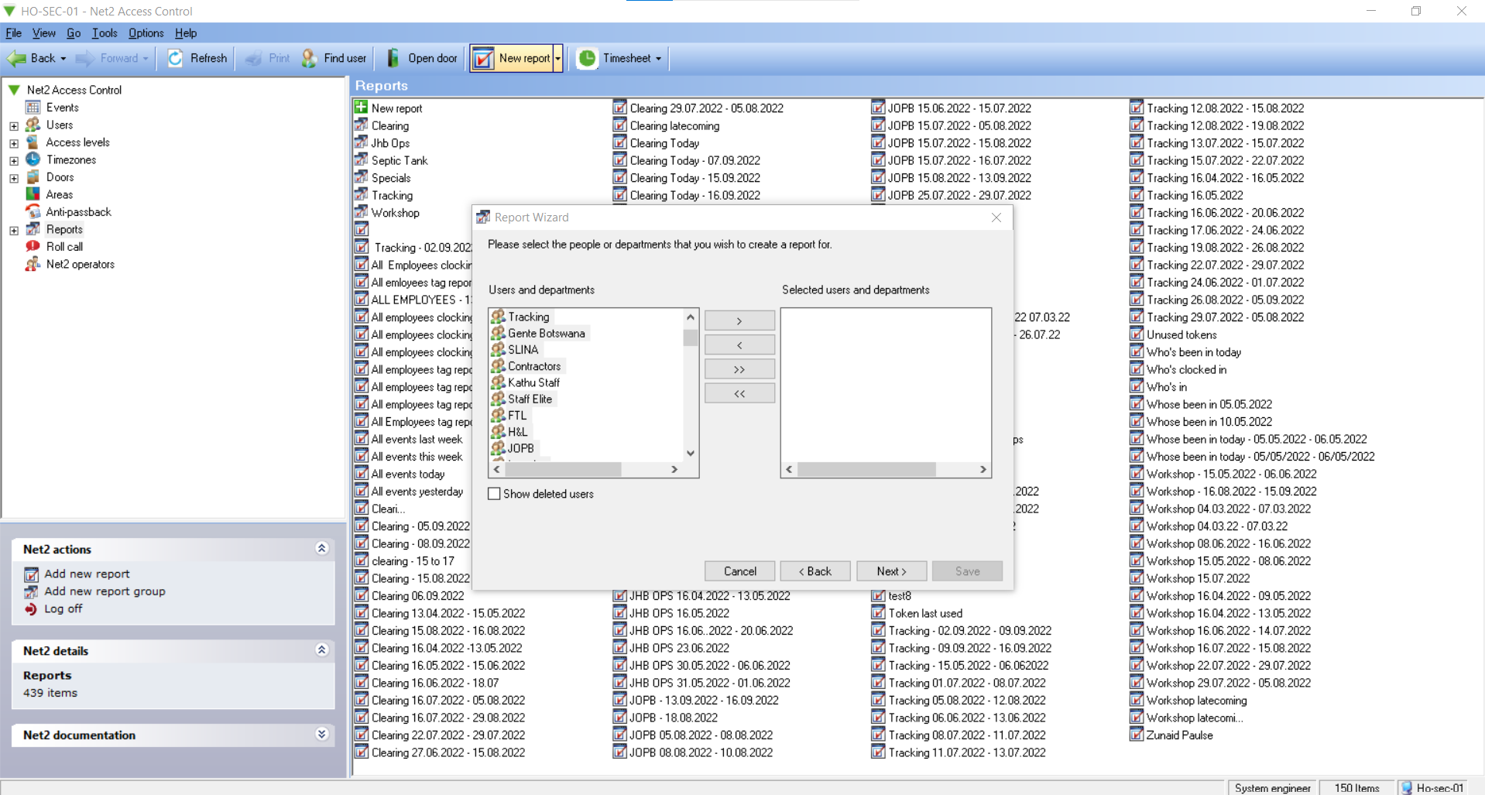
This will move the departments to the right side.
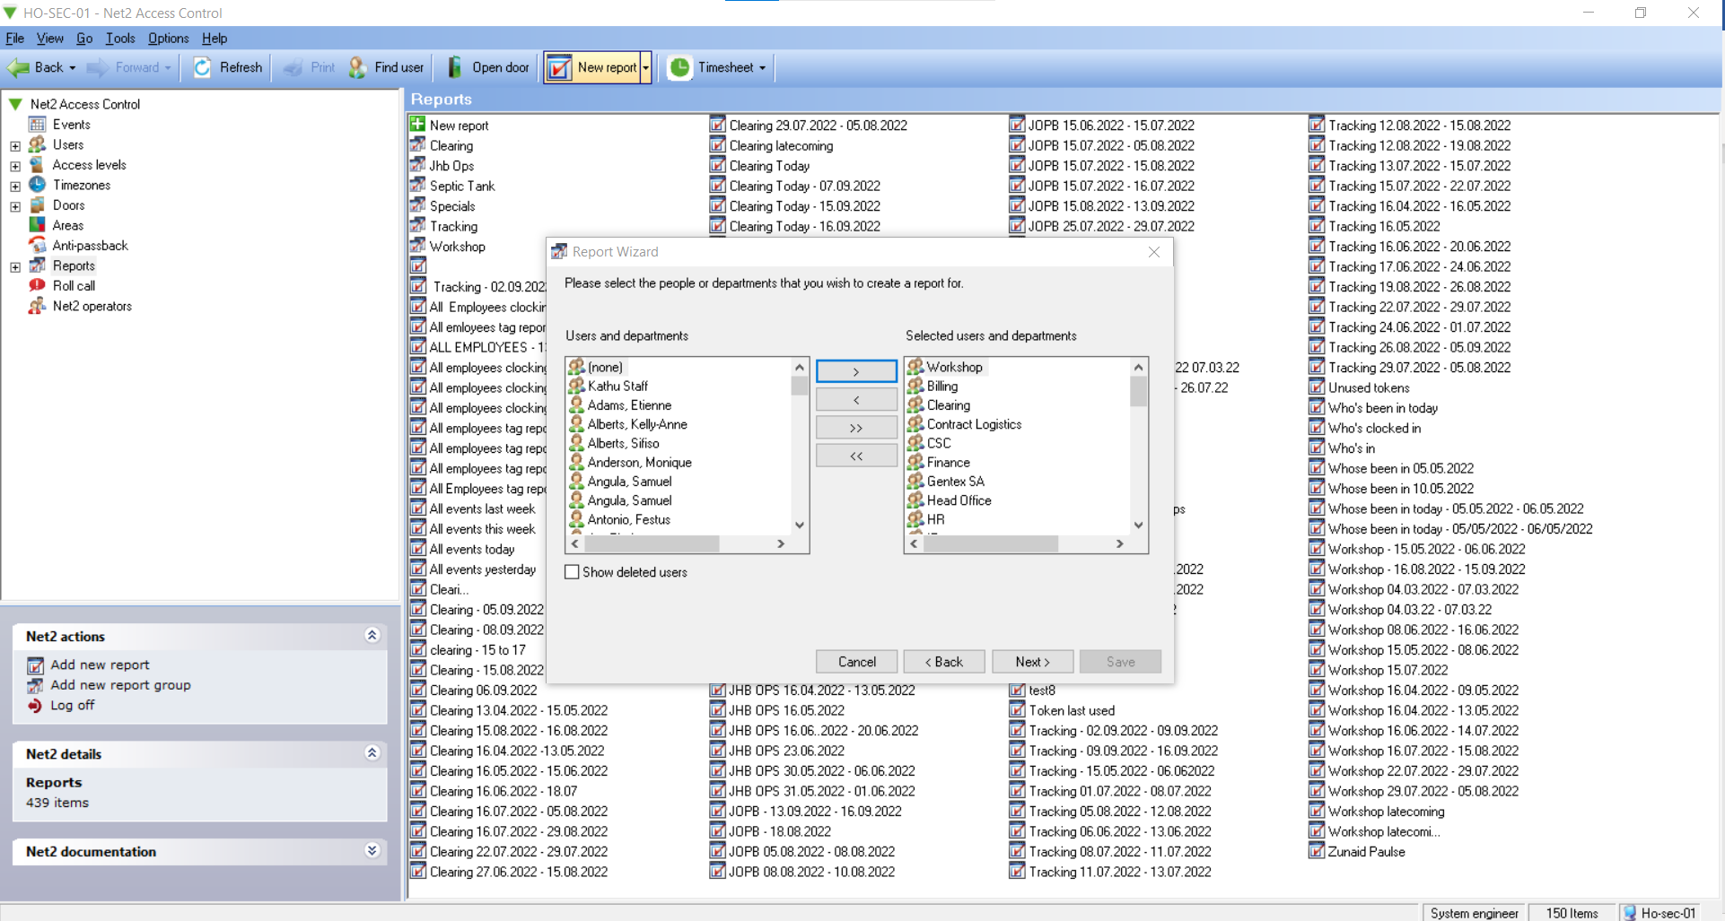
Click on Next
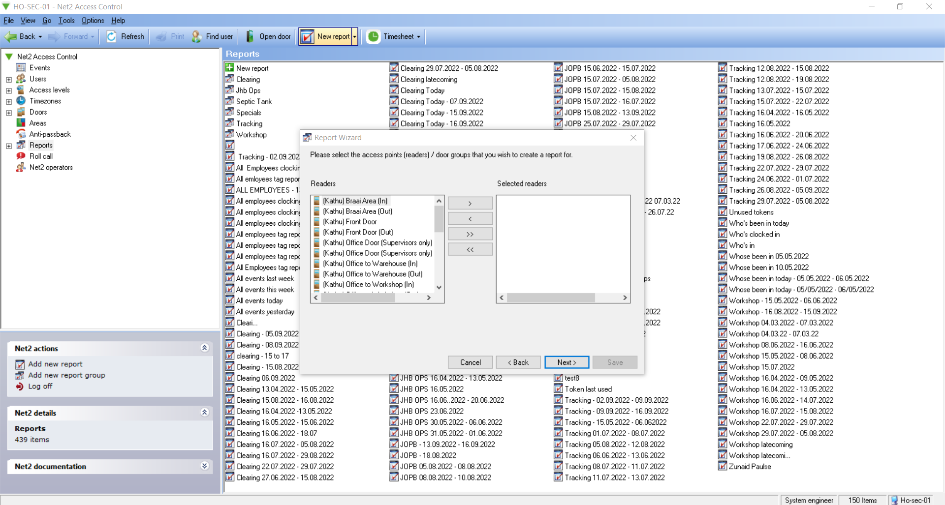
Select all Readers and click on >
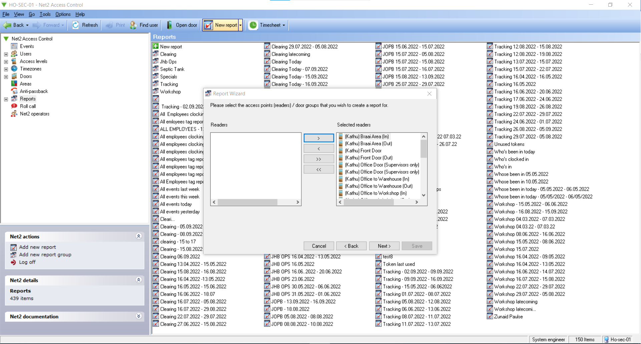
This will move the readers to the right side.
Click Next
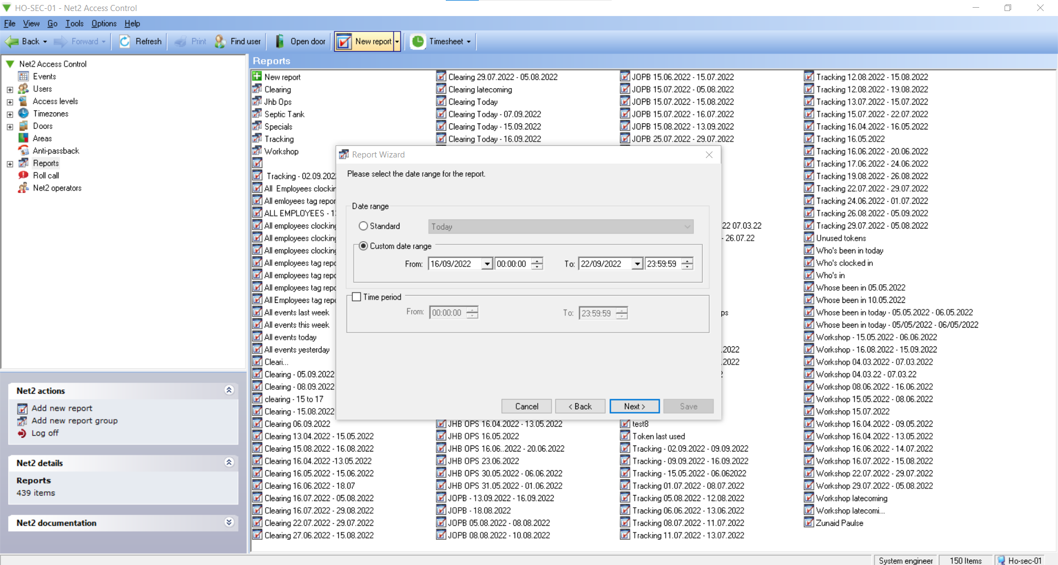
Click on Custom date range. Choose dates from and to.
Septic Tank reports are pulled every Friday. The report will run from previous Friday to Thursday. Eg 16/09/2022 to 22/09/2022.
Click Next.
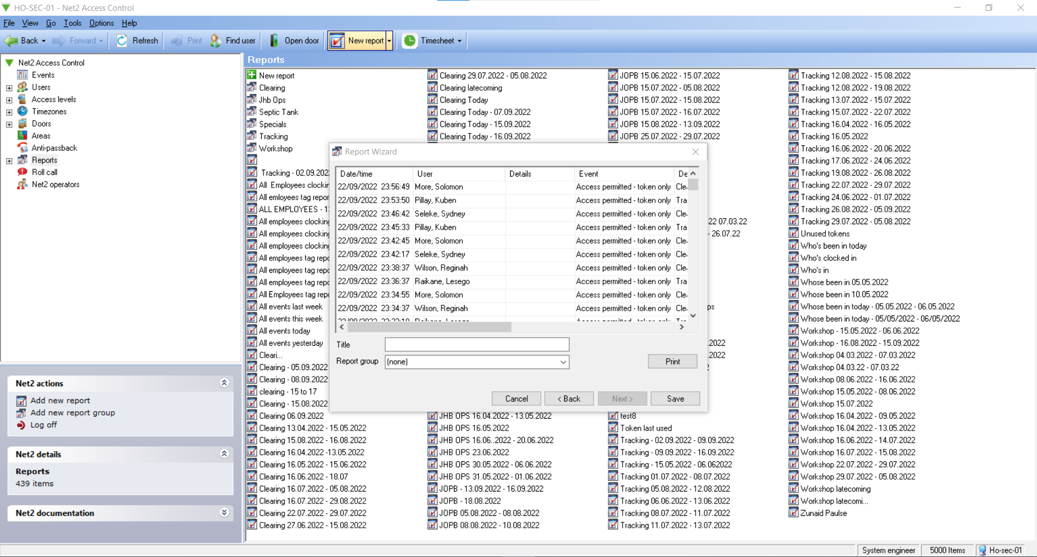
Name the report under Title: Septic Tank 16.09.2022 to 22.09.2022
Click on the drop down by Report Group and choose Septic Tank:
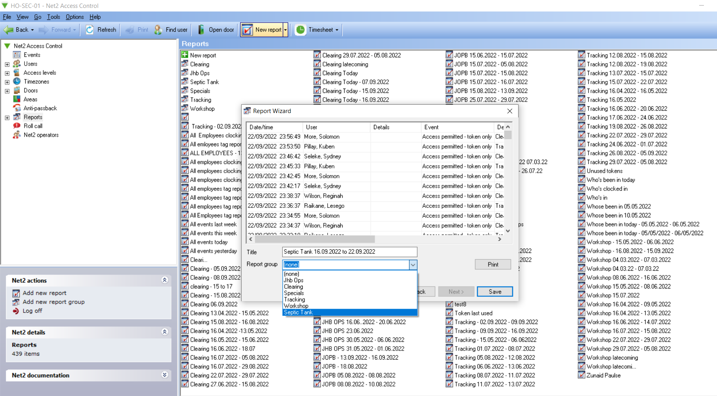
Click Save
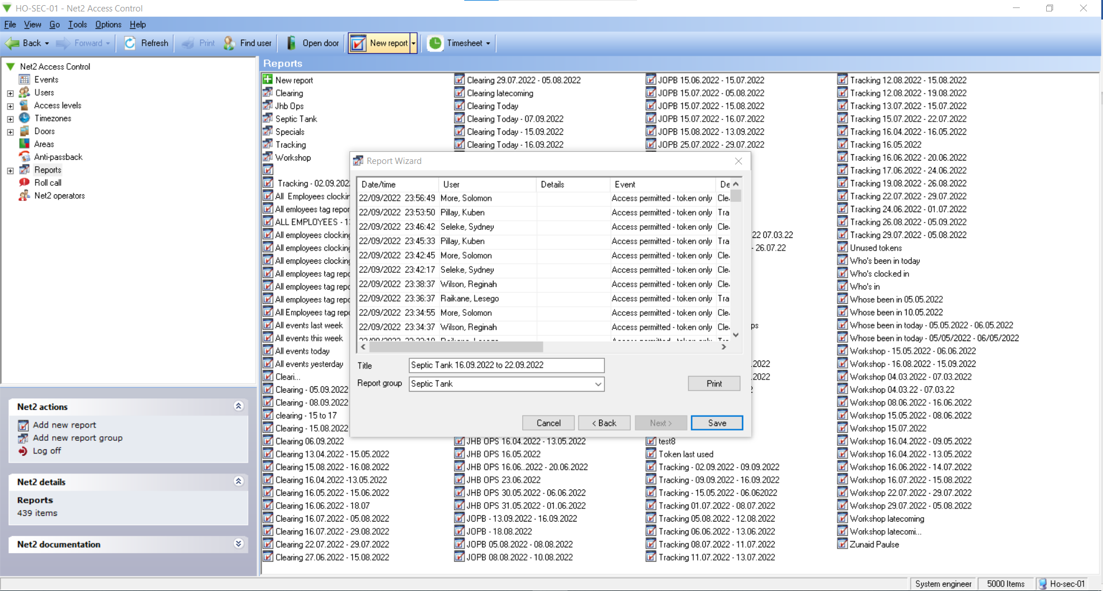
Click on Septic Tank folder under Reports:
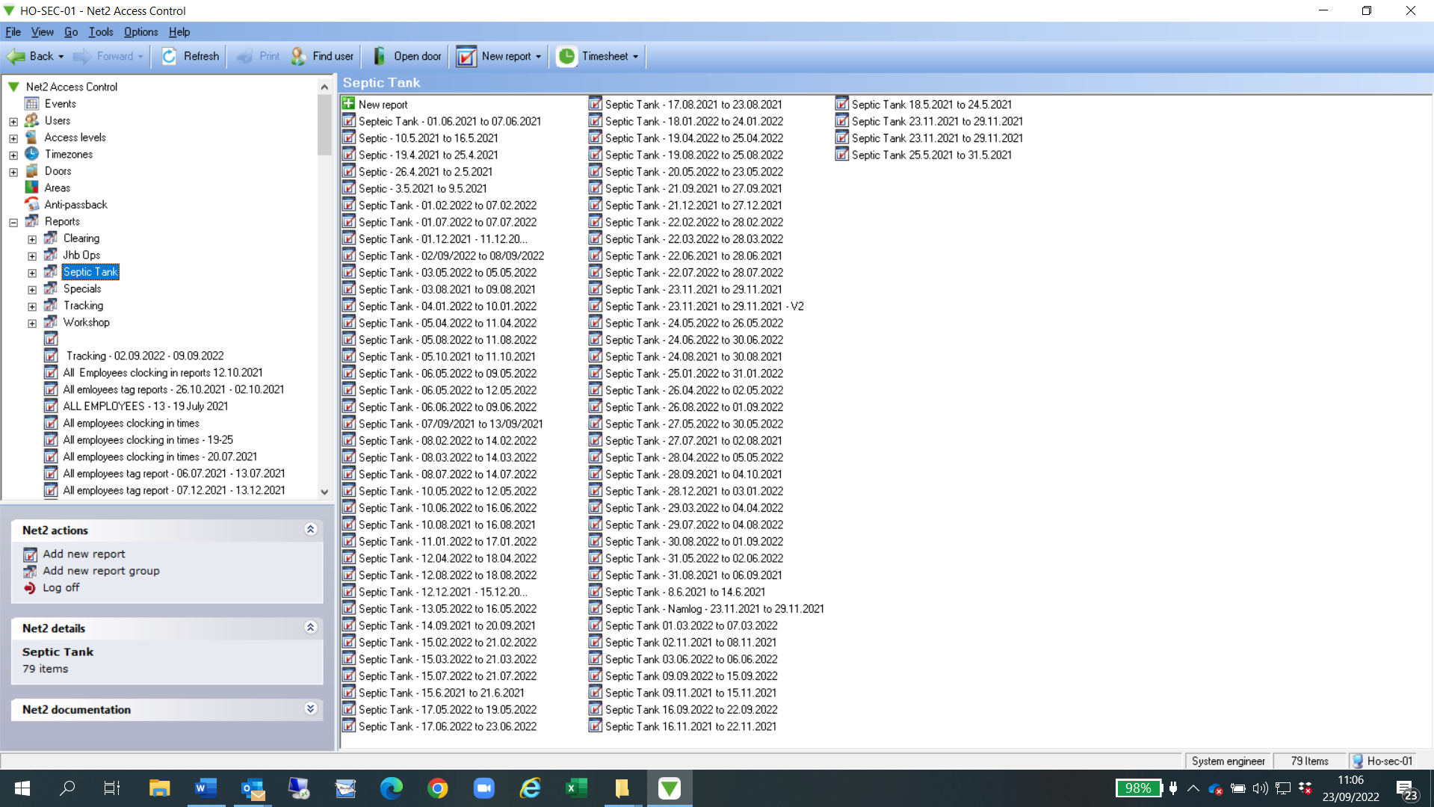
Double click the report you have just saved on the right-hand side.
Click on Export Report:
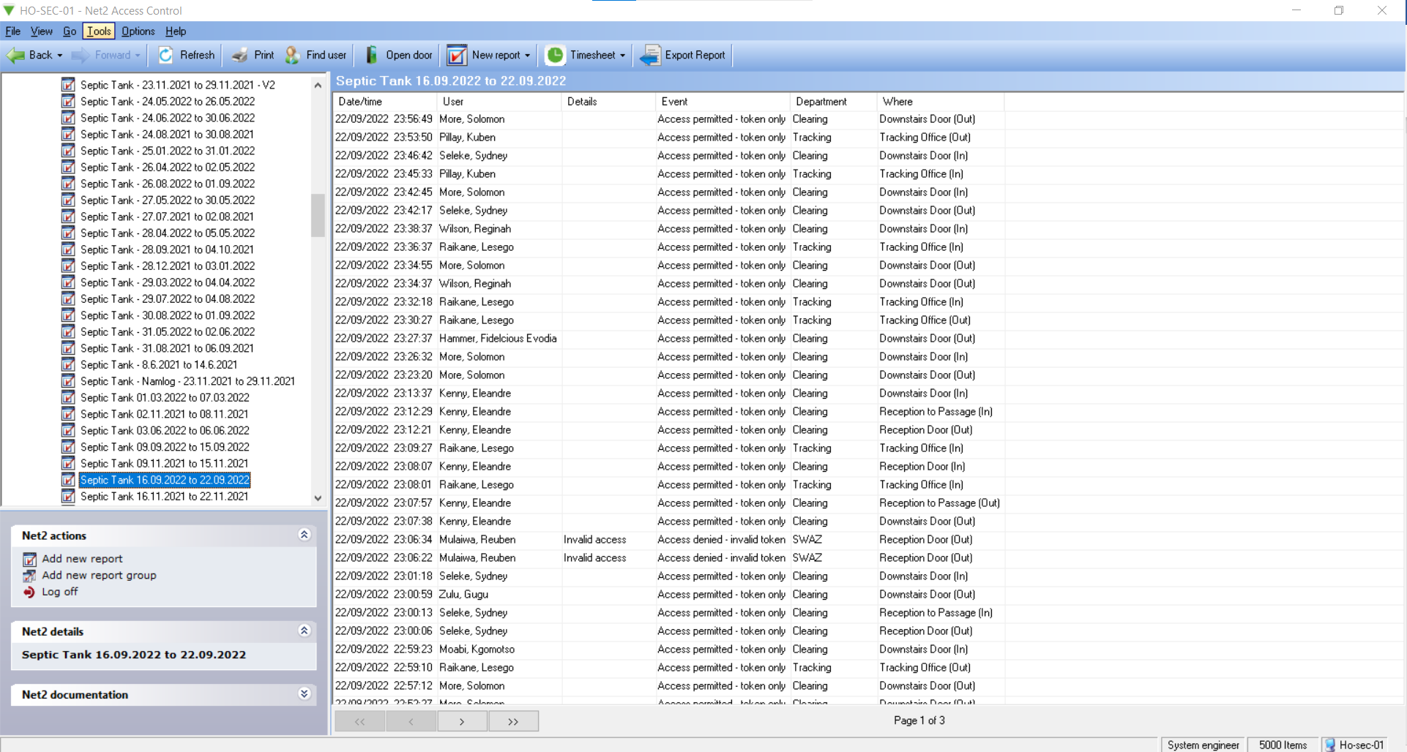

Export report to file:
HO Drive – HR2 – Brentwood Park – Access Tag Reports
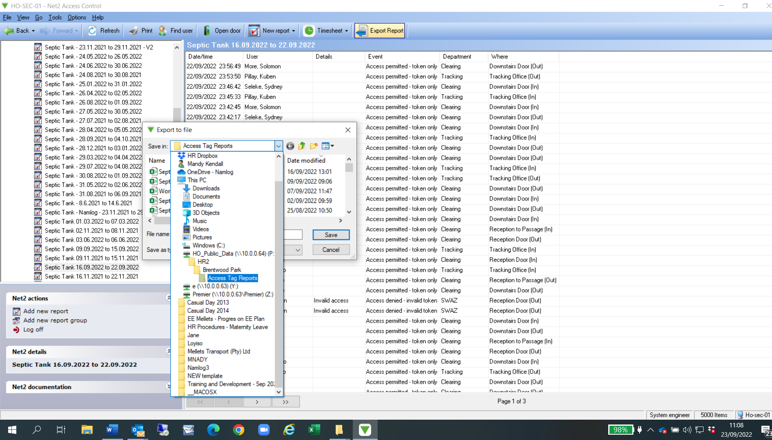

Name file name as Septic Tank – 16.09.2022 to 22.09.2022
Click on Save
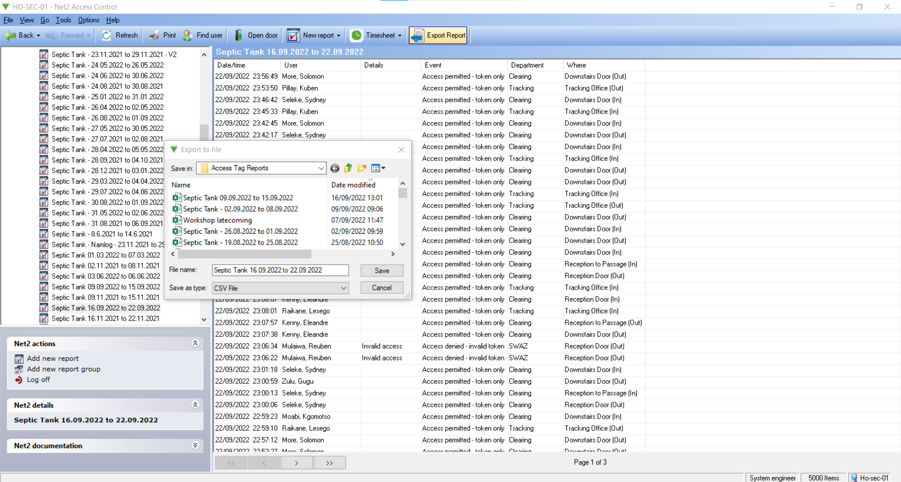
Go to blank Excel sheet, click open
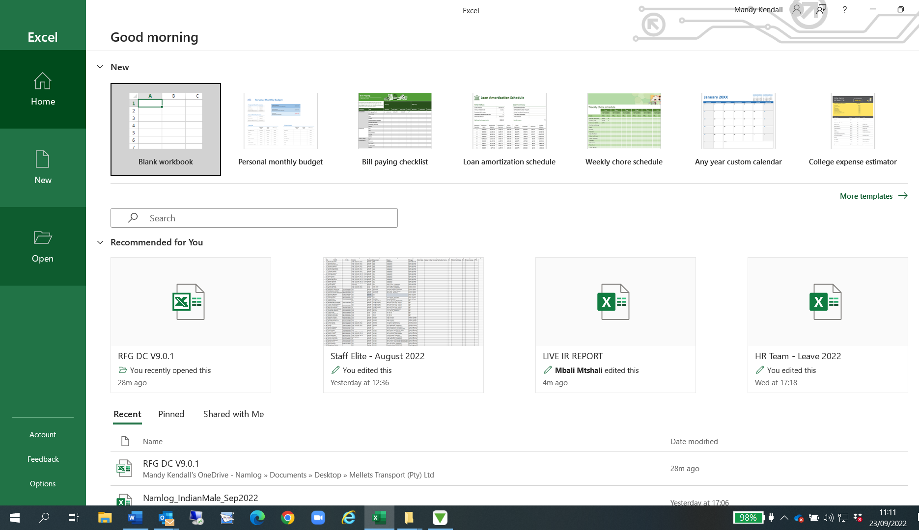
Browse to where you have saved the report:
HO Drive – HR2 – Brentwood Park – Access Tag Reports – Select All Files

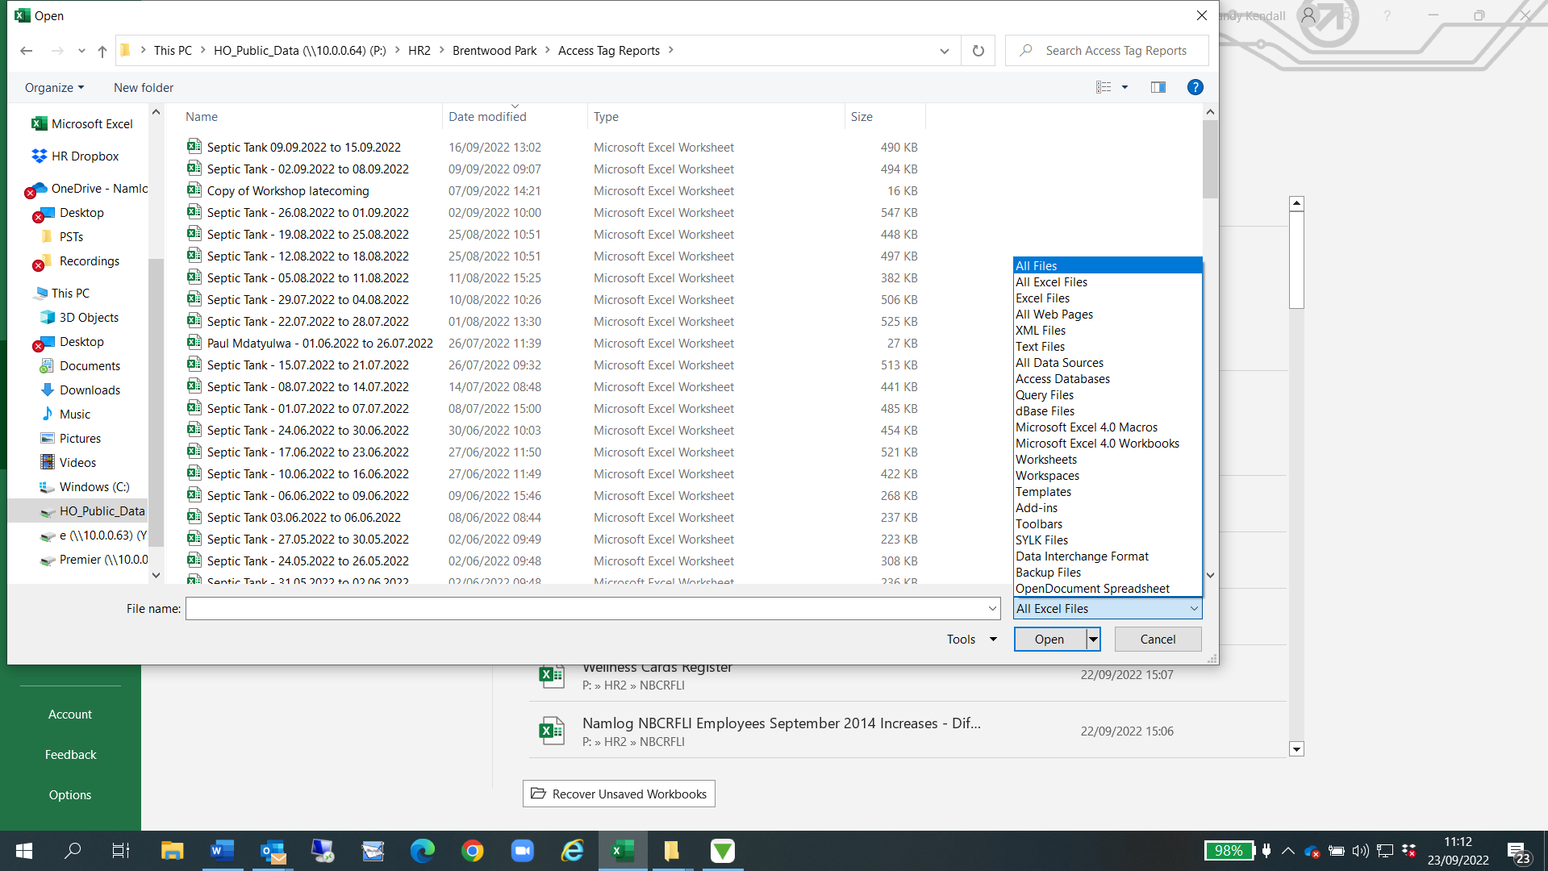
Choose file Septic Tank – 16.09.2022 to 22.09.2022.
Click open
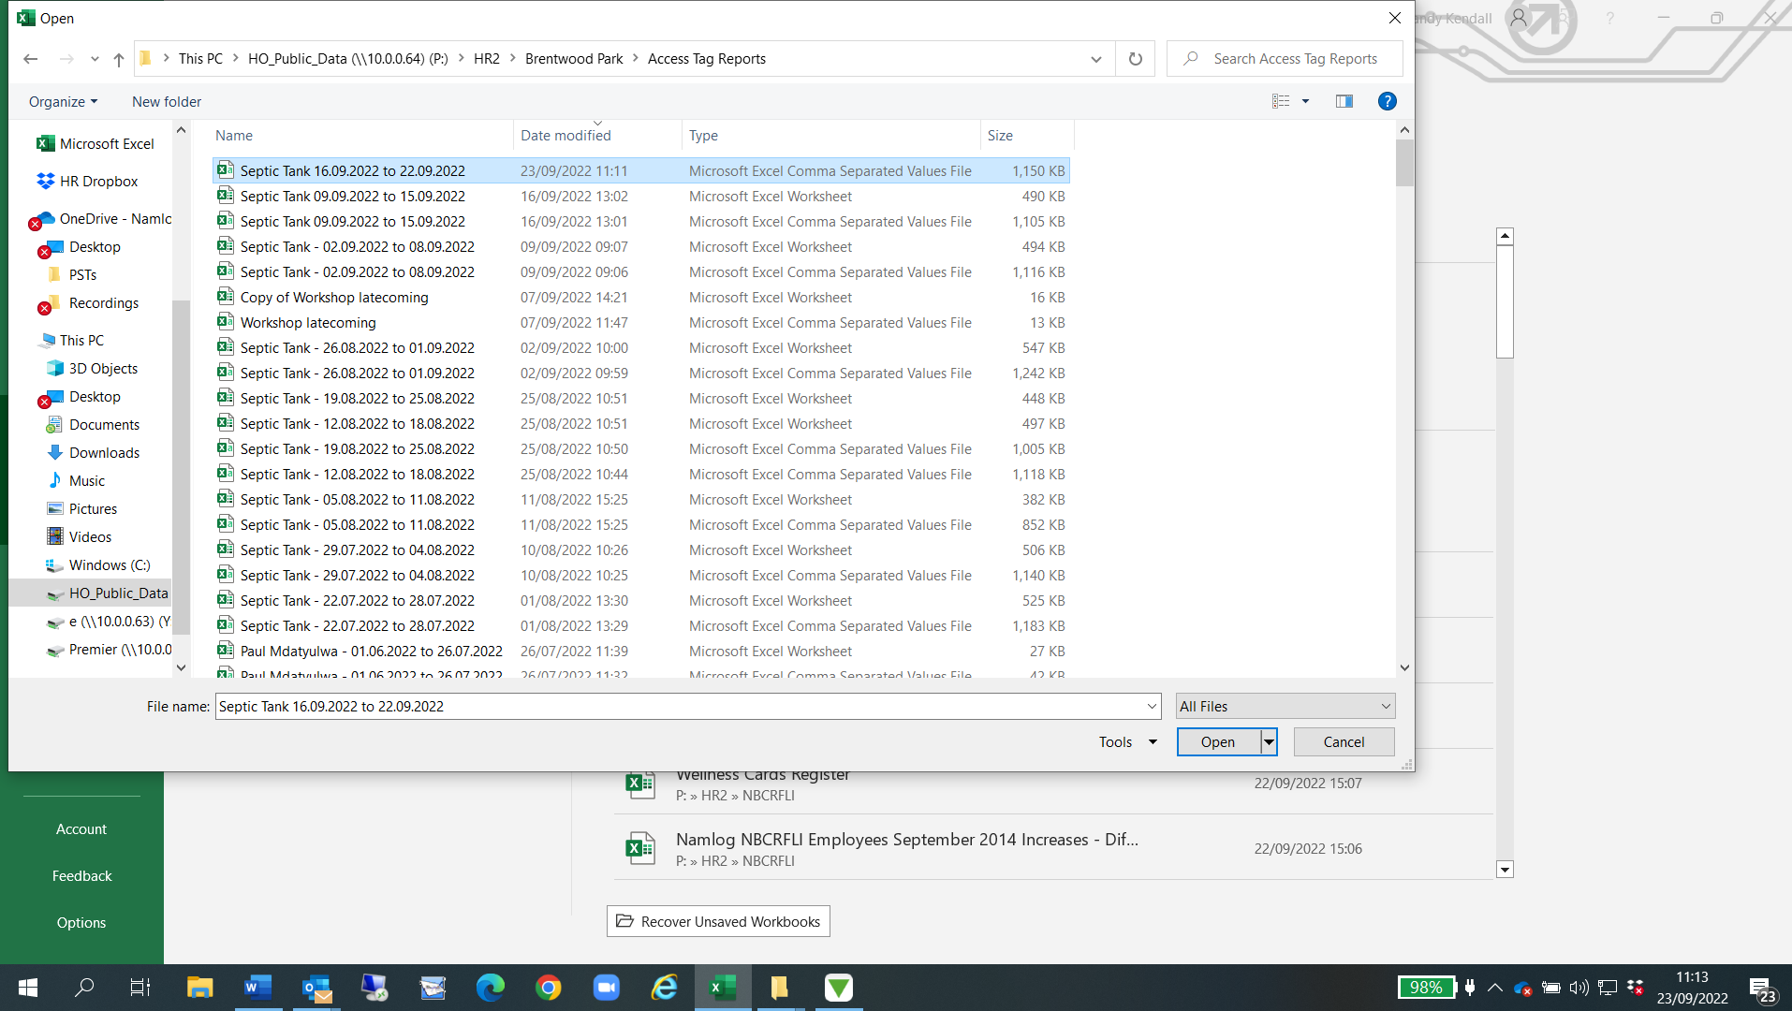
Select A1 to F1 – click Bold
Control shift arrow down to select all information
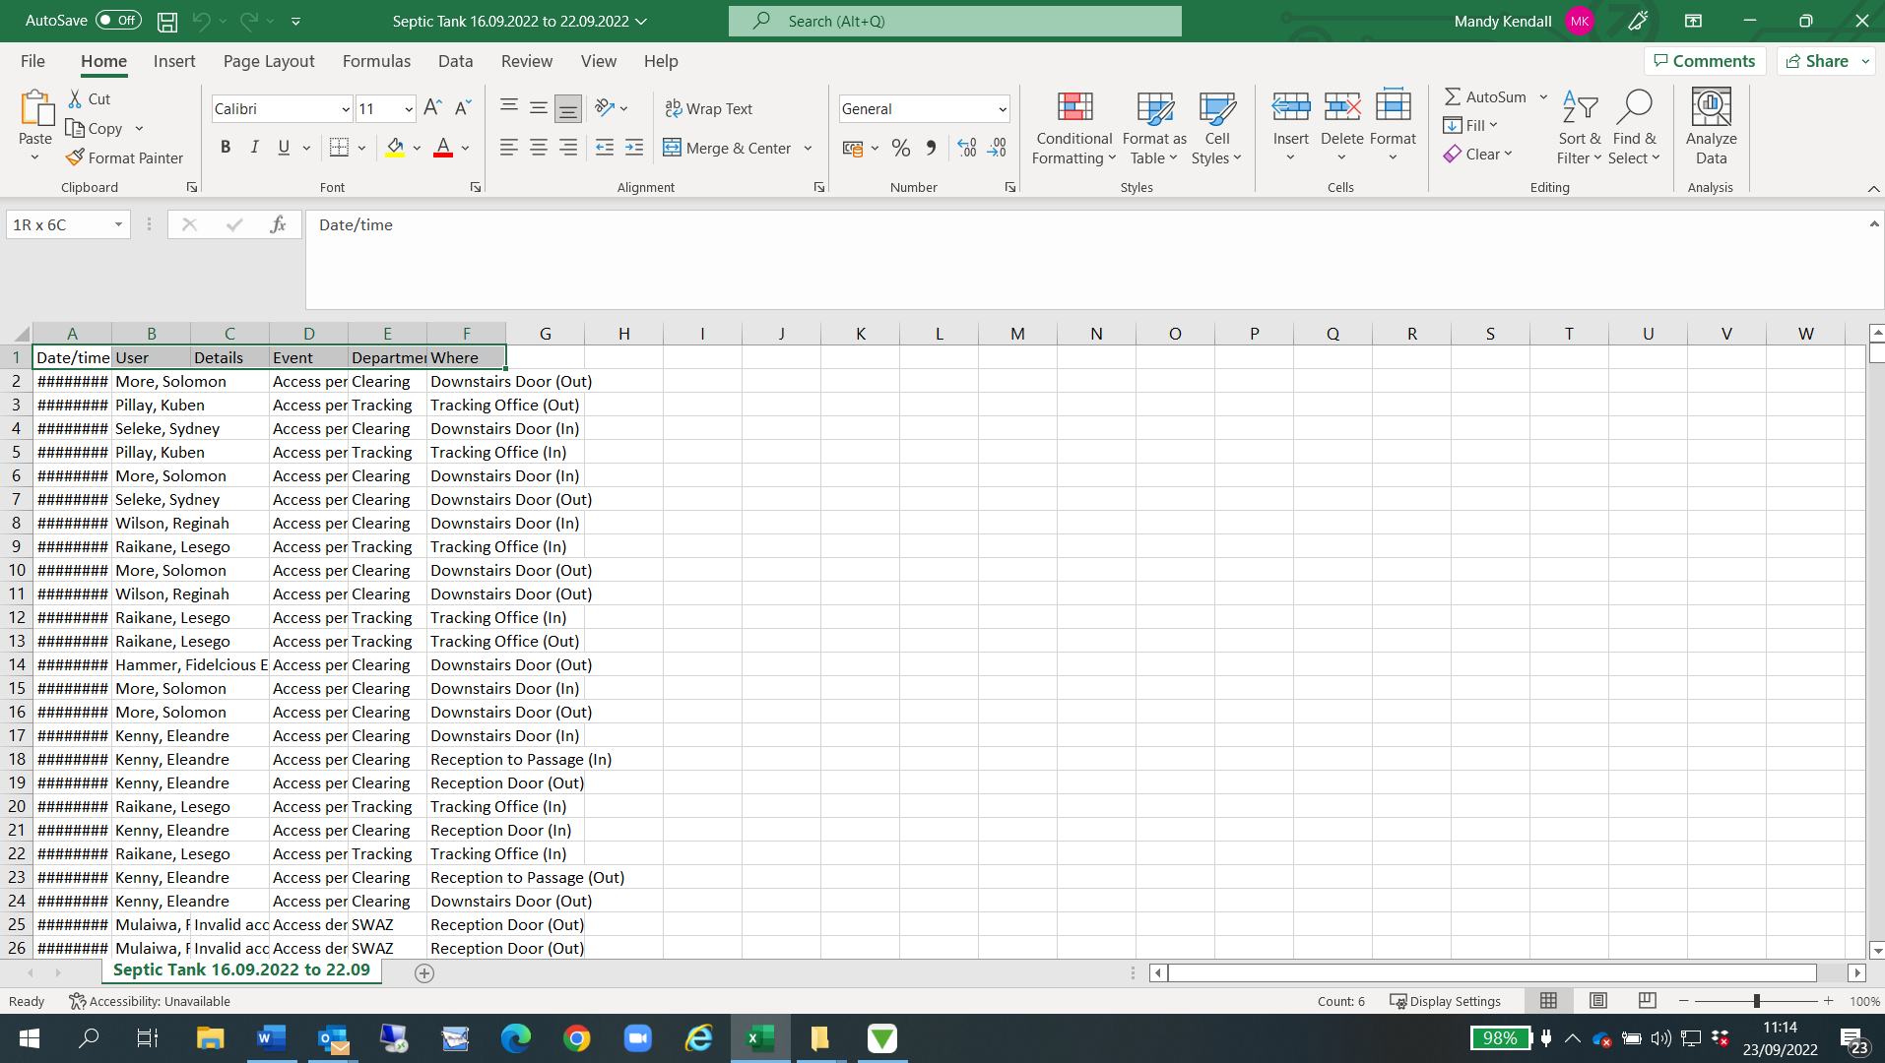
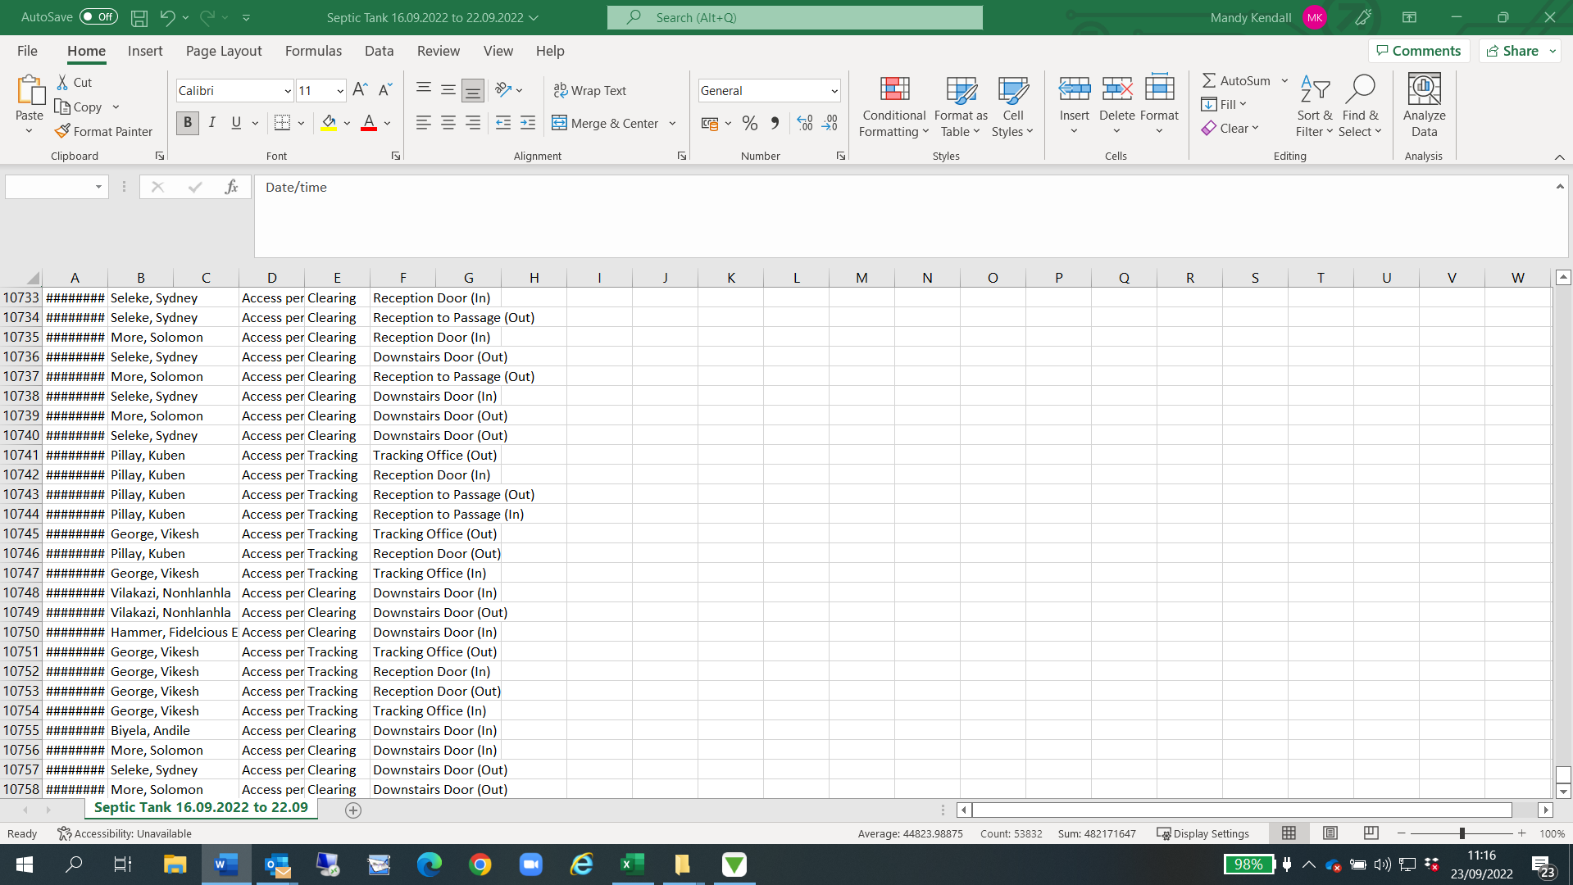
Choose all borders

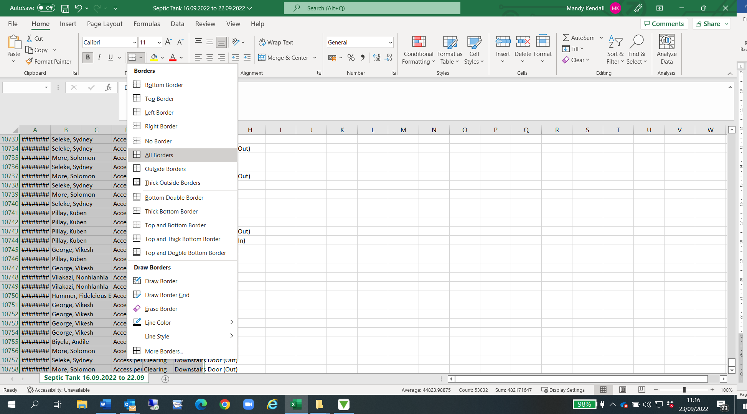
Insert Pivot Table:
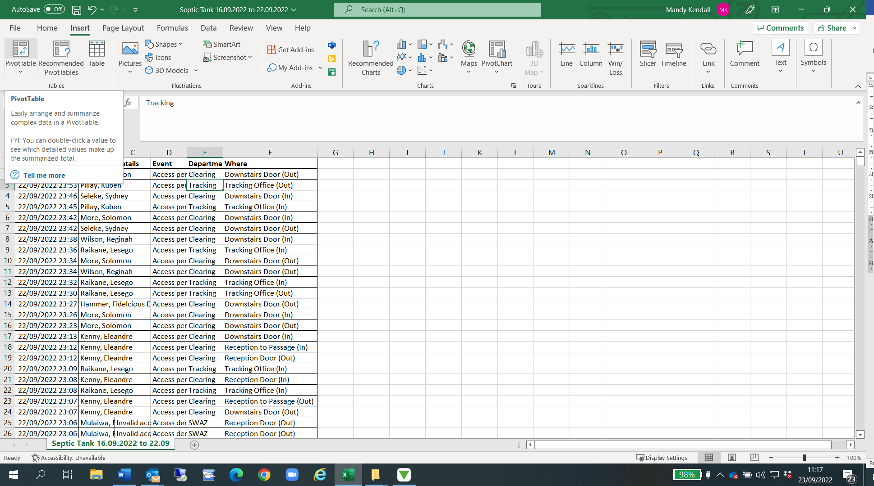
Click OK:
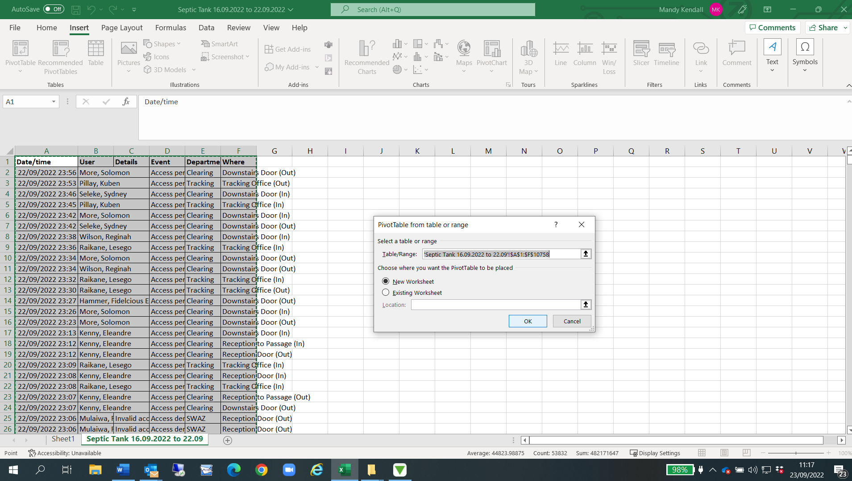
Click on User:
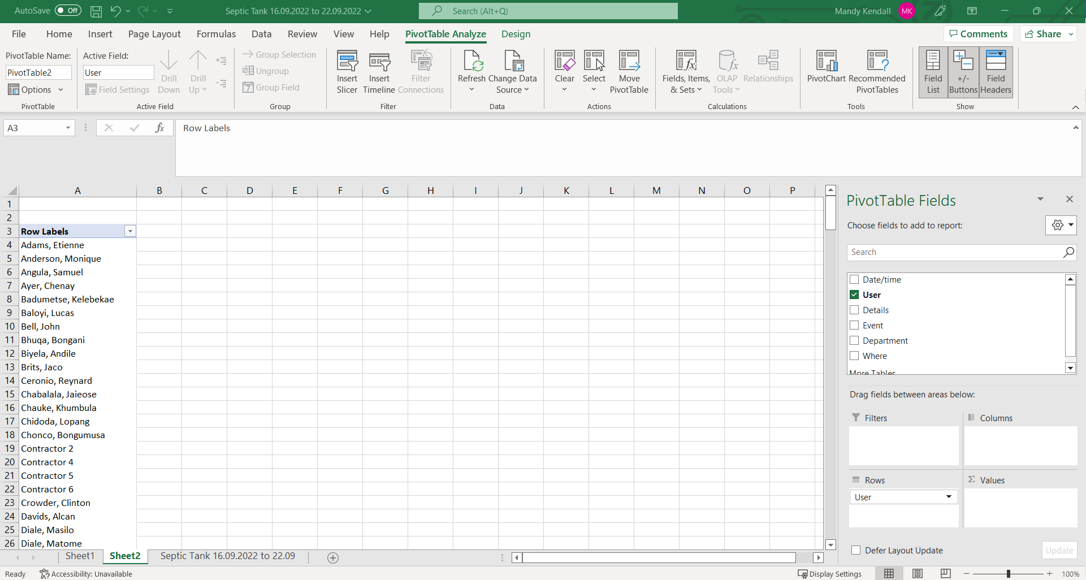
Highlight all names and check total count:
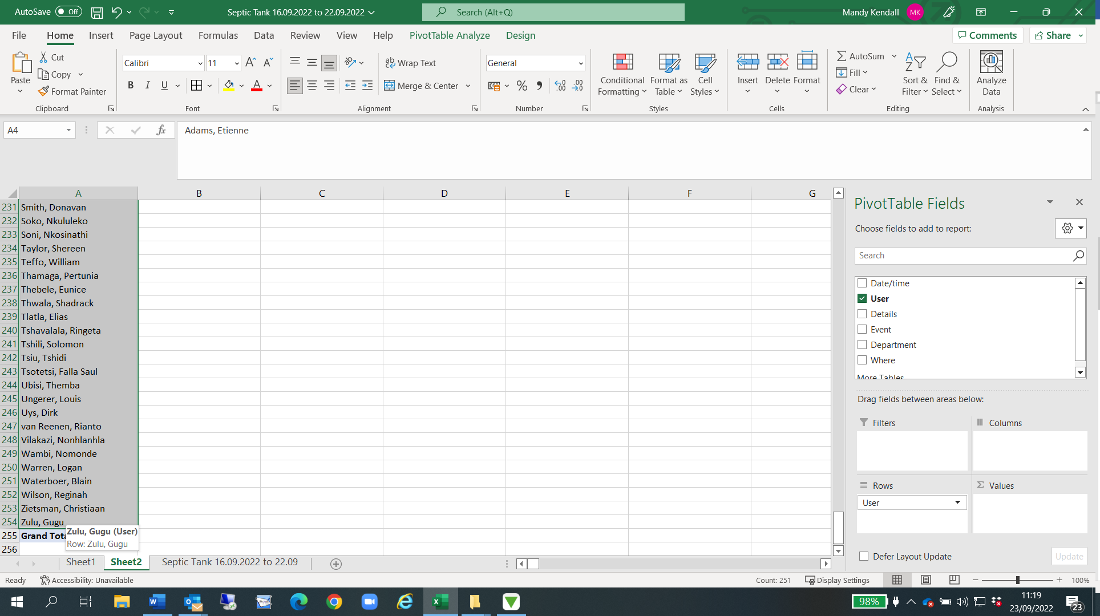
Type total count (251 next to grand total:
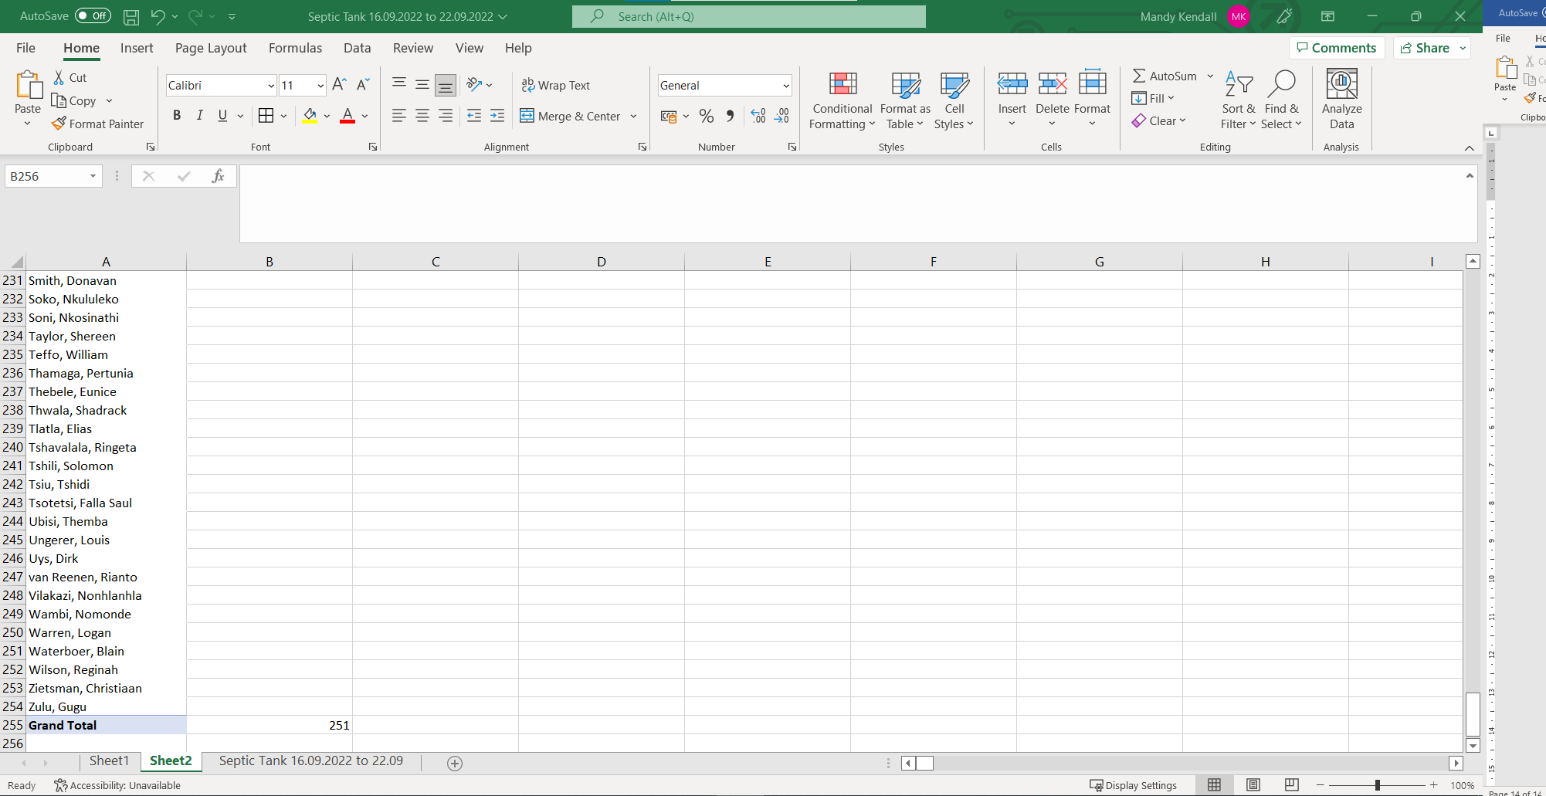
File Save as Excel Workbook:
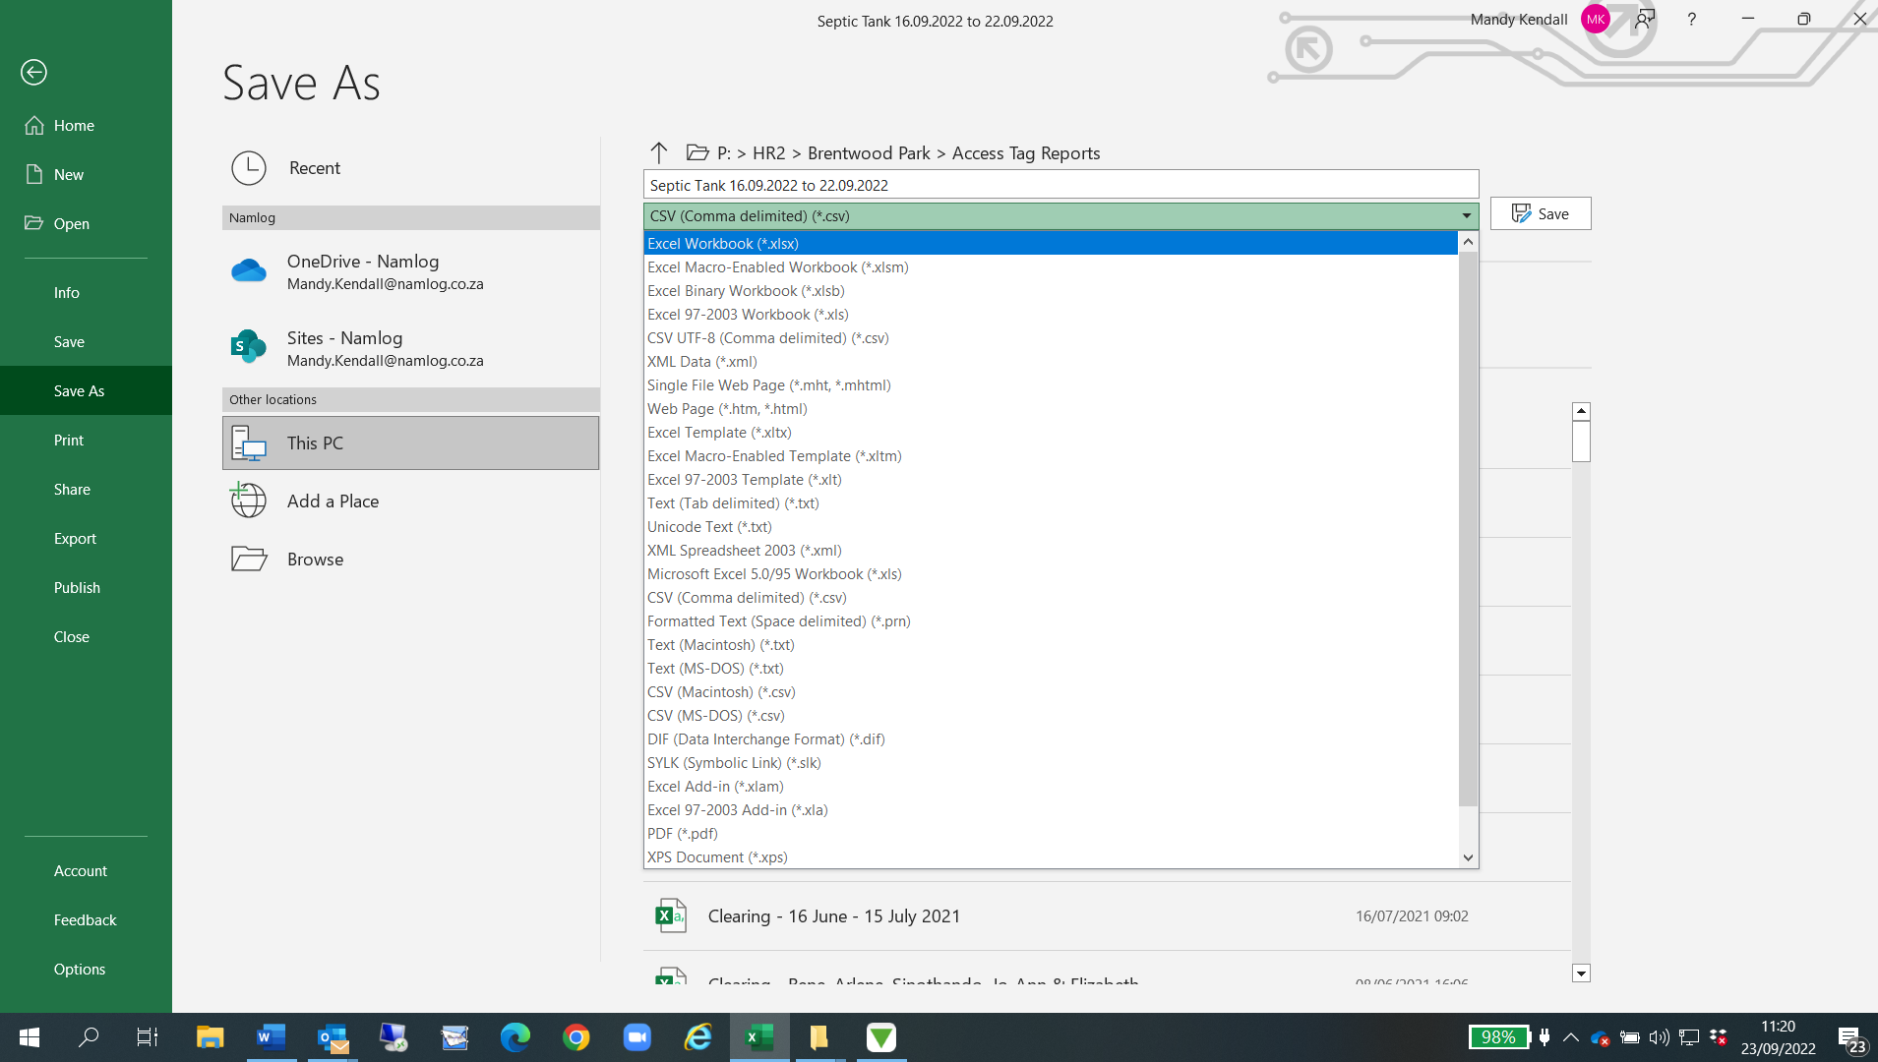
Click Save
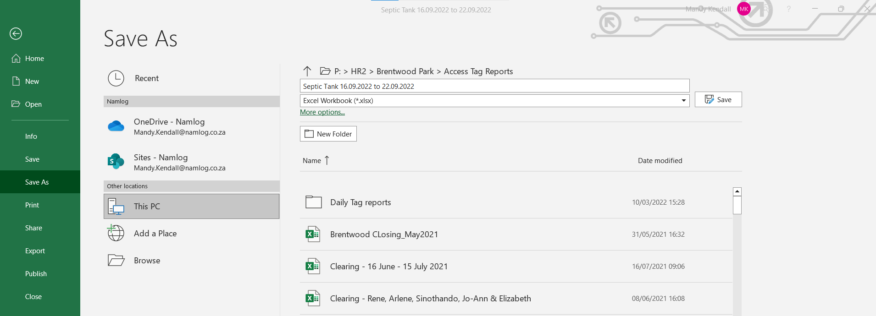
Click on Share:
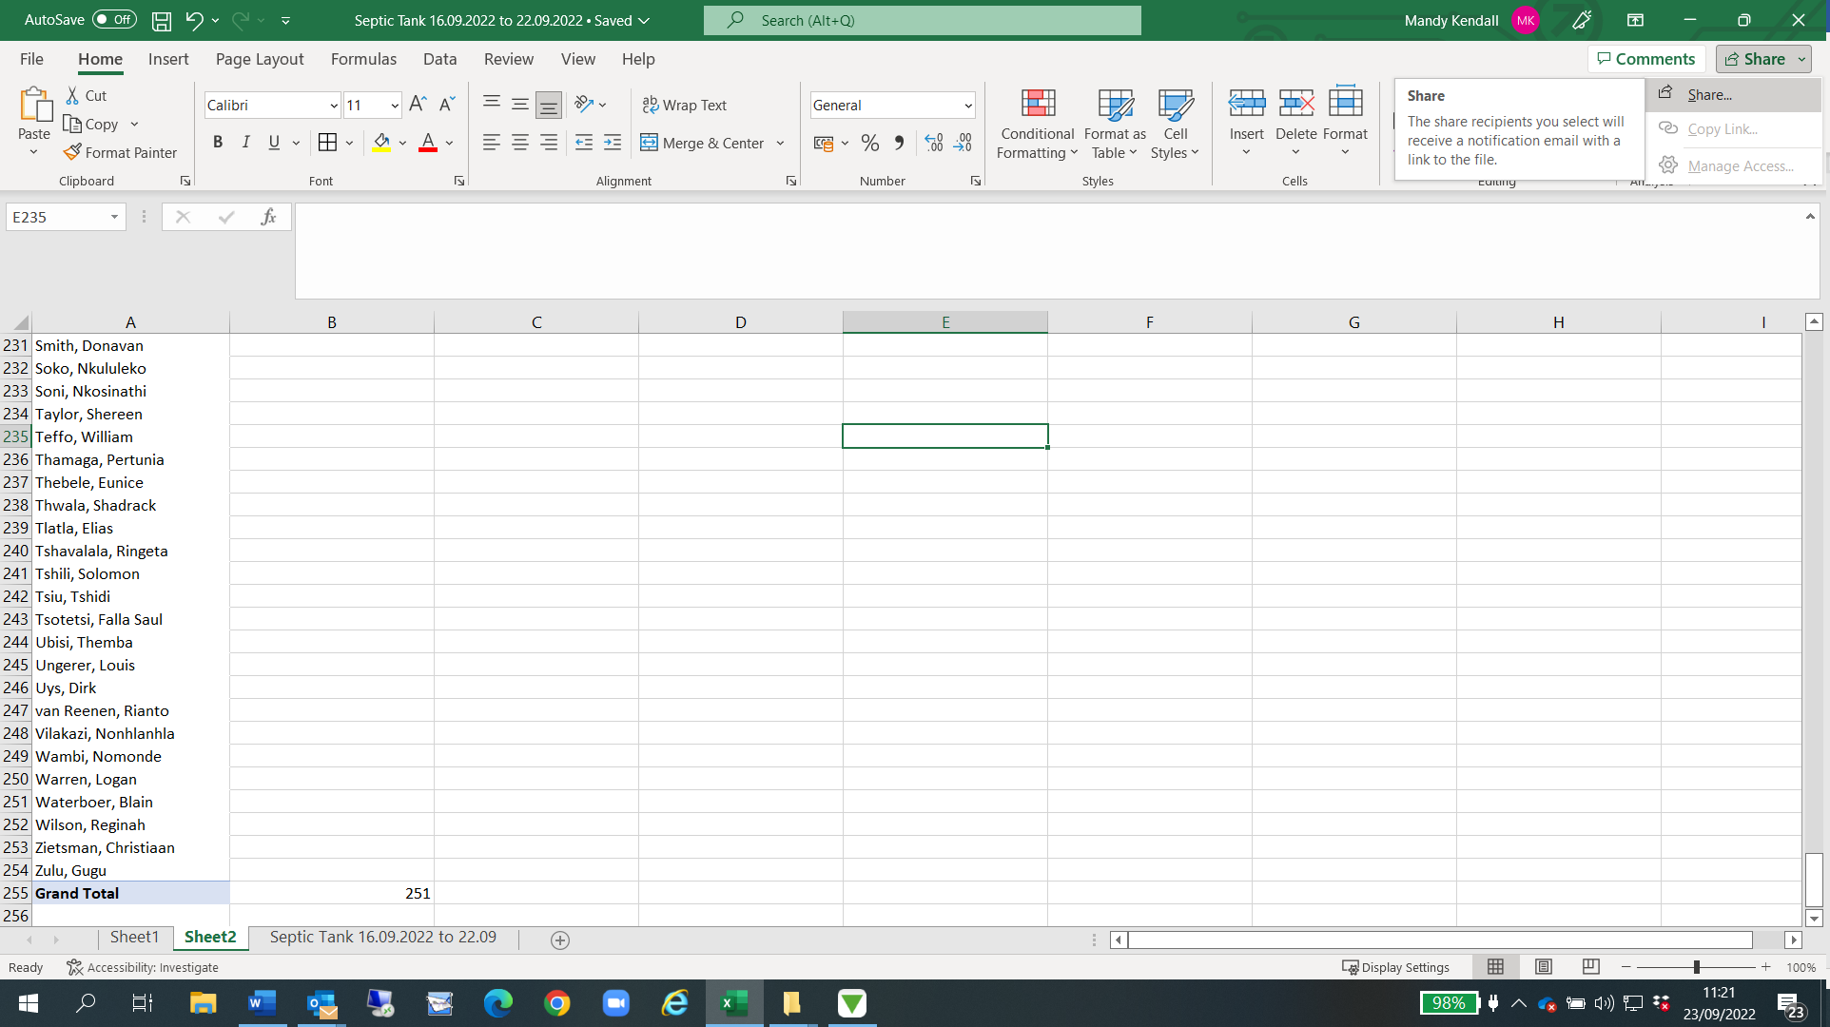
Click on Excel Workbook:
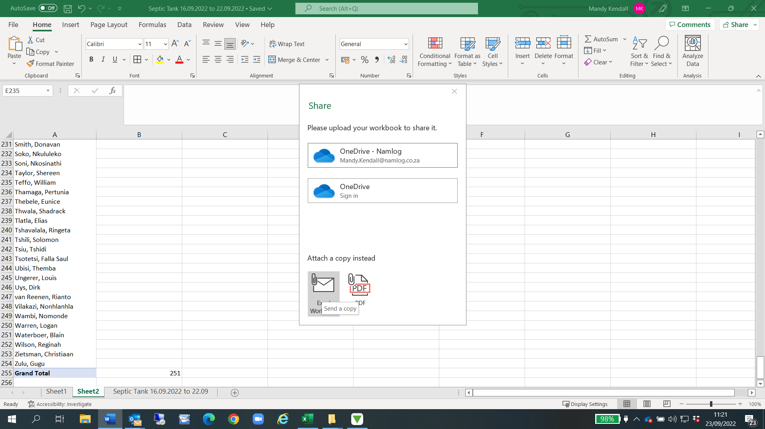
Email will open, send to Monique Anderson
