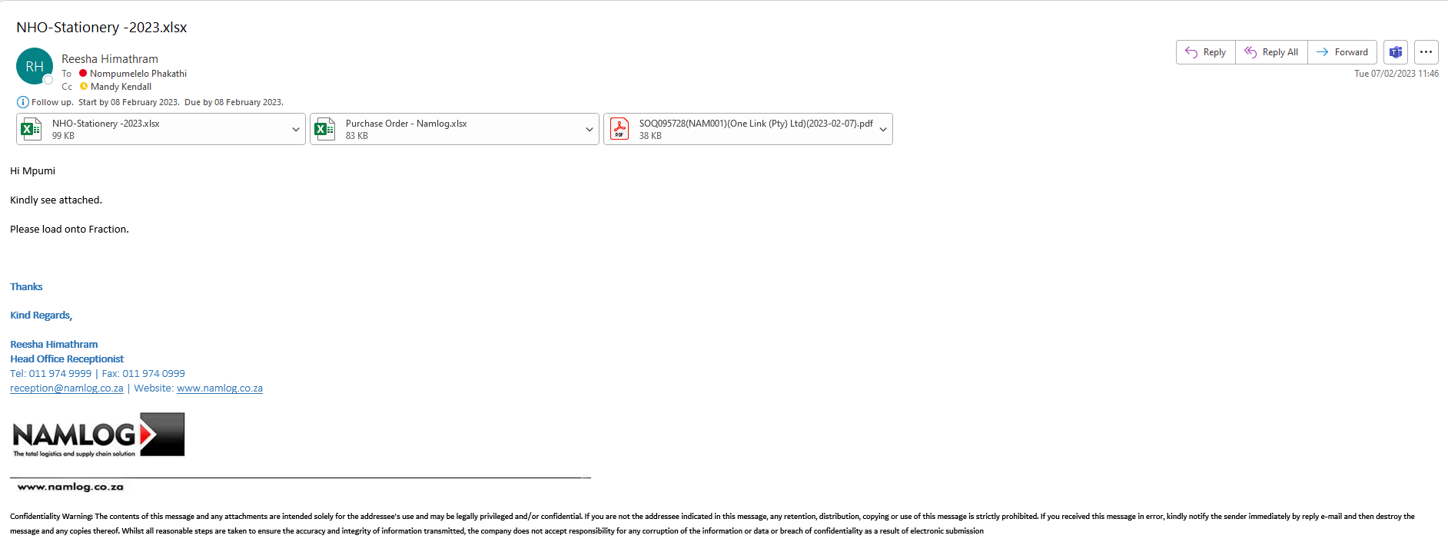
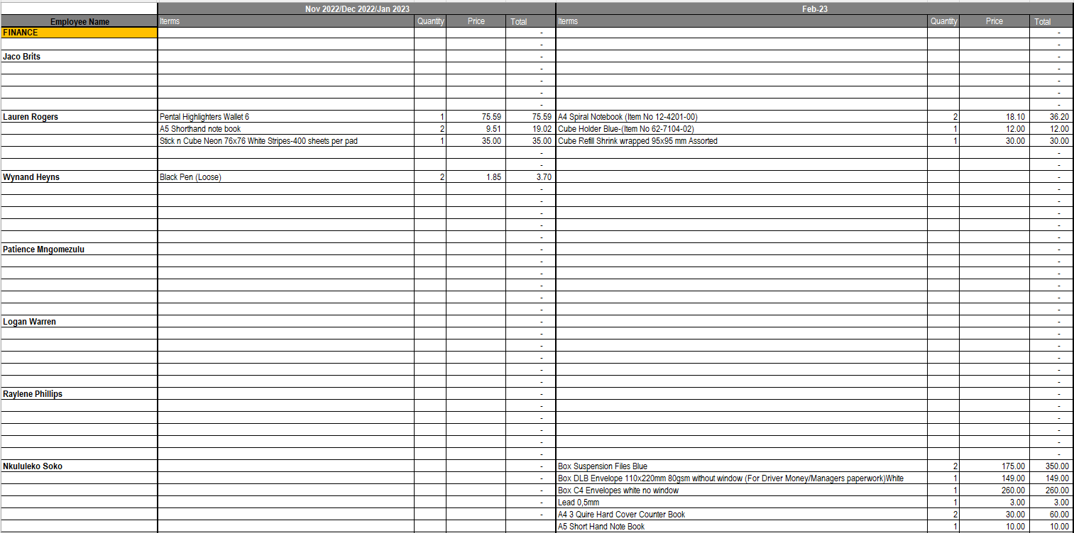
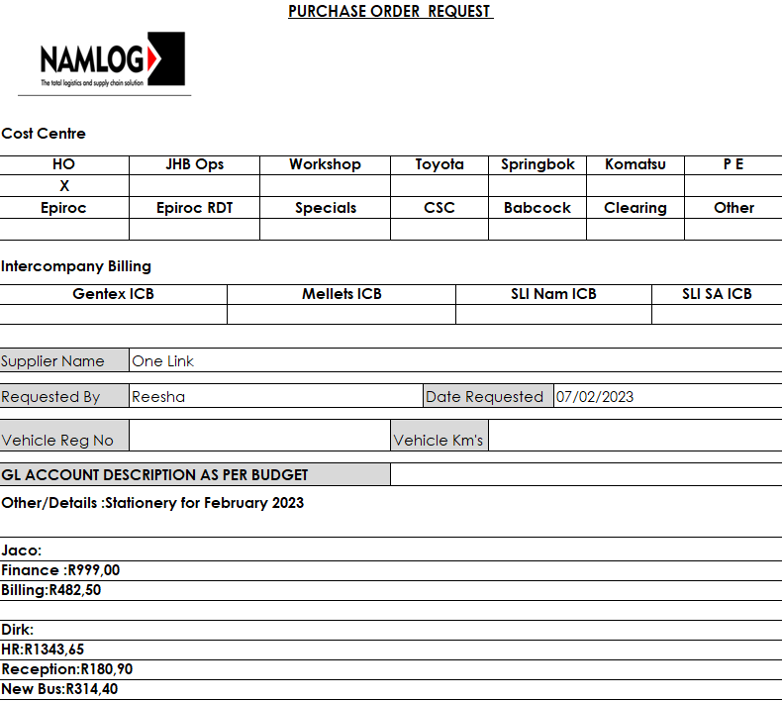

3
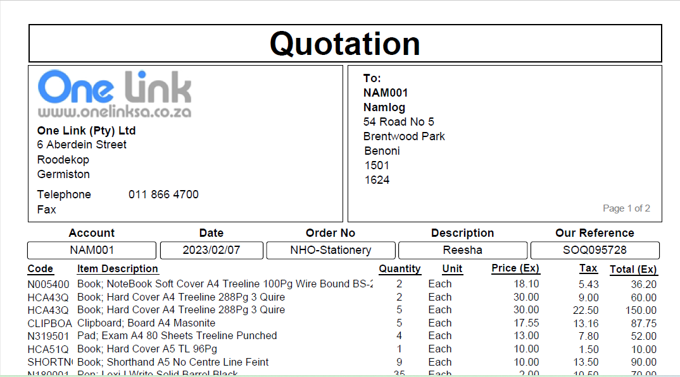

Fraxion Steps

- Log into Fraxion and Click purchase

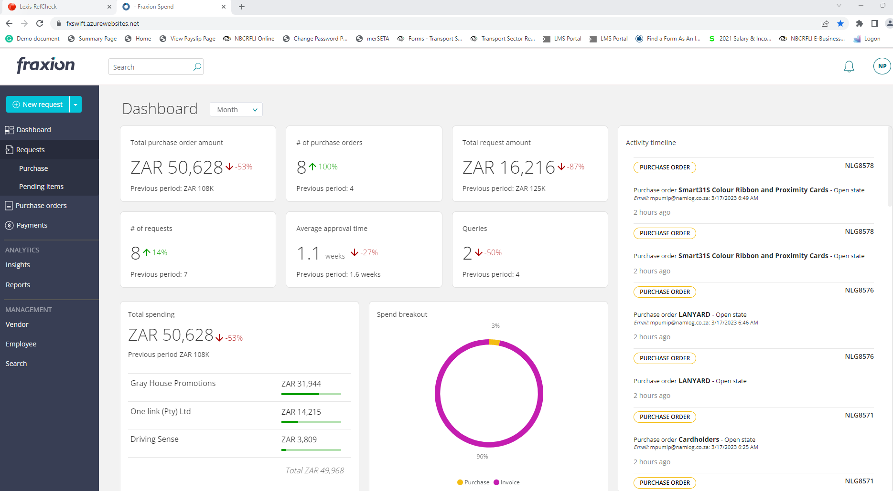

- Click create

- Type in title (Stationery February 2023), REG NO (0), AOD (No, if not applicable) and COD (Yes)
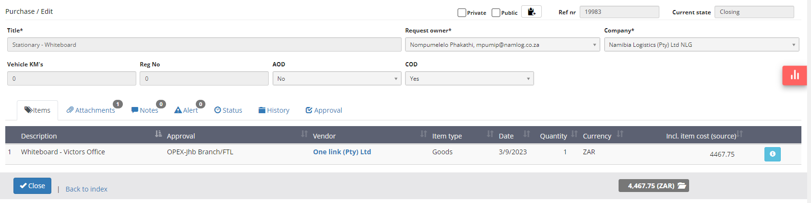

4.
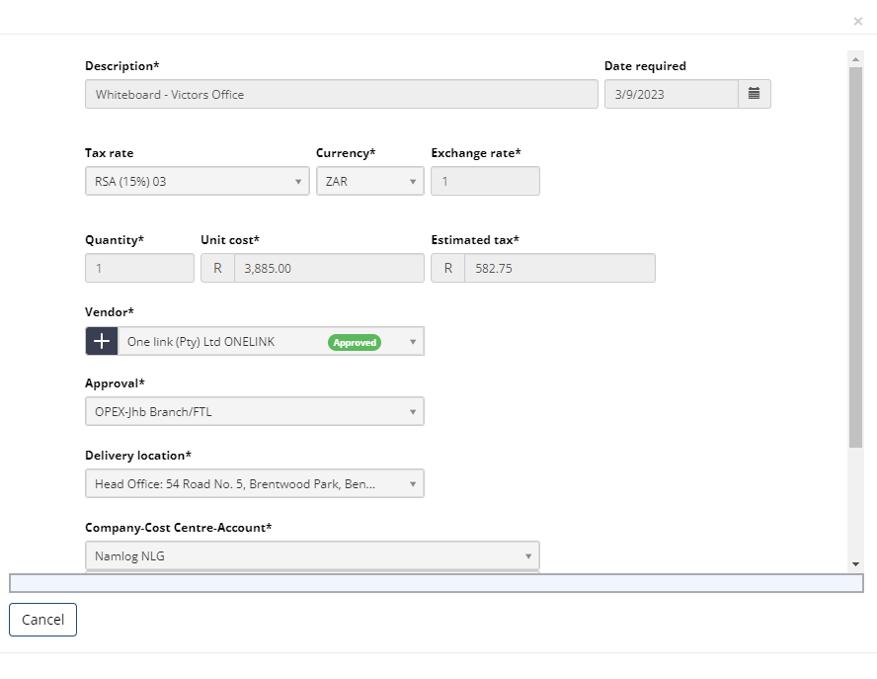
5.
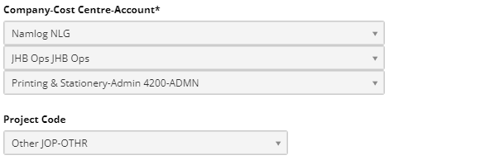

6. Attach quotation and other supporting documents (PO, Stationery order list & Quotation)
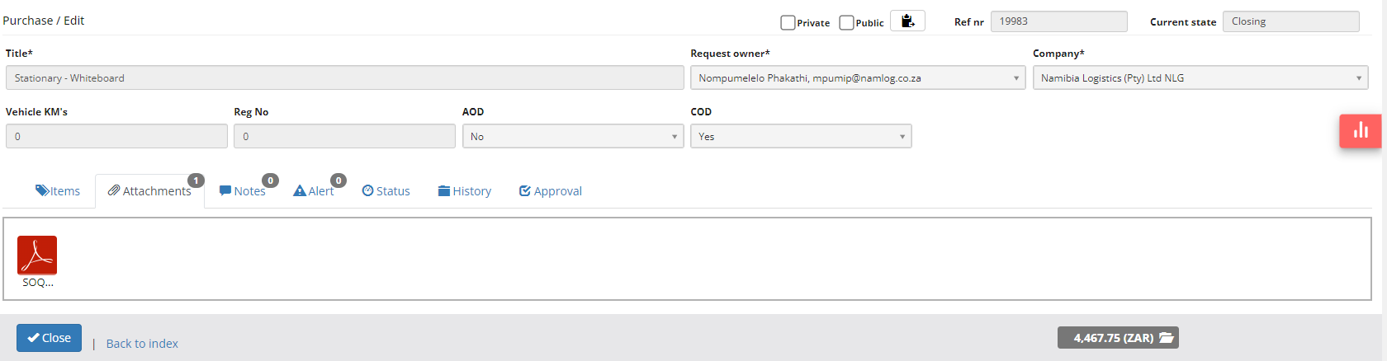

7. Add notes for clarification.

8. Submit and wait for approval

