UIF Submission

  - Extract reports from all 3 South Africa Payrolls
  - Email the report to Labour by the 7^{th.}

  - Login into the Payroll :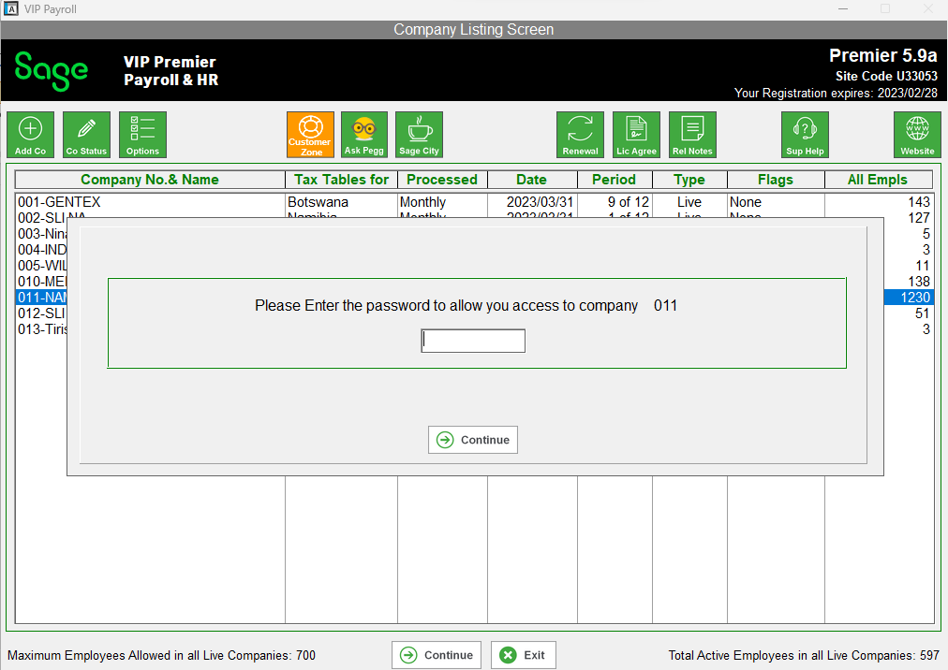

  - Click on the Reports Tab, Click on Reports and Maintenance
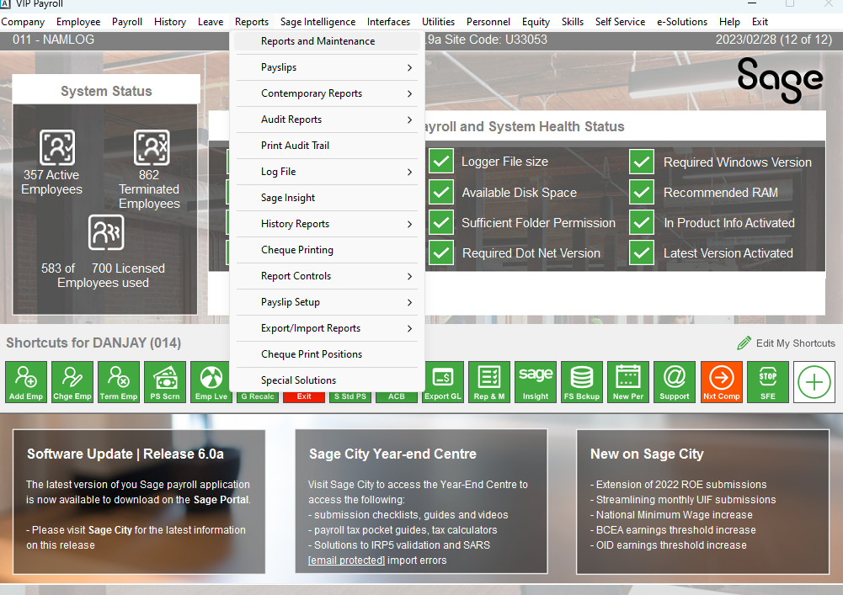

  - then extract report 47 - UIF Submit

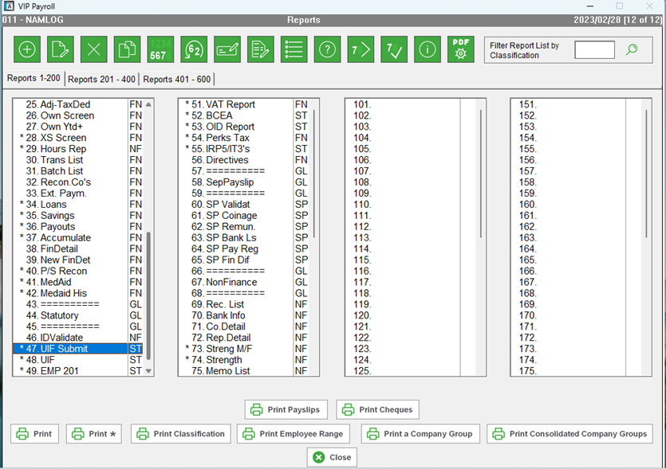

  - Click continue.

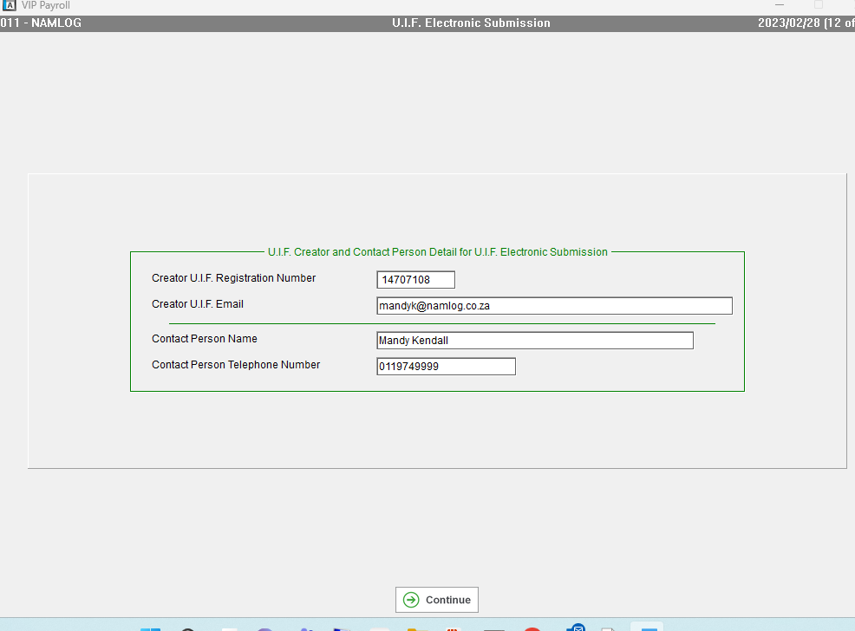

1.5 Click Continue: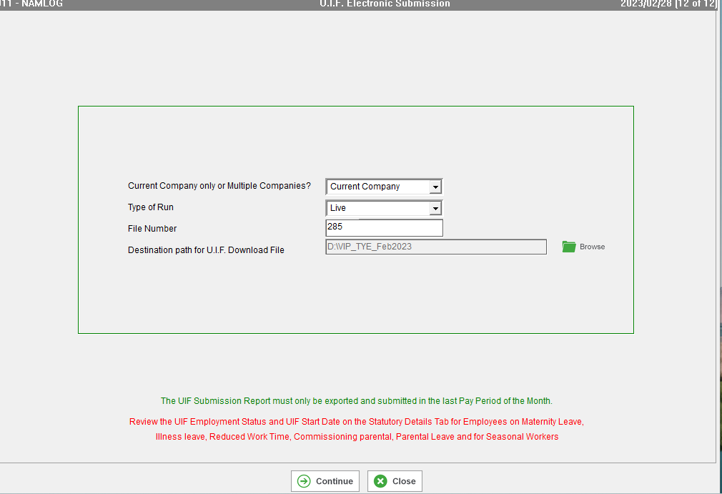

2.1 Then Email the File created to Labour .

