Steps to be followed:
(TRAWU / NUMSA / NTM Unions) - (Namlog / Mellets / SLI SA Payrolls)

  - Extract reports from all 3 South Africa Payrolls for the 3 different Unions.
  - Send all three reports to Finance for Payment by the 7^{th.}
  - Send the Schedules with proof of payment to the Unions.

  - Login into the Payroll :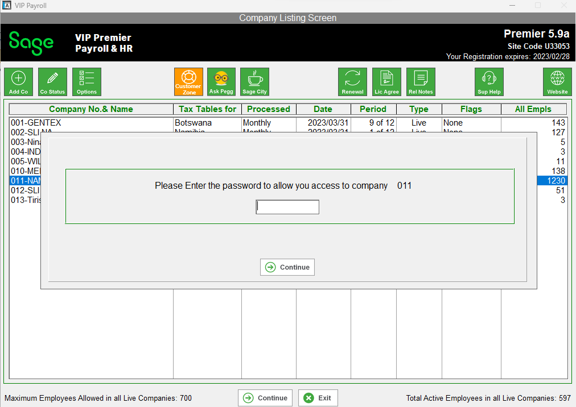

  - Click on the Reports Tab, then click on the Reports 401- 600 Tab

  - Click on the reports 522 – 523 – 524 for the different Unions.
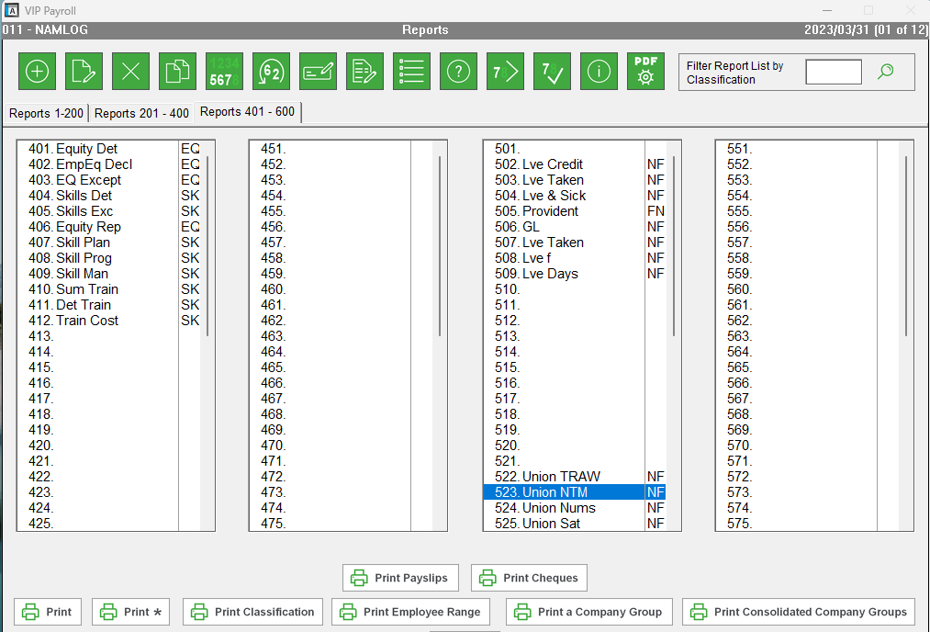

1.4 Save the report to PDF .
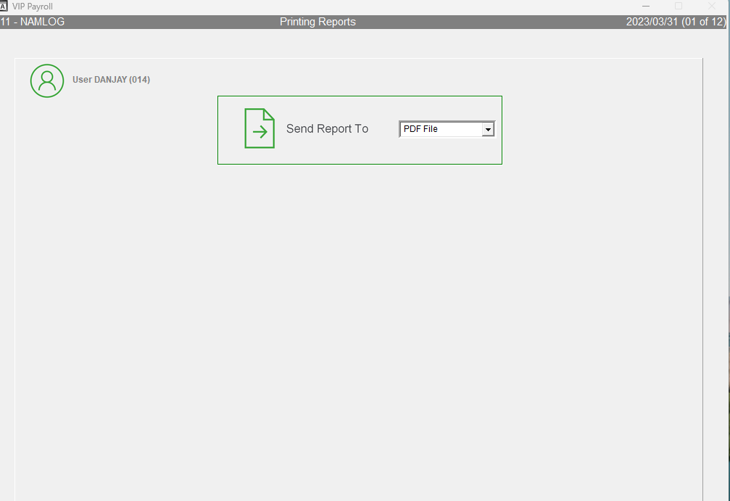

  - Click Yes for the selections are correct .

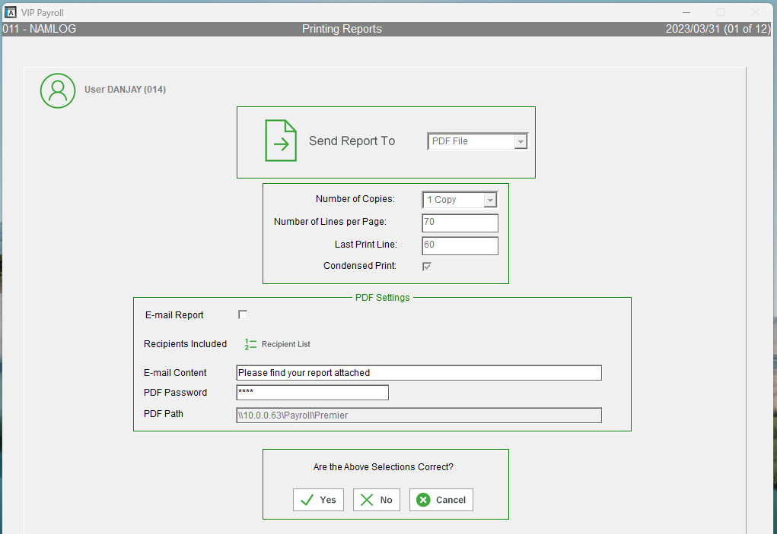

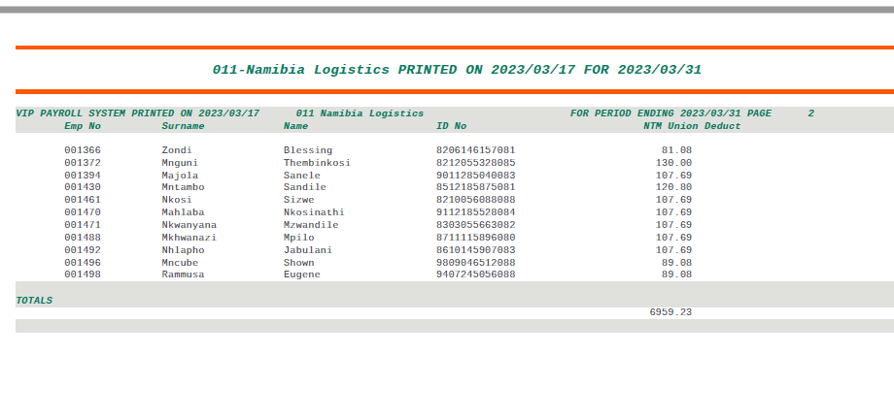

  - Save the report

2.1 Email the report to Finance for Payment :

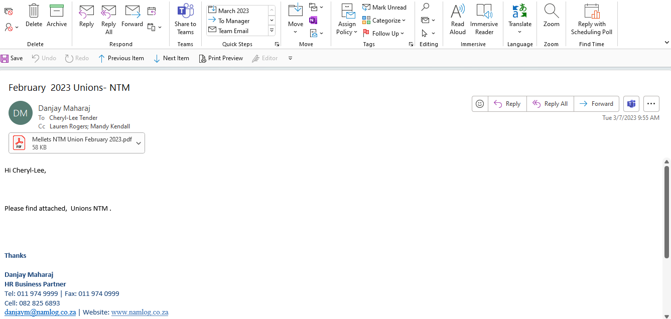

  - Once Finance emails you proof of payment for the unions ,

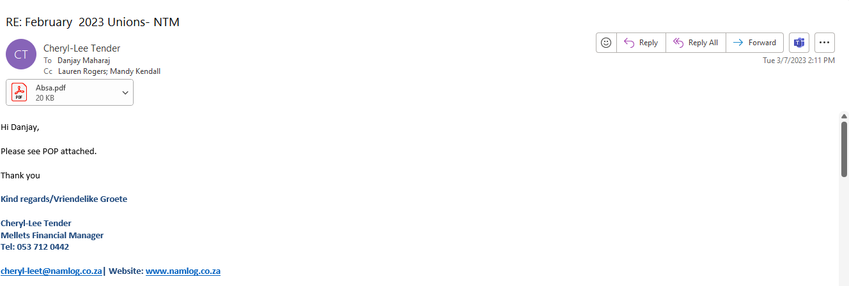

Email the union schedules with the proof of payment to the unions.

4.1. NTM Unions – Email as per below

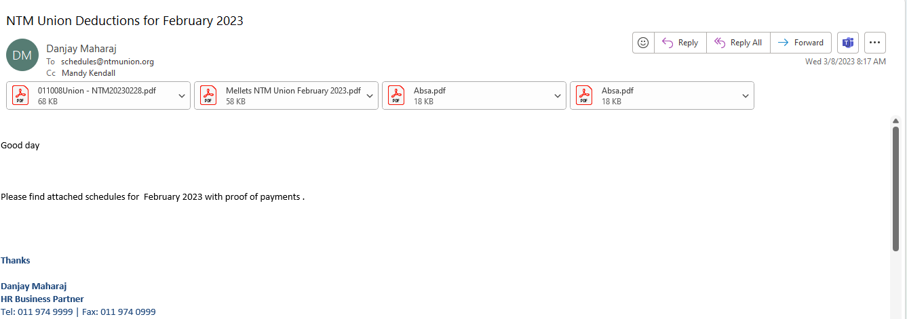

4.2. TRAWU Union -Email as per below :

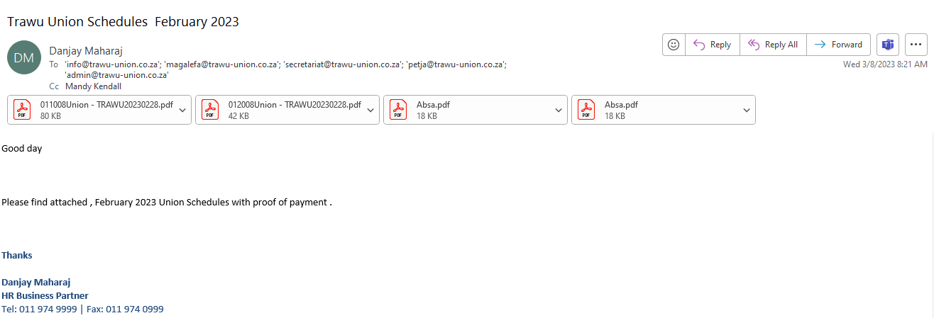

4.3. Numsa Union – Email as per below :

