Once the VIP salary journal has been imported the following checks need to be performed :
Open the previous months salary journal spreadsheet , save it with the current month name
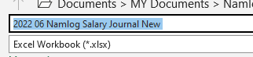
Open the NAM_HistPayListing1 file (Mandy will send it)

Copy the file into the first tab in the spreadsheet called Payroll Listing
Also copy into the 2nd tab called Summary
Sort by Column J (or RSC Code)
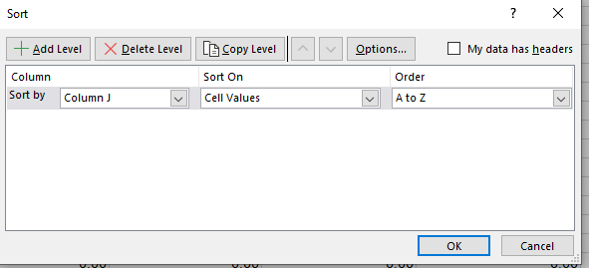
Ensure that totals add up and that Line 391 & 392 add up the correct NBC & NNBC totals respectively
The totals will automatically pull through to the summary table

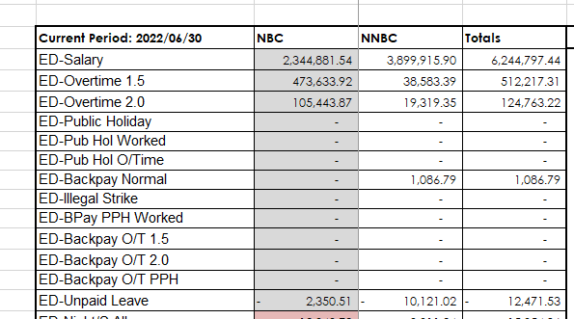
This information will be transferred to the 3rd tab called EVO VIP SUMMARY
In this tab there is a VIP summary table and a Evolution report
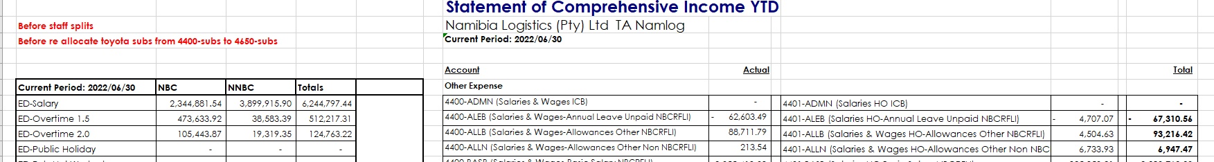

Log into Evolution
Go to General Ledger – Reports – Income Statement and make selections as per below
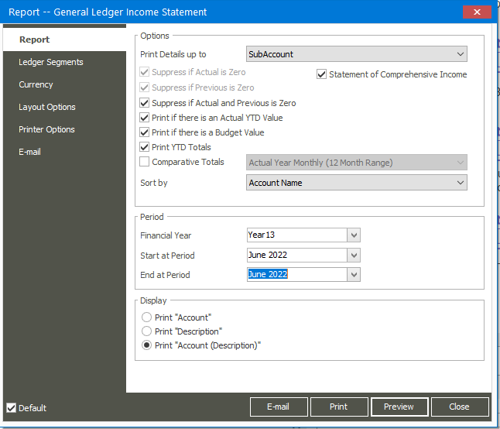
Go to Ledger Segments and select account 4400 to 4401
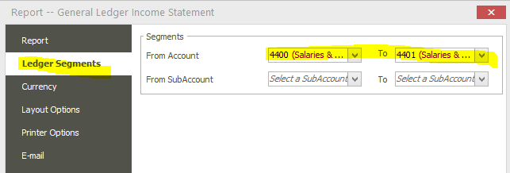
And click on Print and select options as per below
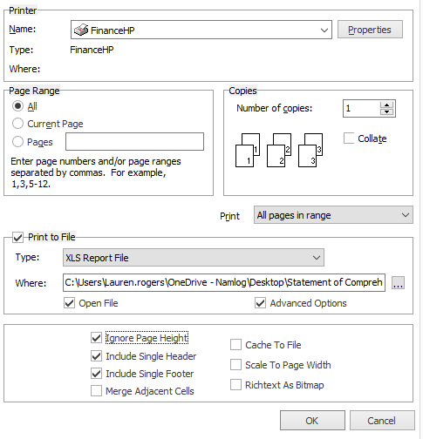
Open excel file and copy into EVO VIP SUMMARY tab
Compare VIP Report to EVO

