Go to saved VIP export file (csv format)
Open csv file
Copy column F over Column B (do not delete)
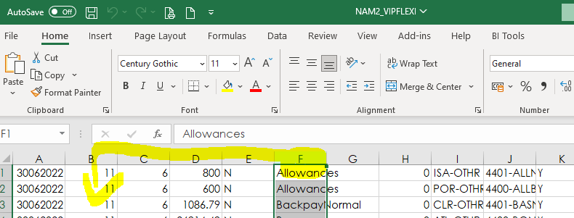

Delete data in column F
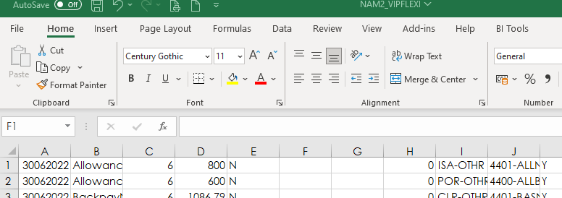

Then search in Column B for “ . “ and delete all lines
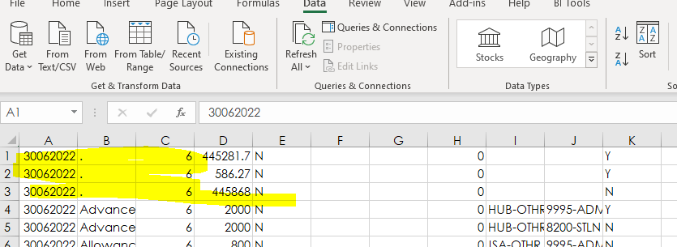

Column D must be saved as text
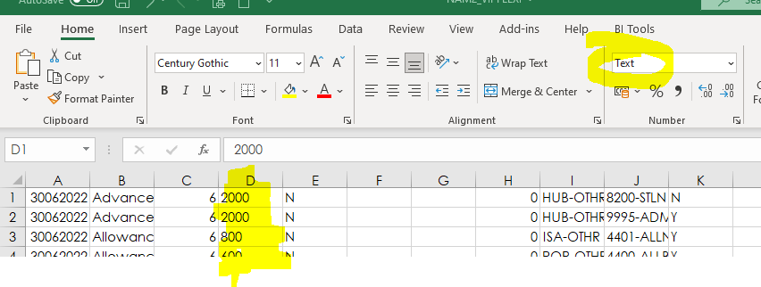
Save file
Log into Evolution
Go to General Ledger – Transactions – Journal Batches - Select New Salary Jnl
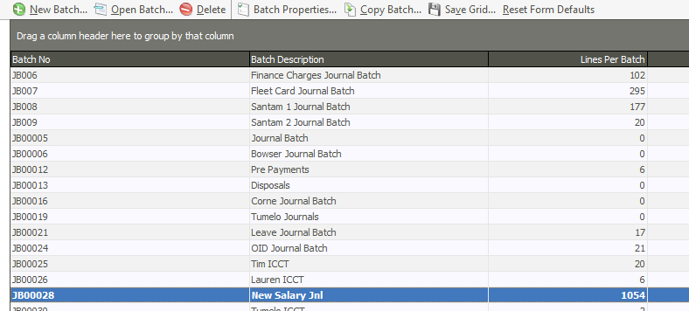

Click on cancel
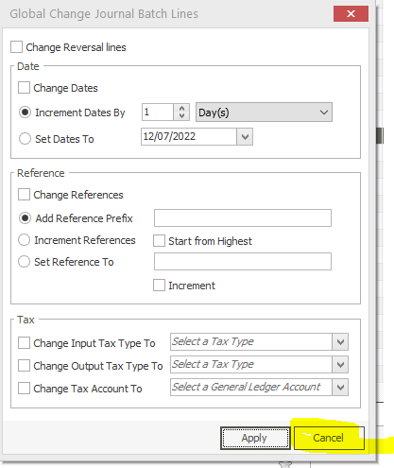
It will open the journal
Click on import
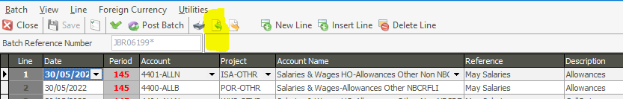
Click on Yes
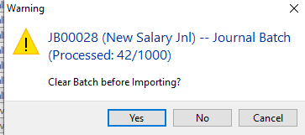

Select file from saved destination
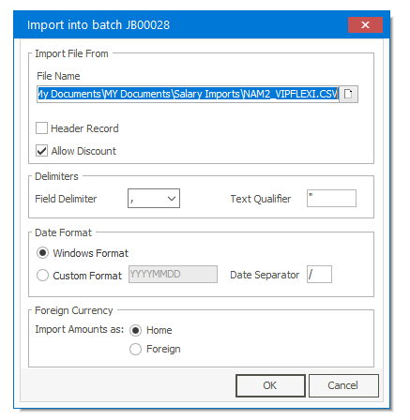
Click on OK
Click on NO
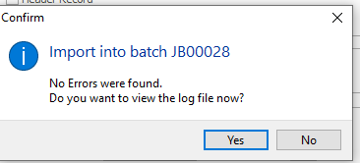
Click on close

Go back to General Ledger – Transactions – Journal Batches - Select New Salary Jnl

Change date and reference as per below
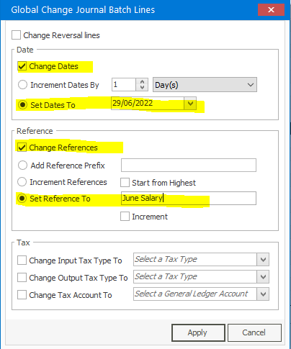
Click on Apply
Ensure that journal balances and that the date is correct
If all is in order, print the batch
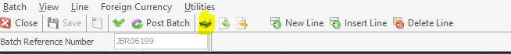
Then post the batch
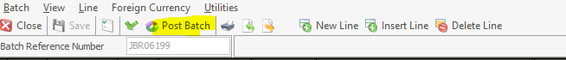
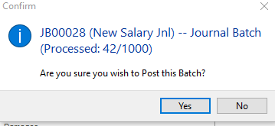

Click on YES (if all is correct)
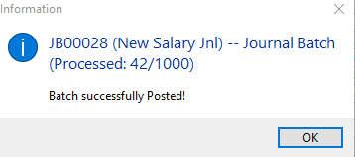
Click on OK

