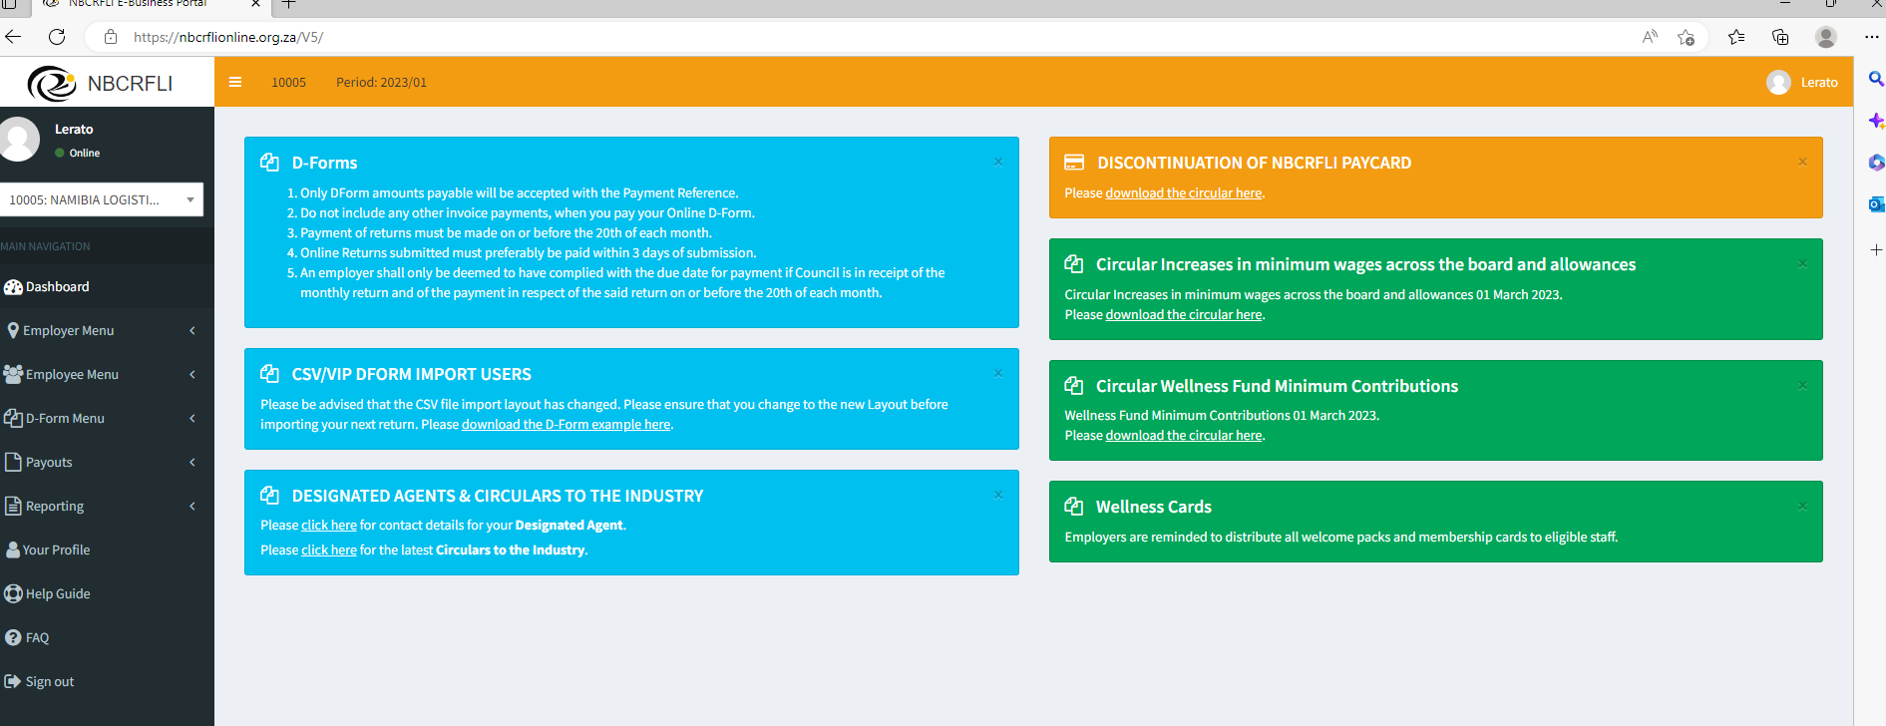
- Log in on NBC https://nbcrflionline.org.za/V5/login/
- Choose the Company

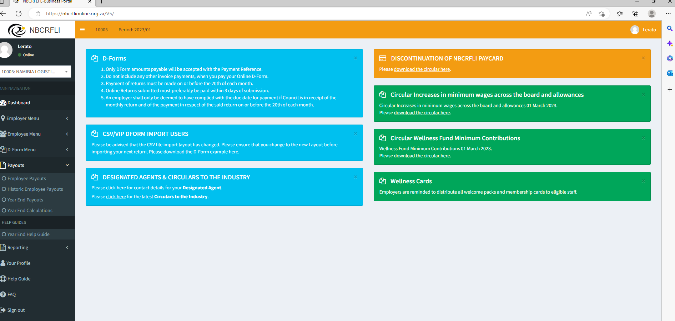
- Click Payouts
- Click Employee Payouts

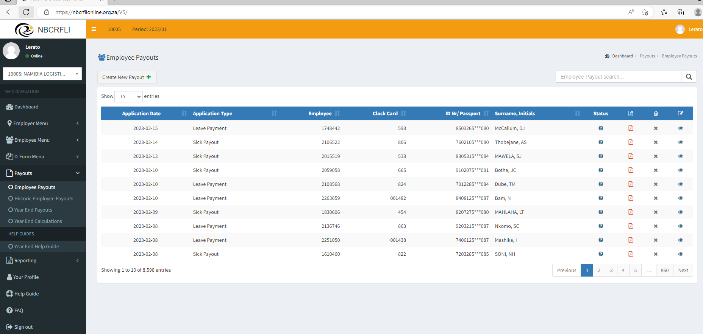
5.Click Create New Payout

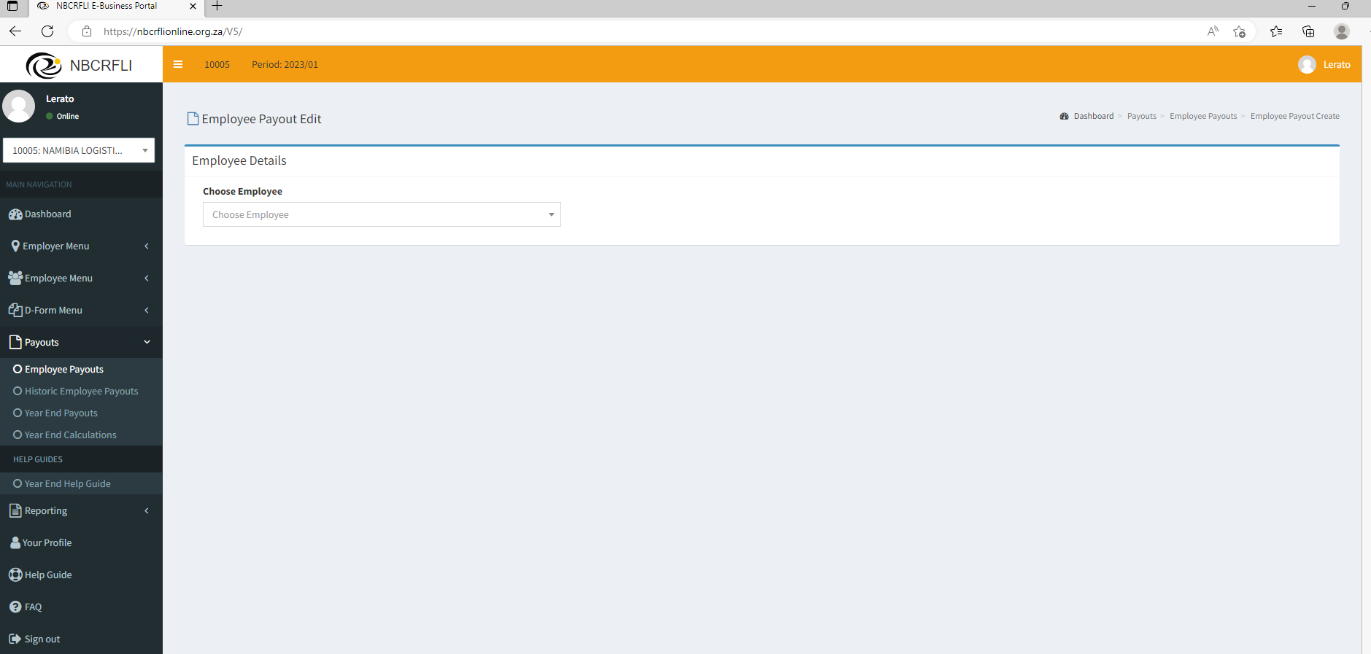
- Enter the employee code or surname

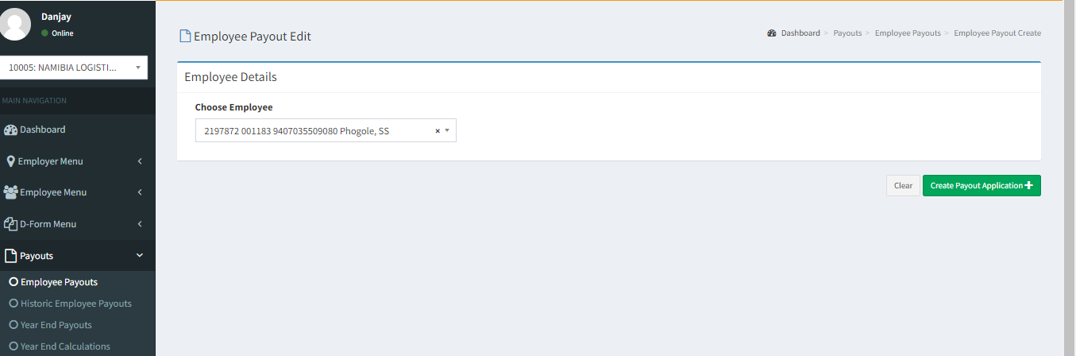

- Click Create Payout Application

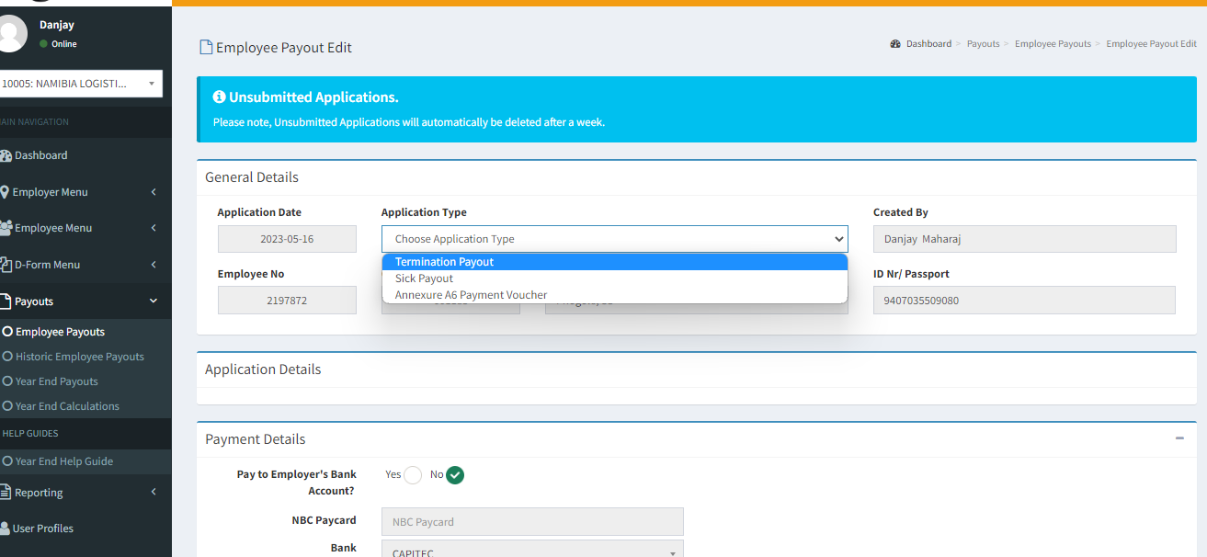

- Click on Application Type – Termination Payout
- Choose the terminations date.
- Choose the Termination Reason.

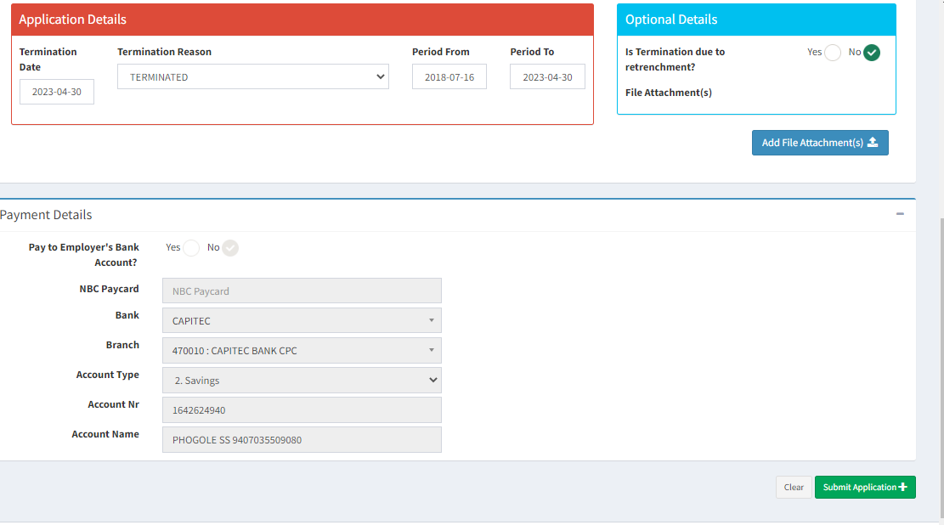
- Click submit application.

