PURPOSE

The objective of the Adding Customers on LMS Standard Operating Procedure (SOP) is to provide clear guidelines for operational departments within Namlog Group to execute the process of adding new customers on LMS. This SOP is intended to be used as a reference for all Mellets personnel who will be adding customers on LMS. The SOP is a supporting SOP for Data Capturing SOP.

SCOPE

The SOP is applicable to operational personnel who are responsible for adding customers on LMS.

PROCESS

- Collection or delivery customer is not loaded on LMS.
- On the waybill capturing screen:
- Click on the plus sign to add customer.

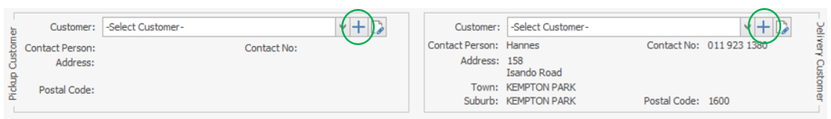

- Add the customer details and select “Address Verified”.

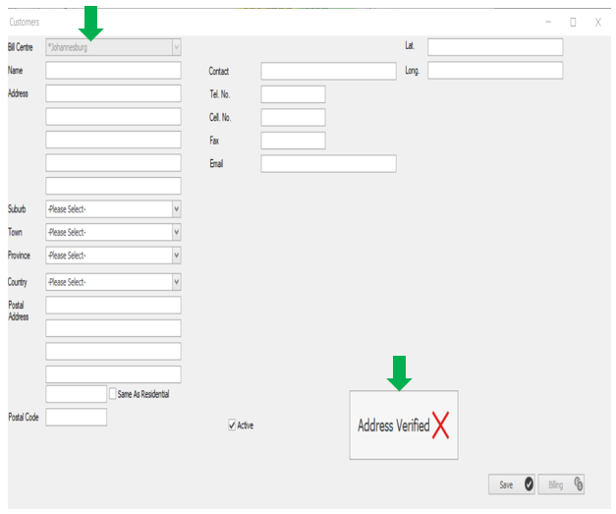

- Type in the address or company name on the address bar.
- Select the search function by clicking on the magnifying glass.

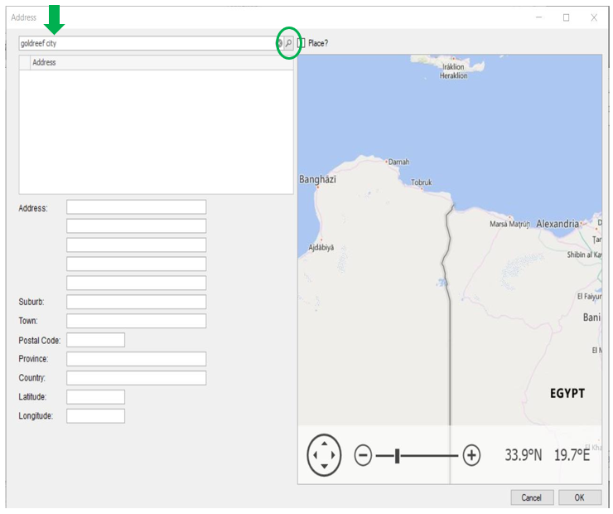

- The screen will refresh and show different addresses, select the correct address.

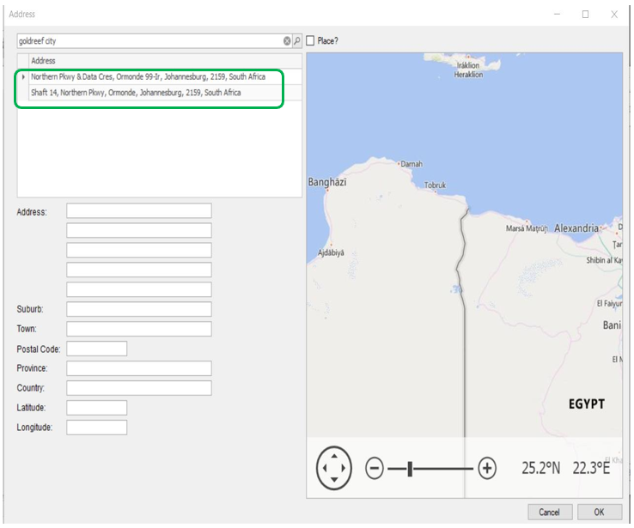

- Once correct address selected the system will complete the rest of the information automatically, select “OK” to save customer’s details.

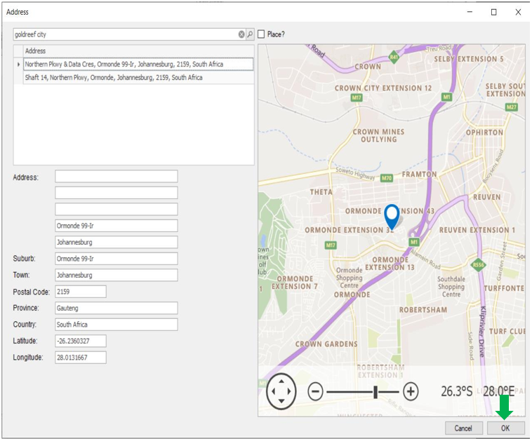

- LMS will refresh and return to waybill capturing screen.

