PURPOSE

The objective of the Collection Request Standard Operating Procedure (SOP) is to provide clear guidelines for operational departments within Namlog Group on executing collection requests. This SOP is intended to be used as a reference for all Mellets collection request activities.

SCOPE

The SOP is applicable to operational personnel who are executing a collection request process.

PROCESS

- Receive a collection via email or phone call from the customer.
  - Complete the Collection Request Form in full, with all the relevant information.
  - The collection request booking cannot be confirmed upon completion of the Collection Request Form.
  - Upon completion, email the completed Collection Request Form to the customer as booking confirmation.

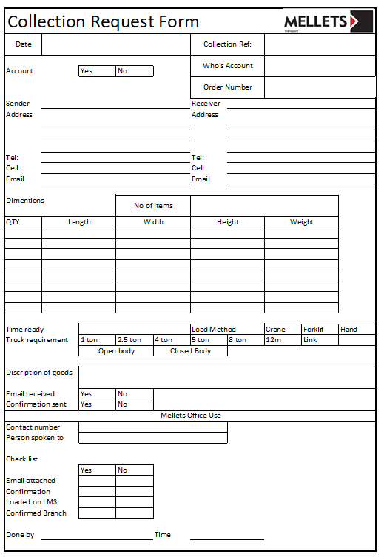

- Login to LMS
  - Select “Collections”.
  - Select “Capture Collection” .

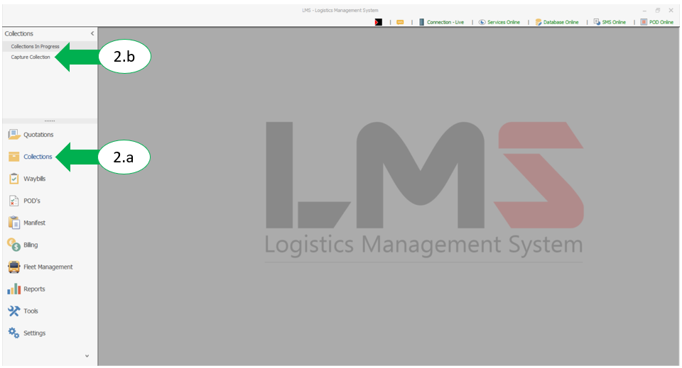

  - Select “New Collection”.

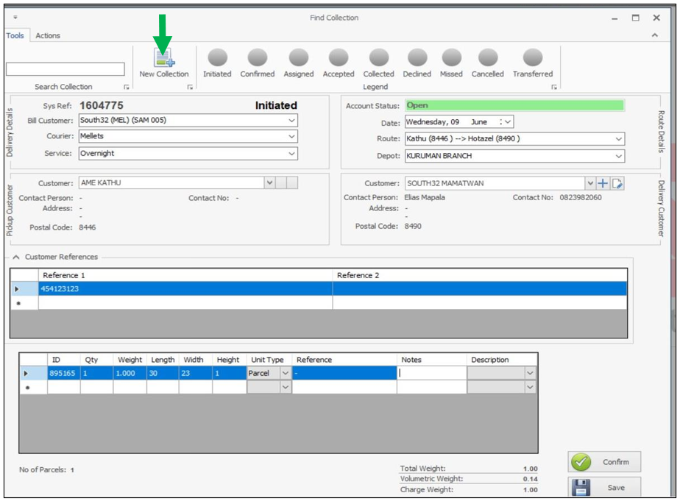

  - Complete the following sections:
- Delivery details (d.1)
- Pickup customer (d.2)
- Route details (d.3)
- Delivery customer (d.4)
- Customer references (d.5)
- Parcel details (d.6)

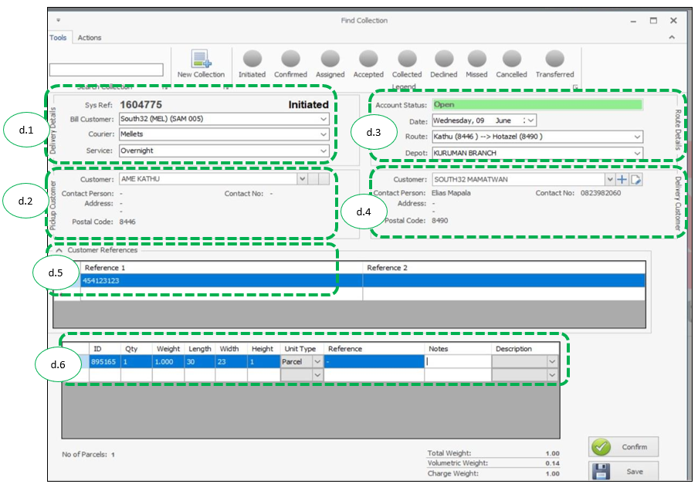

  - Select “Save”

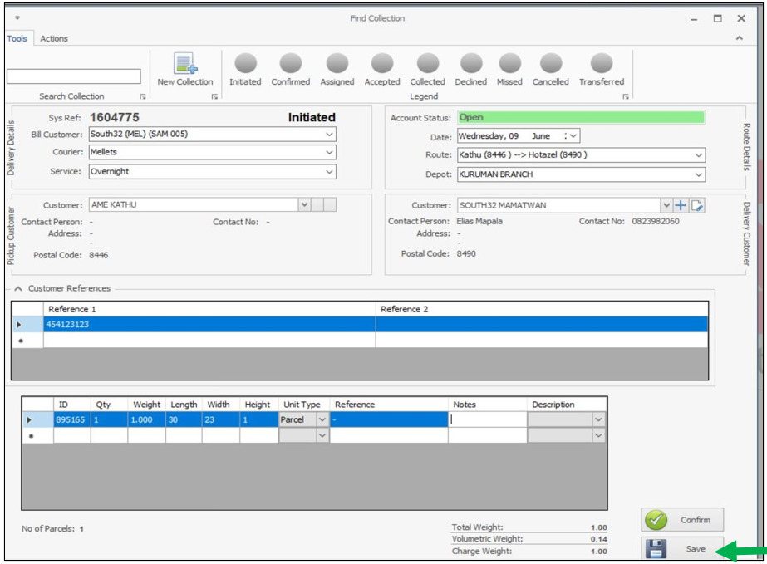

  - Select “Confirm”

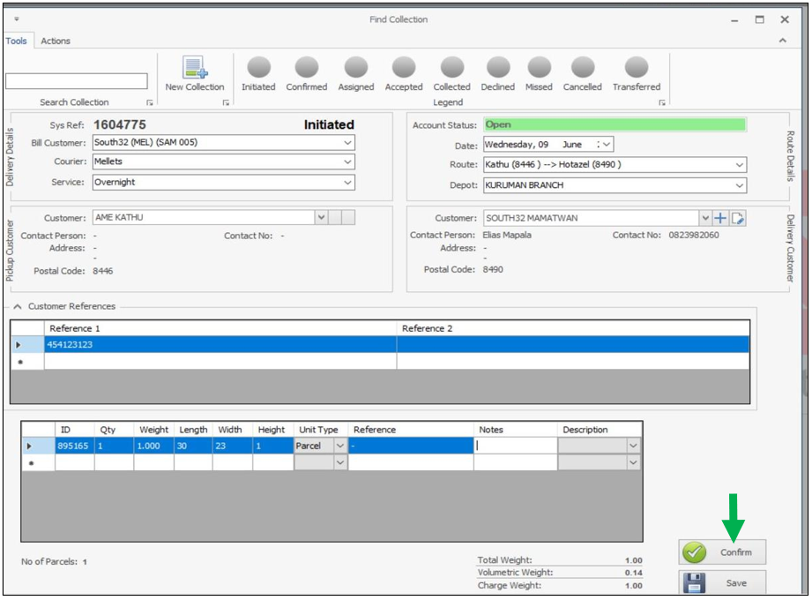

  - Follow the actions as per pop-up screen:
- Contact the collection customer to confirm if items are ready for collection, and business hours.
- Select applicable vehicle size. (g.1)
- Add contact person’s details (name, surname, designation, contact number) on the comment section on the pop-up screen. (g.2)
- Select “Confirm”. (g.3)

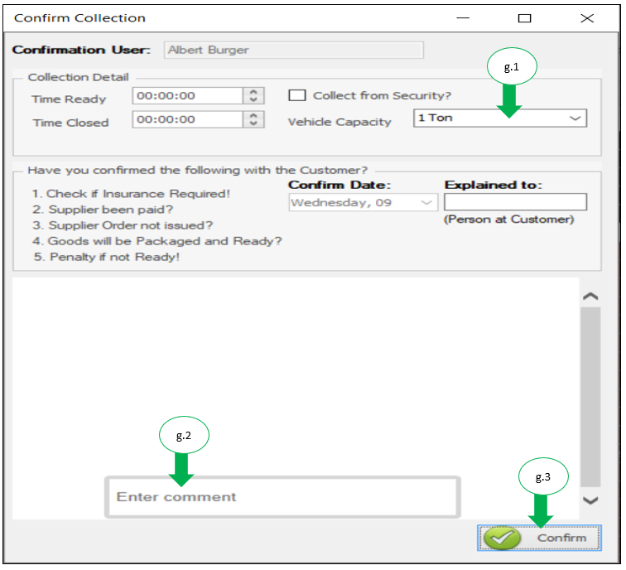

  - On the home screen, under collections select “Collections In Progress” to assign collection to a driver.

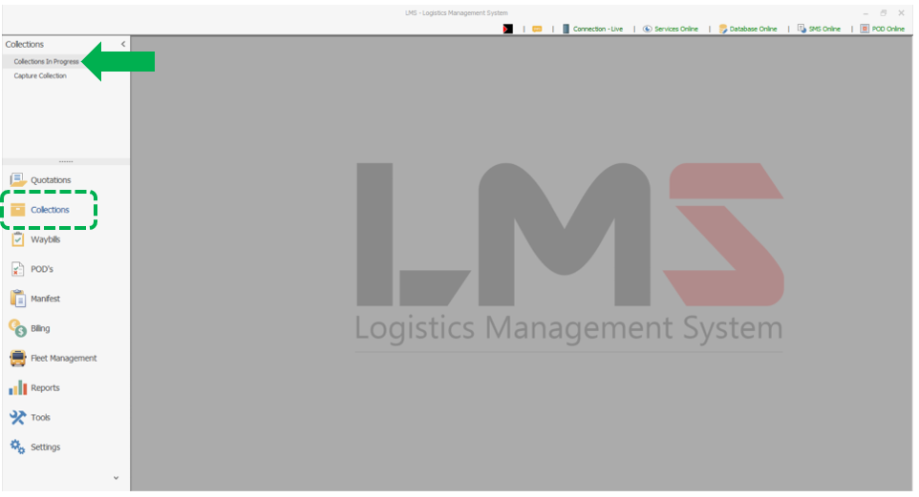

  - Select the collection depot.
- Right click on collection number and select assign to load. (i.1)

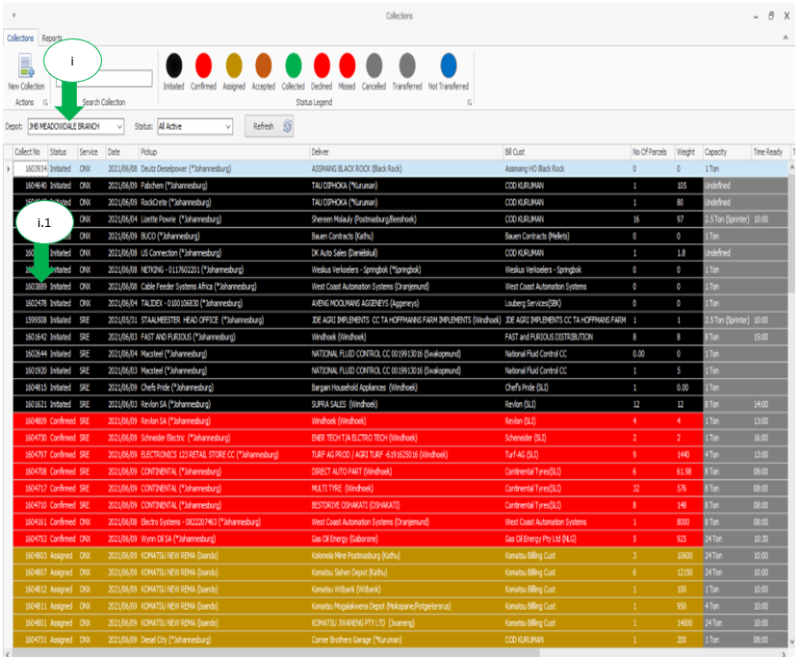

  - Select the load number.
- Select “Assign”.

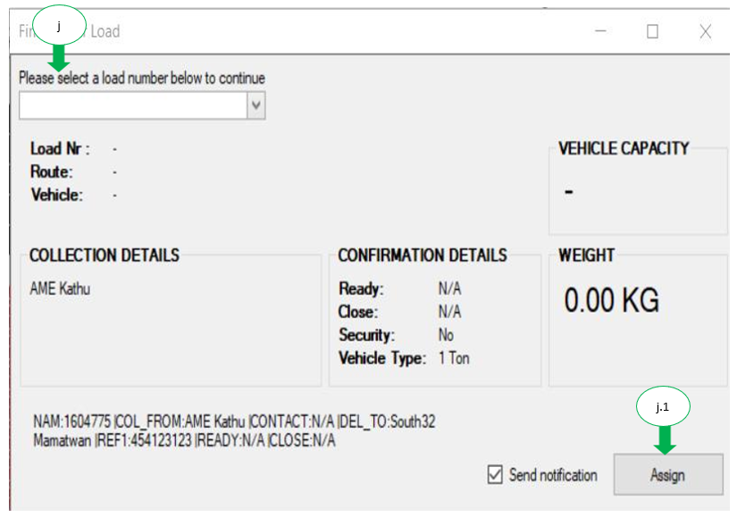

  - The collection is assigned to the driver:
- Driver will receive:
- Collection request on the PDA.
- SMS for the collection.

  - Call the driver to confirm the collection request was received.

