PURPOSE

The objective of Creating a Load Standard Operating Procedure (SOP) is to provide clear guidelines for operational departments within Namlog Group to create a load. This SOP is intended to be used as a reference for all Mellets personnel on creating load activities.

SCOPE

The SOP is applicable to operational personnel who are responsible for creating a load.

PROCESS

- Login to LMS to perform the following:
  - Select “Manifest” from main menu.
  - Select “Create New Load”.

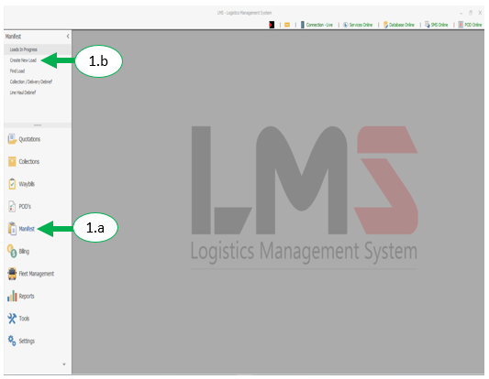

  - Select “Step 2 – Manifest Particulars”.

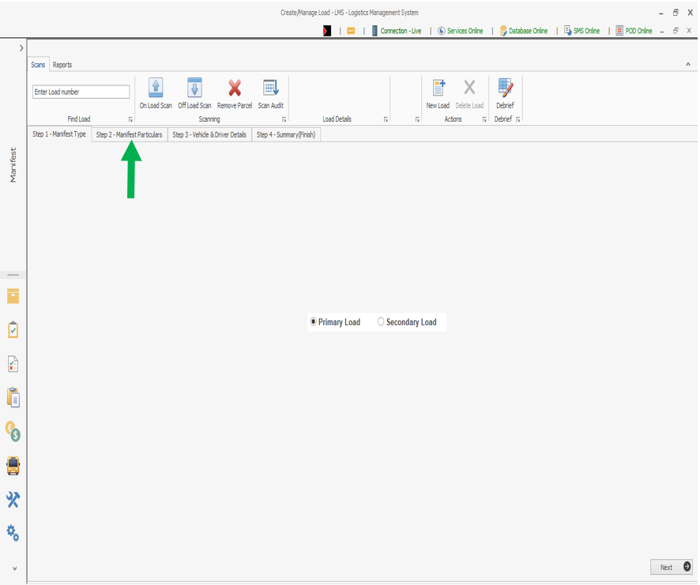

  - Complete load details
    - Select “Next”

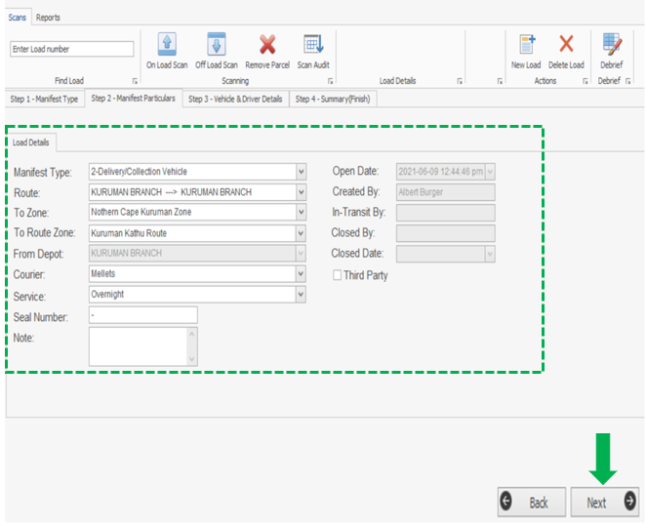

  - Complete vehicle and driver details
    - Select “Next” to save the load.

