PURPOSE

The objective of the Data Capturing Standard Operating Procedure (SOP) is to provide clear guidelines for operational departments within Namlog Group to execute the Induction Data Capturing process. This SOP is intended to be used as a reference for all Mellets Data Capturers and Operations Administrators personnel involved in Data Capturing activities.
SCOPE
The SOP is applicable to the Operational and Clearing Personnel directly and indirectly involved with the Induction Data Capturing and receiving process.

PROCESS

Capturing via LMS by Induction Data Capturer

- Consignments received via LMS collections:

- Select the “Waybill Capture” field on the LMS system

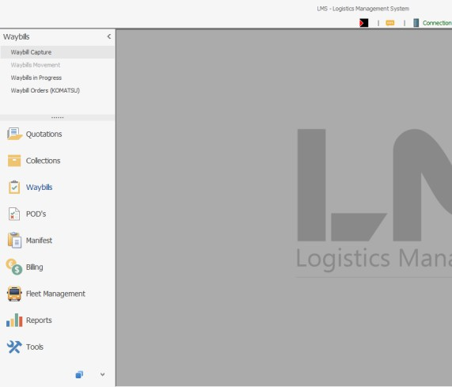

- Scan or manually type the waybill number into the field indicated below.
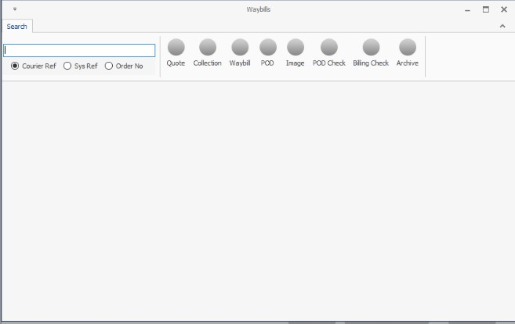

- A pop-up will appear as per below image requesting you to transfer the collection to the waybill number inserted.
- Ensure the collection reference number on the waybill hard copy is the same as the reference number on the pop-up screen.
- Ensure the pick-up and delivery customer name in LMS is the same as the one on the waybill hard copy.
- If the details are the same, select yes.
- If the details are not the same, select no and capture as new waybill, then complete reference section with collection number.
- Upon confirmation that all details are correct, select “Yes”.
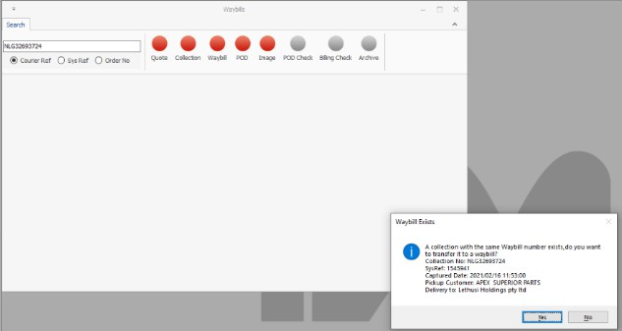

- LMS will display the screen below.

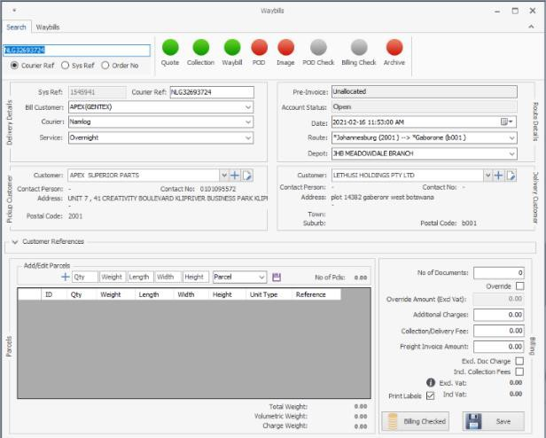

- Confirm information on LMS is the same as the waybill hard copy:

- Billing Customer
- Courier name
- Service level type
- Route
- Depot
- Pickup Customer
- Delivery Customer

- Capture number of parcels, dimensions, and weight as per waybill hard copy.
- Capture the invoice number(s) and customer order number(s).

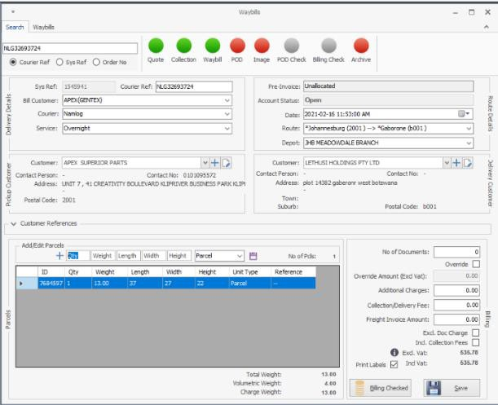

- Confirm the accuracy of all data captured and populated and then click save to print labels.
- Hand over labels to the relevant Team Leader.

- Waybills received from deliveries:

- Select the “Waybill Capture” field on the LMS system.

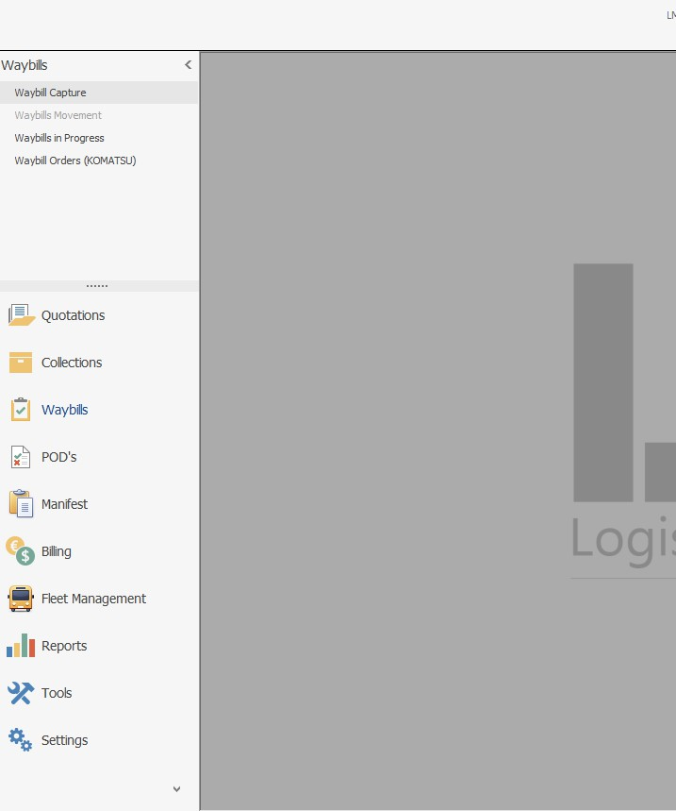

- Scan or manually type the waybill number into the field indicated below.

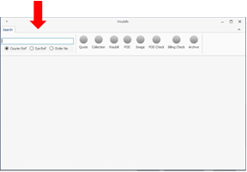

- A pop-up will appear as per image below requesting a selection between transfer collection or new waybill.

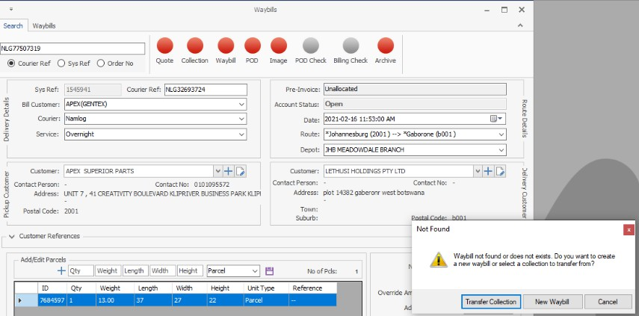

- Confirm if there is no collection reference number mentioned on the waybill hard copy.
- If there is a collection reference number on the waybill hard copy, select “Transfer Collection” and search for the collection number.

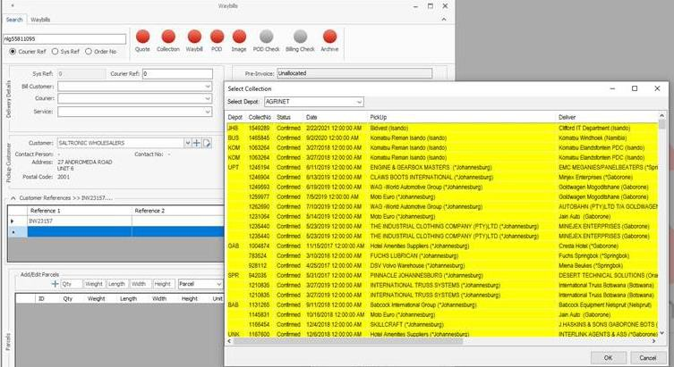

- If there is no collection reference number on the waybill hard copy, select “New Waybill” and the screen below will appear.

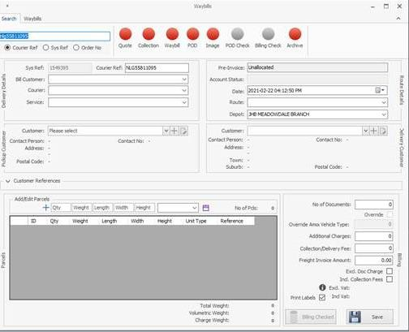

- Select the billing customer on the “Bill Customer” section.

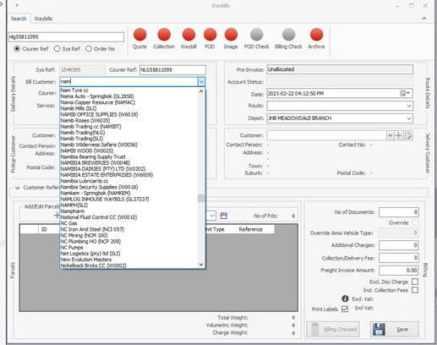

- Select the courier on the “Courier” section.
- Select the service on the “Service” section.

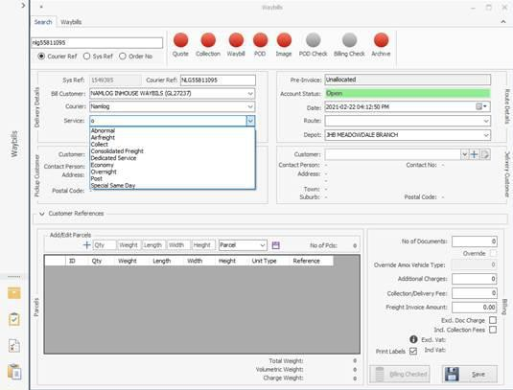

  - Select the route on the “Route” section.

  - Select the departing depot on the “Depot” section.
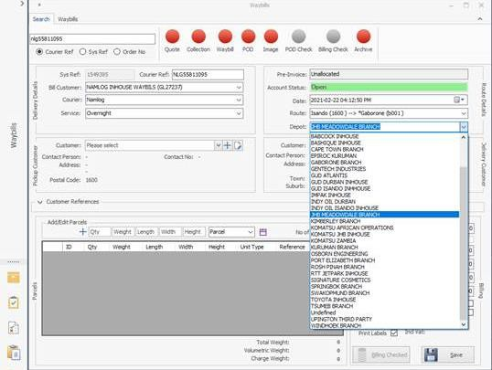

- Click in the drop down in “Pickup Customer” field, type the first 3 letters of the customer’s name and select the applicable customer.

- Click in the drop down in “Delivery Customer” field, type the first 3 letters of the customer’s name and select the applicable customer.
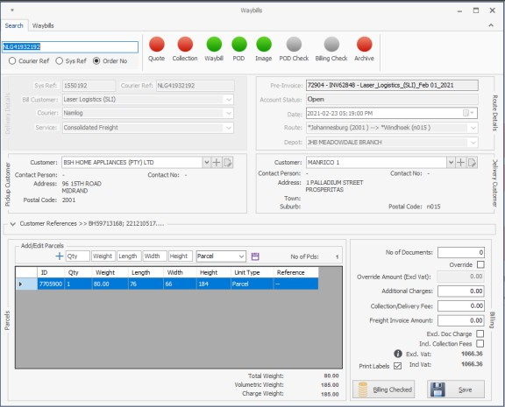

- Type in the reference number and customer order number.
- Capture number of parcels, dimensions, and weight as per waybill hard copy.

- Confirm the accuracy of all data captured and populated and then click “Save” to print labels.

- Hand over labels to the relevant Team Leader.

- Client’s reference number capturing

- Each client’s reference number or invoice number is to be captured under the “Customer References” field.

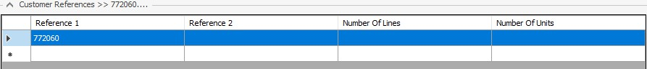

- Clients with Namlog In-House Teams have systems that generate waybills and only require batching of documents.

- Reporting of queries and discrepancies:

- All queries must be escalated to the Branch Manager.
- Any Operations-related queries are to be reported to the Operations Manager.
- Any LMS related queries are to be reported to the Operations Manager, IT team and confirm by email.

