PURPOSE

The objective of the Delivery at the Sishen Mine Standard Operating Procedure (SOP) is to provide clear guidelines for operational departments in Mellets to execute the delivery at the Sishen mine process. This SOP is intended to be used as a reference for all Mellets deliveries at the Sishen mine site.

SCOPE

The SOP is applicable to operational personnel who are responsible for deliveries at the Sishen mine site.

PROCESS

- Correct Personal Protective Equipment (PPE) must be worn at all times.
- Before departing for delivery to the Sishen mine site, ensure all vehicle lights are working.
- The vehicle must be equipped with the following:
- 3x triangles
- 1x first aid kit
- Fire extinguisher
- Depart for delivery and stop at TMM for vehicle test.
- Arrive at the Sishen mine site for delivery, ensure the cargo is delivered to the applicable stores as per the Waybill:
- Reco Stores (Mine store)
- Warehouse 13C
- Drill workshop 16 L-1 & 2
- Mikom is delivered to the mine stores
- Life of mine (LOM)
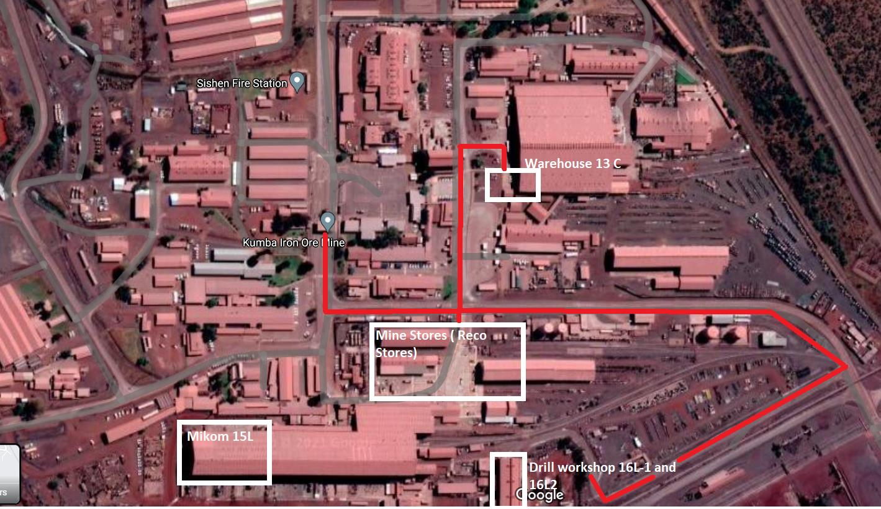

- The person receiving the cargo must stamp the delivery documents with a customer receiving stamp.
- The driver to ensure the following details of the person receiving the cargo is clearly written / captured on the customer stamp section:
- Name and surname
- Clock number
- Cellphone number

- If the delivery documents are not stamped, the cellphone number and name of the person receiving the cargo must be clearly written on the customer stamp section.

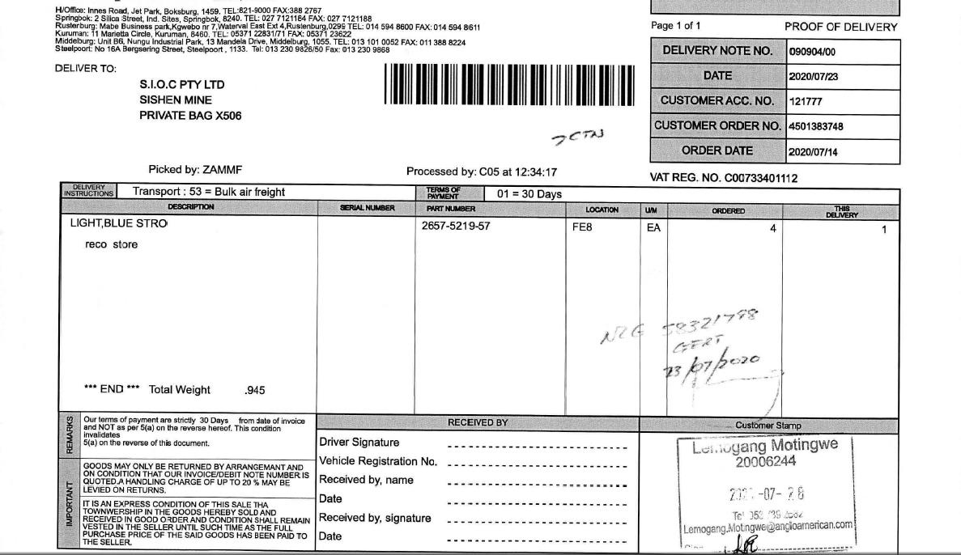

- After delivery completion, take the delivery note to the Reco Stores (Mine store) for the information to be captured and for the delivery note to be stamped with a Khumba Iron Ore stamp.
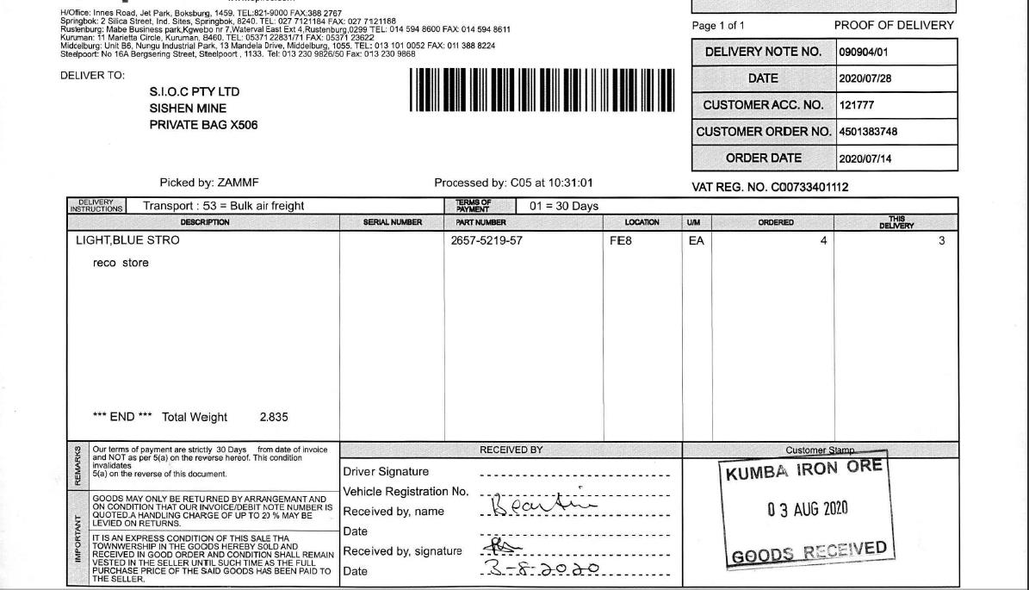

- Ensure all delivery notes have two stamps, before returning to the Mellets branch.
- Upon arrival at Mellets branch, report to debrief station for debriefing.

