PURPOSE

The objective of the Delivery Debrief Standard Operating Procedure (SOP) is to provide clear guidelines for operational departments within Namlog Group to execute the debriefing process. This SOP is intended to be used as a reference for all Mellets driver’s delivery debriefing activities.

SCOPE

The SOP is applicable to operational personnel who are executing the debriefing process which includes the receiving off consignment documents for deliveries and collections.

PROCESS:

The De - briefer will execute the following process on LMS:

- Login to LMS
  - Select “Manifest” from main menu.
  - Select “Collection / Delivery Debrief”.

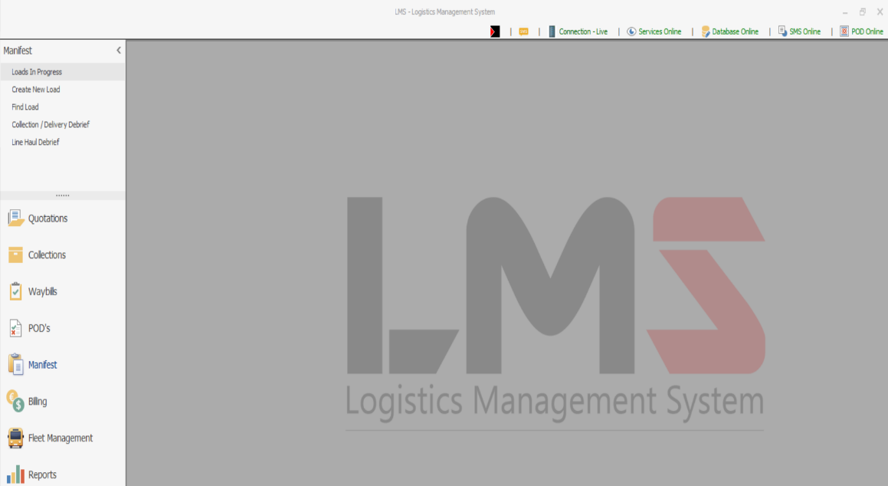

  - Enter the load number on “Please enter load number” section and press enter on the keyboard.

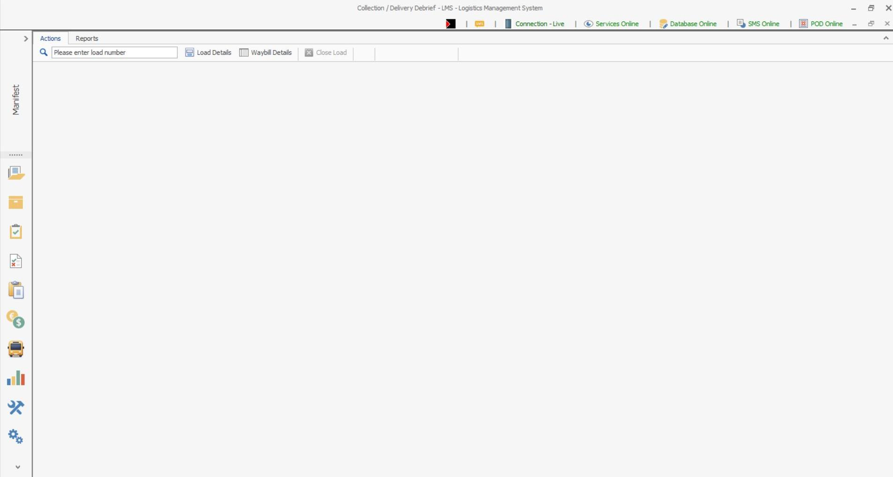

  - Select the first “Delivery”

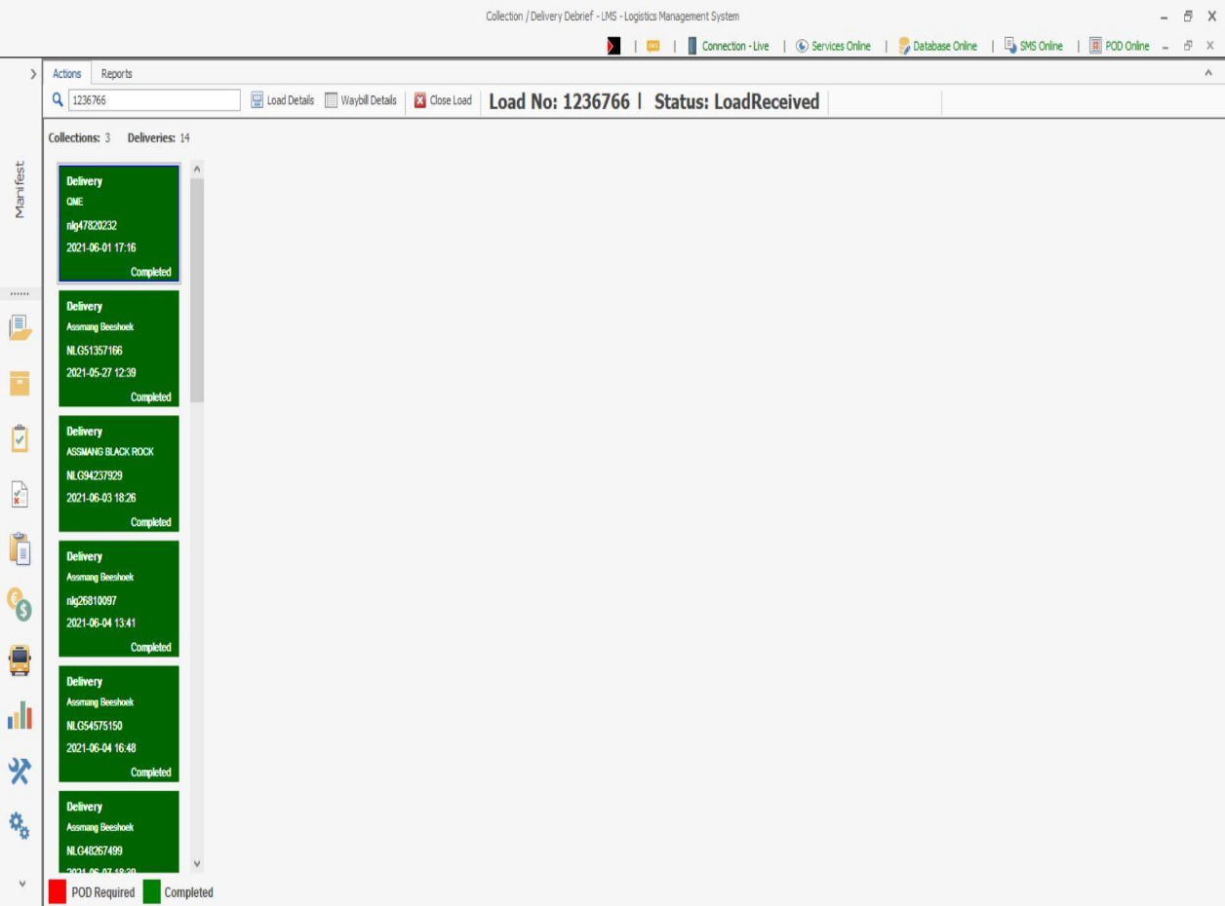

  - POD quality check:
    - Click on the POD to view the photo taken.
    - Inspect the quality of the photo.
    - Rate the quality of the photo with stars, 1 being bad and 5 being good.
    - If the photo is of poor quality, the driver must re-take the photo with a PDA.

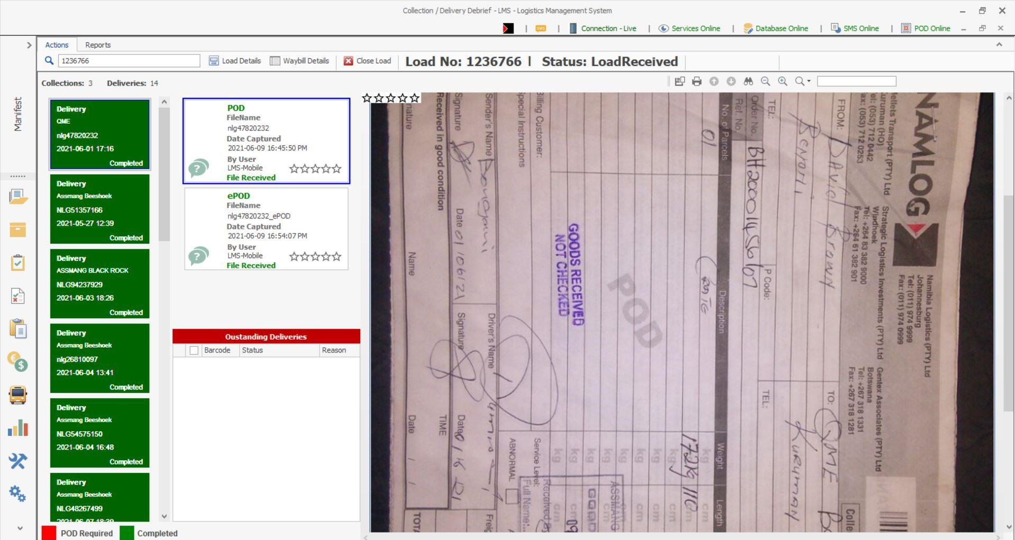

  - ePOD quality check:
    - Click on the ePOD.
    - Check if the name and signature of the customer receiving the freight is recorded.
    - If the name and signature of the client is not on the ePOD, then the rating will be 1/5
    - If the name of the client is not on the ePOD, but the client has not signed on the ePOD, the rating will be 3/5
    - To score 5/5 rating, the following information must be captured on the ePOD:
      - Name of the person accepting the freight
      - Signature of the person accepting the freight

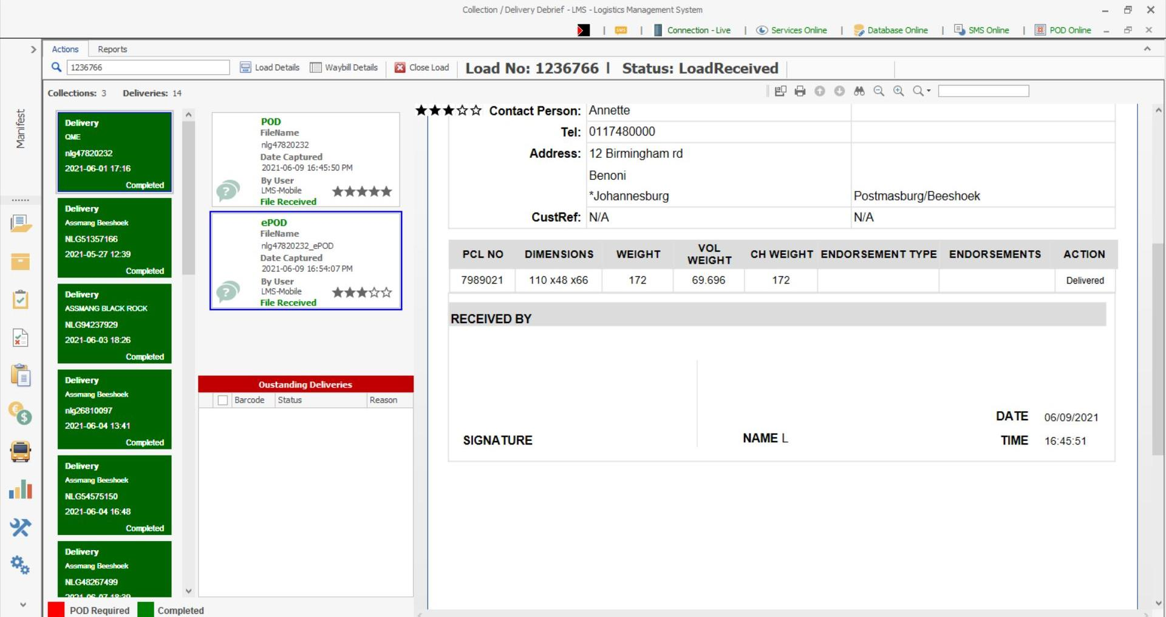

g. Missed collection.
  - Missed collection will be shown in red.
  - Click on “Collection” on the red section.

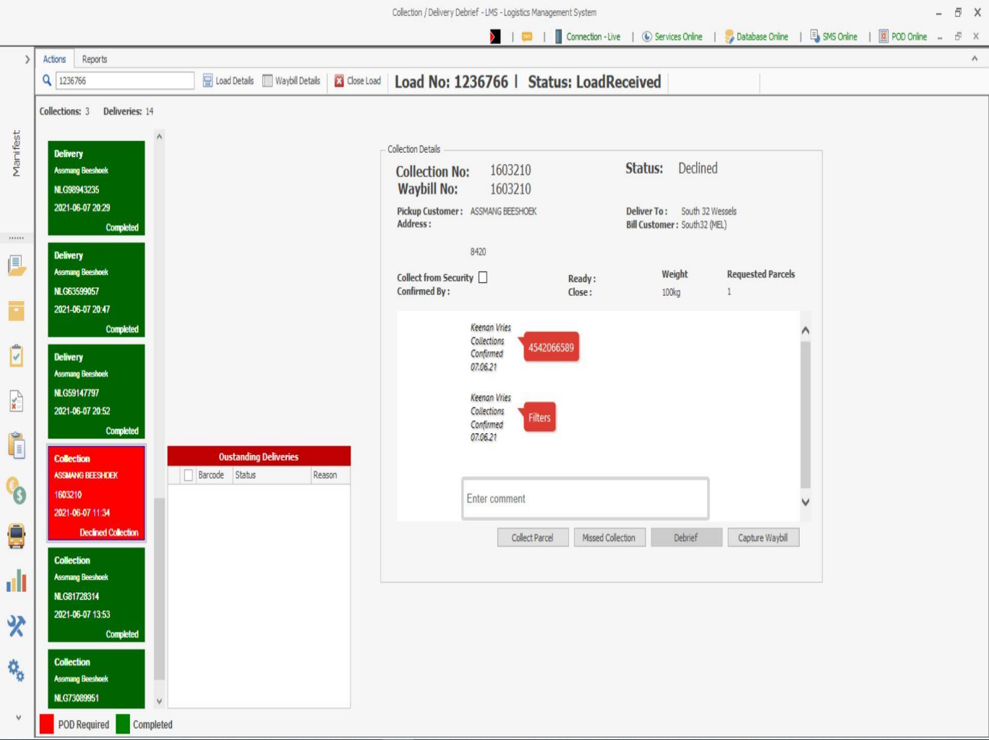
  - Click on “Missed Collection” to add the reason.

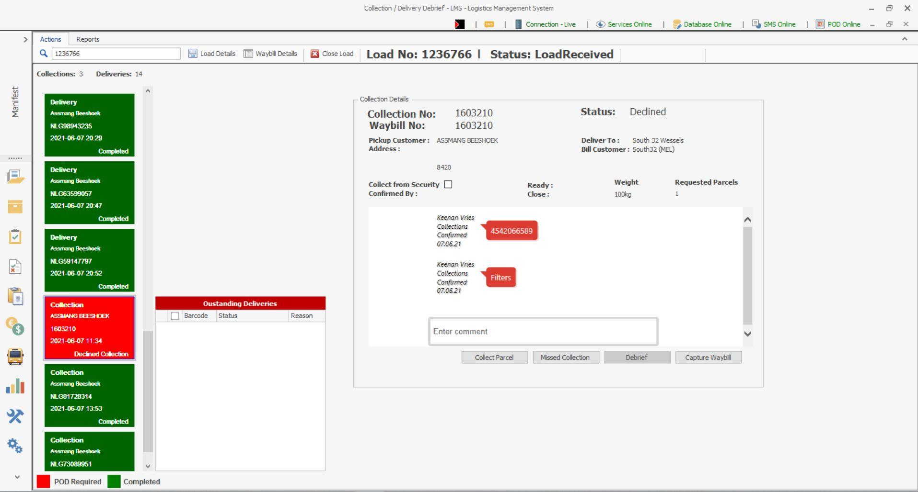

  - Select a drop down on “Missed Collection Reason” to select a reason.
- Add a comment for missed collection and click “OK”.

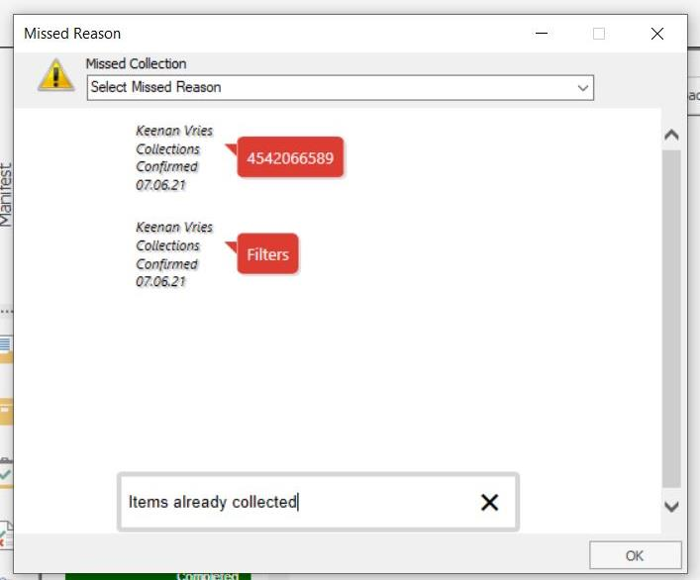

  - Once completed with all POD’s, click on “Load Details”.

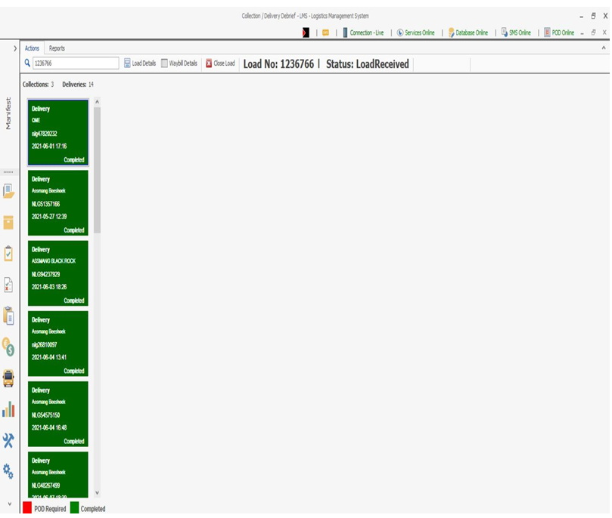

  - Verify “Vehicle & Driver Details”
    - Click “Next”.

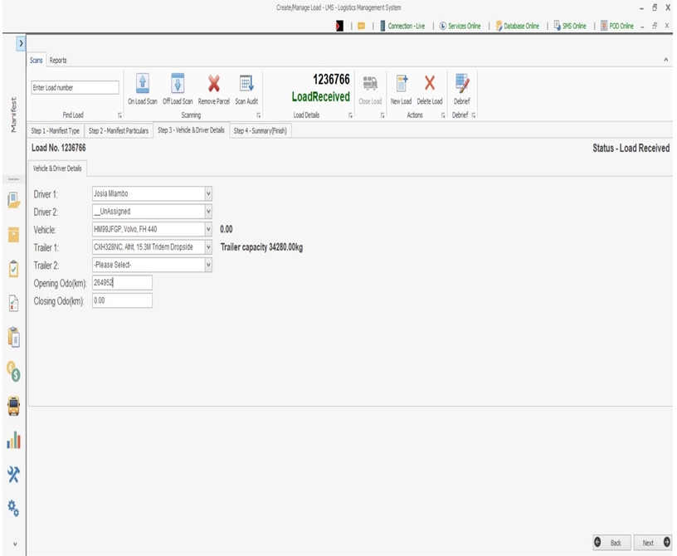

  - Record the driver’s name and vehicle closing odometer readings
    - Click “Save” to close the load.

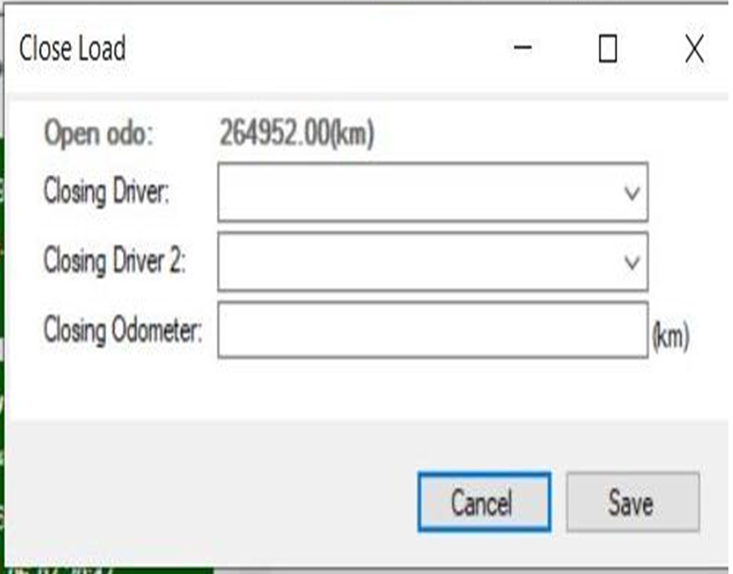

  - PDA day end handover

- Handover PDA to debriefer by signing the mobile device logbook.
- Debriefer to ensure PDA is in operational status:
  - Sim card is in PDA.
  - Recharge PDA for the following day’s operation.

