PURPOSE

The objective of the Driver Induction and Operating Process Standard Operating Procedure (SOP) is to provide clear guidelines for operational departments within Namlog Group to execute Driver Induction and Operating Process. This SOP is intended to be used as a reference for all Mellets personnel involved in Driver Induction and Operating Process.

SCOPE

The SOP is applicable to operational personnel who are responsible for Pre-Loading and Staging Process.

PROCESS

- PPE – Personal protective equipment
- Driver to be issued with PPE once a year according to the mine regulations.
- All issued PPE belongs to the company and must be taken care of.
- Every employee must wear the company issued PPE. No other jackets or caps will be allowed.
  - Grey conti suit with reflective tape
  - Golf Shirt with Company name
  - Safety boots
  - Reflector vest
  - Colmac Jacket
  - Gloves
  - Hardhat
  - Spats
  - Cap
- Note that PPE that is damaged before a year has gone past will be replaced at the cost to the employee.

- Vehicles and inspections
- Daily inspections must be done on each vehicle. This includes trailers as well.
- Ensure that the Odo’s are written down for Odo updates on the system for services and wheel alignments.
- On tautliners indicate that the uprights are there and in good condition. In the event anything on the trailer needs repairs ensure that it is reported.
- Complete every block on the applicable inspection sheet.
  - Odo for the truck
  - Each trailer has an odometer on one wheel. Record this every time you return form your delivery.
  - Mark each scratch on the diagram and write down the reason for the mark i.e. dent, scratch, crack.
  - Ensure tyre pressures are checked on each vehicle and write them down when filling diesel you can check the tyre pressures on the vehicle and trailers.
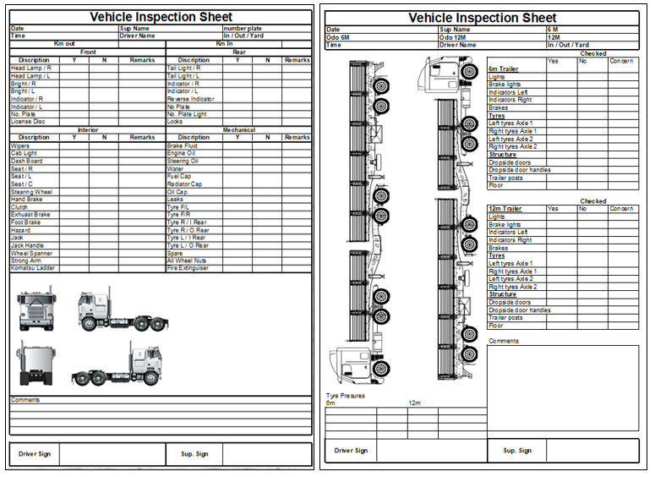

  - Report all defects to the manager immediately.

- Cartrack
- Vehicles are monitored daily on both driver behavior and to check where each vehicle is located.
- In the event of an emergency or you get lost you can contact the control room 24/7 for assistance.
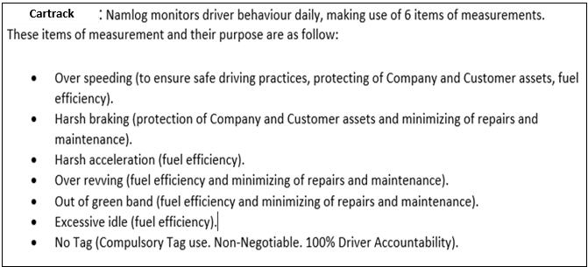

- All vehicles fitted with tracking can be located on either GPRS (cell towers) or GPS (Satellite)
- All information is then available immediately on the system.
- Management can view location of vehicles on either PC or Cellphone.

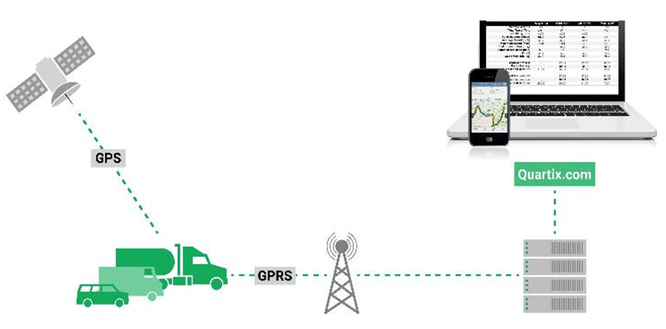

- Each Driver will be issued with a driver tag.
  - Once the driver needs to start the vehicle tag needs to be placed inside the tag reader to activate and allow the vehicle to start.

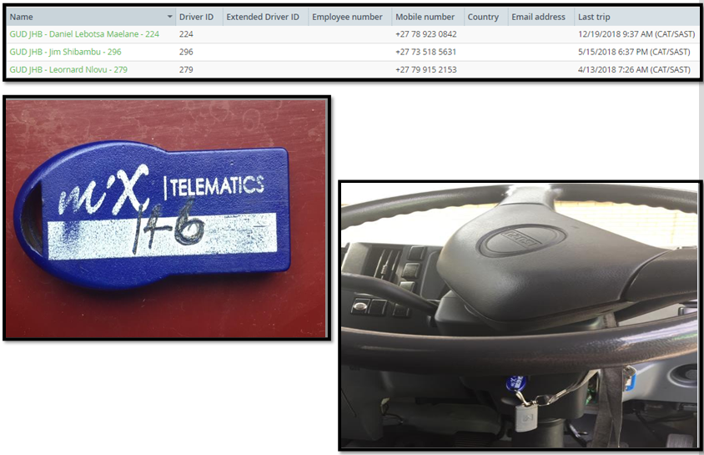

  - The tag will send information to the system who is driving the vehicle
  - The tracking department can get in contact with the driver should they need to assist the driver
- Zones
  - Each area has no go zones for the company vehicles.
  - Once a driver goes into this zone, he will be contacted by tracking to find out why you are in that area.
- Live tracking and replay
  - The trip can be replayed
- Managers can monitor trips on portal

- Tracking control room contacts:
Contact : 011 974 9999
Cell : 076 443 9658
WhatsApp : 081 538 5193

