PURPOSE
The freight administration and control provide a standard operating procedure for the completion of waybills by Assmang Iron Ore Mine’s warehouses and suppliers, the requirements related for packaging and labelling of cargo, and the booking of collections with Mellets Transport.
SCOPE
The scope of the document is to provide guidance to Assmang Iron Ore Mines and their suppliers for the correct and accurate completion of waybills, the requirements of labels and packaging, the process for document management such delivery notes and invoices and the booking of collections to prevent delays, in the collection and delivery process.
PROCESS
- Waybill completion:
- Waybills must be completed by the sender and not by the driver
- Accurate completion of waybills are required to ensure the cargo is delivered as per delivery address on the waybill
- A supplier purchase order number must reflect on all waybills
- Number of packages on the waybill must correspond with the number of packages collected, to streamline verification by the driver before driver signs the waybill in acceptance
- Delivery notes and invoices are handed over at collection point to the driver after acceptance of waybill. Driver to hand over invoices and delivery notes at delivery location after signature of waybill by recipient.
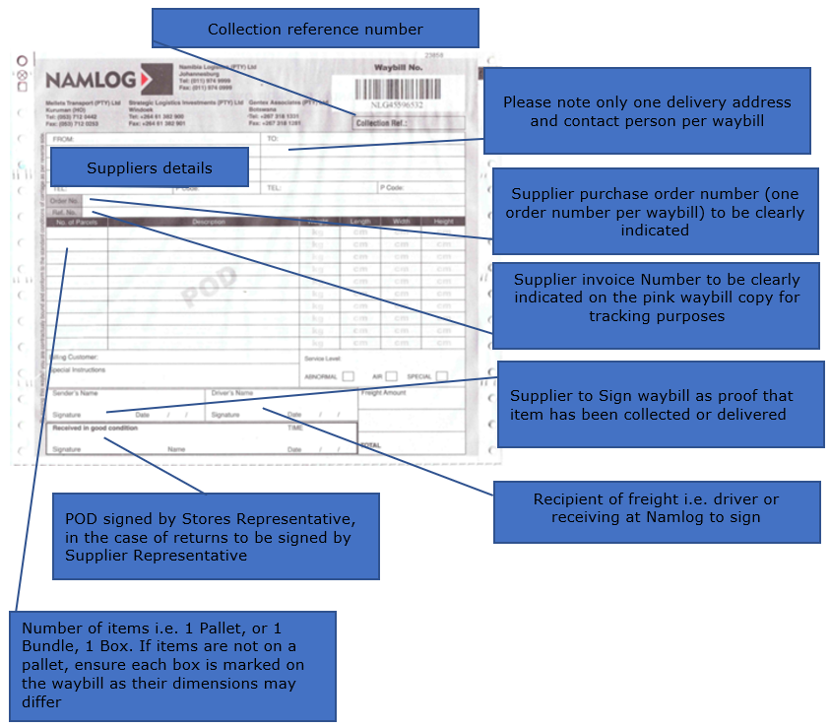

- Packages must be clearly marked / labelled to easily identify the final destination and delivery address, as this will prevent items to be delivered to the wrong delivery address.
- Labels on the packages will ensure the packages are delivered to the correct mine / store.

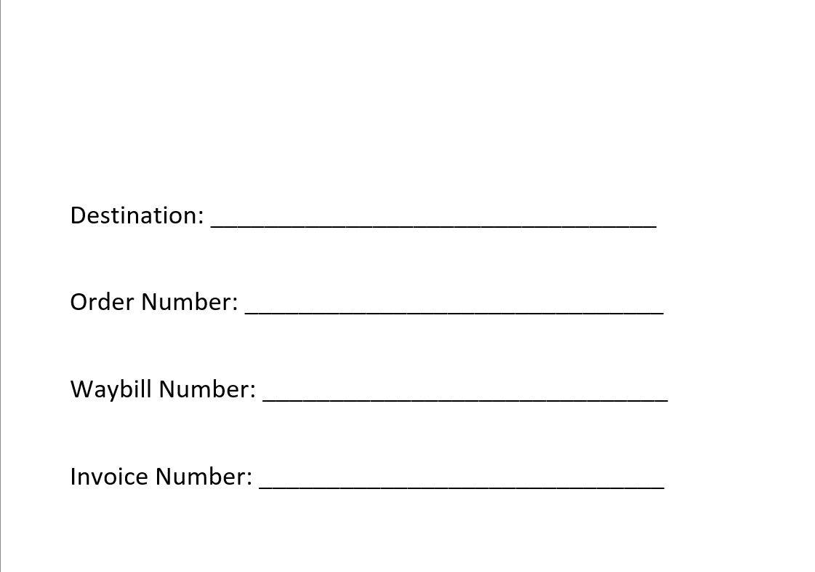

- Suppliers to ensure all items are adequately packaged (palletized, wrapped, boxed, crated) in such a way to be “Ready for Freight” and prevent in transit damage.
- Namlog will endeavour to pack and load all packages for transport in such a way to prevent goods in transit damage.

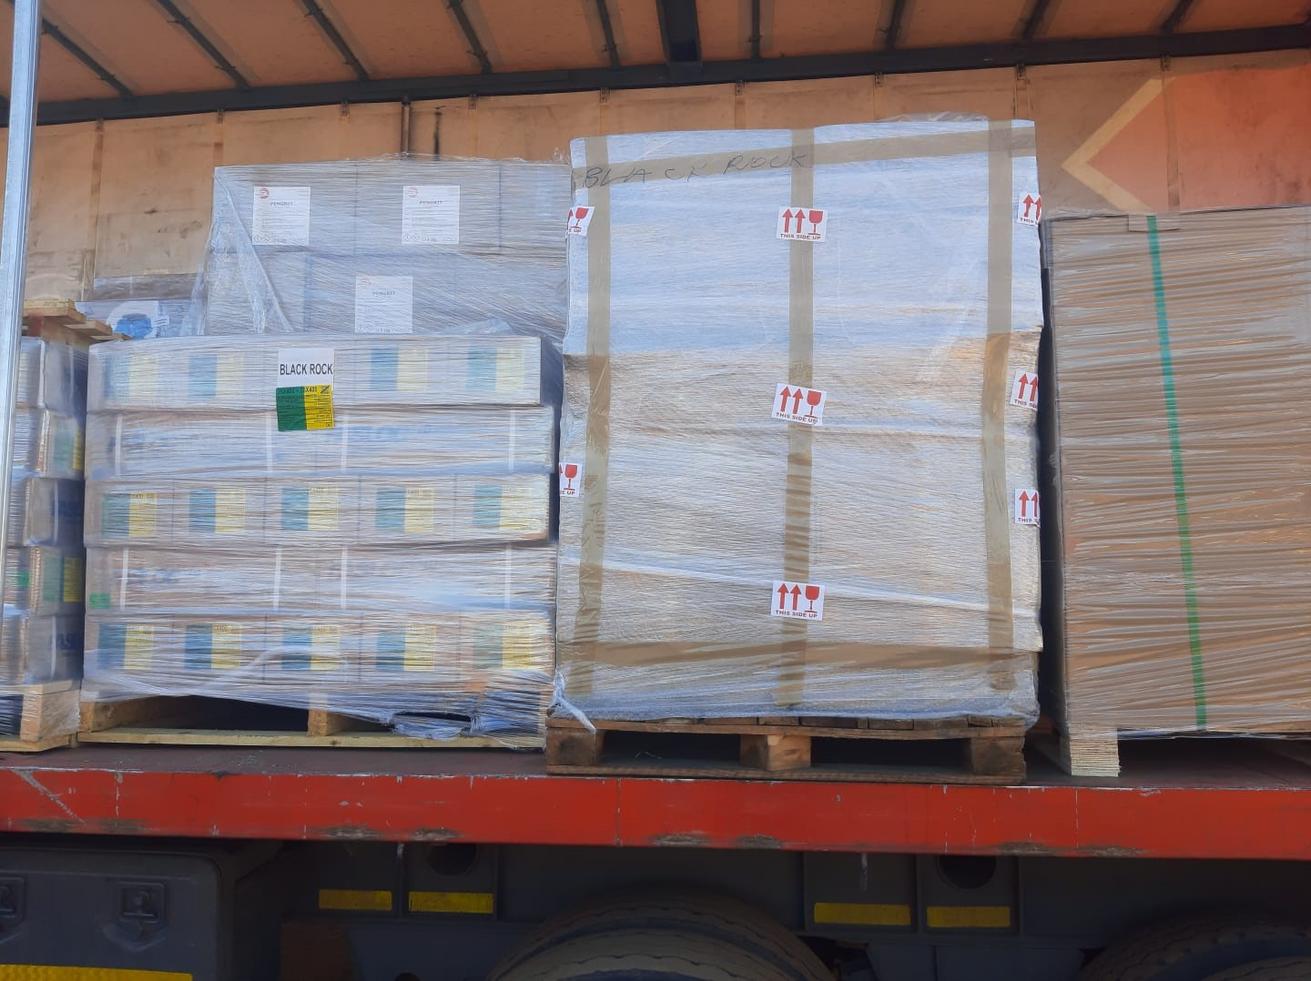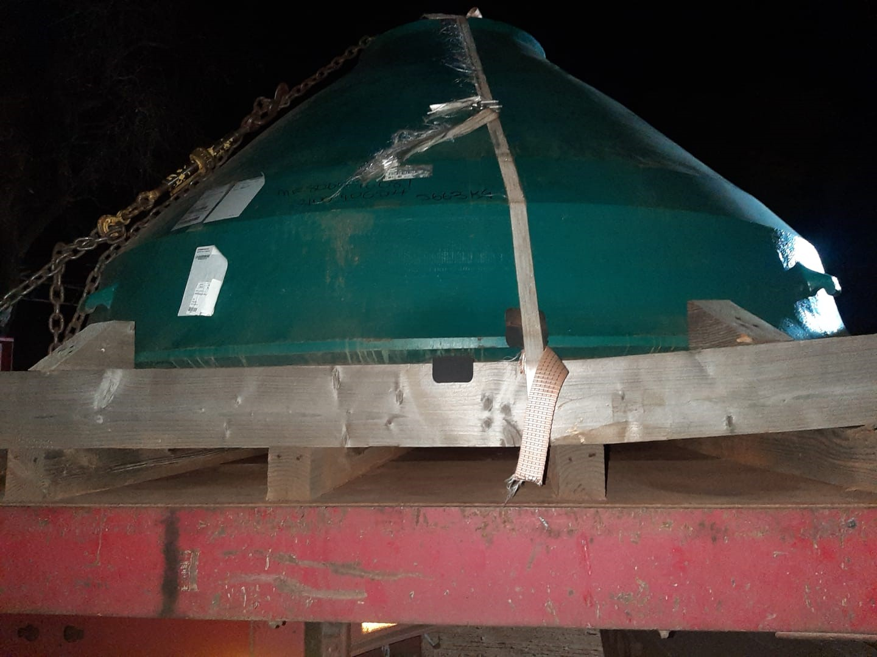
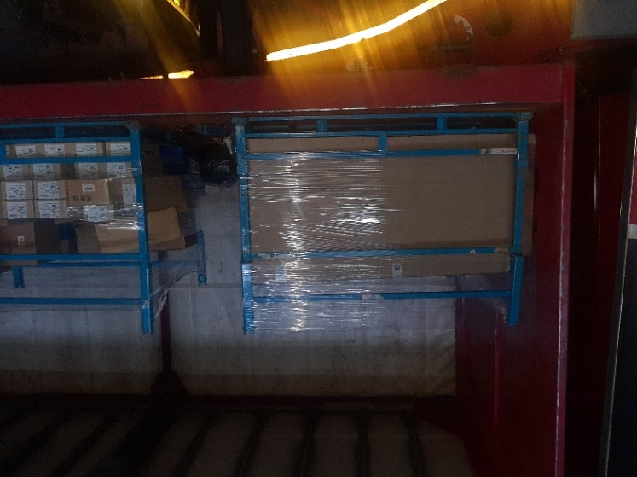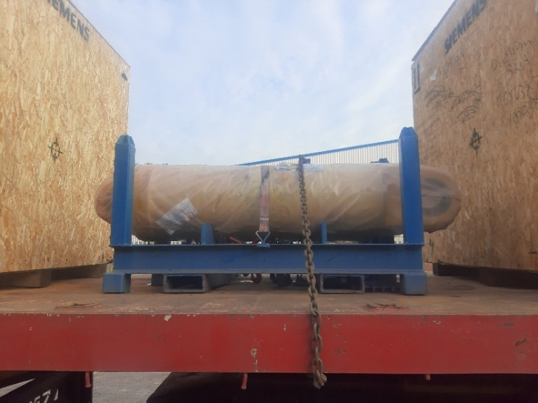

- Booking collections or delivering to Mellets
- All collection bookings must be emailed to melletscollections@namlog.co.za. The email will be received by various staff members at Mellets Transport Kathu branch, who will book a collection on LMS - Namlog’s Logistics Freight Management System.
- Same day collection booking requests close at 12:00.
- Collection bookings requests received after 12:00 will be collected the following day.
- Collection booking requests will be confirmed with a collection reference number which should be added on the waybill below the barcode. The collection reference number is used to cross reference the cargo details on LMS, ensuring the correct cargo is collected.
- Should a collection reference number not be supplied, please contact the office on 053 712 0442.
- Drivers will only proceed with the collection if the waybills are not completed accurately, all packages are clearly marked / labelled.

- Contact details.

- Mellets 24-hour standby number - 083 557 2405
- Operations manager Vincent Josop 083 279 2157
- Branch Manager Johannes Esterhuizen 063 026 9631
- General Manager Albert Burger 083 973 1597
Mellets Johannesburg
54 road number 5
Brentwood Park
Benoni
011 974 9999
https://www.google.com/maps/dir/-27.6922368,23.0752256/namlog+transport+brentwood+park+johannesburg/@-26.6451499,23.4339453,7z/data=!3m1!4b1!4m9!4m8!1m1!4e1!1m5!1m1!1s0x1e9513c8c7600e39:0x598ce1515d5669f3!2m2!1d28.2810326!2d-26.1235521

- Mellets Kathu
York street 3
Bestwood Supply Park
Kathu
053 712 0442
https://www.google.com/maps/dir/-27.6922368,23.0752256/namlog+transport+johannesburg/@-27.6924263,23.0724593,17z/data=!3m1!4b1!4m9!4m8!1m1!4e1!1m5!1m1!1s0x1e9ef91bfd2254af:0xddc51d3eca671f3c!2m2!1d23.0740779!2d-27.6924635

- Mellets Kimberley
1 Silson way
Sunny Rock Park
Kimberley
053 712 0442
https://www.google.com/maps/dir/-27.6922368,23.0752256/1+Silson+Way,+Riviera,+Kimberley,+8301/@-28.7462151,24.7324989,16.66z/data=!4m9!4m8!1m1!4e1!1m5!1m1!1s0x1e9b1a6231ee5221:0xe3bac53cabaac459!2m2!1d24.7312643!2d-28.7451004

- Mellets Upington
22 Progressus street Unit 1
Upington Industrial
051 072 0998
https://www.google.com/maps/dir/-27.6922368,23.0752256/22+Progressus+Street,+Upington/@-28.4429037,21.1934957,12.7z/data=!4m9!4m8!1m1!4e1!1m5!1m1!1s0x1c2153298efda905:0xf9c0088b9e416fd7!2m2!1d21.2347824!2d-28.4340626

