PURPOSE

The objective of the PDA Offload Scanning Standard Operating Procedure (SOP) is to provide clear guidelines for operational departments within the Namlog Group to accurately execute the PDA Offload Scanning process. This SOP is intended to be used as a reference for all Mellets personnel involved with PDA Offload Scanning activities.

SCOPE

The SOP is applicable to operational personnel who are executing the PDA Offload Scanning process.

PROCESS

- Driver login to LMS Delivery on the PDA.

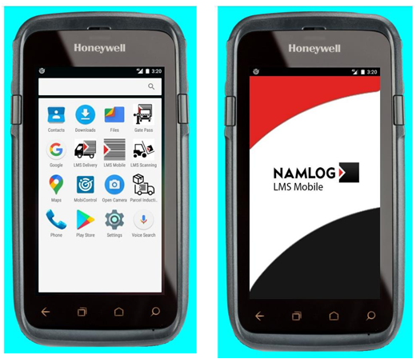

- Select “NEW LOAD”.

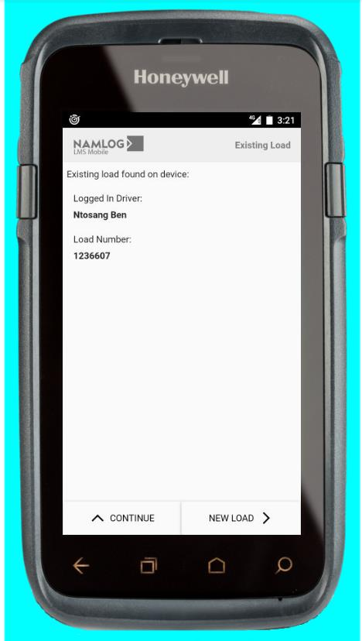

- Enter ID number on the screen and press the green arrow.

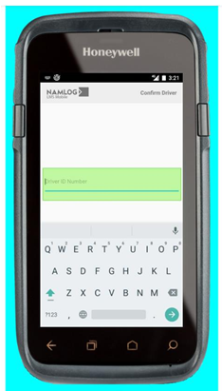

- Scan the load number on the manifest.

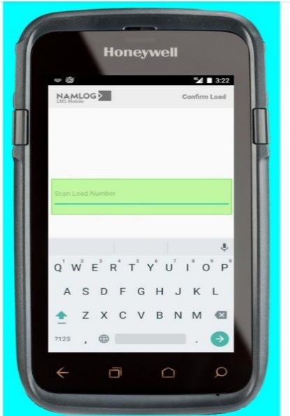

- The screen will refresh and show different waybills, select the waybill number that needs to be delivered by touching the screen.

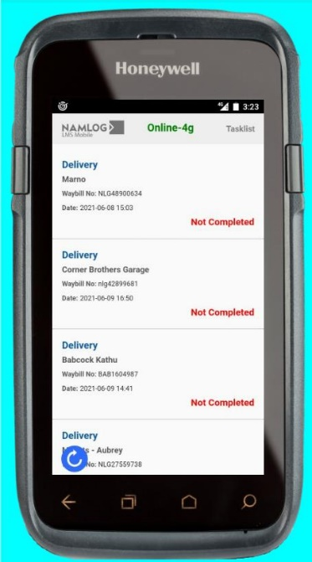

- The screen will refresh and show “Scan Parcels”:
  - Perform offload scanning:
- Scan barcode on parcels.
- PDA will show valid scan.
- Offload the scanned cargo from the vehicle.
- When all parcels are scanned and offloaded, click on the back button.

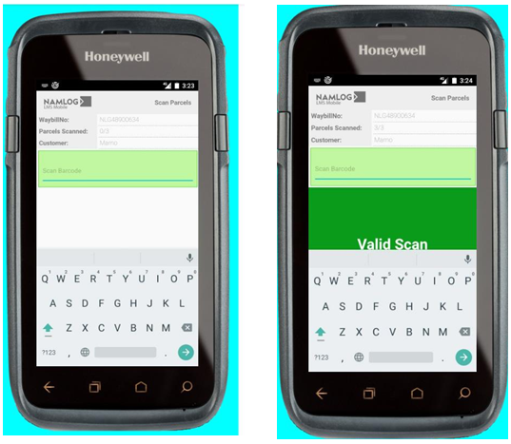

- Endorsement process:
  - If there are damages, click on “Endorsement”.

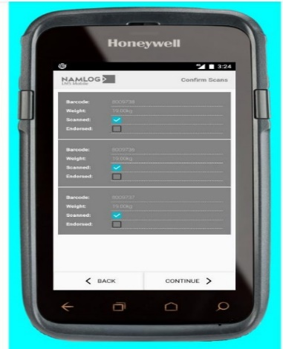

  - Click on “Endorsement Type”.

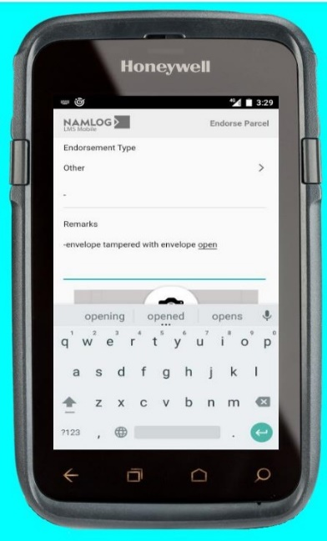

  - Select the endorsement type.

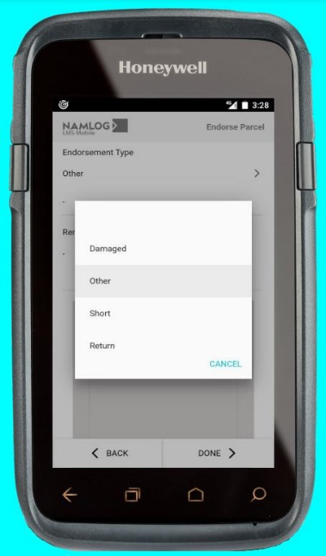

  - Type remarks in the “Remarks” section stating the reasons for endorsement.
  - Click on the camera icon.

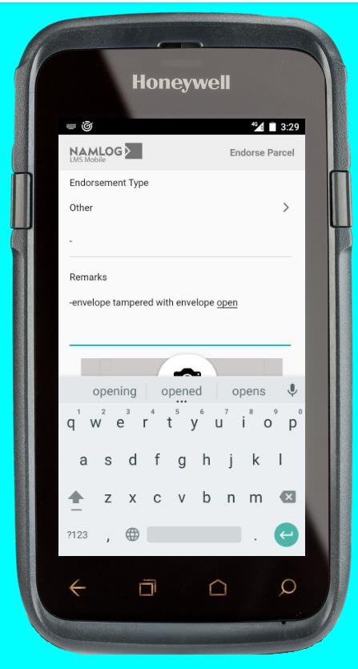

  - Take a photo of the damage(s) or the reason for the endorsement, for example a defective label.

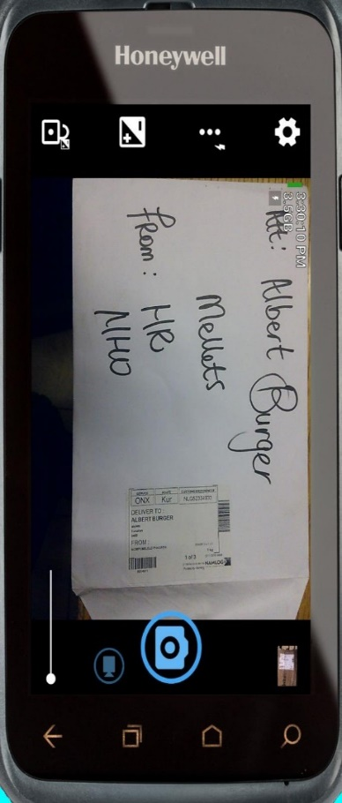

  - Once the endorsement process is complete click “Done”.

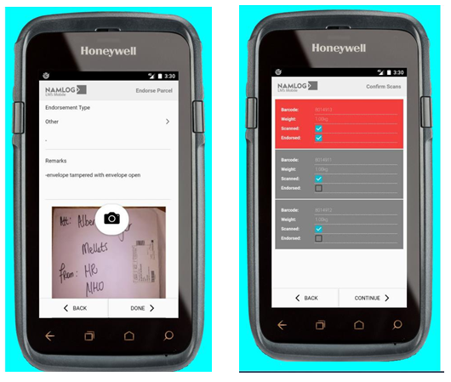

  - The screen will refresh to show the completed endorsement in red.

- If there are no damages and all parcels are delivered in good condition, press “CONTINUE”.

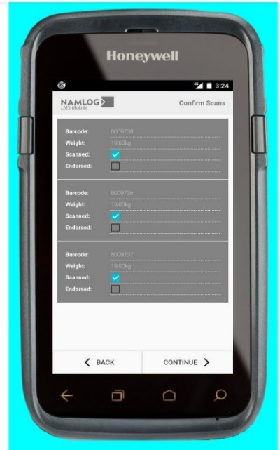

- The screen will refresh to show “Customer Summary” for the number of parcels scanned related to the waybill being delivered.
  - Press “CONTINUE”.

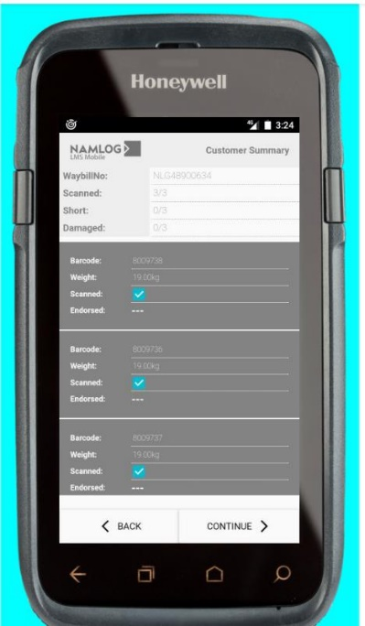
Figure 4:
- The screen will refresh to show “Signee” details.
  - Enter the recipient’s name representing the customer.
  - Request the recipient to sign on the PDA.
  - Click “NEXT”.

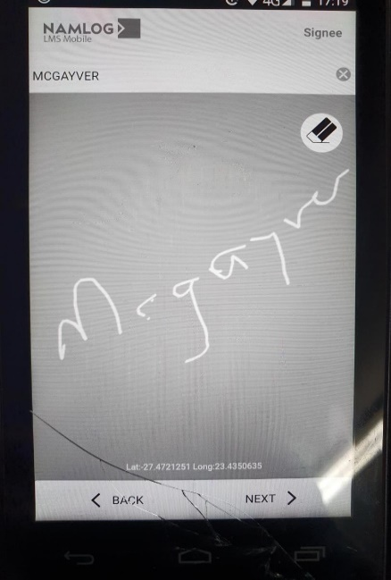
- The screen will refresh to show “Required Documents”.
  - Tap on “POD” for all customers deliveries excluding Epiroc
  - Tap on “Delivery Notes” for Epiroc customer deliveries

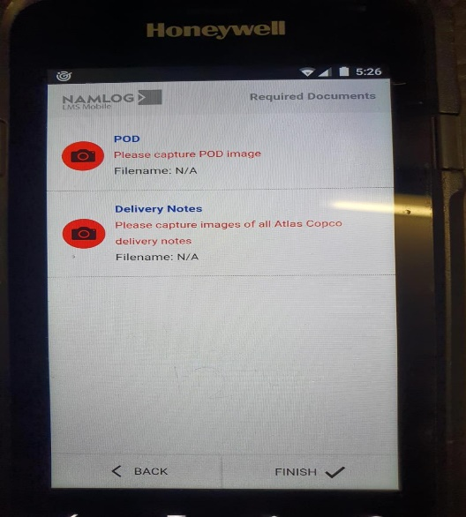

  - The screen will refresh to open a camera.
- Take a photo of the waybill, ensure the waybill is in the center of the photo to see the waybill number and signatures of all parties.
- Should there be supporting documents, the photo of the supporting documents must be taken with the waybill photo.

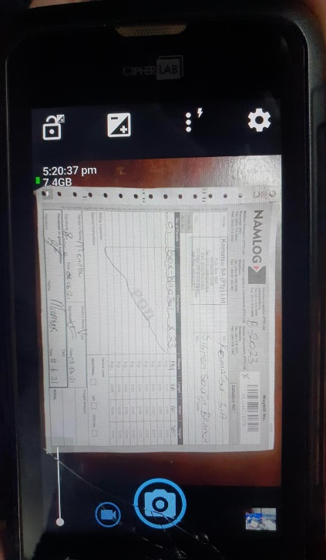

- Once complete, press “FINISH”.

