PURPOSE

The objective of the Securing Cargo Standard Operating Procedure (SOP) is to provide clear guidelines for operational departments within Namlog Group to execute loading process. This SOP is intended to be used as a reference for all Mellets personnel involved in cargo securing.

SCOPE

The SOP is applicable to operational personnel who are responsible for cargo securing process.

Process:

- Proper loading and securing of freight.
- Ensure that items are properly packed on a pallet or stand.
- Supplier to ensure all items are properly plastic wrapped and packed to prevent movement during transit.

- Ensure items are clearly marked with destination and order number + Waybill number.
- Customer to ensure all items are clearly marked or labelled with the following information:
- Customer details
- Waybill number
- Consignee details
- Number of parcels
- Drivers must ensure all items are marked as above before loading.

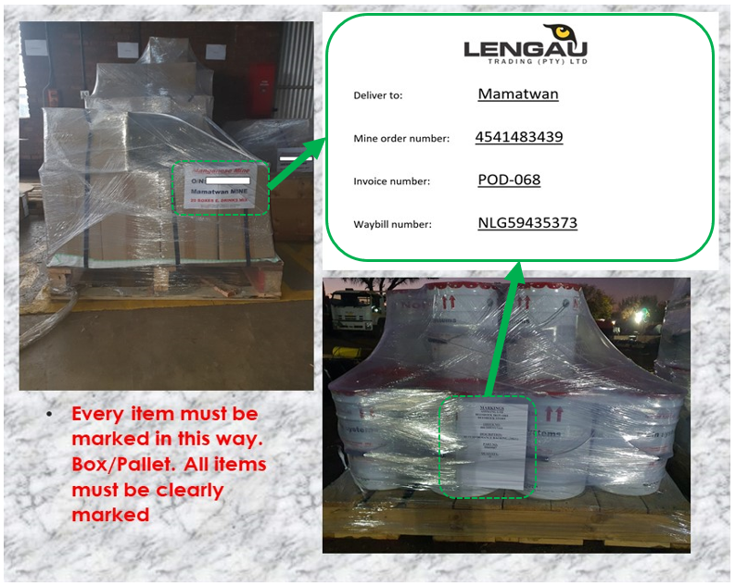

- Cylinder

- Cylinders must be on V-Block or a stand.
- All round objects must be secured in a way to reduce the risk of rolling and falling off the truck.
- Cylinders can be tied down with either belts and ratches or chains and satangs.

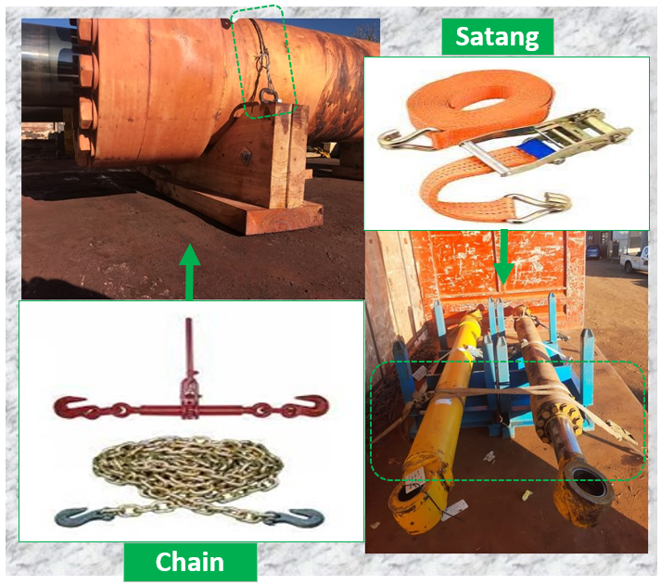

- Spindles
- Spindles must be secured on a stand.
- Ensure whilst loading that the spindle is not moving.
- Secure with 1 chain and satang.

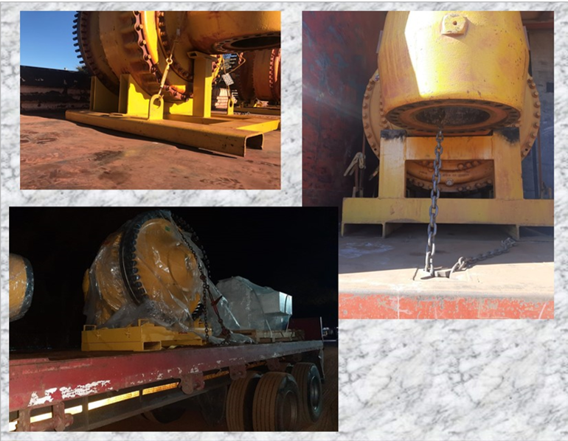

- Alternator, Traction motors and Tracks
- Alternators, Blower motors and Traction motors to be secured on a steel pallet with chains and satangs.
- Tracks to be loaded on pallets or dunnage wood and secured with chains and satangs.

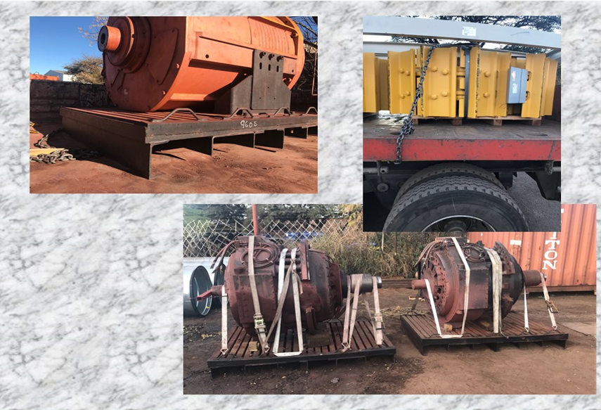

- Dump, Hoist and Suspension Cylinders
- Cylinders are secured to an upright stand.
- Ensure that all the bolts are properly fastened before loading.
- Use chains and ratchets to secure the stands to the truck.

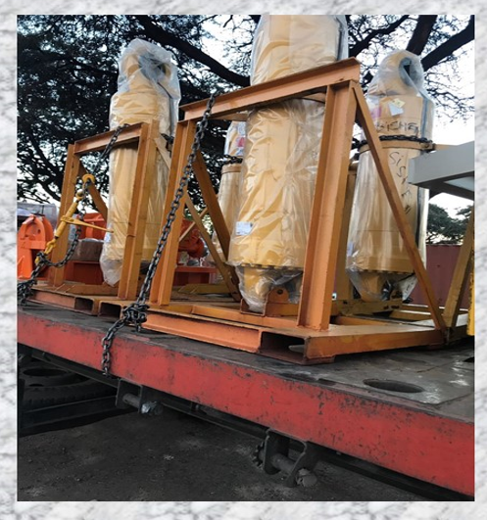

- Final Drives
- Final drives are bolted to a stand.
- Final drives and stand to be secured with chains and satangs to prevent movement whilst in transit.
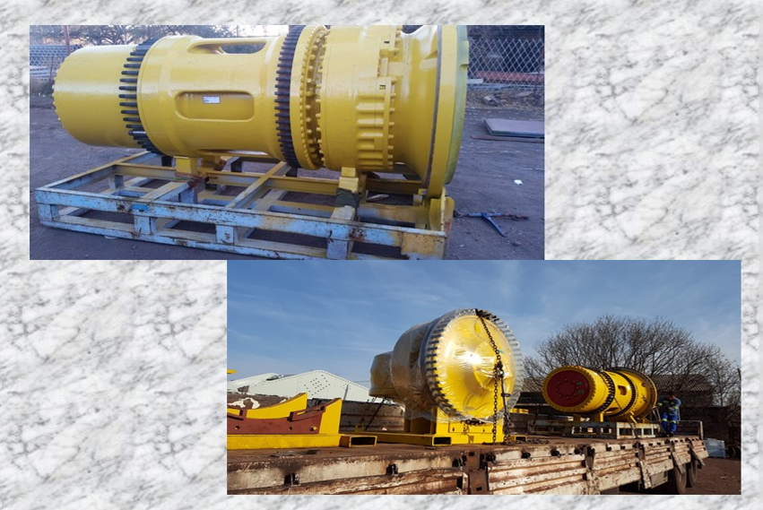

- Engines and transmissions
- Engines and transmissions are secured to the stand stands.
- No engine or transmission can be loaded or accepted if not secures on a stand.
- Use chains and Ratchets to sure this to the truck.
- Customer to ensure engines and transmissions are secured on stands before loading.

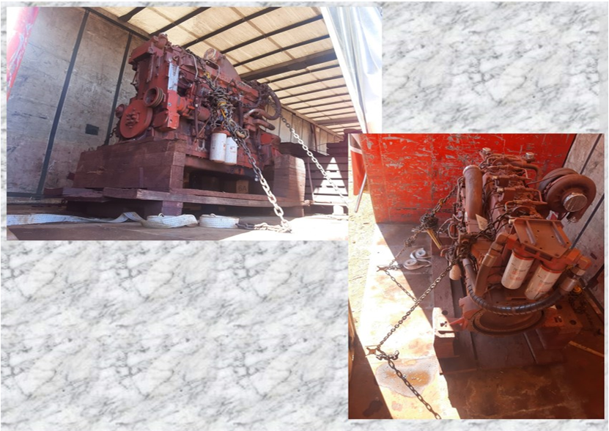

- Huge Items
- All heavy items to be secured with chains and satangs to prevent movement during transit.
- Drivers are responsible to secure loads before departure.

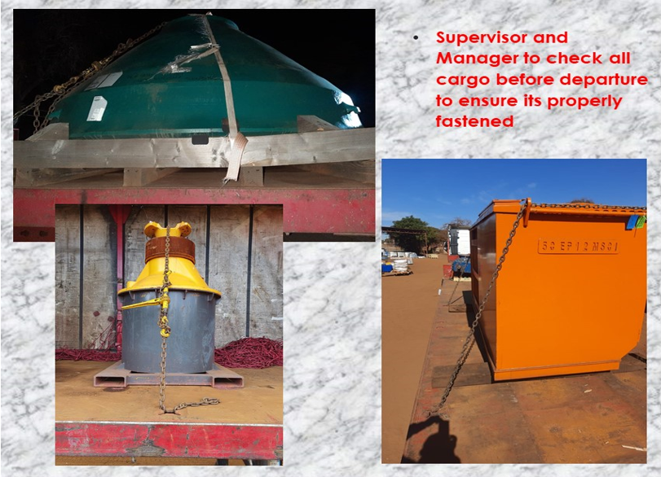

- Should Cargo not be secured as per above.
- Driver to report immediately to Direct Line Manager
- Driver to take photos of the Cargo (if possible)
- Line Manager / Account Executive to contact the customer.
- Driver to wait for Line Manager instruction.

- Securing loads before departure
- Secure cargo on vehicles to prevent in transit damage.
- Cargo securing equipment must always be used when loading cargo.
- Cargo securing equipment:
- Types of Fastening equipment
- Cargo Nets
- Belts and Ratchets
- Chains and Satangs
- Tarpaulin
- Corner plates

