- Imports

Purpose: The refund of Provisional payments made to SARS

- SARS grants a 6 month period for goods to be repaired and returned to the exporting country.
- The liquidation / Acquittal is to be completed within the time period granted as well
- The following documents are required in order to successfully complete the acquittal / liquidation to SARS
  - A Voucher of Correction requesting for a refund of the Provisional Payment paid to SARS (see pt. 4)
  - Import Invoice
  - Re-export invoice –
  - Import SAD500
  - Re-export SAD500
  - Import Release Notification
  - Re-export Release Notification
  - Proof of Payment for the Provisional Payment made to SARS
- Once all documents are available the Voucher of Correction can be passed requesting for the refund of the Provisional Payment paid to SARS
- Passing a Voucher of Correction using the Easy Clear System
  - When creating a Voucher of Correction, the same information as the import declaration will be made available on the system

  - 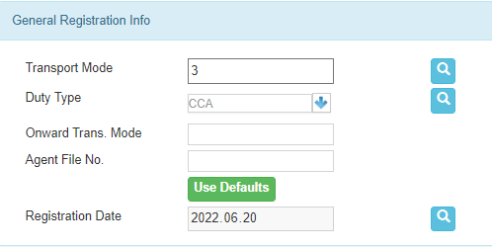
  - Please leave the above as is
  - 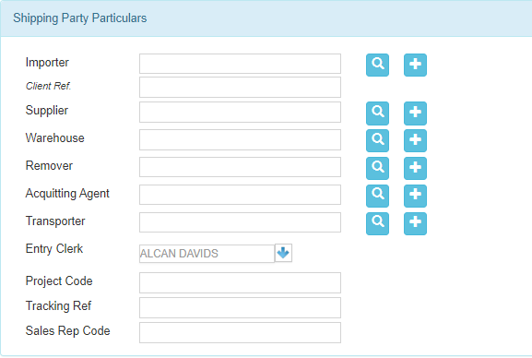
  - Please leave the above as is

  - 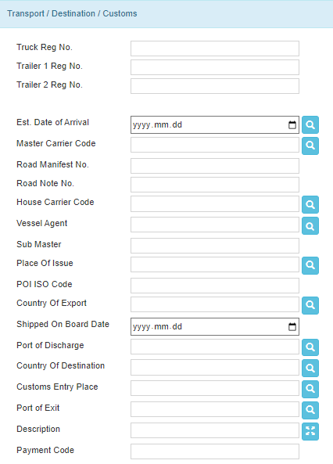
  - Please leave the above as is

  - 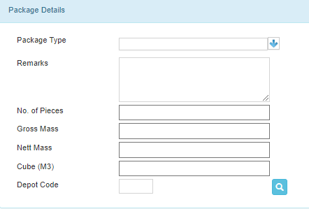
  - Please leave the above as is

  - 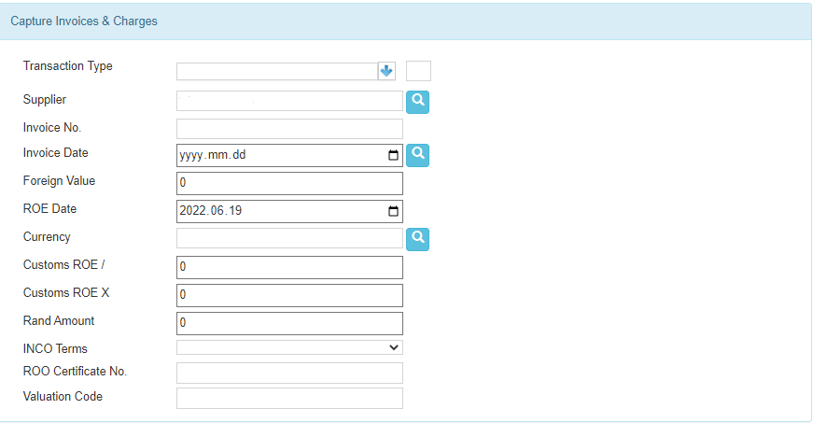
  - Please leave the above as is

  - 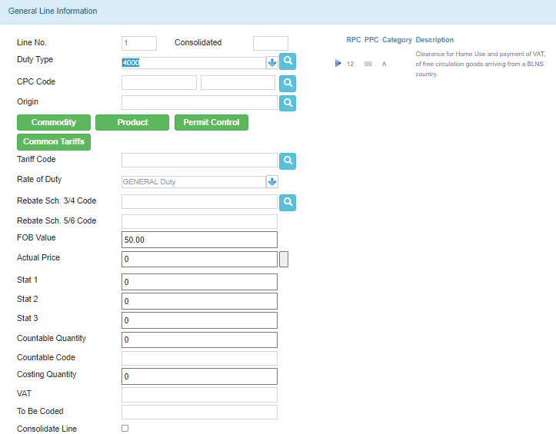
  - Please check if the following matches the re-export declaration:
    - Country of Origin
    - Tariff Code
    - Number of Parcels
    - Weight
  - If the abovementioned points match, proceed to the run the worksheet
    - 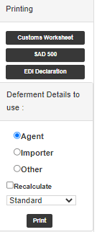
    - To calculate worksheet, double click on Customs Worksheet as indicated on the picture above.
    - Click Print as indicated
    - Verify that the FOB Value is correct and as per the total value on the invoice.
    - Close the worksheet once verified.
    - 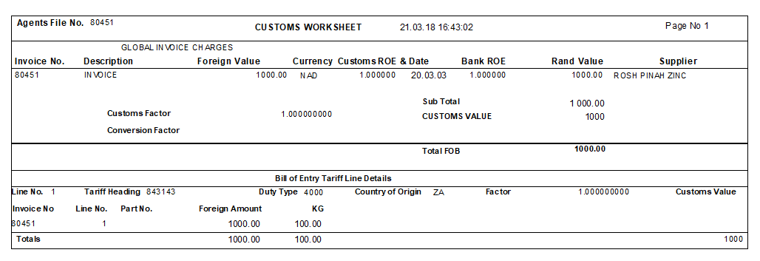
  - Proceed to create the SAD500
  - Click the SAD500 button as indicated below
  - The below screen should appear.
  - 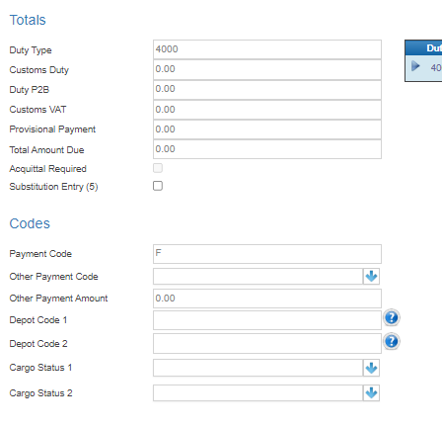
  - The Provisional Payment and Total Amount Due should be blank
  - Leave everything else as is
  - Scroll down to the below – Financial Information
  - 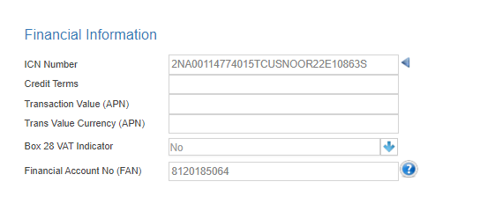
  - Insert the UCR Number found on the Import declaration
  - Add in the Financial Account No as per the above image
  - Leave everything else blank
  - Scroll to the below – Voucher of Correction Details
  - 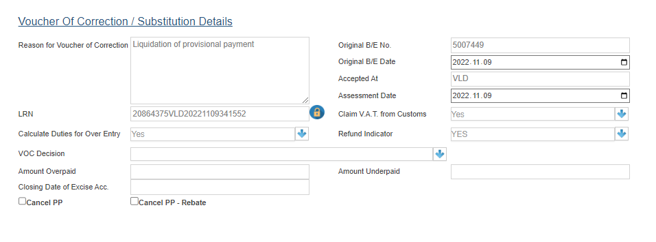
  - The reason for the VOC will be “Liquidation of Provisional Payment”
  - Click the Cancel PP block as indicated above
  - Click the Refund Indicator Button and select Yes as indicated above
  - Once Completed, please click Save and Print
  - It will then save and Print the VOC as per below

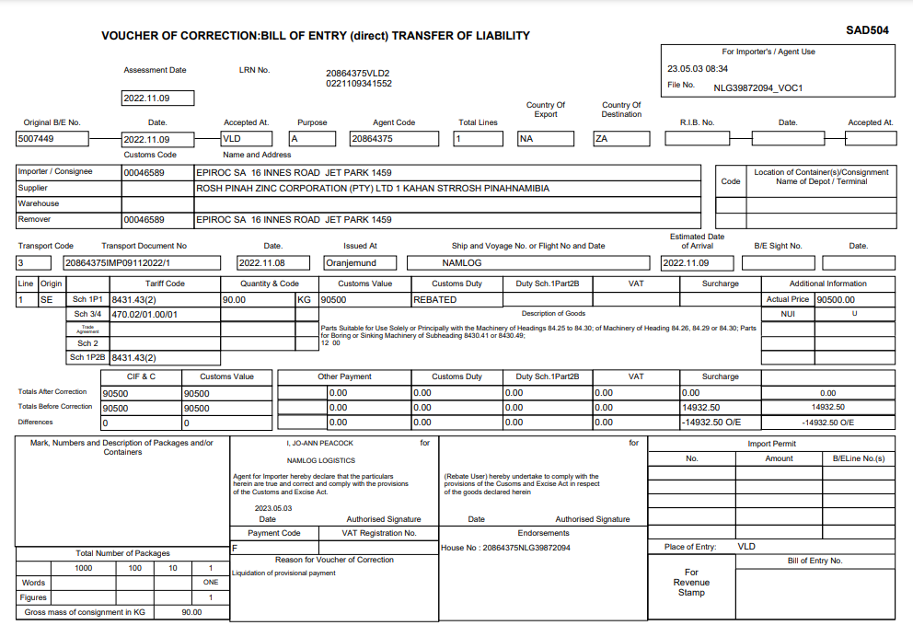
- Please check that the Refund Value matches the Provisional Payment amount as indicated above
- If in order, proceed to submit the VOC via EDI

- The VOC will be document queried by SARS (Code 33)
  - The following documents will need to be uploaded to SARS Via the Easy Clear system
  - By clicking the below Supporting Documents button, please upload the following:
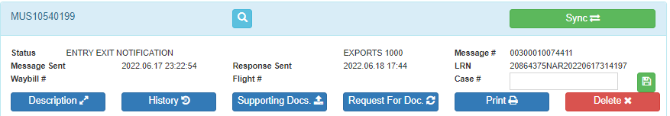
    - The Voucher of Correction created
    - Import Invoice
    - Re-export invoice
    - Import SAD500
    - Re-export SAD500
    - Import Release Notification
    - Re-export Release Notification
    - Proof of Payment for the Provisional Payment made to SARS
  - Once the documents have been uploaded, monitor the SARS response until the Case has been closed
  - Once the Case has been closed, the refund will be issued to you within the next 1-3 months

