Purpose:
The purpose of this document is to ensure the correct process is followed in the case of an Alarm Notification received on the What’s App Group created.

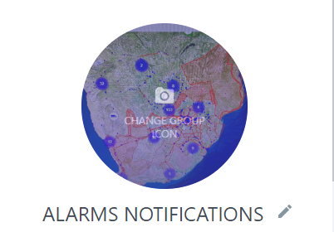

This SOP is in line with the Mix Escalation SOP
- NAM-SOP162-V001

Role Players
- Control Room Operators
- Divisional Managers
- Operations Managers and Supervisors
- Risk Manager
- Operations Director.
- Once Control Room Operator has logged into Mix, ensure you open streams (Notifications).

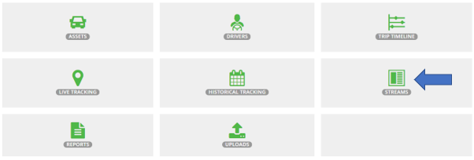
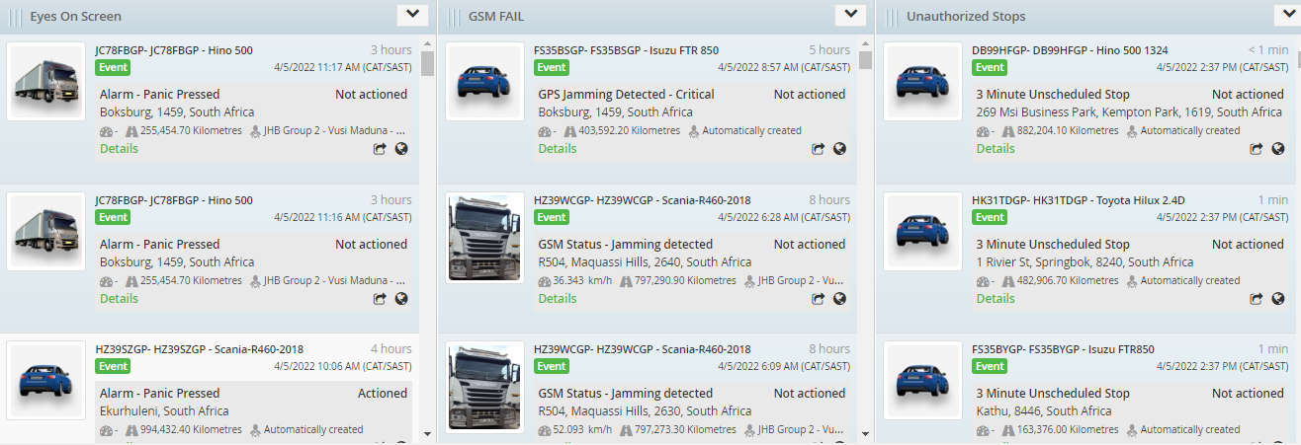

- For the purpose of the Group created the Controllers will only post the following Alarm Notifications on the group.
- Panic Button Pressed.
- Battery Disconnect.
- Power Down Alert.
- Dash Tamper Alert.
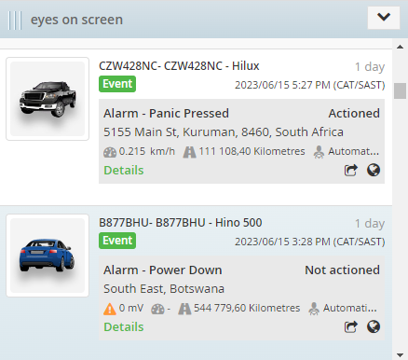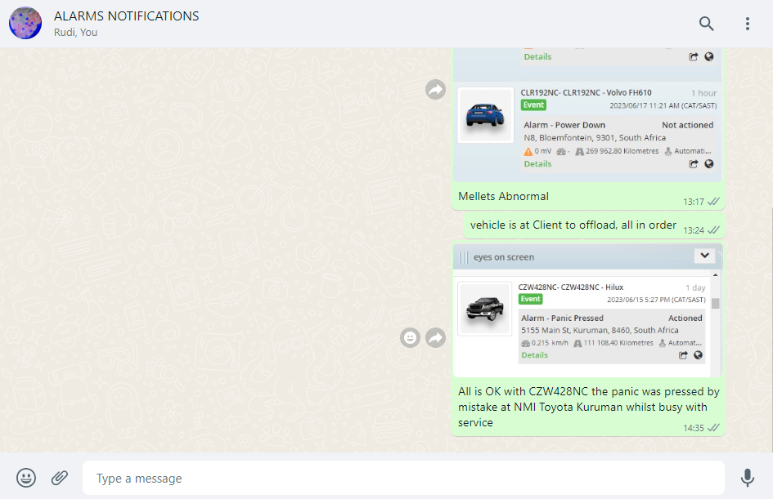
- The posting of these alarms on the Alarm Notification What’s App Group is the sole responsibility of the control room operators.
- The notification MUST be posted immediately upon receipt of the notification on the stream’s platform to the Group for the Managers to see and act upon whilst in the 07h00 to 19h00 timeframe.
- During the hours of 07h00 in morning to 19h00 at night it is the sole responsibility of the Divisional managers and supervisors to monitor the group for any new updates related to their vehicles under their fleet, they will need to call the driver and obtain proper details from the driver to be able to report back to the control room on each alarm received.
Work on the 5 W’s scenario
Who / what / where / when / why ?
Example:
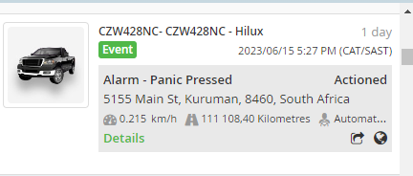
WHO - Mechanic
WHAT – vehicle is in for a service
WHERE – Toyota Kuruman
WHEN – vehicle at service Centre since 14th June 2023
WHY - Full Service history

All above need to be provided and send back to the control room on the group within 5 minutes of the notification been posted.
It will be the control room operators’ duties to follow up if no response was received on the group in the 5 minutes as they need closure on the Streams link of Mix Telematics within 10 minutes as per their SOP.
Alarm received note captured and closed
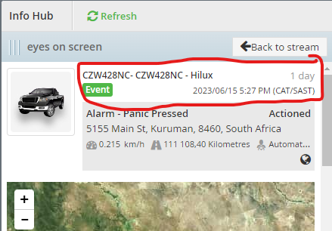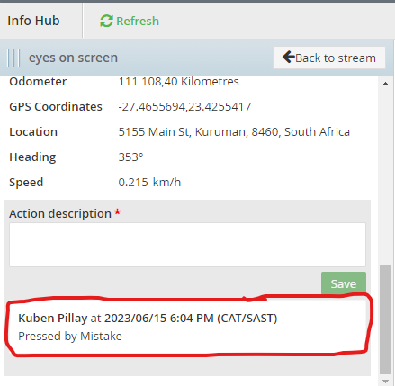

The controller will use the response from the manager on the group to add it to the task bar on Mix Telematic platform as seen in above comment.
The controller must post the name of the manager next to the post as reference to who provided the feedback
The driver Aaron pressed the button by mistake when he tried to get his cell phone from the dashboard when it fell, and he grabbed it. – as per Rudolph from SBK.
The time frame of these notifications and responses will be reviewed at KPI performance level and will affect the individual that was responsible at the time to act and respond within time, this include the manager, supervisor and controller who posted the event.

The controllers need also to bear in mind that Mix Telematic will contact them in regard to the alarms received to obtain information regarding those events triggered and need to hand over proper information back to them, for Mix to know if they need to close the event by them or to send recovery team out.

Where the information was not available at the time to stipulate to Mix to call back after 5 minutes, so that the controller have the information available from the manager when they call back.

The managers need to follow the rules of the questions set out in the Mix Escalation SOP as referred to above, for each Alarm notification.

In the event an Alarm notification was received during the hours of 19h00 at night to 07h00 the next morning (nightshift).

It will be the sole responsibility of the control room to Post it on the group, attend to those alarms within 5 minutes and will provide detailed feedback on the group as per normal SOP required.

Example of alarm:
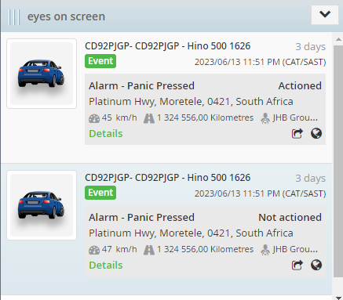

Example of feedback:
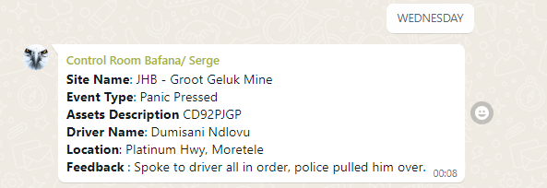
This Group and the notifications of the alarms received is a supporting tool for the monthly reports that is being sent to the managers and will be able to be used when asked about the alarms received during the month.

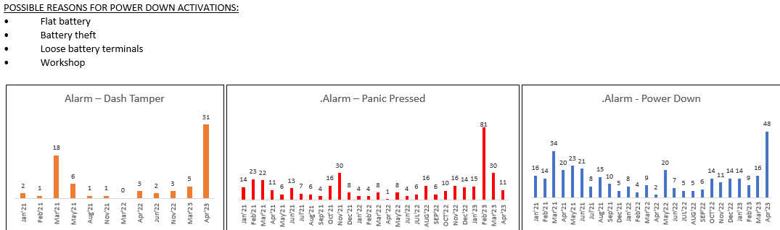

The managers will now be able to refer to answer for those alarms and the quantities of those alarms.

Why so many?
What has been done to reduce the notifications?
Proof of such action taken
- repairs booked a faulty devise.
- drivers addressed regarding the quantity of alarms pressed unnecessarily.
- Drive cam footage reviewed related to alarms pressed due to been stopped by Police.

