PURPOSE
The purpose of the Clearing Cash-up Standard Operating Procedure (SOP) is to align the Clearing team on expectations pertaining to the cash-up of documents process prior to handing over documentation to the Linehaul driver to dispatch to the border. Also, to ensure all queries are directed to the correct individual. The SOP must be utilised as a guideline for all Clearing staff. This is to ensure delays are mitigated as far possible and limit any risk of financial loss to the company.

SCOPE
The SOP is applicable to Clearing team directly and indirectly involved with the dealing of documentation handed over to the Operations Managers/Linehaul drivers prior to the vehicle departing to the border. Clearly defining the process and expectation in which the process flow and dealings must be conducted. The SOP details to the clearing team in specific, Supervisors verifying the documents, of the standard to follow.

Process
Document Cash- up: Refer to Cash-up Control Sheet.
Figure 1
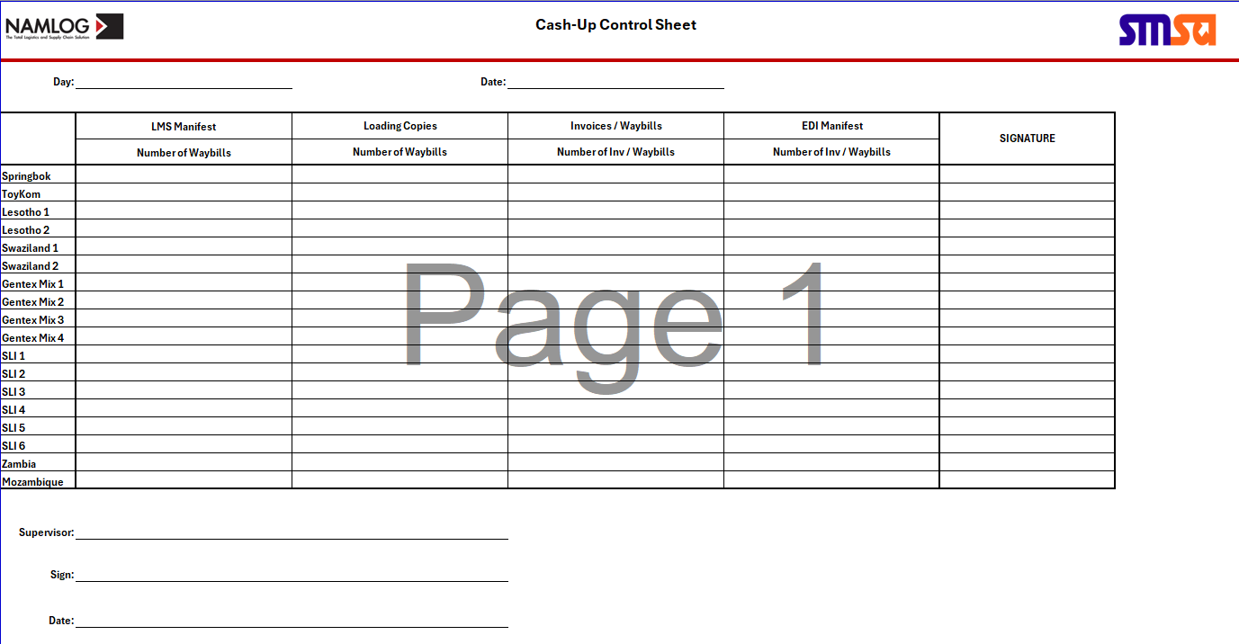

Cash-up must be conducted as stipulated:
- Upon receipt of the last loading documentation from Linehaul, the supervisor on duty must verify that all documentation corresponds using the Cash-up template.
- The supervisor must print 2 copies of the LMS manifest and the EDI manifest.
- Documentation must be please on 4 piles in the order stipulated on the Cash-up Sheet.
- The supervisor must verify that each waybill number reflects on the LMS and EDI manifest by utilizing the waybills and invoice documentation, ticked off on 1 copy of the LMS manifest and 1 copy the EDI manifest.
- The supervisor must verify that that each waybill was issued a loading copy and that the loading copy was received back signed by Operations, including loading position.
- Once the manifests have been verified and balanced, the final numbers must be written on the Cash-up Control Sheet.
- The control sheet must be signed by the supervisor conducting the verification and attach the verified LMS and EDI manifest to the control sheet.
- This should be completed per over border vehicle departing from Namlog as stipulated on the control sheet.
- The control sheet and supporting manifests (LMS and EDI) must be scanned and saved on the server, in the folder Clearing / Cash-ups / applicable month, and file name must be the date i.e. 2024.07.26
- The completed Cash-up Control sheet with addendums, must be placed on the Clearing and Forwarding Manager’s desk at the end of shift. Refer to figure 2.

Figure 2
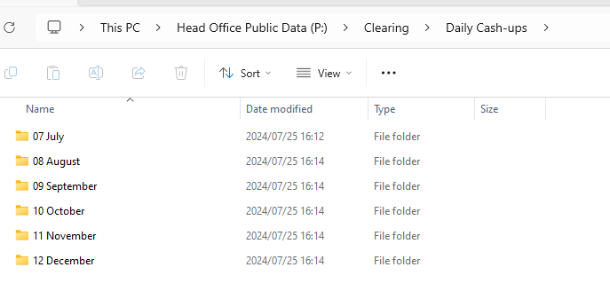

This SOP is implemented to ensure maximum efficiency and ensuring dedication to cut off times as stipulated in Linehaul Operations.

Operational and Clearing Contacts:
- Clearing and Forwarding Manager: 066 286 9987
- Customs Controller: 060 961 9038

