Purpose:
The purpose of this document is to combine the individual SOP’s that is set out for the control room. It also adds duties that was not specifically set out on the individual SOP’s.

All previous SOP’s is still in force related to their individual requirements.

The duties set out here in this SOP, will have reference to the previous individual SOP’s that was drafted and set out to perform and added daily duties not specified in these SOP’s.

SOP reference numbers.

- NAM-SOP037-V004- Duties when a Panic Button was received.
- NAM-SOP036- V004 – Mix Telematics updates of drivers’ details on the system.
- NAM-SOP038-V004- Loss of GPS signal
- NAM-SOP039-V005- Unauthorized Stops
- NAM-SOP049-V001 – Eyes on screen
- NAM-SOP162-V001 – Mix Alert Escalation Procedure
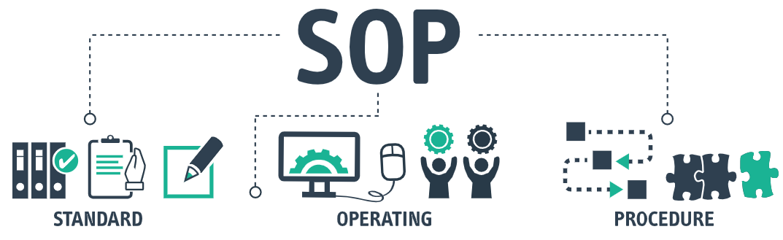

In this SOP the Control Room Operator will also be given the guidance and methods to improve their daily functions such as:
- Time and attendance.
- Office etiquette and hygiene.
- Telephone etiquette.
- Texting grammar.
- Email communication and escalation procedures.
- Correct Escalation Procedures in any event.
- Hand over at shift change.
- Daily Reports generation and distribution.
- Radio communication to Security.
- Booking out and monitoring the Mobile Tracking Devises (MOB)

- Time and Attendance
The operators will be required to be on time to take over from the previous shift and they will do a brief handover of the events that occurred during the previous shift.
Weekdays:

- Day shift of 07h00 to 17h00
- Night shift (first shift) 17h00 to 03h00.
- Night shift (second shift) 21h00 to 07h00
- LG & Epiroc day shift (07h00 to 19h00)
- LG & Epiroc night shift (19h00 to 07h00)

Weekends:
- Dayshift (07h00 to 19h00)
- Nightshift (19h00 to 07h00)

- Office etiquette and hygiene.

- Controllers need to clean up their desks before and after their shift.
- Controllers need to ensure their computer, keyboard, mouse and box are kept clean.
- Cutlery, plates and cups to be cleaned before leaving at the end of their shift and not to leave if dirty and lying around on the desks or bucket.
- Controllers to ensure the fridge is kept clean and old foods are disposed of in the outside dustbin.
- Daily rubble such as paper, plastics enc. to be thrown in the dustbin provided and ensure the cleaners comes regularly to clean it out.
- Controllers to ensure the cleaners come regularly to clean the desks and floor.
- No food or dirty plates and Tupperware is to be left in the microwave.
- Microwave to be cleaned by the controller if his food or drinks spilled over and not to leave it for next person or cleaner.
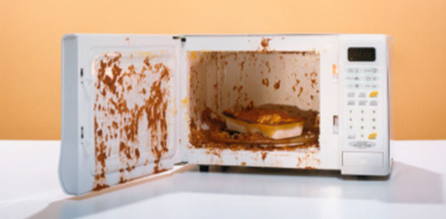

- Telephone etiquette.

- Controllers will be friendly over the phone.
- Controllers will speak English unless spoken to in their home language.
- Controllers not to use slang whilst speaking over the phone.
- Professional Greetings (Good day Namlog and Mellets how can we help ?)
- Controllers to listen attentively when answering or receiving calls to what the person is saying on the other side.
- Controllers not to eat, chew or drink / slurp whilst on a call.
- Controllers to ask the 5 basic principles of gathering information to have the sound knowledge of the call. Each call is different but to get the information to each call can be obtained by these 5 principles when asking questions.
Who
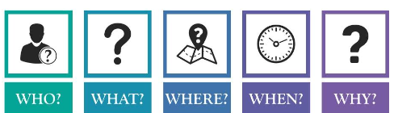
What
where
When
Why / how



- Texting grammar.


- Controllers to ensure when texting on the relevant groups that the grammar is correct, the format is correct, spelling of the Towns or Business names is correct, spelling of events is correct.
- Updates on the groups need to be in one text bracket and not individual texts per vehicle.
- Sequence of routes to be correct. Start first with Head Office to the related Division, return route then individual routes. Keep all vehicles headed in same direction together and not to mix it up.
- Controllers to keep the sequence of the texting to not get confused as to the directions the vehicles are travelling.
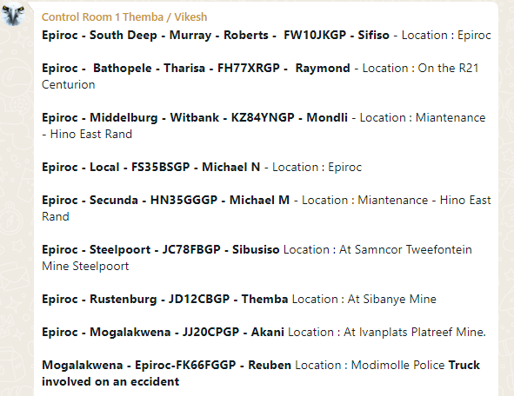
- Email communication and escalation procedures.

- Controllers to ensure to be always professional when communicating on email to employees, clients, suppliers or public.
- Ensure spelling is correct in the sentences and grammar of those sentences.
- Controllers to ensure that the mail to be send is addressed to whom it is attended to and not to send to wrong recipients.
- Be direct to what you are requesting or has sent to the recipients in the subject line and on the mail message.
- Refrain from using nick names, abbreviations of names or words.
- Controllers to ensure if an escalation is done on mail, the direct recipients are on the name and their managers to be included in the CC subject line of the mailbox.
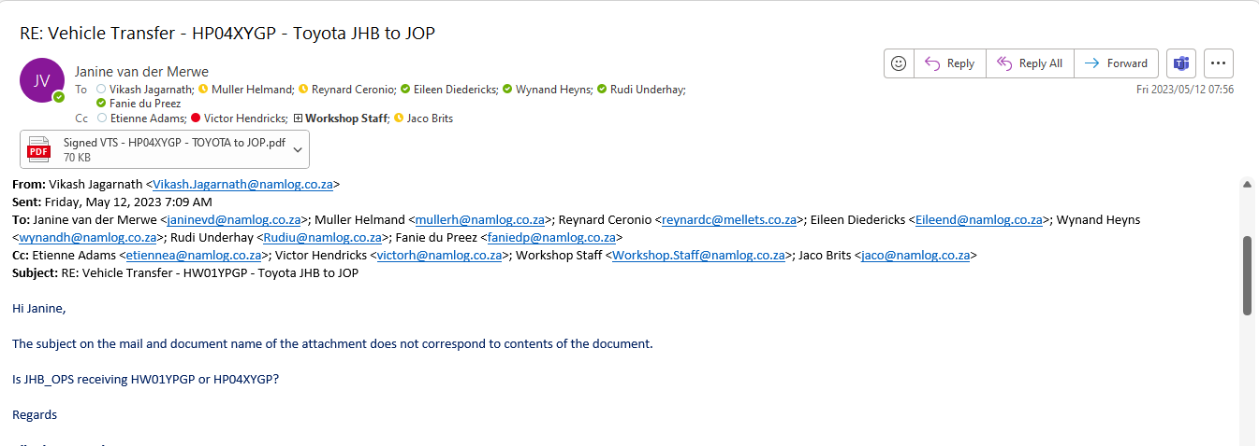

- Correct Escalation Procedures in any event.

- Controllers to ensure they follow the escalation list as provided in the relevant SOP’s for the relevant notifications.
- Controllers to send a text message to the manager on duty at the time regarding the event and await his response if no response in 3 minutes or in an event of an emergency to contact the manager directly to provide the relevant information and gather the feedback / response to be able to send the feedback to the Risk Manager.
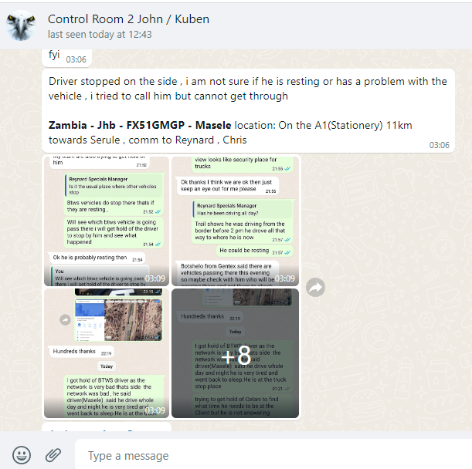
- If the manager doesn’t respond to text or calls, to contact the next manager on the list, prior to going to senior management and executives.
Remember the senior manager or executive will ask you if you contacted the managers prior to him and what their response were.
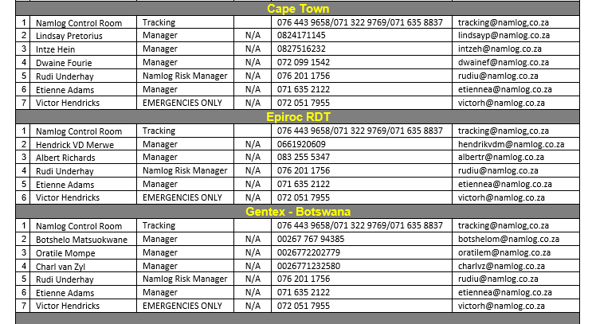

- Hand over at shift change
- Controllers need to be a few minutes earlier to discuss with the previous shift on the events that occurred on the shift, from breakdowns where vehicles are still on scene, drivers resting and times to depart. Special instructions such as to closely monitor specific vehicles due to concerns flagged.
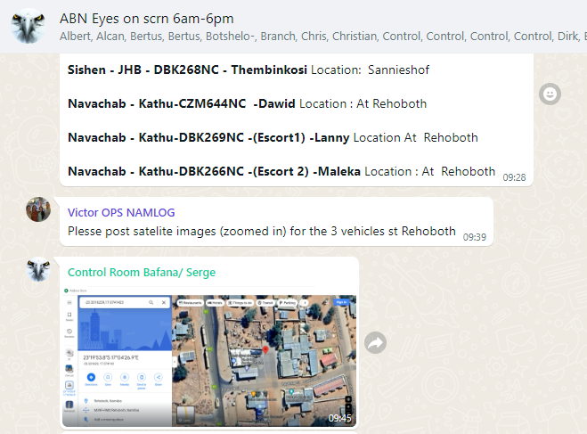
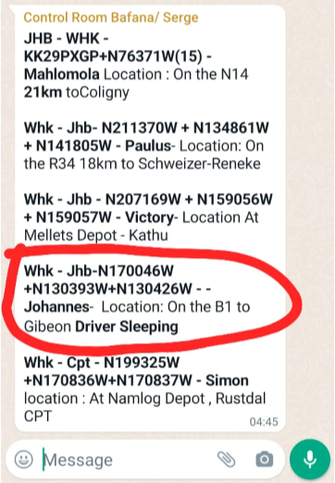
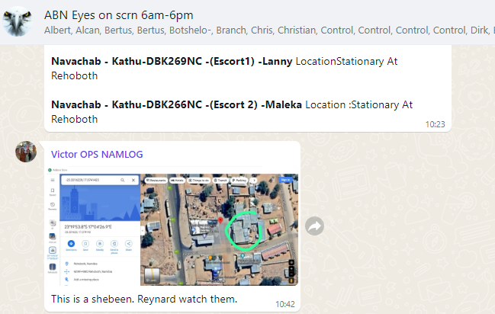
The purpose of this hand over is for the new controllers that is coming on shift, to know what the status of those events is, to be able to respond to queries immediately and directly without delay or hesitation to find out first.
It is time consuming, looks unprofessional and affect operations.
- Daily Reports generation and distribution.

- Dayshift controllers are required to send multiple reports to all the divisional managers and executives as per below list of examples.
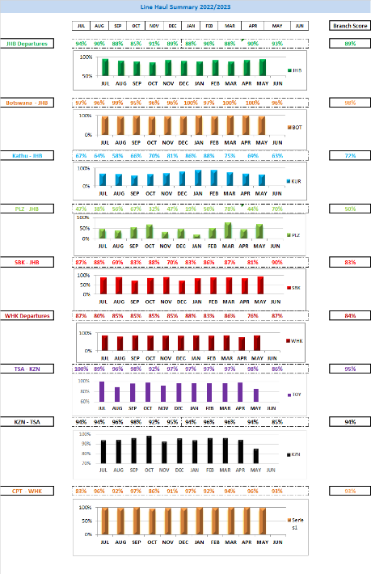
- Speeding Reports
- Cross border Tracking Updates (Zambia, enc…)
- Line Haul Report
- No Tag Report
- Scoring Report
- Daily Movement Report.

- Email distribution need to go to the designated recipients and ensure those not required to be removed.
- Below is example of mail where members were not removed that is not required to receive the relevant mails.
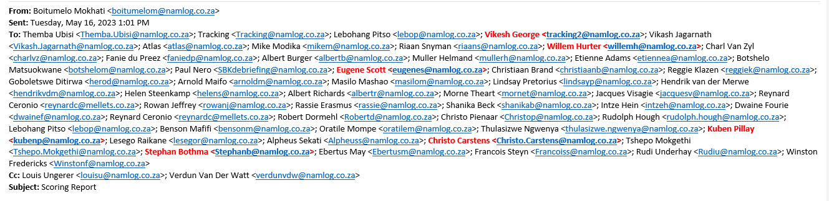
- Radio communication to Security.
- Controllers has been issued with a two-way hand radio and need to ensure it is always charged, working and loud enough to hear, not switched on silent.
- Controllers and the security at the gate will be required to be in contact with each other, to provide information about Company vehicles entering and exiting to ensure it is recorded on the relevant groups assigned to that vehicle and route.
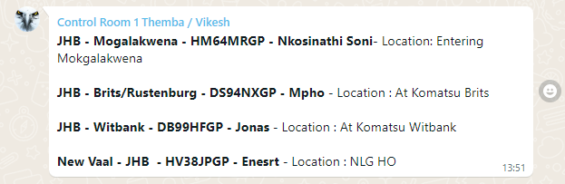
- Communication on the radios will be in English.
- The security will notify control of the following information for them to verify and capture correctly.
- Vehicle registration numbers, including the trailers registration numbers.
- Driver’s name and surname
- Destination
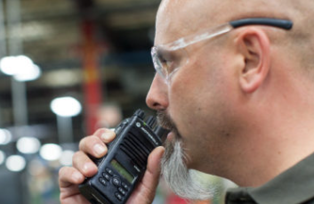

STANDARD OPERATING PROCEDURES AS PER PREVIOUS VERSIONS
- Booking out and monitoring the Mobile Tracking Devises (MOB)

- Control room operator will ensure the Mobile Devises are fully charged.
- Control room operator will ensure prior to issuing the managers the devise that is updating correctly on ACM Tracking Portal.
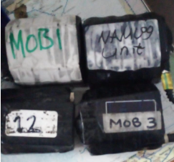
Date and time is correct
External battery is full
Internal battery is full
- Controller will record the details on the white board when handing over devise to manager.
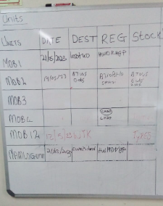
Date
Destination
Vehicle registration
Cargo (tires)
- Controllers to regularly check up on devise status whilst out on the delivery(route).
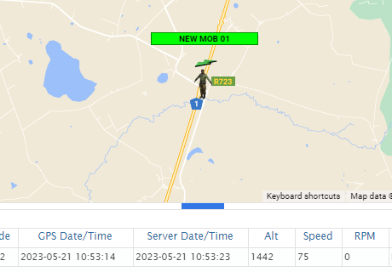
- Should a high jacking occur, and devise is separated from the truck and trailers to contact ACM immediately to dispatch recovery team.
010 591 8169
Record dispatch time and standing down time for billing purposes.
- Notify Rudi and managers to where devise was placed in set vehicle.
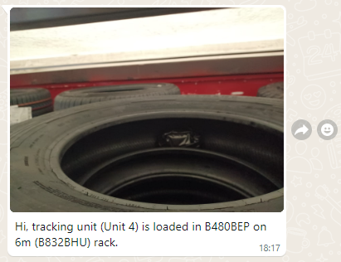
- Contact Police and provide Pin Location and reason for dispatch
Vehicle was hijacked, truck is stationary @ …… cargo is moving on ….. road
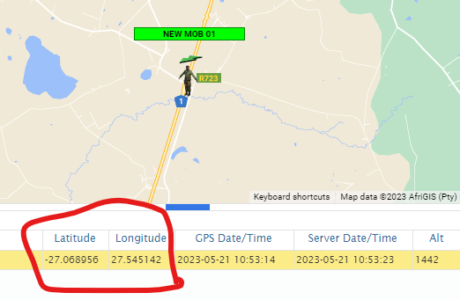
NAM-SOP037-V004- Duties when a Panic Button was received.
Once you’ve logged into Mix, ensure you open streams (Notifications).
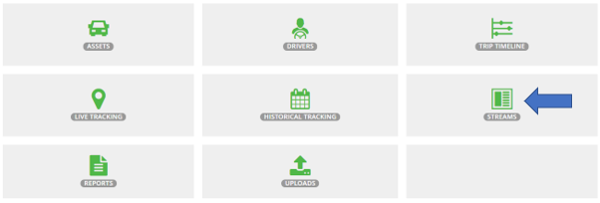

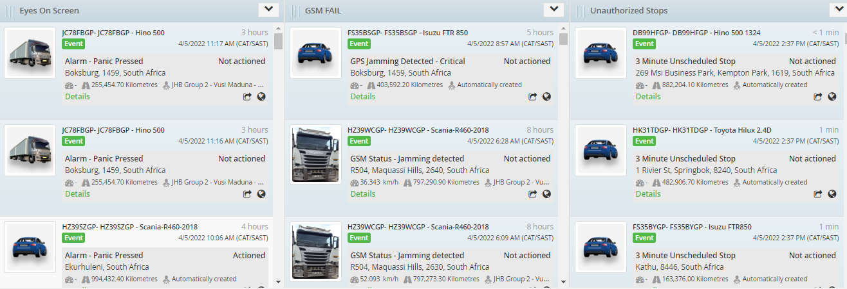

Panic activations will appear on the screen together with a sound notification that will be generated.
Mix Telematics will phone the control room to confirm if all is in order.
Phone the driver / drivers to confirm current situation.
- If Pressed by Mistake.

(Follow up with 1st contact point if Mix followed up). Send email confirmation to Business unit manager and HO Management as to why incident occurred.
Complete action on the MIX screen that panic action was attended to ensure short but informative details are recorded.

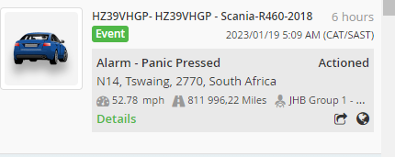
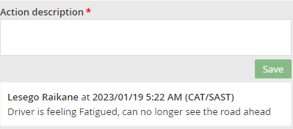

- Notification purpose.
Driver pressed button for notification purpose such as below examples.
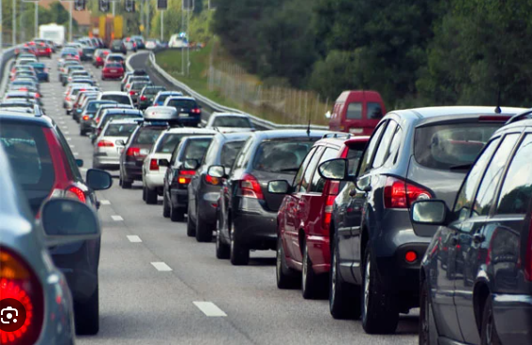
> Traffic congestion
> New stop and go – road construction.
> new road closure.
> Food or toilette stop.
Send email confirmation to Business unit manager and HO Management as to why incident occurred.
Complete action on the MIX screen that panic action was attended to ensure short but informative details are recorded.
Make notes to inform other drivers on route and where applicable to amend route, notify Business Management, Risk Manager about rerouting.

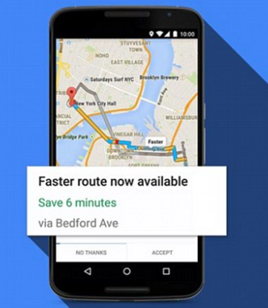

- Accident.

Contact driver to confirm on his status / injury. Inform driver to take photos of accident scene and damages, driver to obtain all 3rd party details for reference, if a 3rd party is involved;(Name, contact details, vehicle details) and photos of 3rd party vehicle, vehicle license.

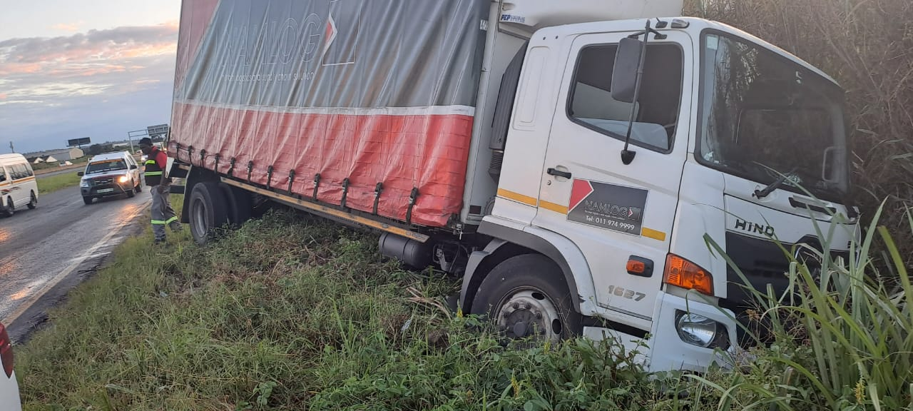

(Notify Business unit manager/your direct manager).
Follow escalation list and confirm if Mix followed up.
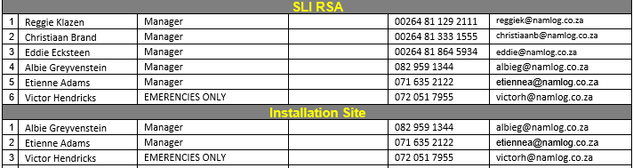
Contact SAPS to assist and attend to accident scene where serious injury or damages occurred.
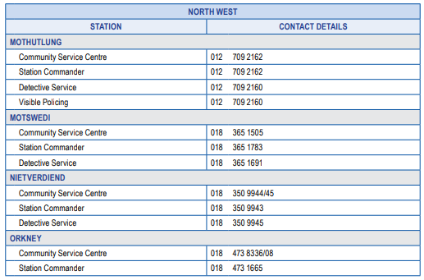

- Hijacking. Follow below. (Refer to Hi Jacking SOP)

If panic was pressed and a positive Hi Jacking verified with driver, or driver doesn’t answer calls after 3 attempts.
Notify Mix Telematics to dispatch recovery team, notify Business Unit Manager, Risk Manager.
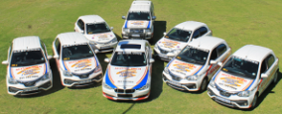
On Mix tracking, lock on asset to get constant location updates.

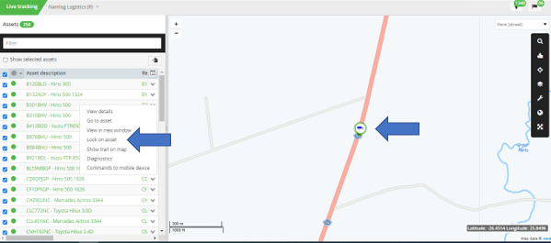

Activate Beame device.

Refer to the “SAPS contact details” under the shared control room folder and request assistance from the nearest police station.
Provide the officers with the necessary information to dispatch their team.
Vehicle make,
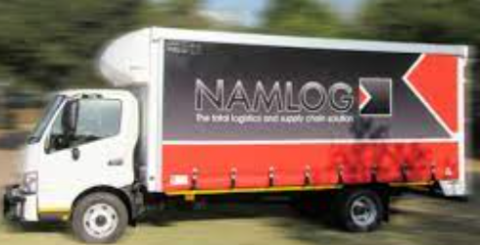
model,
color,
branding,
current location
direction,
Driver’s name, surname
contact details.
Ensure constant communication between control and driver.
Ensure constant communication between control with Mix recovery team, SAPS that is on route.
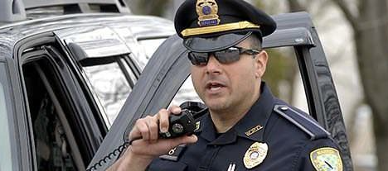

Provide feedback to Business Unit Manager, Risk Manager.
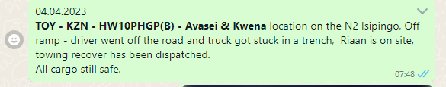

NAM-SOP036- V004 – Mix Telematics updates of drivers’ details on the system.
Purpose:
The purpose of this document is to ensure the correct process is followed when updating driver details on the tracking system.

- User will access Mix via the following link. Note this link is only compatible in Google Chrome.
https://za.mixtelematics.com/#/login

- The User will be asked to enter his username and password.
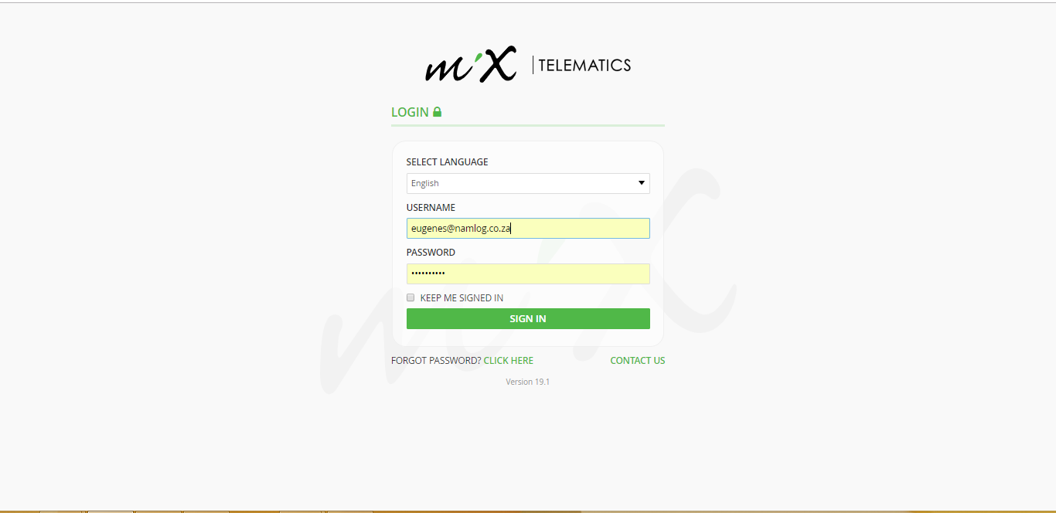

- Once logged in, navigate to “DRIVERS” screen.

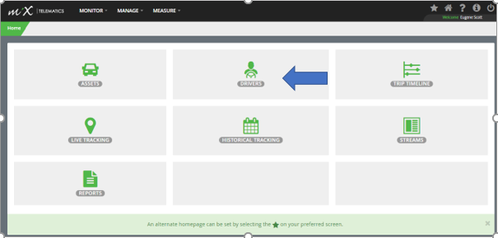

- The User will now have access to all drivers, allocated to his specific business unit.

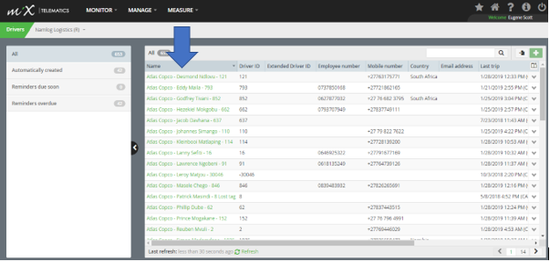
- The user will now need to identify the specific driver by clicking on the driver’s name. The user will be directed to the information page based on the specific driver profile.
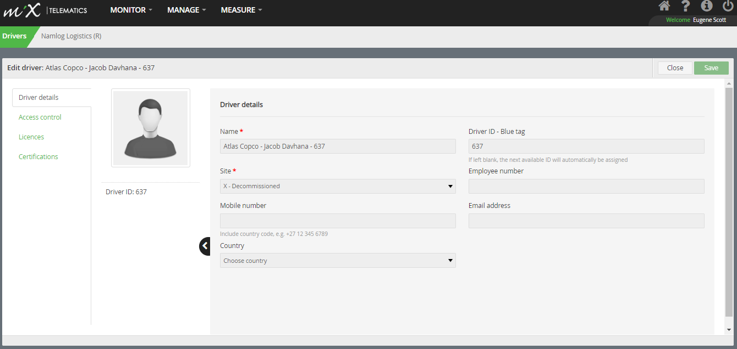
- The user will need to update the driver’s mobile number in the
“MOBILE NUMBER” section as seen below screenshot. A Secondary number can be added in “EMPLOYEE NUMBER” S
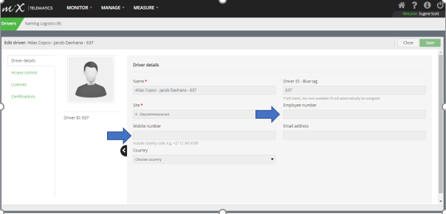
- Once driver details are updated select “SAVE” top right corner.

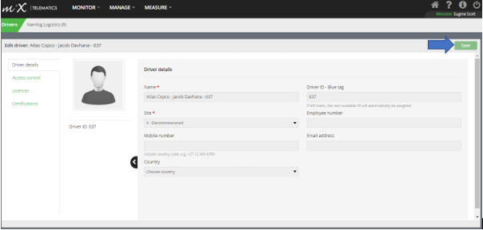

Return to main screen.
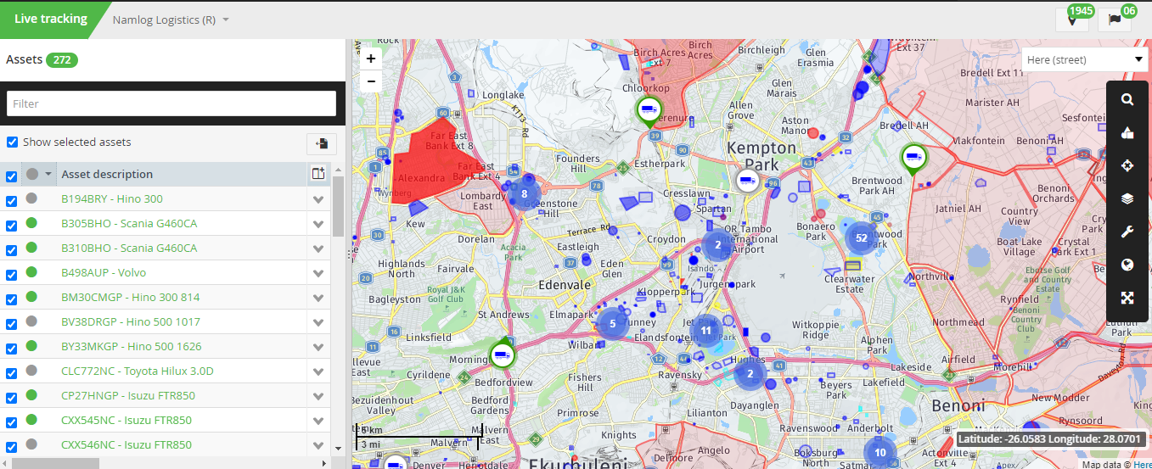
NAM-SOP038-V004 Standard Operating Procedure Loss OF GPS

Once you’ve logged into Mix, ensure you open streams (Notifications).

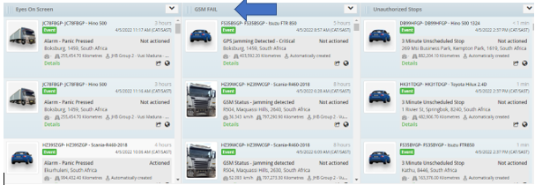

GPS Jamming events will appear on the screen together with a sound notification that will be generated.

Refer to the map and see if the vehicle icon changed to Orange. This is an indication that the vehicle lost GPS connectivity.
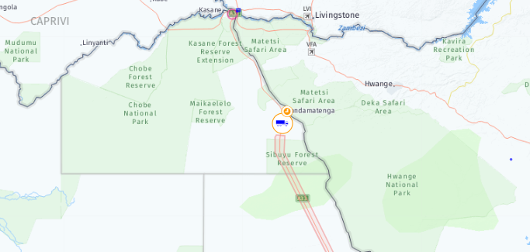

On Mix tracking, lock on asset to get constant location updates.

Ensure to phone the driver first, to get an updated location.
- If the driver’s contact detail is unreachable, contact his manager for alternative contact details.
- Phone the driver again after 5 minutes due to possible Dead spot (No signal areas).
- See if there are any other vehicles nearby to go and assist to have additional eyes on, especially if vehicle was stationary for a period of time, prior to signal loss.
- Escalate and dispatch the Mix ground unit immediately, if we can’t get hold of the driver after a few attempts.
- Activate the Beame unit.
Refer to the “SAPS contact details” under the shared control room folder and request assistance from the nearest police station.
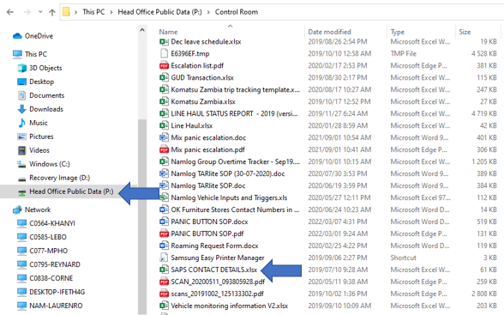

- Provide the officers with the necessary information to dispatch their team.
- Vehicle make and model,
- registration number,
- color,
- branding,
- drivers’ names,
- contact details,
- last location,
- direction it was travelling.
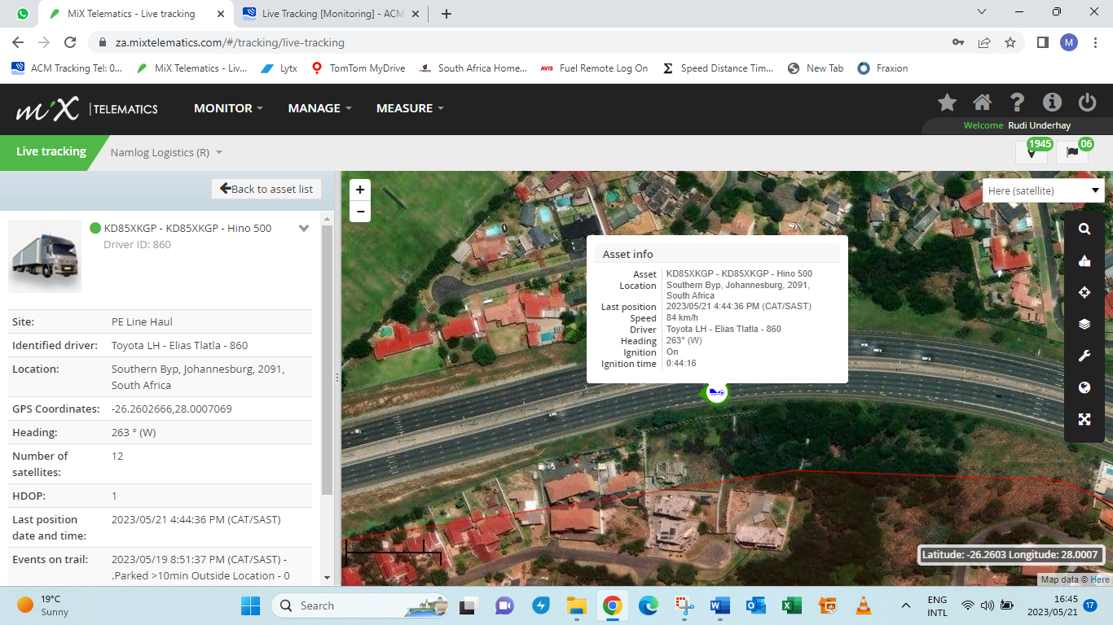

Escalate matter to both your manager/Business unit manager, keep them informed throughout until driver was reached, and all confirmed as in order.
Please ensure we cancel the ground unit should we get hold of the driver, capture dispatch time and cancellation times on related group for reference.
Ensure Alarm activation was actioned, a brief and informative note made on system.
Return to normal screen monitoring.
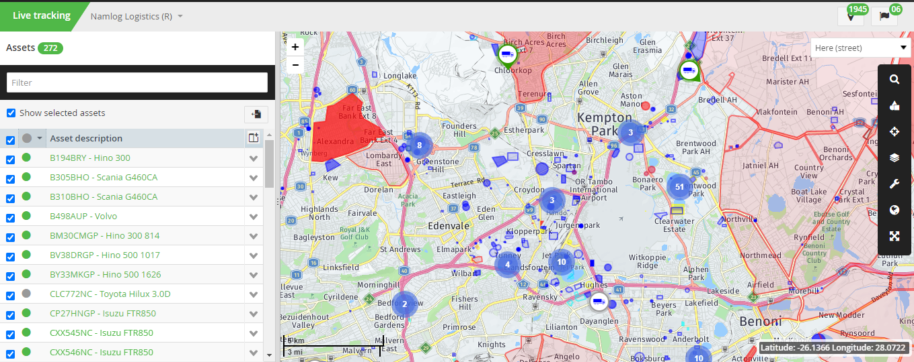

NAM-SOP039-V005 UNAUTHORISED STOPS / DEVIATION

Once you’ve logged into Mix, ensure you open streams (Notifications).

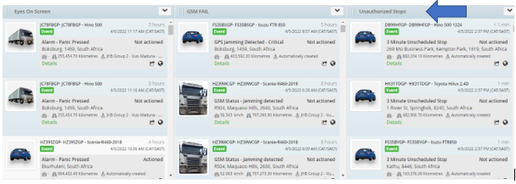

An unauthorized stop will occur when a driver stops for a period longer than 3min. A sound notification will be generated at the same time.

Monitor vehicle on the map and ensure that the vehicle is on the correct route.
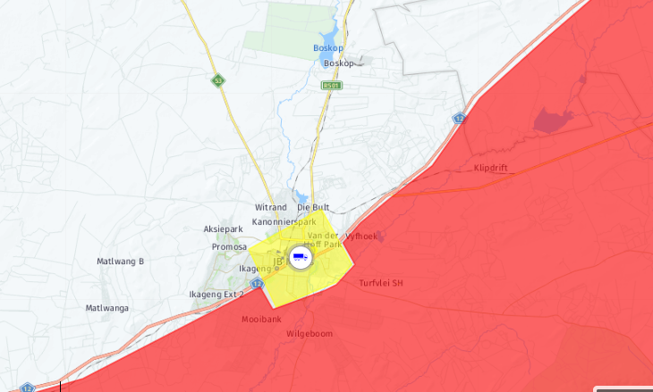

Phone driver to confirm situation. (At least 3 attempts.)
- Voicemail.
Escalate Immediately to his Manager, obtain alternative contact details.
- Accident.
(Notify Business unit manager/your direct manager). Follow escalation list. Ensure that Etienne Adams is also notified.
- Hijacking.
Follow below as referred to by Hi Jacking SOP

On Mix tracking, lock on asset to get constant location updates.

Phone Mix and report the panic activation/incident. “Deploy recovery team”.

Activate Beame device.

Refer to the “SAPS contact details” under the shared control room folder and request assistance from the nearest police station.

Provide the officers with the necessary information to dispatch their team.
Vehicle make,
model,
color,
branding,
drivers name and surname,
drivers contact details.
Last location
current direction of travel.

Escalate matter to both your manager/Business unit manager. 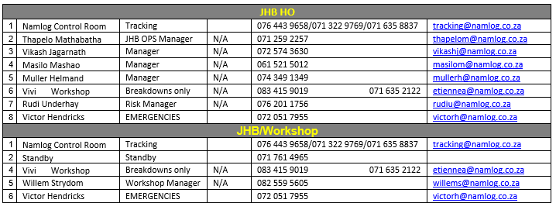
Ensure constant communication between control and driver.

Ensure constant communication between control, Mix Ground team and Police.
Update your manager and Business Manager regular on status of the case.

NAM-SOP049-V001 Standard Operating Procedure Eyes On Screen
Purpose:
The purpose of this document is to ensure the correct process is followed when providing all units with hourly locations updates.
Log on to WhatsApp Web. (Control 1/2/3/4)
https://web.whatsapp.com/
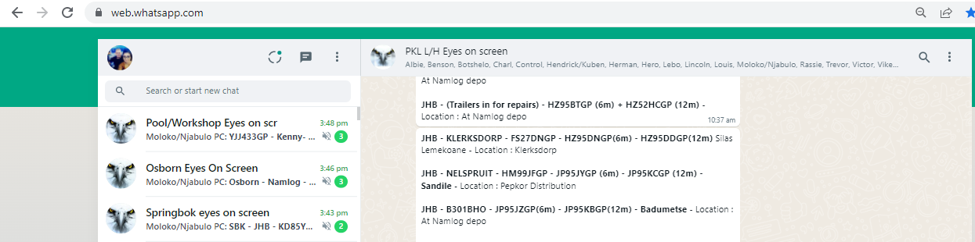
Each business unit will notify control once vehicles are scheduled to depart. This update will be done on the specific business unit group.
“Springbok Eyes on screen” etc.
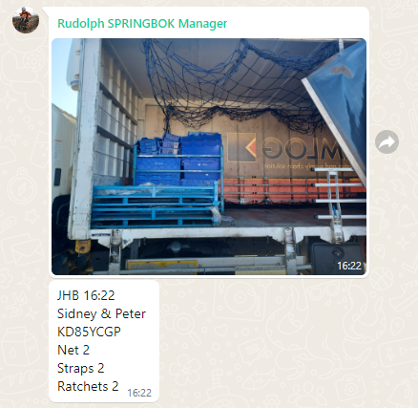
It is very important to make sure the details are recorded correctly, spelling and grammar is checked every time an update is made, to avoid confusion and providing incorrect / false information to management.
JHB -SBK – KD85YCGP – Pieter – Location: 25 km’s to Aggeney
JHB –SBK – KD58GCGP – Pieter – Location: 35 km’s to SBK.
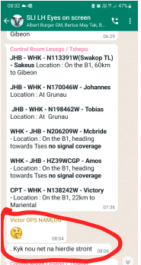

The following format will be used to notify control.
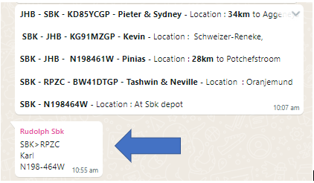

- SBK >RPZC (Destination)
- KARL (Driver)
- N198464W (Vehicle Utilized)

Control will start reporting on this asset once it departs the depot. Please refer to the example below.
Remember sequence must be kept the same as per below.

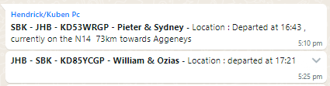

All assets need to be reported on, every hour until the trip is completed and back at the home base. Depart A / Deliver B/ Return A
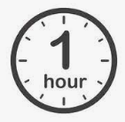

Line Hauls must be reported continuously even if returned at base.
Any issues during the trip duration need to be escalated to the business unit & Risk Manager, through what’s App, email and where applicable a call to be made to them.
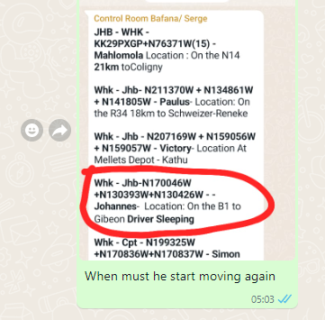

- P:\Control Room

NAM-SOP162-V001 – Mix Alert Escalation Procedure

Purpose:
The purpose of this document is to ensure quick and correct procedures are followed in the case of receiving a panic button alert, dash tamper alert, battery tampering alert and power down alert on SMS or E-mail.

Role Players:

- Control Room Operators
- Divisional Managers
- Operations Managers
- Risk Manager

Duties

Managers will receive an What’s App Message on the ALARMS NOTIFICATION group that was specifically created for this reason, they will also receive an Email notification, from Mix Telematics in the event of the following 4 important events.
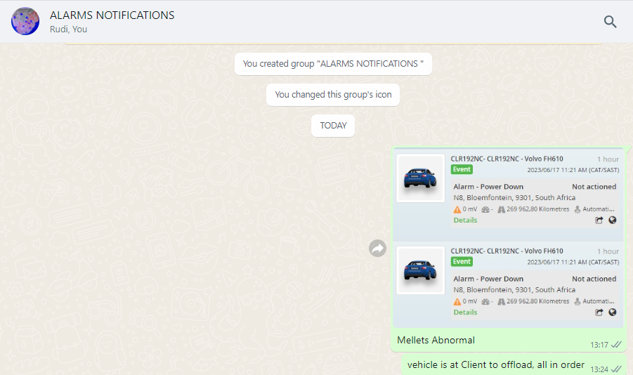
- Panic Button pressed.
- Dash Tamper Alert.
- Alarm Power Down.
- Battery Disconnect.

Mix Alert Escalation between 07h00 to 19h00

The Managers or Supervisors assigned to the group that is on duty between the hours of 07h00 to 19h00, will be required to monitor the group and look at the postings received from the control room to see to those alarm notifications related to the vehicles under their fleet. The Manager or supervisor will need to phone the driver immediately upon receipt of the notification, verify with the driver on the status related to the alarm received, in order to provide feedback within 5 minutes of the notification posted on the group, back to the control room, via a detailed text message regarding the alarm notification received.

The following questions will be required to be asked in the specific events triggered.
(Taking in mind to listen to the driver’s voice when he responds to determine if he might be in distress.)
Alarm: Panic Pressed
- Verify with driver – his vehicle registration number – the driver needs to provide it “Hello Samuel, it is (CONTROL ROOM) please confirm for me the registration number of the vehicle you are driving now!”
- Once verification done to ask! “Samuel what is wrong? I see you pressed the Panic Button.”
- Wait for his response; if response is that he pressed by mistake; to ask him “please explain how you pressed the button by mistake?”
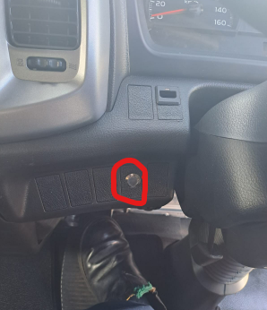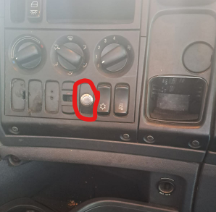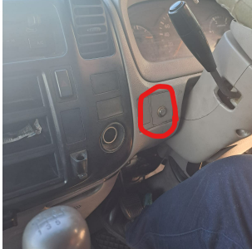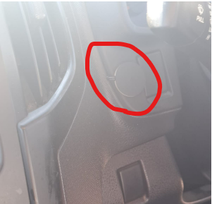
All Panic buttons are placed in a safe reachable distance and away from the normal movement when entering or exiting a vehicle, so drivers should not be able to press buttons by mistake.
Alarm: Panic Pressed
- Verify where driver is and confirm direction of travel.
(20 km’s before Rehoboth direction to JHB)
- Confirm with driver where is his next stop. (Client) should driver give wrong details he might be in danger, and cant talk.
- Where in the managers opinion, he can ask the driver to reboot the dash cam by pressing the two buttons for about 3 seconds until lights flashes, to have footage for this event captured.
(if driver say he cant press it now, he might be in danger and use that information. To escalate to control room.
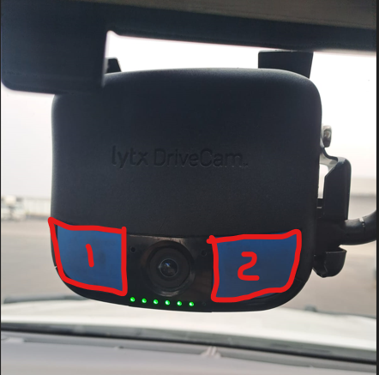
- Once verification done that all is in order with the driver, to contact the control room to inform them of the outcome.
- Should driver have pressed panic for non-emergency related matters, the driver needs to be addressed to this as it is not a please call me button, panic button is for the below specifics reasons to be used only.

> hi-Jacking
> Theft out of or from vehicle
> accident
> Roadblocks or closures (construction or public unrest)
> if any Police Pulls vehicle over, Police/Metro/ Highway Patrol
Drivers has used the panic button as a please call me for giving messages to managers, telling control room they left documents behind to hand over to managers, asked managers to call them back, enc…. This is not allowed and needs to stop.
- Should driver not answer calls after 4 attempts, directly after each other, to notify control room immediately as the driver might be in danger.
- Control room will notify Mix ground team and nearby Police to the situation. If manager do get hold of driver afterwards, to provide feedback to control room of situation.
- Control room will provide feedback to the Police and Mix Recovery team about situation such as look out while responding to scene, example: how many suspects, vehicles, directions, accident, any injuries, or to stand down and say driver is OK.
- If it determined the panic is faulty to notify control room to escalate and book a repair as soon as possible. Managers needs to keep track and still contact drivers on every panic notification to ensure safety of driver, vehicle and cargo until vehicle returns safely and back to branch, and repairs can be done.
- Vehicles will be grounded until panic button has been repaired.
These telephone call must be done immediately and feedback to control room in 5 minutes of receiving the notification.
See illustration of the What’s App message that will be received on the Alarm Notification Group from Control room.
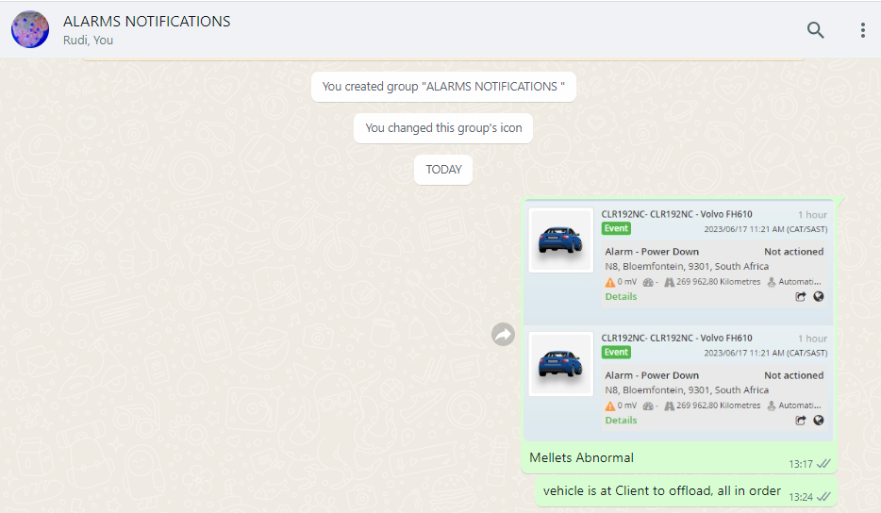

Alarm: Dash Alert Tampering and power down.
(Taking in mind to listen to the driver’s voice when he responds to determine if he might be in distress.)
- Manager to contact driver directly; verify with driver to which vehicle he is driving – numberplate verification.
- Ask driver if he is driving or stationary and on what road is he currently and the condition of the road.
- Where a concern arises from drivers’ response and voice, to ask the driver to press the two buttons on the Drive Camera to do a force download – keep buttons in till the lights flash.
(+- 3 seconds)
- Manager to provide feedback to the control room to above verification.
Driver Samuel in HZ39VHGP, dash tamper alert, driver was contacted, he is driving on N12 20 KM’S before Benoni, all in order.
Manager to record time of notification to go and review dash camera footage to determine if further action will need to be taken, once reviewed to report back to Risk Manager with findings.
Below is an example of the dashcam footage to be provided on mail.
Image 2
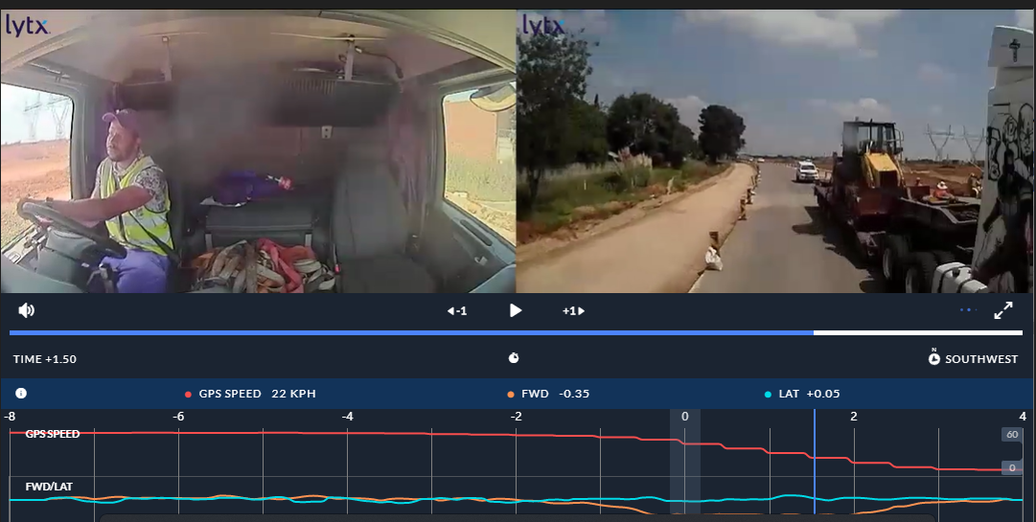

Alarm: Battery Disconnect.
(Taking in mind to listen to the driver’s voice when he responds to determine if he might be in distress.)
- Manager to contact driver directly and first question to ask is if he is driving or stationary?
“Hello Samuel! where are you now, and are you still driving?”
- Wait for his response and if said he is driving to ask:
“on what road, what is his current speed?”
- If driver is stationary; “are you next to the truck?” Then tell driver to go inspect the vehicle and go look at the batteries whilst keeping him on the line; do not end the call.
- Once above verification is done to escalate to control room and if needed to Workshop/ fleet if battery was stolen.
Control room to be contacted and stipulate the feedback as follow.
HV95RTGP had a battery disconnect, vehicle is at the dealership for service / Samuel in HV95RTGP checked battery and terminals are lose, it has been reported to Etienne / Willem / Fleet Controllers to fix upon return to branch.
- Driver needs to verify if battery terminals is tight by just moving battery cable at the terminal to determine if battery cables are tight or lose. If lose to escalate to workshop to fix upon return.
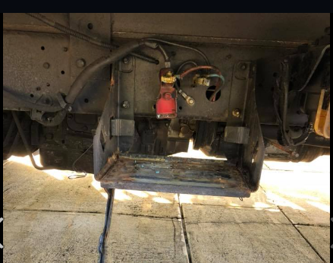
- Manager to request a photo from
the driver in the event of battery
terminals were found to be lose,
or if battery was stolen.

- If vehicle is at dealership for service – and known to manager, the manager must first confirm on tracking platform that the vehicle is there, contact control room and provide feedback. HV95RTGP had a battery disconnect, vehicle is at the Hino dealership for service.
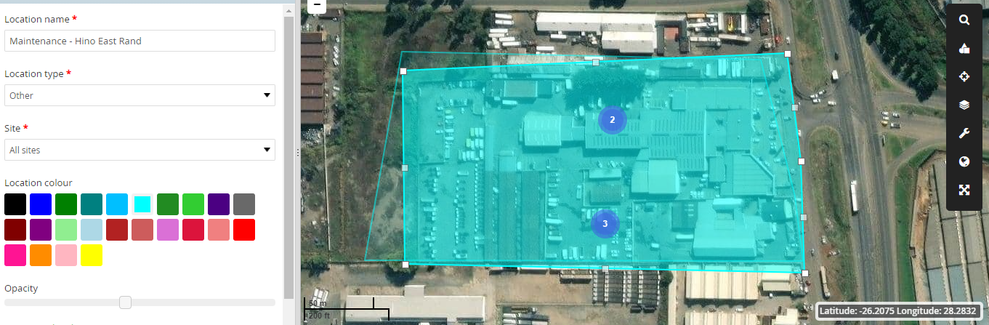

In any positive event such as a panic Alert received and driver was hi jacked, in an accident, stuck in roadblock, road closure or riot, to ensure control room is notified immediately, the senior manager of the division and Risk Manager.
Control room will take over, to dispatch relevant role players such as Mix Recovery team, Police, and any other emergency services. Control room will notify the rest as per Escalation list who has not been notified yet.
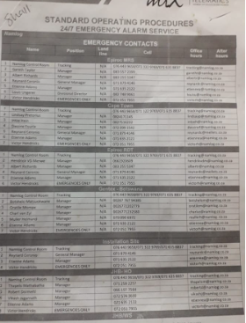

Mix Alert Escalation between 19h00 to 07h00 Night
During the hours of 19h00 to 07h00 the control room operators will monitor and respond to all alarm notifications as per normal SOP assigned. In the event of the below alarm Notifications the control room will still post the notifications on the Alarm Notification Group, but they need to call the drivers and report back and provide feedback on the group for the managers to see. When they review the Group for their assigned vehicles. Where a reported incident occurs, the managers will be called as well, as per normal escalation.
- Panic Button. Power Down.
- Dash Tamper Alert. Battery Disconnect.
The control room will contact the driver in the above events and ask the same questions as the managers should, the controller will then notify the relevant managers of the outcome via What’s App Group.
All must be actioned within 10 minutes after alarm received.
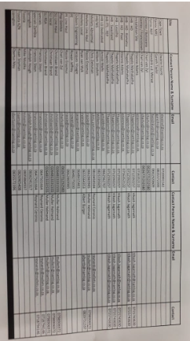

Alarm: Panic Pressed
(Taking in mind to listen to the driver’s voice when he responds to determine if he might be in distress.)
- Verify with driver – his vehicle registration number – the driver needs to provide it.
“Hello Samuel, how are you? please just confirm for me the registration number of the vehicle you are driving now!”
- Once verification done to ask! “Samuel what is wrong? I see you pressed the Panic Button.”
- Wait for his response; if response is that he pressed by mistake; to ask him “please explain how you pressed the button by mistake?”
- Verify where driver is and which direction he is going!
(20 km’s before Rehoboth direction to JHB)
Once verification done that all is in order with the driver, to send a what’s App text message to the relevant managers as per list provided, the message must be send within 5 minutes of the alarm notification received.

See example below:
Image 3
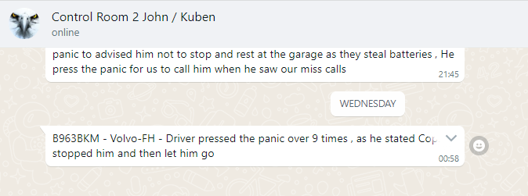
The telephone call must be done immediately of receiving the notification and must provide feedback to relevant managers within 5 minutes.
If driver doesn’t answer after 3 attempts, the normal SOP procedures are followed as per escalation list.

Alarm: Dash Alert Tampering and power down.
(Taking in mind to listen to the driver’s voice when he responds to determine if he might be in distress.)
- Control room operators contact driver directly; verify with driver to which vehicle he is driving – numberplate verification.
- Ask driver if he is driving or stationary and on what road is he currently.
- Ask driver to press the two buttons on the Drive Camera to do a force download – keep buttons in till the lights flash.
(+- 3 seconds)
- Control room to provide feedback to the relevant managers to above verification via what’s App.
Driver Samuel in HZ39VHGP, dash tamper alert received, driver was contacted, he is driving on N12 20 KM’S before Benoni, all in order, driver was asked to do a force download on the drive Cam cameras.

Alarm: Battery Disconnect.
(Taking in mind to listen to the driver’s voice when he responds to determine if he might be in distress.) Control room must have eyes on the vehicle when calling driver to verify his answers.
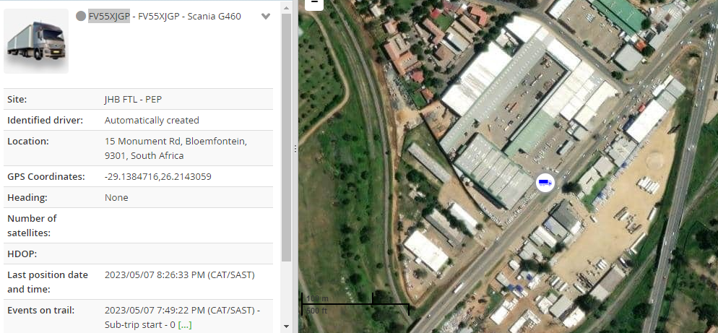
- Control room to contact driver directly and first question to ask is if he is driving or stationary?
“Hello Samuel! where are you now? And are you still driving?”
- Wait for his response and if said he is driving to ask: “on what road are you? what is your current speed?” “What condition is the road, good or poor?”
- If driver is stationary; “are you next to the truck?” Then tell driver to go inspect the vehicle and go look at the batteries whilst keeping him on the line.
MUST STAY ON THE LINE WITH HIM DURING THIS TIME.
Control room to provide feedback to manager on What’s App text:
Samuel in HV95RTGP had a battery disconnect, vehicle at the Total N2 Stop, battery terminals found to be loose. Driver advised to report to workshop on return. Fleet to be notified please.
If terminals are loose to escalate as per normal Escalation procedures after message the message was send to direct manager.
- Control room to request a photo from the driver if battery terminals are lost, or if battery was stolen. Once received to send to his managers and to Risk manager. Escalation process to follow.
- If vehicle is at dealership for service – the location must be verified as the dealership on Mix Platform, (Toyota Boksburg)
- Managers to be notified as there shouldn’t be a battery disconnect during these hours and notify the Police to dispatch a vehicle to investigate.
- Follow up regularly with Police until confirmation is received on vehicle status. (Positive battery stolen / negative vehicle and battery safe)
- Provide feedback to managers and Risk managers of outcome.

In any positive event that battery is stolen, the normal escalation process is followed.
All notifications done will also be send to Risk Manager, to who control room has notified, what their responses was and outcomes.
Example:
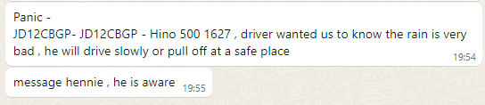

In any positive event the driver will need to go to the nearest Police station to report and open a case, the case number to be provided

