Successfully carry out the capturing of all cross-border waybills and the emailing of documents to the relevant clearing agents.

1. Capturing of waybills:

a. Waybills received from a collection placed:

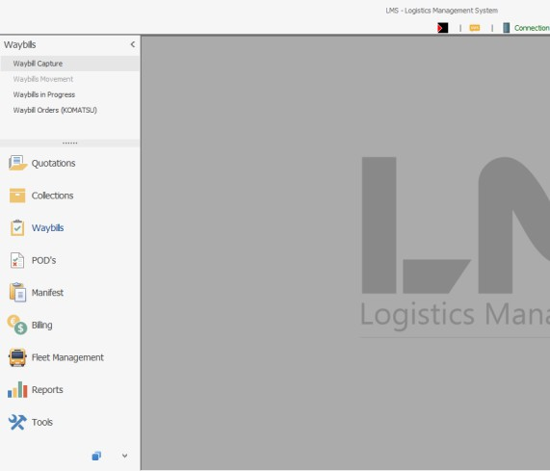• Click on Waybill Capture on the LMS system

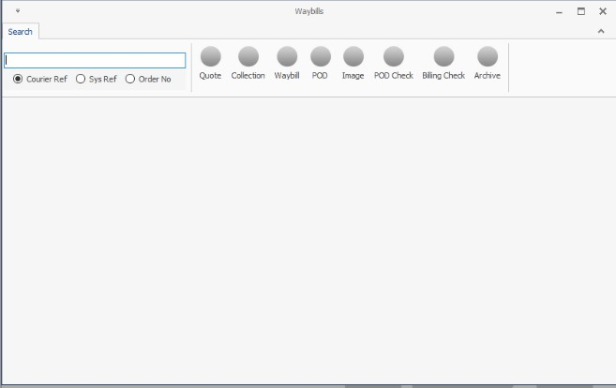• Scan or manually type the waybill number into the field indicated below

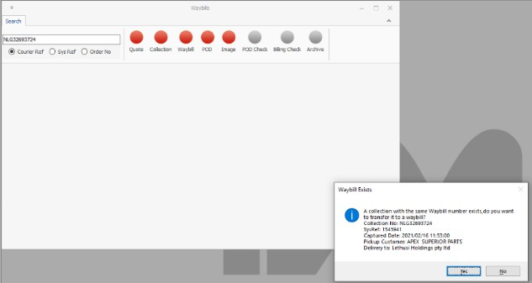• A pop-up will appear as per below image requesting you to transfer the collection to the waybill number inserted

• Please check that the Collection reference mentioned on the waybill matches the reference on the pop-up screen

• Check that the pick-up and delivery customer matches

• If so, please select yes

• If not, please click no and hand waybill back to the debriefing counter to allocate the collection to the correct waybill

• Once yes is clicked the below screen would appear

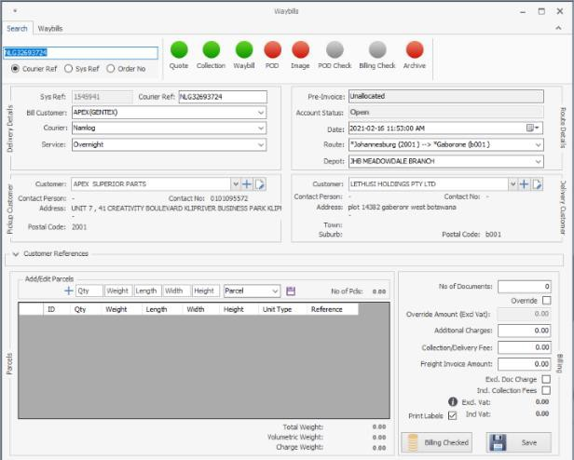

• Check if the following is correct:

o Billing Customer

o Courier o Service o Route
o Depot

o Pickup Customer

o Delivery Customer

• Capture number of parcels, dimensions, and weight as per waybill
• Capture the invoice number/s

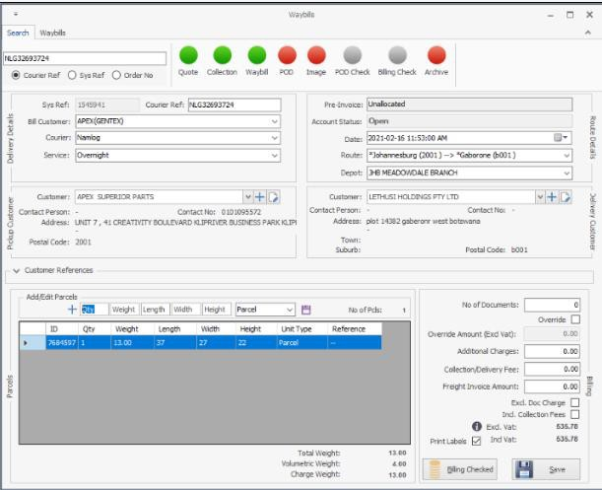

• Quality check the above then click save - Labels will then be printed

b.Waybills received from deliveries:

• Click on waybill Capture on the LMS system

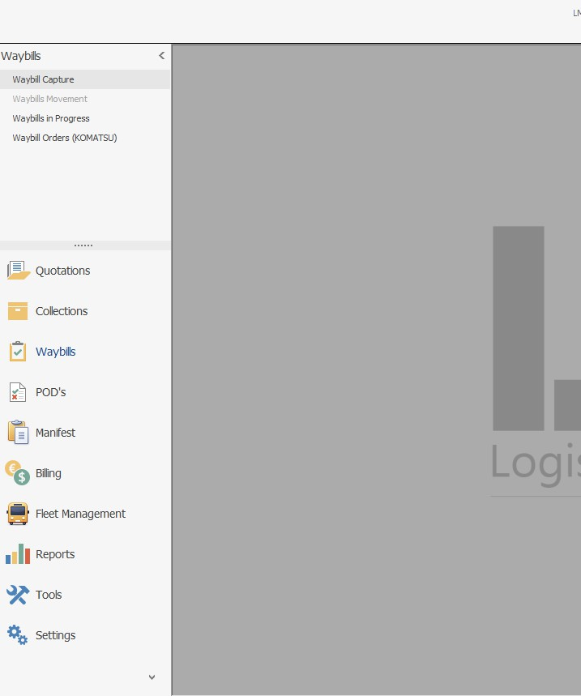

• Scan or manually type the waybill number into the field indicated below

• Scan or manually type the waybill number into the field indicated below

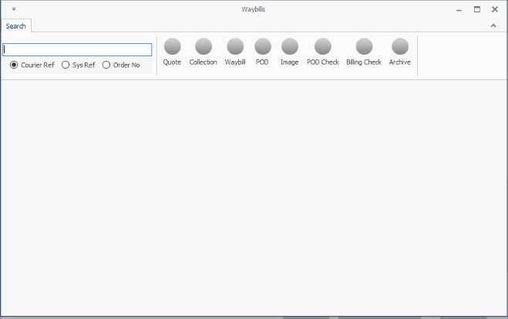

• A pop-up will appear as per below image requesting you to transfer from collection or capture as a new waybill

• Please check that there is no collection reference mentioned on your waybill.

o If so, click transfer collection and search for the collection.

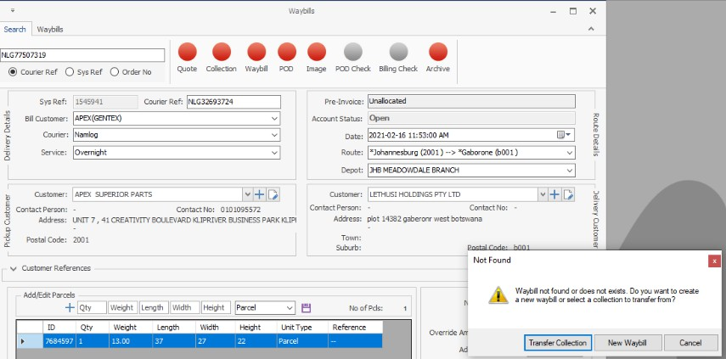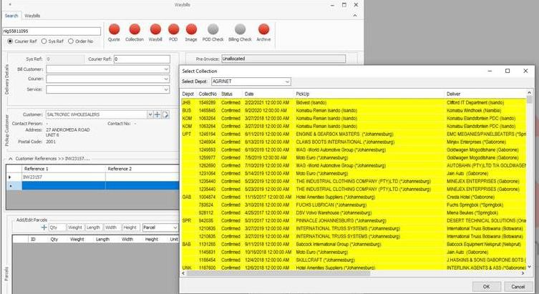

o If not, please click New waybill and the below screen will appear

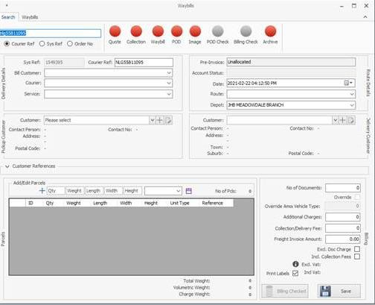

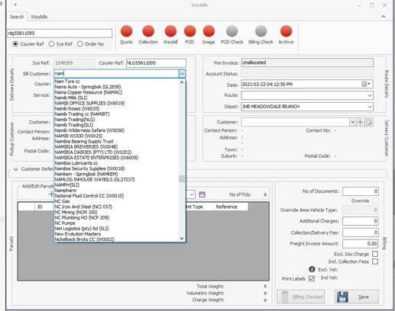• Select the correct billing customer

• Select the correct courier

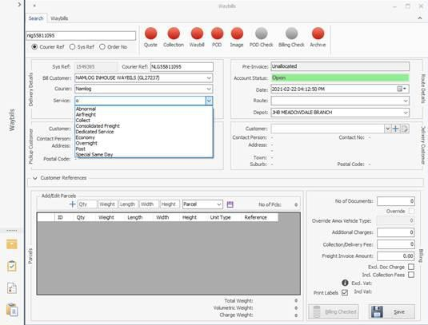• Select the correct service

• Select the route

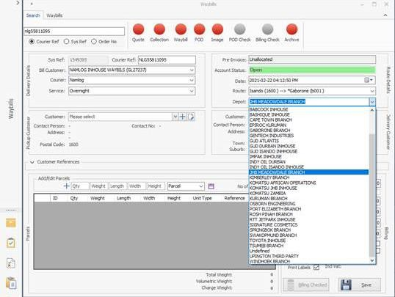• Select the correct depot

• Select the pickup customer, type the first 3 letters

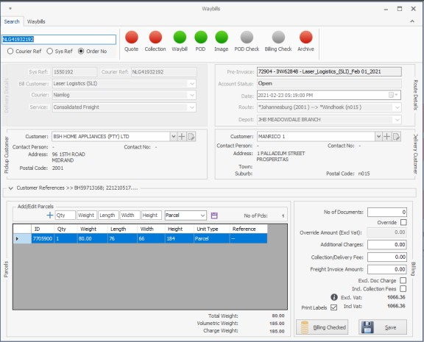• Select the delivery customer, type the first 3 letters

• Type in the reference number

• Capture number of parcels, dimensions and weight as per waybill.

• Quality check the above then click save - Labels will then be printed

2. Client Requirements:

• Each clients reference number or invoice number is to be captured under the
Customer Reference field on LMS

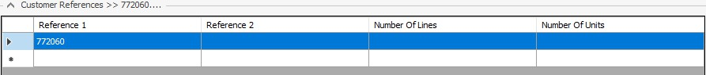

• The following clients have system generated waybills and the only thing to be done for them is the batching of documents

o Komatsu

o Epiroc / Atlas Copco o Osborn Engineering o Babcock

3. Batching of documents

• Namibia

o 2 copies of the waybill to be made, parcel sticker to be attached to one

o Remaining copies and the scanning of documents will be done by Solomon

• Botswana

o 2 copies of the waybill and 1 copy of the invoice is needed and to be batched as follows

a. 1 copy of the waybill to be used as a loading copy, parcel sticker to be attached to this copy

b. 1 copy of the waybill + original invoice + SAD500 to be scanned and emailed to the clearing agent. Hand over to Clearing once done

c. Original waybill + Copy invoice also to be handed to Clearing team

4. Reporting of queries and discrepancies:

a. All queries are to be confirmed on email with Trisha and Alcan in copy

b.Any Operations related queries are to be reported to the floor manager, confirm on email as well

c. Any LMS related queries are to be reported to the IT team, confirm on email as well

d.Any waybills capturing queries are to be reported to the account managers, confirm on email as well

e. COD waybills to be emailed for capturing to the relevant account managers

f. The below report is to be completed daily

• Waybill number – Type in your waybill number

• Shipper – The company the shipment is originating from

• Consignee – The company the shipment is destined for

• Comments – Here you add the query e.g. no route, difference in waybill and invoice information etc.

• Escalated to – An email is to be sent to the individual handling the account explaining your query, their name is to appear here

• There are different tabs for each destination

o Please ensure the information is completed on the correct country tab

• This report is to be sent daily to Trisha Jaykaran with Alcan Davids in copy

• If no queries are to be reported, please email Trisha Jaykaran with Alcan Davids in copy stating the same

• All queries are to be confirmed on email with Trisha Jaykaran with Alcan Davids in copy

• COD waybills to be emailed for capturing to the relevant account managers

• LMS manifest to be ticked off for items that you have scanned as a handover to the clearing team. This is to be emailed to the clearance email address before the end of your shift.

• Please ensure a random quality check is done on your waybills captured to ensure accuracy

