PURPOSE

The purpose of the Delivery Debrief Standard Operating Procedure (SOP) is to align all operational teams on expectations pertaining to the debriefing process. The SOP must be utilised as guideline for all Namlog driver delivery debriefing.

SCOPE

The SOP is applicable to operational teams involved in receiving consignment documents, freight delivery and collection.

The De - briefer will execute the following process on LMS:

- Login to LMS
  - Select manifest from main menu.
  - Select Collection / delivery debrief.

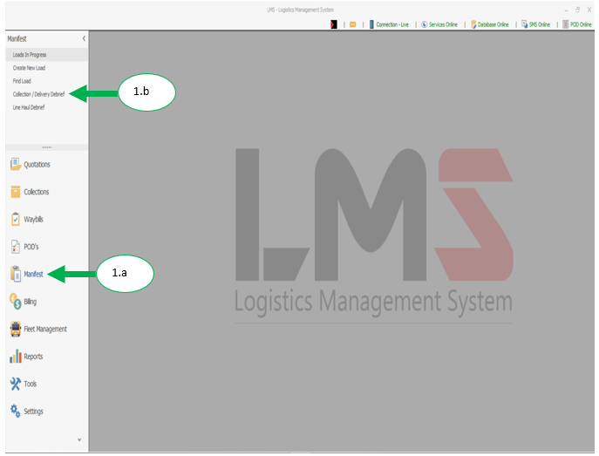

  - Enter the load number and press enter on the keyboard.

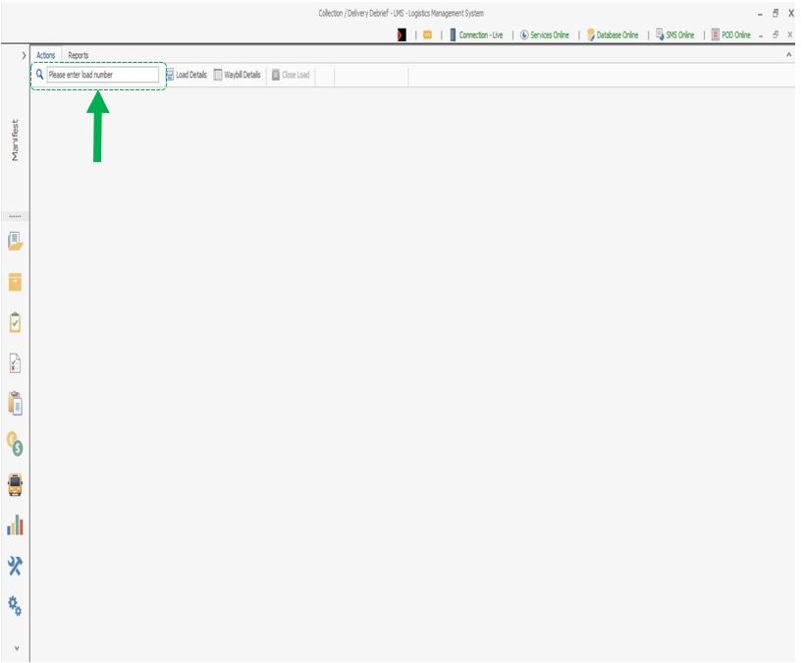

  - Select the first POD

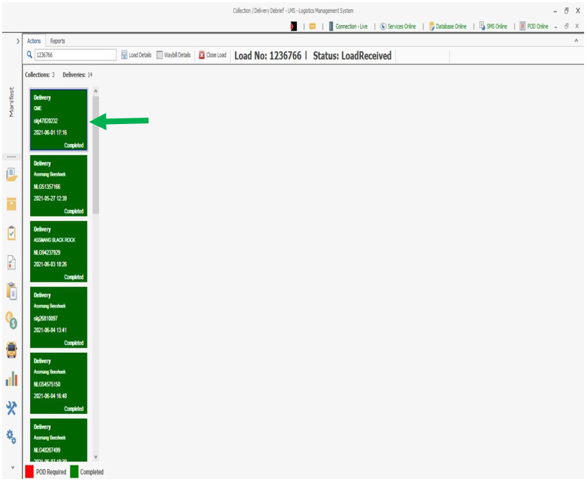

  - POD quality check:
- Click on the POD to view the photo taken.
- Inspect the quality of the photo.
- Rate the quality of the photo with stars, 1 being bad and 5 being good.
- If the photo has poor quality, rescan the POD to replace the photo.

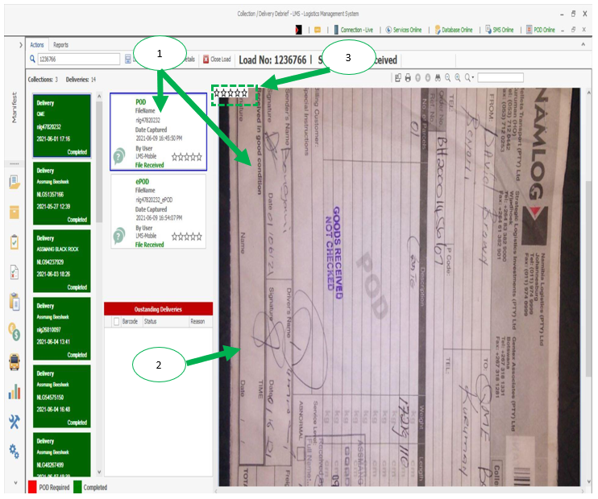

  - ePOD quality check:
- Click on the ePOD.
- Check if the name and signature of the customer receiving the freight is recorded.
- If the client has not signed on the PDA the rating will be 3 if the name of the person accepting the freight is not on the POD, then it will be 1.

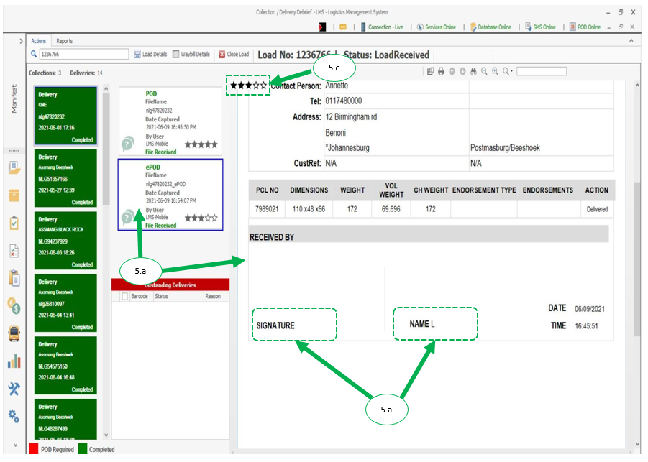

  - Missed collection.
- Missed collection will be shown in red.
- Click on missed collection to add the reason.

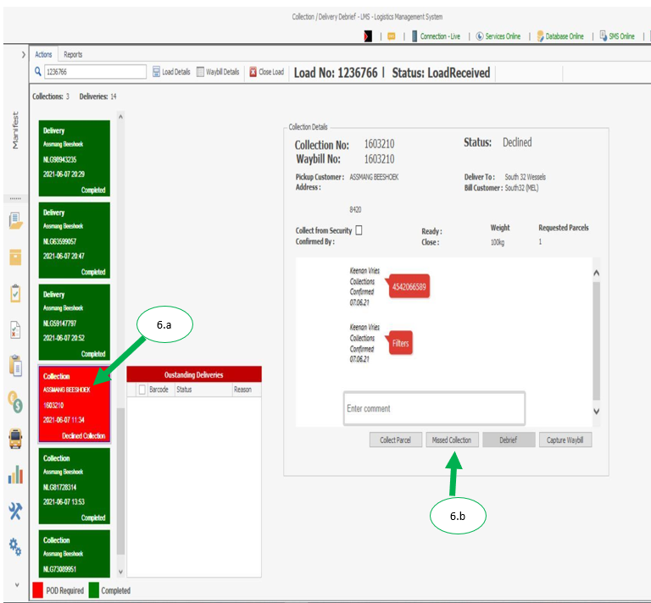

  - Select a drop down on missed collection to select a reason.
  - Add a comment for missed collection and click ok.

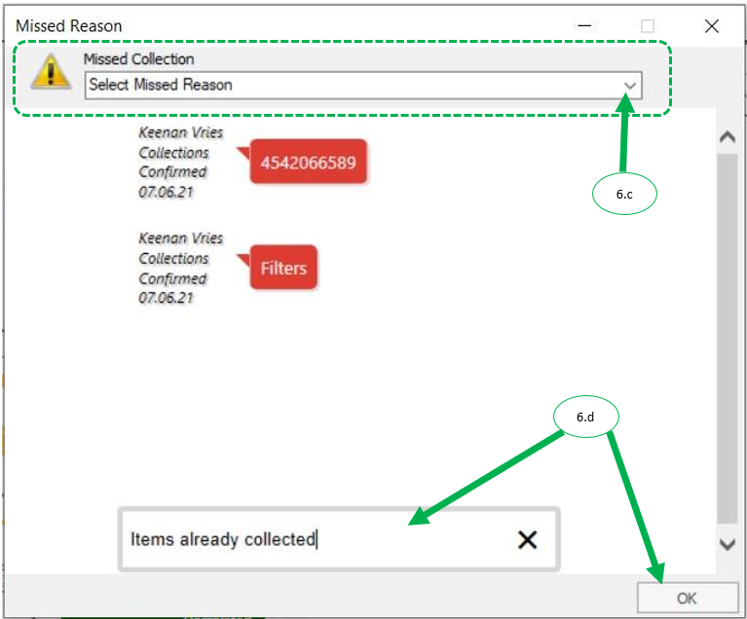

- Once completed with all POD’s, click on load details.

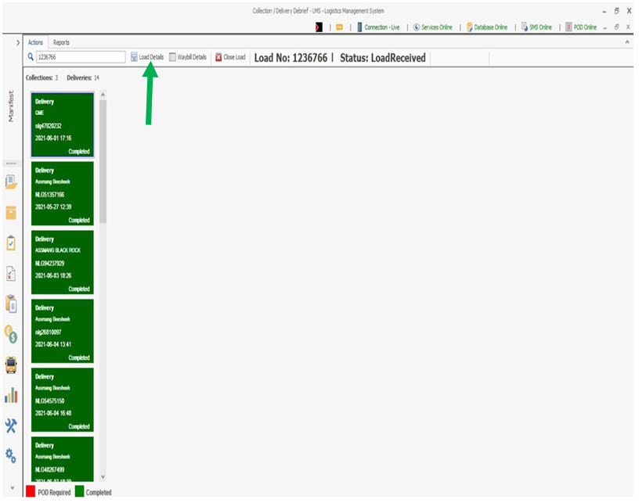

- Verify vehicle and driver details, then click next.

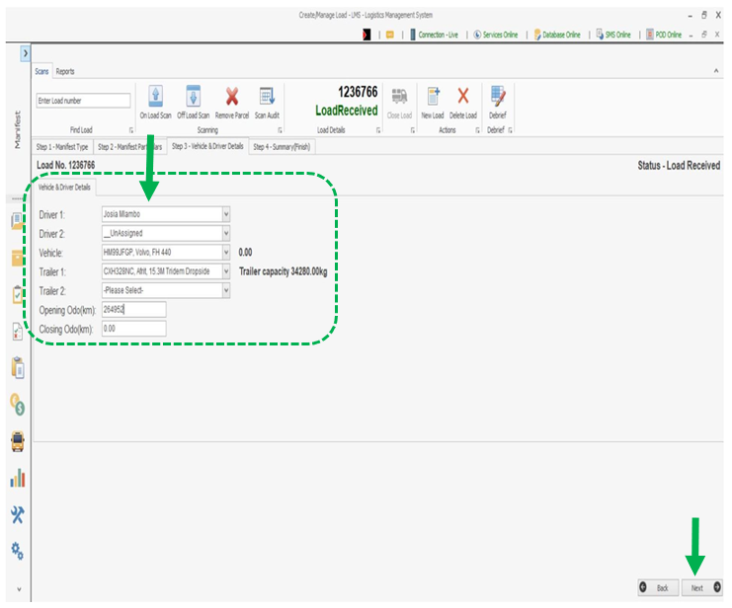

- Record the driver’s name and vehicle closing odometer readings, then click save to close the load.

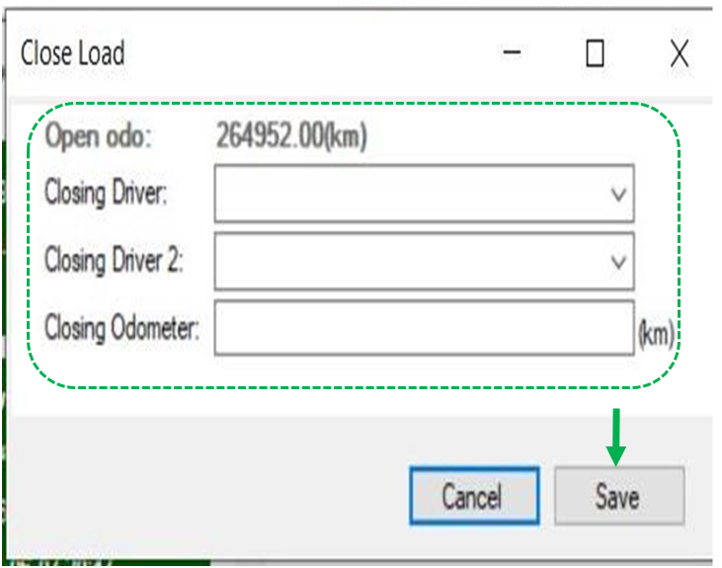

PDA day end handover

- Handover PDA to debriefer by signing the mobile device log-sheet.
- Debriefer to ensure PDA is in operational status:
  - Sim card is in PDA.
  - Delete old data from PDA.
  - Recharge PDA for the following day’s operation.
  - All non-RSA PDA’s: Check Data available balance.

