    - A new quote is requested from the supplier monthly or if there is a price increase or decrease in diesel. This quote is valid for 30 days.
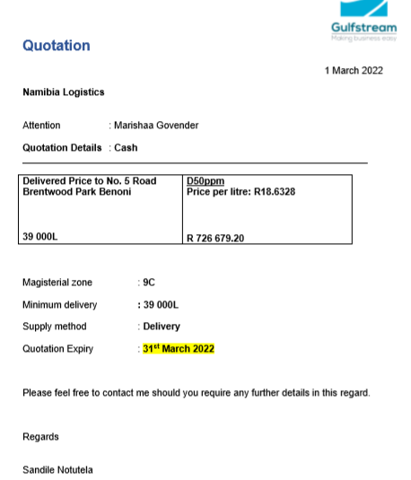

    - This quote is loaded on Fraxion , whilst approval of the POR(Purchase order request) takes place bowser levels are carefully monitored on all issues and disel dip levels.
    - A Order number is received and forwarded to the supplier as an indication of a fuel delivery being required very soon.
    - Once the combined value of the bowsers reach 21 000 litres an order is a payment is requested to be made to the supplier for 40 000 L of 50 PPM diesel.
    - Diesel takes three days to arrive and payment is made in advance to ensure delivery is timeous.
    - When the diesel arrives on site the closing reading of bowsers are taken and the Bill of Lading is inspected to ensure the seals on the diesel tankers correspond to the ones mentioned on the Bill of Lading and manual diesel tests are done to ensure diesel quality.

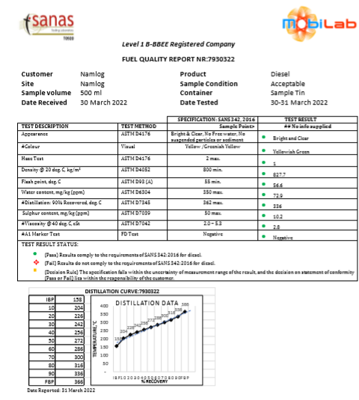

    - Should the diesel arrive more than 18 hours after loading a sample of the diesel is sent to a lab for testing before the diesel is offloaded in the tanks.

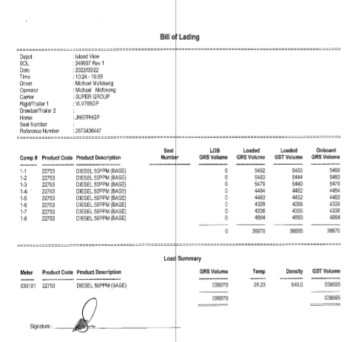

    - Diesel is only offloaded once all the tests are received from the lab and results are cleared.
    - A manual dip is done after delivery is done and matched to the print out received from the diesel tanker.
    - All documentation is forwarded tracking and finance.
