Purpose:
The purpose of this document is to ensure the correct process is followed when providing all units with hourly locations updates.

- Log on to WhatsApp Web. (Control 1/2/3/4)
- https://web.whatsapp.com/
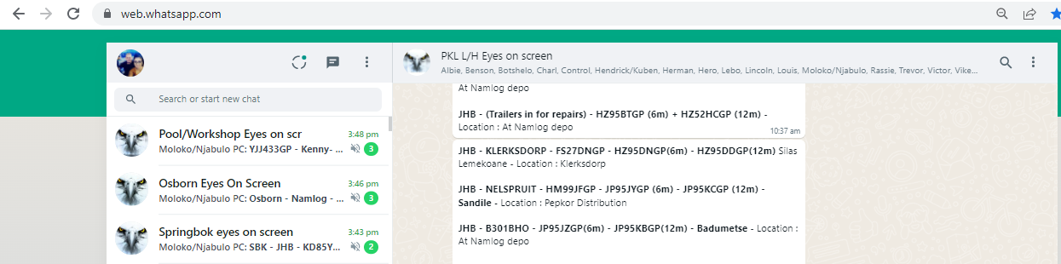

- Each business unit will notify control once vehicles are scheduled to depart. This update will be done on the specific business unit group “Springbok Eyes on screen” etc.

- The following format will be used to notify control.

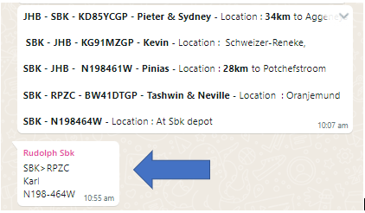

- SBK>RPZC (Destination)
- KARL (Driver)
- N198464W (Vehicle Utilized)

- Control will start reporting on this asset once it departs the depot. Please refer to the example below.

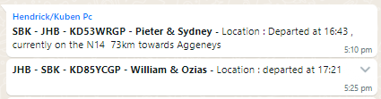

- All assets need to be reported on, every hour until the trip is completed and back at the home base. Depart A / Deliver B/ Return A

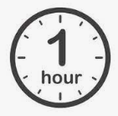

- Any issues during the trip duration need to be escalated to the business unit/Risk Manager.
- P:\Control Room

