PURPOSE

The objective of Fuel Management (Dreamworx) Standard Operating Procedure (SOP) is to provide clear guidelines for operational departments within Namlog Group on the fuel management process. This SOP is intended to be used as a reference for all Namlog fuel management activities.

SCOPE

The SOP is applicable to operational personnel who are responsible for the fuel management process.

PROCESS

- Pump Attendant:
  - Perform daily dip level measurements on the small and large tank.
  - Record the day, date and opening dip reading on the "Depot - Daily Diesel Capture Sheet" for both tanks.

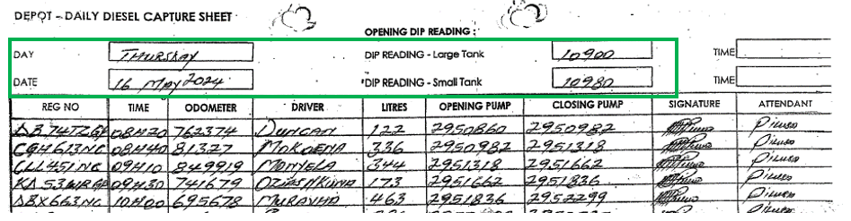

  - Vehicle arrives at the bowser for refuelling, complete the "Depot - Daily Diesel Capture Sheet”.
- Before refuelling, record:
- Vehicle registration number
- Time
- Odometer reading
- Driver's name
- Opening pump reading

- After refuelling, record:
- Closing pump reading
- Litres
- Signature (pump attendant)
- Pump Attendant's name

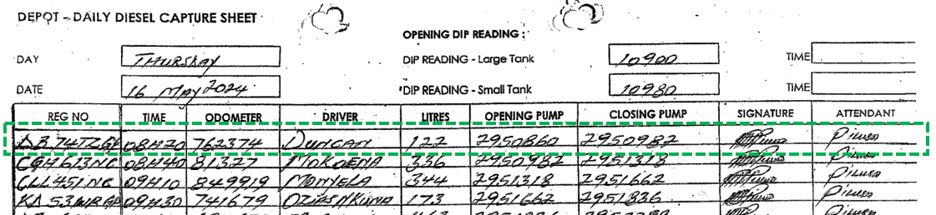

  - At the end of the shift:
- Perform dip level measurement and complete the Bowser Admin section on the "Depot - Daily Diesel Capture Sheet".
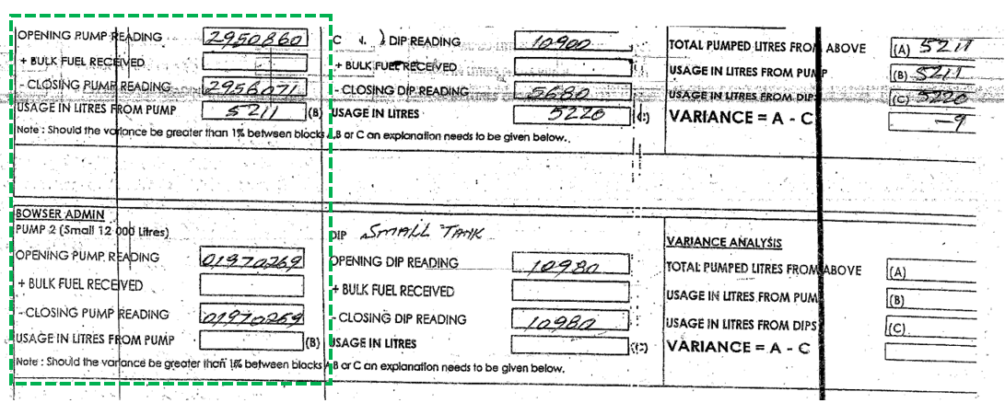

  - Before the start of the shift the next day, hand over the previous day "Depot - Daily Diesel Capture Sheet" to Workshop.

- Workshop Buyer verify the information recorded and complete the Bowser Admin section on the "Depot - Daily Diesel Capture Sheet".
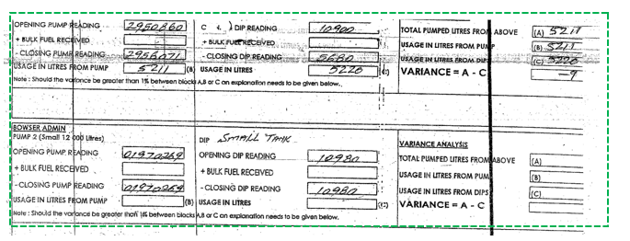

- Workshop Manager verify the information on the "Depot - Daily Diesel Capture Sheet" and sign off as approved.
- Workshop Buyer:
  - Scan and email the "Depot - Daily Diesel Capture Sheet" to all relevant parties, as per current distribution list.
  - Login to Dreamworx to capture the information from the "Depot - Daily Diesel Capture Sheet".

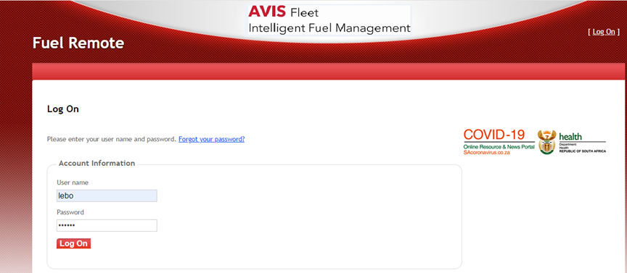

    - Select the correct role and depot, then press save.

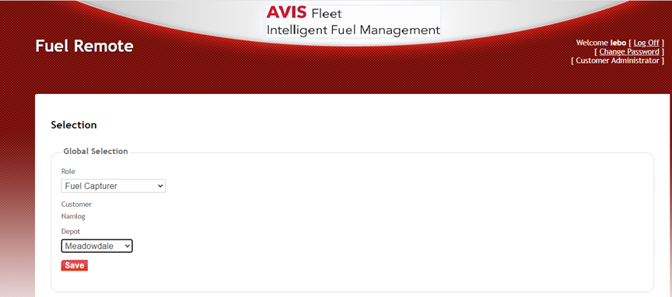

    - Select “Transactions”, then select “Create Dips” for capturing the dip readings.

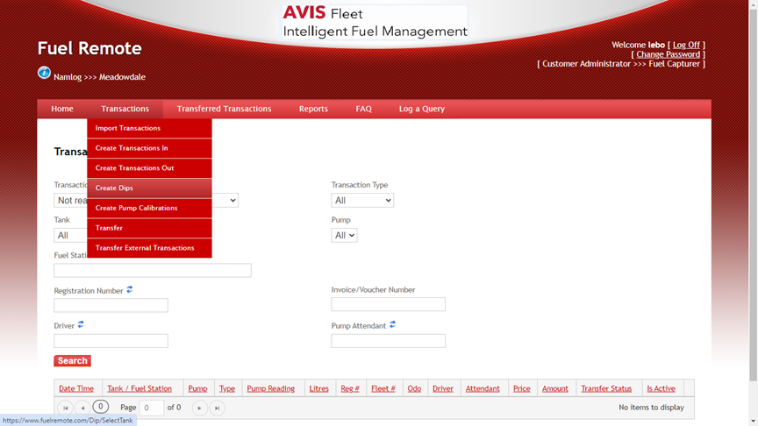

    - Capture the Dip readings and select “Create”.

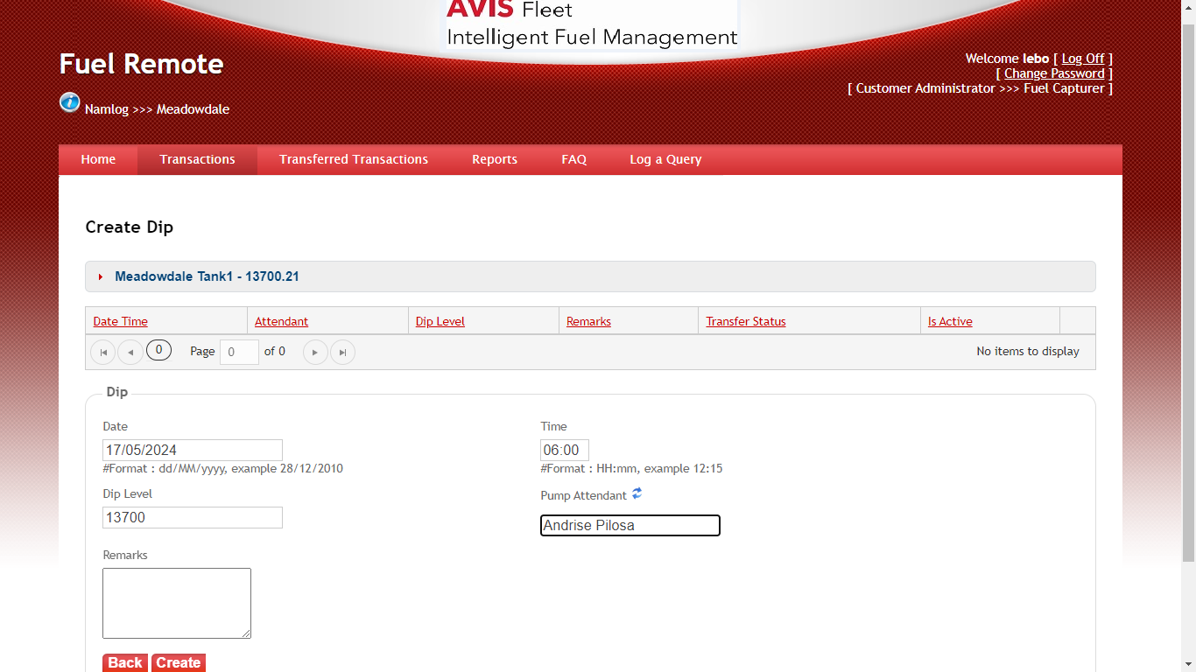

    - Under transactions, select “Create Transaction Out”.

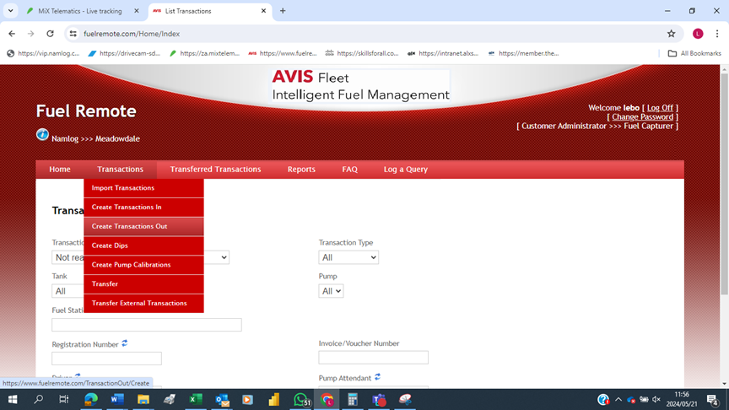

    - Select the correct transaction type and pump.

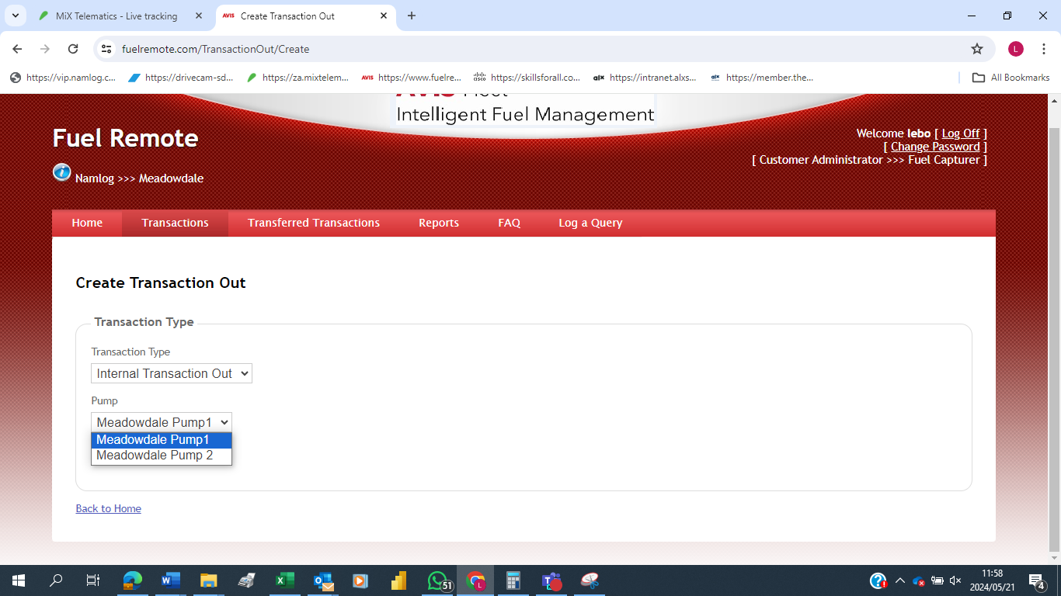

    - Capture all the data according to the "Depot - Daily Diesel Capture Sheet", then click “Create” after each transaction/line.

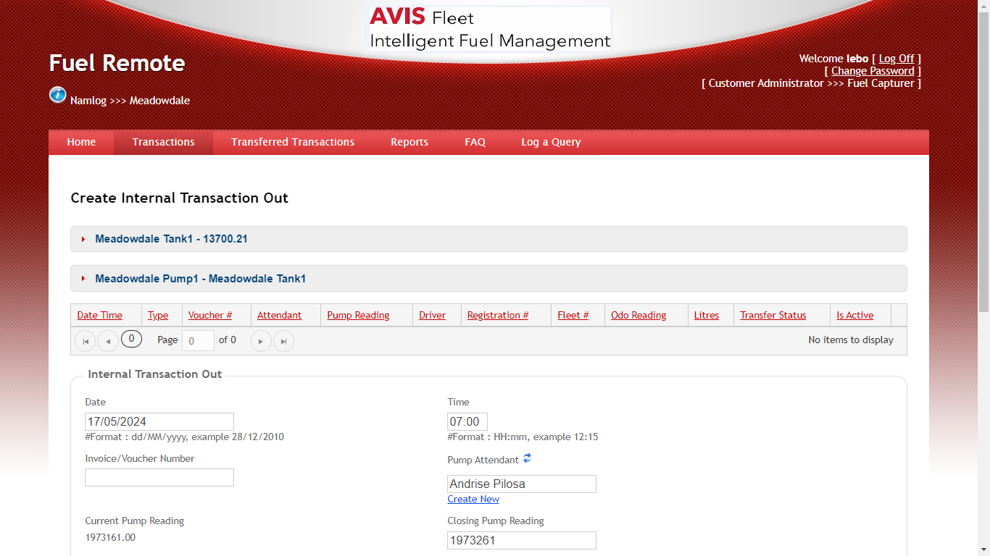
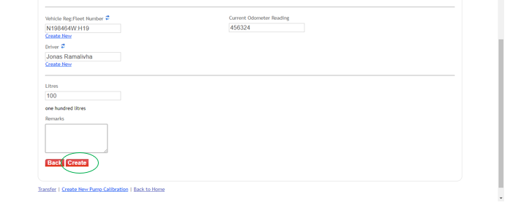

    - After all transactions have been captured on the system, click “Transfer” to upload the entries on Dreamworx server.

