PURPOSE
The purpose of the Incompatible & Manual Processing, Standard Operating Procedure (SOP) is to align all operational teams on expectations pertaining to the operational processes regarding all incompatible parcels being received and manual processing. The SOP must be utilised as a guideline for processing of incompatible cargo.
SCOPE
The SOP is applicable to JHB OPS warehouse staff involved in the induction and processing of inbound cargo specifically cargo that are incompatible for the Parcel & Pallet Dimensioner and require manual processing.
PROCESS
Cargo offloaded and documents handed over to Data Capturers:
Data Capturers will receive consignment documentation from the debriefer.
Data Capturers will capture the waybill if not captured by Namlog In-houses manned by Namlog staff.
Data Capturers will only print Namlog labels for the consignment if there are no integration labels from the customer.
Data Capturers will then save the waybill.
The Namlog labels will then be handed over to the relevant team leader responsible for manual processing.
Handover from Data Capturer to Team Leader
The Team Leader will then paste the labels onto the relevant items, and process through the specific Induction processing method, in this case Manual Processing. Refer to figure 1 below.
Figure 1.
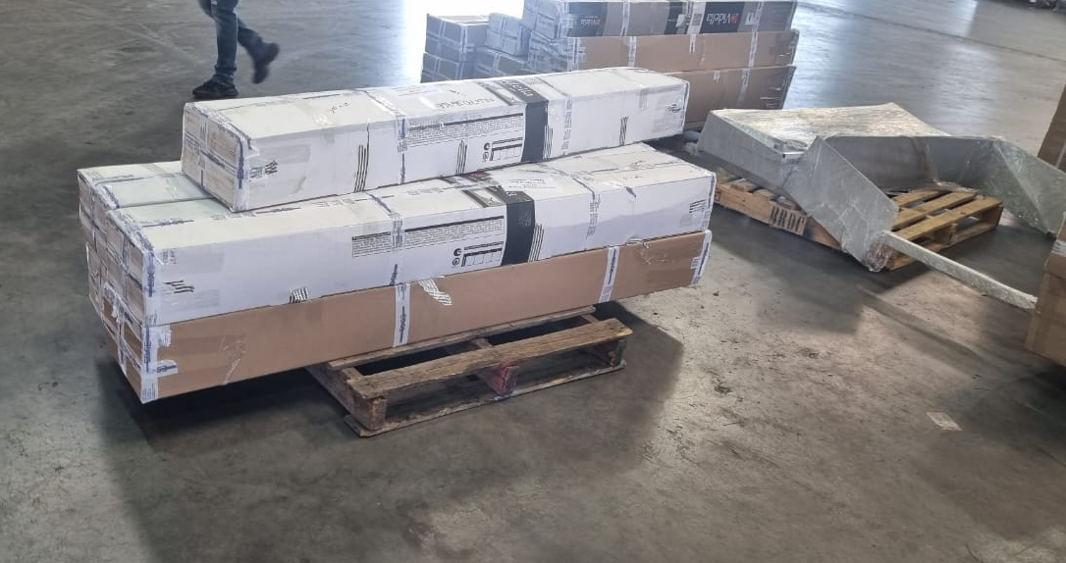

The manual induction scale has a weight limitation of 3000kg.
The Team Leader will instruct the Forklift driver on which parcel must be fetched from the staging area and placed onto the manual scale. Refer to figure 2 below.
Figure 2.
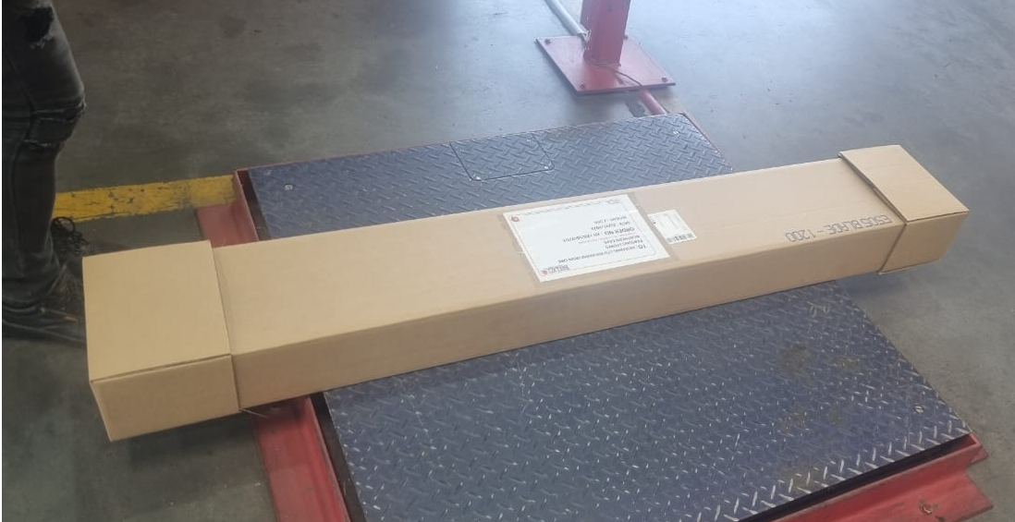
The Team Leader will then scan the barcode of the Namlog label.
The scale will update the mass of the parcel.
The Team Leader will then manually measure the dimensions of the parcel and capture on the screen.
Then the Team Leader will save the mass and dims. Refer to figure 3 & 4 below.
Figure 3. Figure 4.
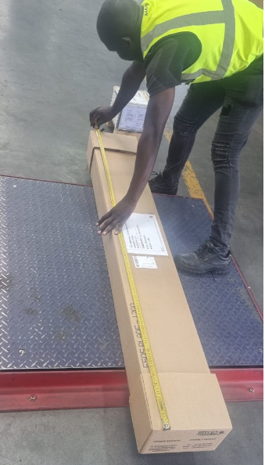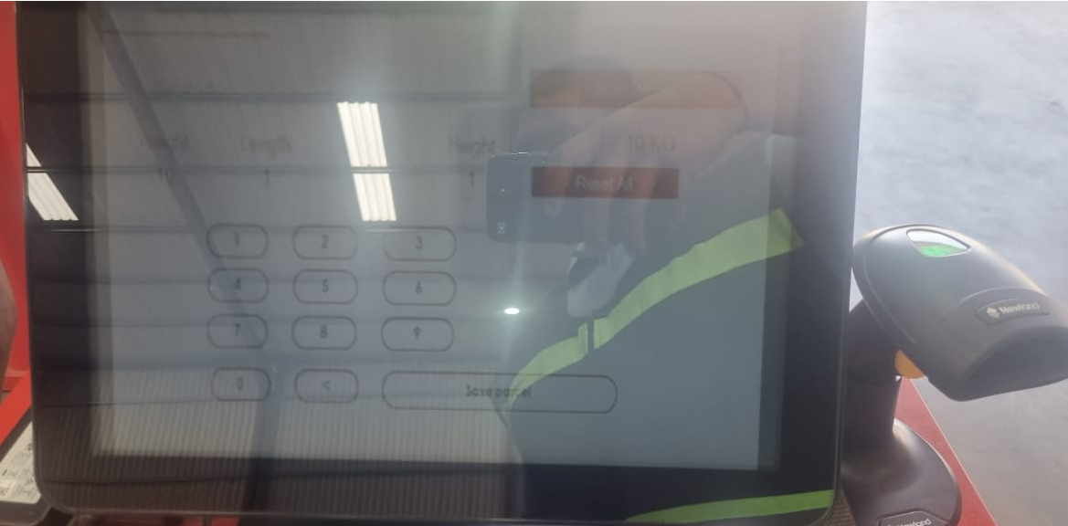
Parcels processed through Manually will then be transferred to specific dispatch bays for branches and or countries.
The Team Leader will inform the Data Capturer once the entire consignment is mass and dimensioned.
The Data Capturer will then save the waybill in LMS, print the Delivery Note in Portal and handover the documents to the Clearing Department. The Delivery Note contains all the consignment information such as:
- Waybill number
- Sending customer
- Receiving customer with address
- Mass & Dimensions
- Number of parcels
HANDOVER RESPONSIBILITIES:
- Drivers are responsible to handover documents to the Debriefer.
- Debriefer is responsible to handover debriefed consignment documents to the Data Capturers.
- Data Capturers are responsible to handover labels to Team Leaders and consignment documents with delivery notes to Clearing Department.
- Forklift Drivers are responsible to handover freight to Hub & Linehaul Managers in Warehouse B.
- Warehouse A Operations Manager on shift is accountable for the above processes.
OPERATIONAL CONTACT:
Operations Manager – 071 259 2257
Shift Supervisor – 071 401 7825
Branch Manager - 082 427 6028
GM Operations – 066 197 7570

