Objective

- Securing freight on vehicles to ensure minimal damage occurs during transit
- Ensuring freight is transported safely and preventing damage or loss of items during transit
- Freight securing equipment must always be available when loading freight for deliveries or collections

Securing loads before departure
- Types of Fastening equipment
- Cargo Nets
- Belts and Rachets
- Chains and Satangs
- Tarpaulin
- Corner plates

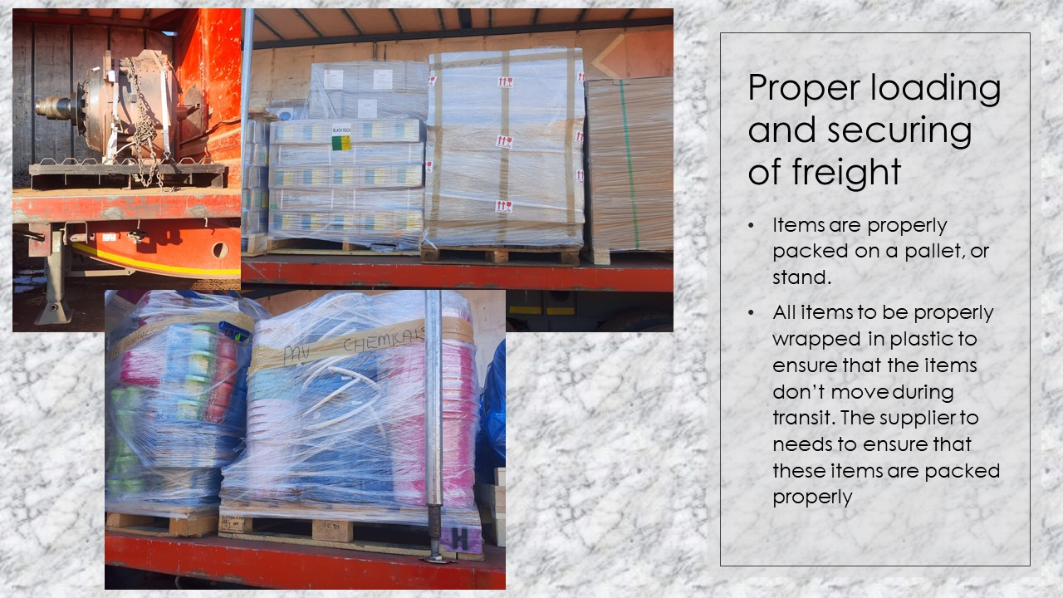
Proper loading and securing of freight

- Items are properly packed on a pallet or stand.
- Supplier to ensure all items are properly plastic wrapped and packed to prevent movement during transit.

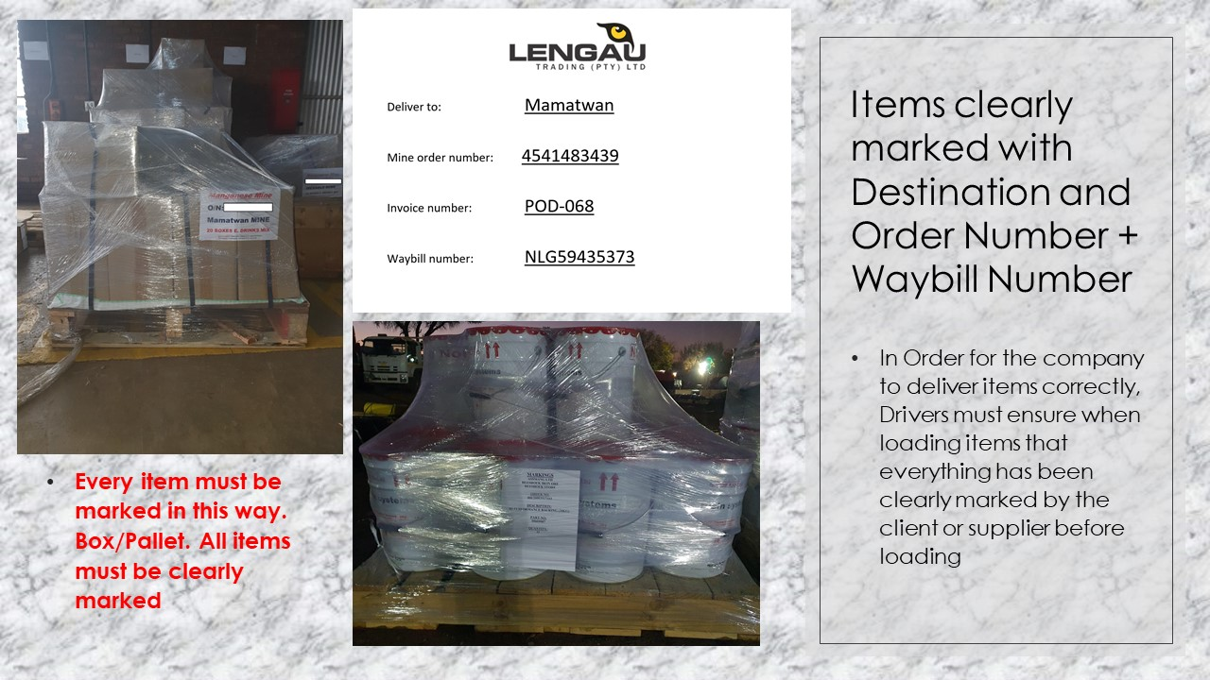
Items clearly marked with Destination and Order Number + Waybill Number

- Customer to ensure all items are clearly marked or labelled with the following information:
- Customer details
- Waybill number
- Consignee details
- Number of parcels
- Drivers must ensure all items are marked as above before loading.

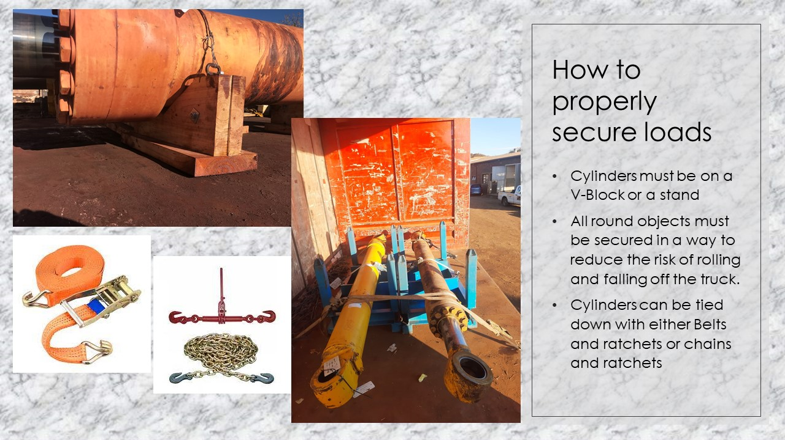
How to properly secure loads

- Cylinders must be on V-Block or a stand.
- All round objects must be secured in a way to reduce the risk of rolling and falling off the truck.
- Cylinders can be tied down with either belts and ratches or chains and satangs.
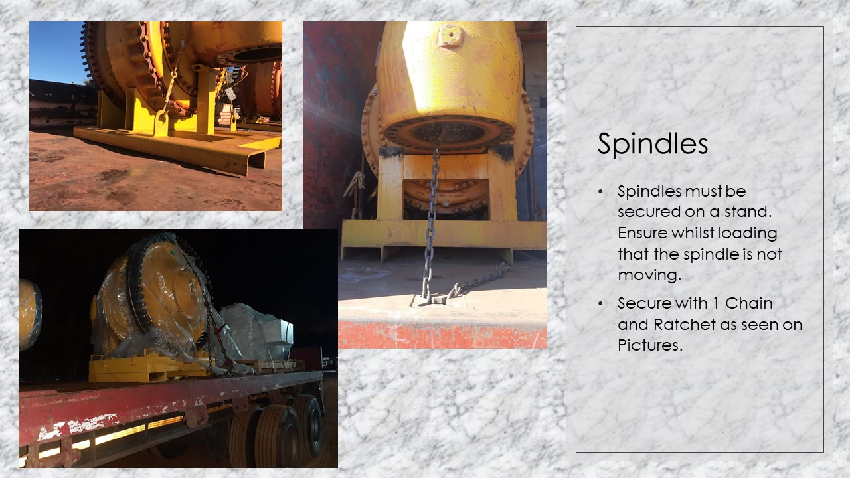
Spindles

- Spindles must be secured on a stand.
- Ensure whilst loading that the spindle is not moving.
- Secure with 1 chain and satang as seen on the Pictures.

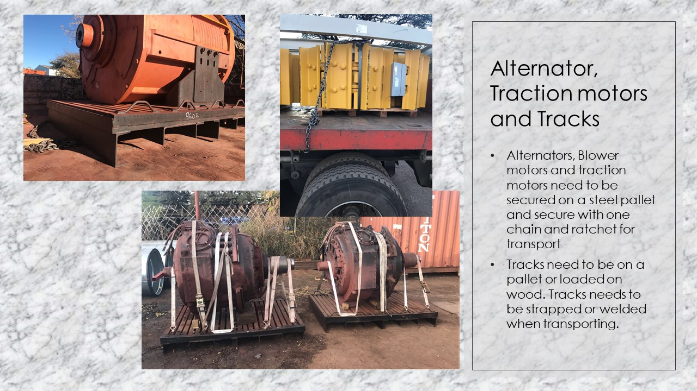
Alternator, Traction motors and Tracks

- Alternators, Blower motors and Traction motors to be secured on a steel pallet with chains and satangs.
- Tracks to be loaded on pallets or dunnage wood and secured with chains and satangs.

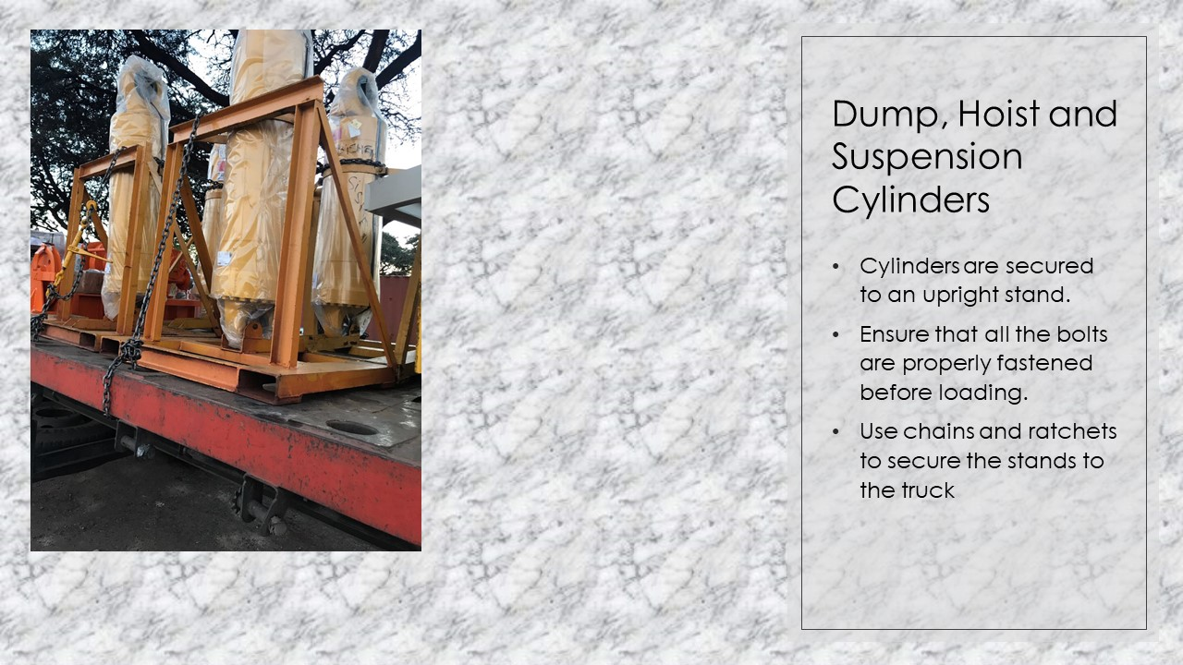
Dump, Hoist and Suspension Cylinders

- Cylinders are secured to an upright stand.
- Ensure that all the bolts are properly fastened before loading.
- Use chains and ratchets to secure the stands to the truck.

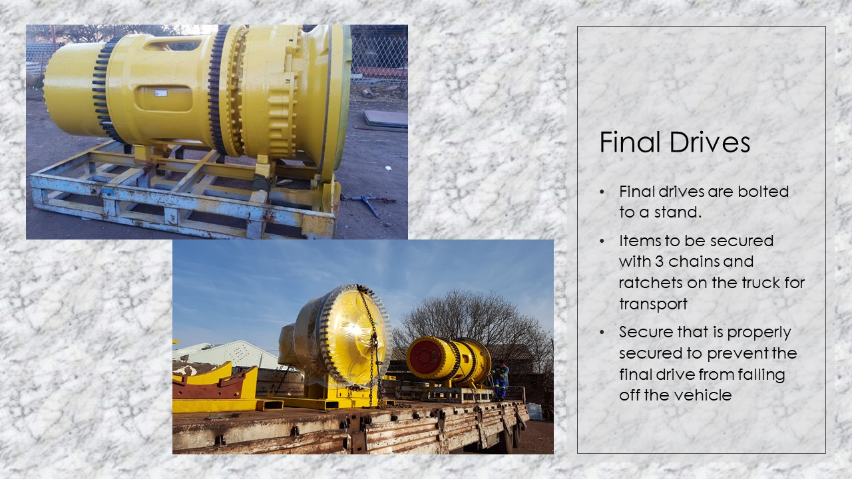
Final Drives

- Final drives are bolted to a stand.
- Final drives and stand to be secured with chains and satangs to prevent movement whilst in transit.

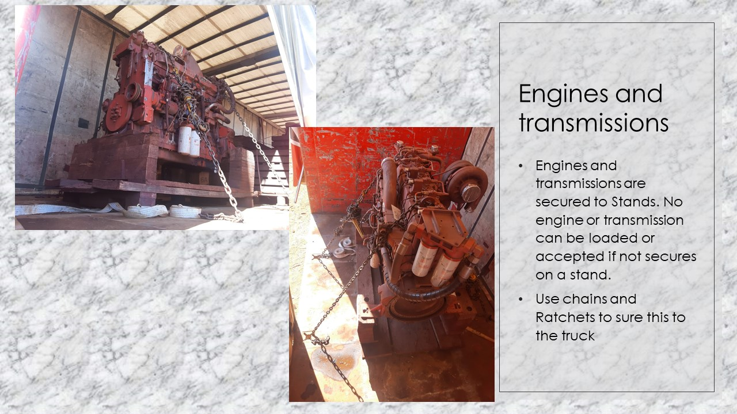
Engines and transmissions

- Engines and transmissions are secured to the stand stands.
- No engine or transmission can be loaded or accepted if not secures on a stand.
- Use chains and Ratchets to sure this to the truck.
- Customer to ensure engines and transmissions are secured on stands before loading.

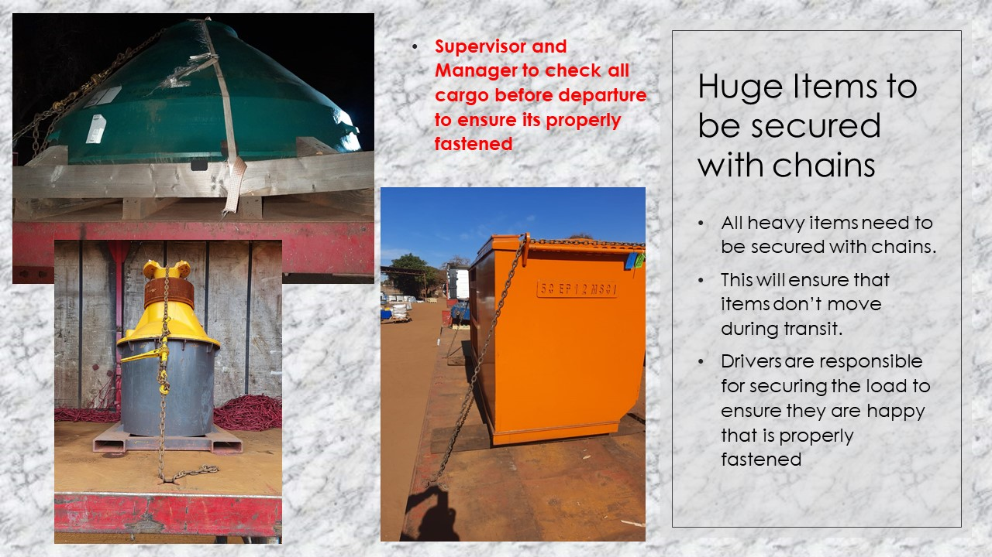
Huge Items to be secured with chains

- All heavy items to be secured with chains and satangs to prevent movement during transit.
- Drivers are responsible to secure loads before departure.

Should Cargo not be secured as per above:

- Driver to report immediately to Direct Line Manager
- Driver to take photos of the Cargo (if possible)
- Line Manager / Account Executive to contact the customer.
- Driver to wait for Line Manager instruction.

Securing loads before departure:

- Secure cargo on vehicles to prevent in transit damage.
- Cargo securing equipment must always be used when loading cargo.
  - Cargo securing equipment:
- Types of Fastening equipment
- Cargo Nets
- Belts and Ratchets
- Chains and Satangs
- Tarpaulin
- Corner plates

