Purpose:
The purpose of this document is to ensure the correct process is followed when a Namlog asset losses GPS connectivity.

• Once you’ve logged into Mix, ensure you open streams
(Notifications).

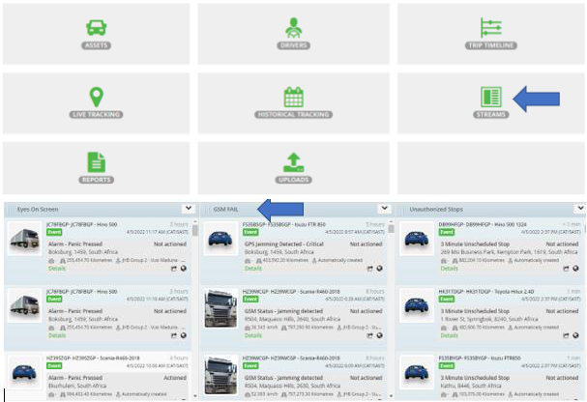

• GPS Jamming events will appear on the screen together with a sound notification that will be generated.

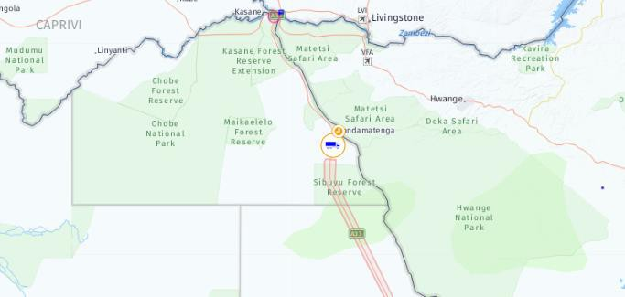• Refer to the map and see if the vehicle icon changed to Orange. This is an indication that the vehicle lost GPS connectivity.

• Ensure that we phone the driver first, to get an updated location.
• If the driver’s contact detail is unreachable, contact his manager for alternative contact number.
• Phone the driver again after 5 minutes due to Dead spot (No
signal areas).
• Escalate and dispatch the Mix ground unit immediately, if we
can’t get hold of the driver after a few attempts.

• Activate the Beame unit.

• On Mix tracking, lock on asset to get constant location updates.

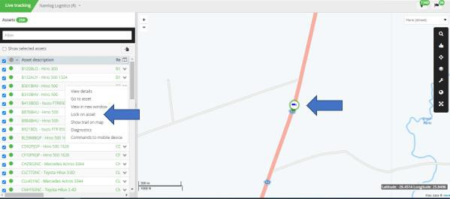

• Refer to the “SAPS contact details” under the shared control room folder and request assistance from the nearest police station.

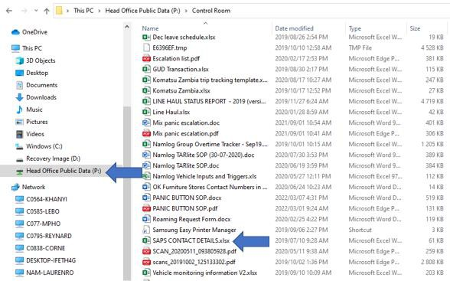
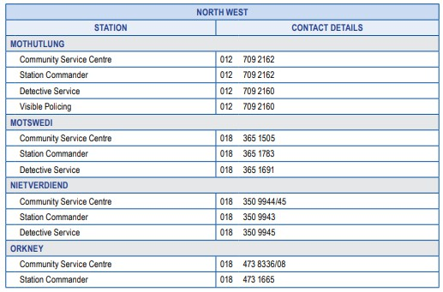• Provide the officers with the necessary information to dispatch their team.

• Escalate matter to both your manager/Business unit manager.

• Please ensure we cancel the ground unit should we get hold of the driver.

