Purpose:
The purpose of this document is to ensure quick and correct procedures are followed in the case of receiving a panic button alert, dash tamper alert, battery tampering alert and power down alert on SMS or E-mail.

Role Players:

- Control Room Operators
- Divisional Managers
- Operations Managers
- Risk Manager

Duties

Managers will receive an What’s App Message on the ALARMS NOTIFICATION group that was specifically created for this reason, they will also receive an Email notification, from Mix Telematics in the event of the following 4 important events.
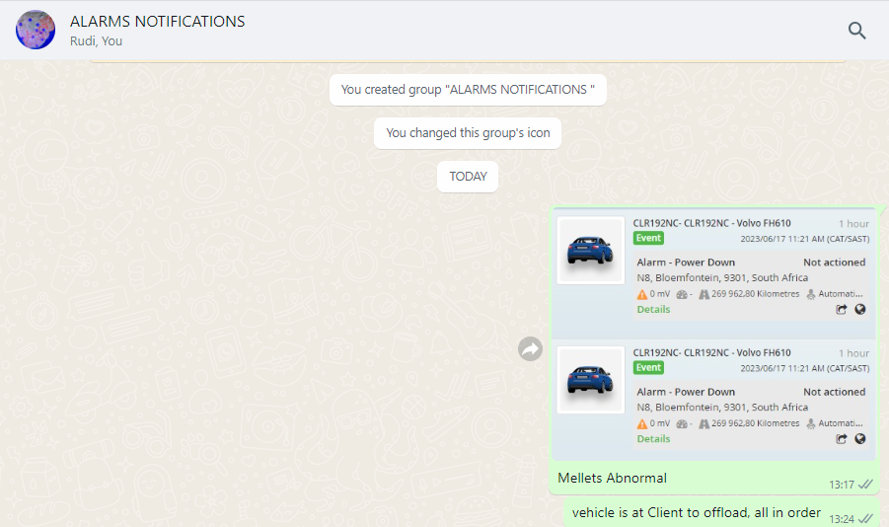
- Panic Button pressed.
- Dash Tamper Alert.
- Alarm Power Down.
- Battery Disconnect.

Mix Alert Escalation between 07h00 to 19h00

The Managers or Supervisors assigned to the group that is on duty between the hours of 07h00 to 19h00, will be required to monitor the group and look at the postings received from the control room to see to those alarm notifications related to the vehicles under their fleet. The Manager or supervisor will need to phone the driver immediately upon receipt of the notification, verify with the driver on the status related to the alarm received, in order to provide feedback within 5 minutes of the notification posted on the group, back to the control room, via a detailed text message regarding the alarm notification received.

The following questions will be required to be asked in the specific events triggered.
(Taking in mind to listen to the driver’s voice when he responds to determine if he might be in distress.)
Alarm: Panic Pressed
- Verify with driver – his vehicle registration number – the driver needs to provide it “Hello Samuel, it is (CONTROL ROOM) please confirm for me the registration number of the vehicle you are driving now!”
- Once verification done to ask! “Samuel what is wrong? I see you pressed the Panic Button.”
- Wait for his response; if response is that he pressed by mistake; to ask him “please explain how you pressed the button by mistake?”
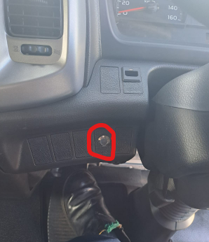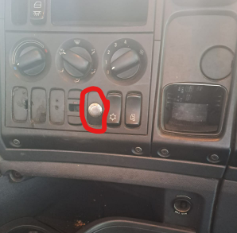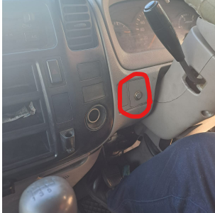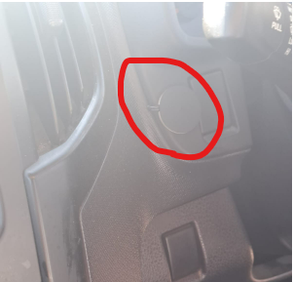
All Panic buttons are placed in a safe reachable distance and away from the normal movement when entering or exiting a vehicle, so drivers should not be able to press buttons by mistake.
Alarm: Panic Pressed
- Verify where driver is and confirm direction of travel.
(20 km’s before Rehoboth direction to JHB)
- Confirm with driver where is his next stop. (Client) should driver give wrong details he might be in danger, and cant talk.
- Where in the managers opinion, he can ask the driver to reboot the dash cam by pressing the two buttons for about 3 seconds until lights flashes, to have footage for this event captured.
(if driver say he cant press it now, he might be in danger and use that information. To escalate to control room.
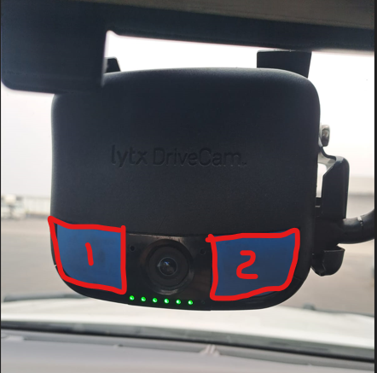
- Once verification done that all is in order with the driver, to contact the control room to inform them of the outcome.
- Should driver have pressed panic for non-emergency related matters, the driver needs to be addressed to this as it is not a please call me button, panic button is for the below specifics reasons to be used only.

> hi-Jacking
> Theft out of or from vehicle
> accident
> Roadblocks or closures (construction or public unrest)
> if any Police Pulls vehicle over, Police/Metro/ Highway Patrol
Drivers has used the panic button as a please call me for giving messages to managers, telling control room they left documents behind to hand over to managers, asked managers to call them back, enc…. This is not allowed and needs to stop.
- Should driver not answer calls after 4 attempts, directly after each other, to notify control room immediately as the driver might be in danger.
- Control room will notify Mix ground team and nearby Police to the situation. If manager do get hold of driver afterwards, to provide feedback to control room of situation.
- Control room will provide feedback to the Police and Mix Recovery team about situation such as look out while responding to scene, example: how many suspects, vehicles, directions, accident, any injuries, or to stand down and say driver is OK.
- If it determined the panic is faulty to notify control room to escalate and book a repair as soon as possible. Managers needs to keep track and still contact drivers on every panic notification to ensure safety of driver, vehicle and cargo until vehicle returns safely and back to branch, and repairs can be done.
- Vehicles will be grounded until panic button has been repaired.
These telephone call must be done immediately and feedback to control room in 5 minutes of receiving the notification.
See illustration of the What’s App message that will be received on the Alarm Notification Group from Control room.
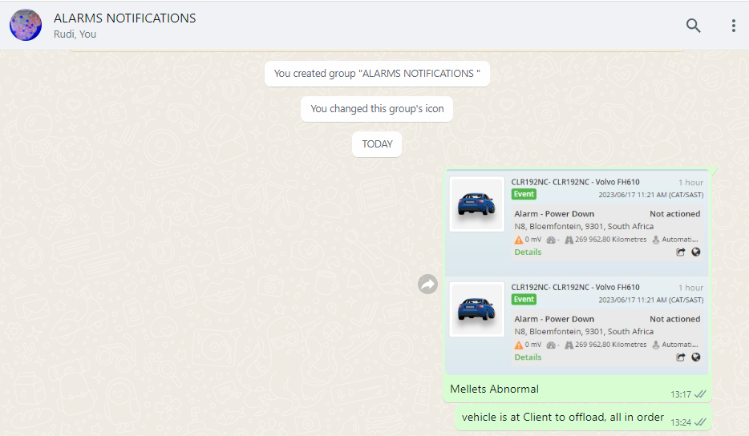

Alarm: Dash Alert Tampering and power down.
(Taking in mind to listen to the driver’s voice when he responds to determine if he might be in distress.)
- Manager to contact driver directly; verify with driver to which vehicle he is driving – numberplate verification.
- Ask driver if he is driving or stationary and on what road is he currently and the condition of the road.
- Where a concern arises from drivers’ response and voice, to ask the driver to press the two buttons on the Drive Camera to do a force download – keep buttons in till the lights flash.
(+- 3 seconds)
- Manager to provide feedback to the control room to above verification.
Driver Samuel in HZ39VHGP, dash tamper alert, driver was contacted, he is driving on N12 20 KM’S before Benoni, all in order.
Manager to record time of notification to go and review dash camera footage to determine if further action will need to be taken, once reviewed to report back to Risk Manager with findings.
Below is an example of the dashcam footage to be provided on mail.
Image 2
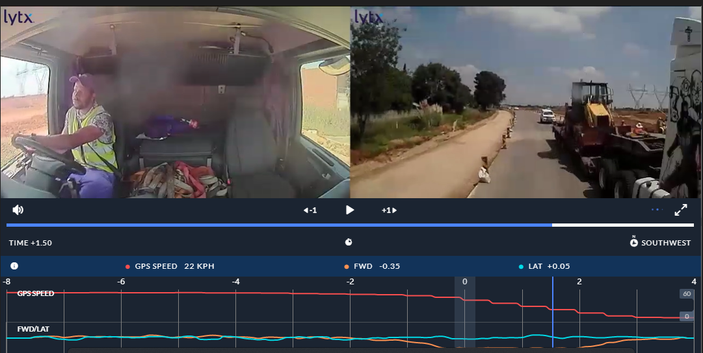

Alarm: Battery Disconnect.
(Taking in mind to listen to the driver’s voice when he responds to determine if he might be in distress.)
- Manager to contact driver directly and first question to ask is if he is driving or stationary?
“Hello Samuel! where are you now, and are you still driving?”
- Wait for his response and if said he is driving to ask:
“on what road, what is his current speed?”
- If driver is stationary; “are you next to the truck?” Then tell driver to go inspect the vehicle and go look at the batteries whilst keeping him on the line; do not end the call.
- Once above verification is done to escalate to control room and if needed to Workshop/ fleet if battery was stolen.
Control room to be contacted and stipulate the feedback as follow.
HV95RTGP had a battery disconnect, vehicle is at the dealership for service / Samuel in HV95RTGP checked battery and terminals are lose, it has been reported to Etienne / Willem / Fleet Controllers to fix upon return to branch.
- Driver needs to verify if battery terminals is tight by just moving battery cable at the terminal to determine if battery cables are tight or lose. If lose to escalate to workshop to fix upon return.
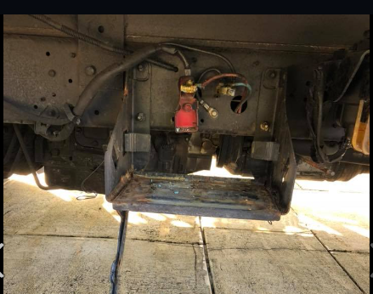
- Manager to request a photo from
the driver in the event of battery
terminals were found to be lose,
or if battery was stolen.

- If vehicle is at dealership for service – and known to manager, the manager must first confirm on tracking platform that the vehicle is there, contact control room and provide feedback. HV95RTGP had a battery disconnect, vehicle is at the Hino dealership for service.
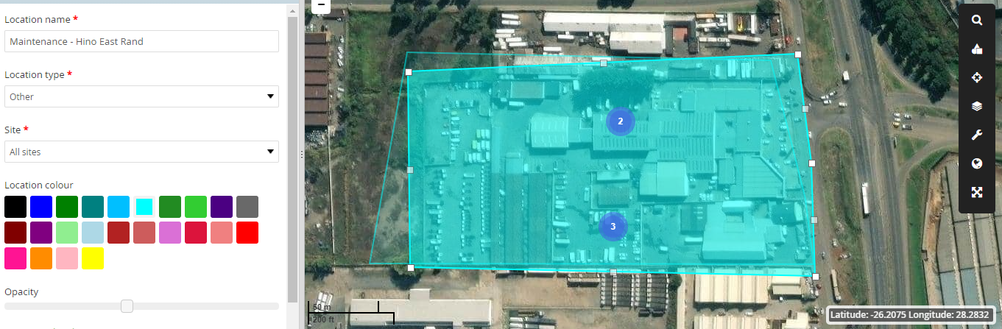

In any positive event such as a panic Alert received and driver was hi jacked, in an accident, stuck in roadblock, road closure or riot, to ensure control room is notified immediately, the senior manager of the division and Risk Manager.
Control room will take over, to dispatch relevant role players such as Mix Recovery team, Police, and any other emergency services. Control room will notify the rest as per Escalation list who has not been notified yet.
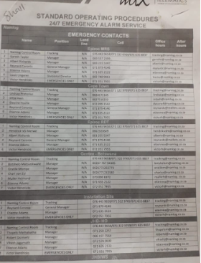

Mix Alert Escalation between 19h00 to 07h00 Night
During the hours of 19h00 to 07h00 the control room operators will monitor and respond to all alarm notifications as per normal SOP assigned. In the event of the below alarm Notifications the control room will still post the notifications on the Alarm Notification Group, but they need to call the drivers and report back and provide feedback on the group for the managers to see. When they review the Group for their assigned vehicles. Where a reported incident occur, the managers will be called as well, as per normal escalation.
- Panic Button. Power Down.
- Dash Tamper Alert. Battery Disconnect.
The control room will contact the driver in the above events and ask the same questions as the managers should, the controller will then notify the relevant managers of the outcome via What’s App Group.
All must be actioned within 10 minutes after alarm received.
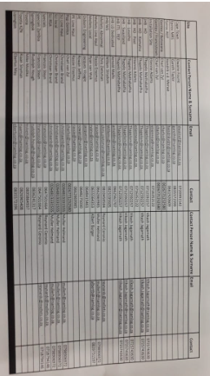

Alarm: Panic Pressed
(Taking in mind to listen to the driver’s voice when he responds to determine if he might be in distress.)
- Verify with driver – his vehicle registration number – the driver needs to provide it.
“Hello Samuel, how are you? please just confirm for me the registration number of the vehicle you are driving now!”
- Once verification done to ask! “Samuel what is wrong? I see you pressed the Panic Button.”
- Wait for his response; if response is that he pressed by mistake; to ask him “please explain how you pressed the button by mistake?”
- Verify where driver is and which direction he is going!
(20 km’s before Rehoboth direction to JHB)
Once verification done that all is in order with the driver, to send a what’s App text message to the relevant managers as per list provided, the message must be send within 5 minutes of the alarm notification received.

See example below:
Image 3
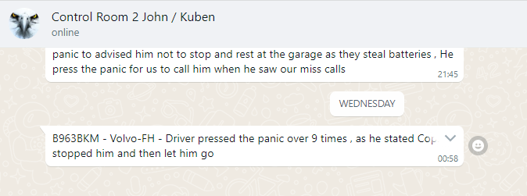
The telephone call must be done immediately of receiving the notification and must provide feedback to relevant managers within 5 minutes.
If driver doesn’t answer after 3 attempts, the normal SOP procedures are followed as per escalation list.

Alarm: Dash Alert Tampering and power down.
(Taking in mind to listen to the driver’s voice when he responds to determine if he might be in distress.)
- Control room operators contact driver directly; verify with driver to which vehicle he is driving – numberplate verification.
- Ask driver if he is driving or stationary and on what road is he currently.
- Ask driver to press the two buttons on the Drive Camera to do a force download – keep buttons in till the lights flash.
(+- 3 seconds)
- Control room to provide feedback to the relevant managers to above verification via what’s App.
Driver Samuel in HZ39VHGP, dash tamper alert received, driver was contacted, he is driving on N12 20 KM’S before Benoni, all in order, driver was asked to do a force download on the drive Cam cameras.

Alarm: Battery Disconnect.
(Taking in mind to listen to the driver’s voice when he responds to determine if he might be in distress.) Control room must have eyes on the vehicle when calling driver to verify his answers.
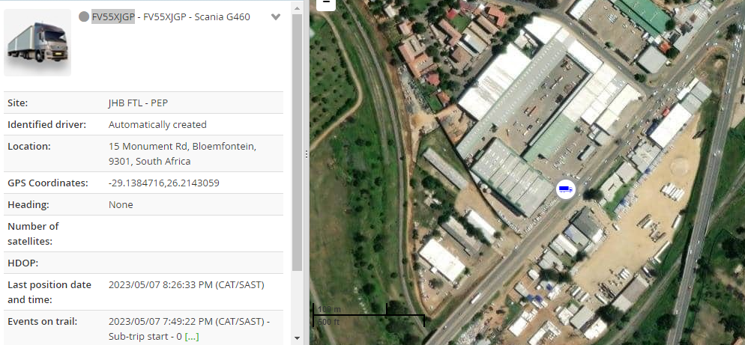
- Control room to contact driver directly and first question to ask is if he is driving or stationary?
“Hello Samuel! where are you now? And are you still driving?”
- Wait for his response and if said he is driving to ask: “on what road are you? what is your current speed?” “what condition is the road, good or poor ?”
- If driver is stationary; “are you next to the truck?” Then tell driver to go inspect the vehicle and go look at the batteries whilst keeping him on the line.
MUST STAY ON THE LINE WITH HIM DURING THIS TIME.
Control room to provide feedback to manager on What’s App text:
Samuel in HV95RTGP had a battery disconnect, vehicle at the Total N2 Stop, battery terminals found to be loose. Driver advised to report to workshop on return. Fleet to be notified please.
If terminals are loose to escalate as per normal Escalation procedures after message the message was send to direct manager.
- Control room to request a photo from the driver if battery terminals are lost, or if battery was stolen. Once received to send to his managers and to Risk manager. Escalation process to follow.
- If vehicle is at dealership for service – the location must be verified as the dealership on Mix Platform, (Toyota Boksburg)
- Managers to be notified as there shouldn’t be a battery disconnect during these hours and notify the Police to dispatch a vehicle to investigate.
- Follow up regularly with Police until confirmation is received on vehicle status. (Positive battery stolen / negative vehicle and battery safe)
- Provide feedback to managers and Risk managers of outcome.

In any positive event that battery is stolen, the normal escalation process is followed.
All notifications done will also be send to Risk Manager, to who control room has notified, what their responses was and outcomes.
Example:
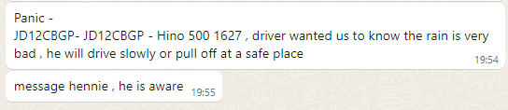
In any positive event the driver will need to go to the nearest Police station to report and open a case, the case number to be provided as soon as possible to Fleet, Risk and Insurance team of Namlog.

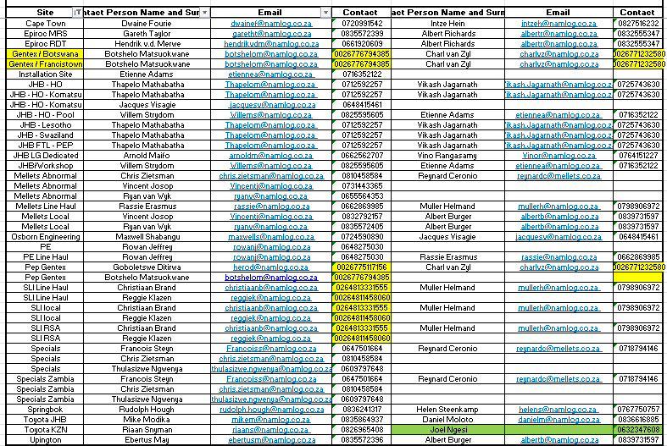
Escalation list
Detailed Incident report need to be done by the manager.
Escalation list
the below list can change at any time.

