Purpose:
The purpose of this document is to ensure the correct process is followed when updating driver details on the tracking system.

• User will access Mix via the following link. Note this link is only compatible in Google Chrome. https://za.mixtelematics.com/#/login

• The User will be asked to enter his username and password.

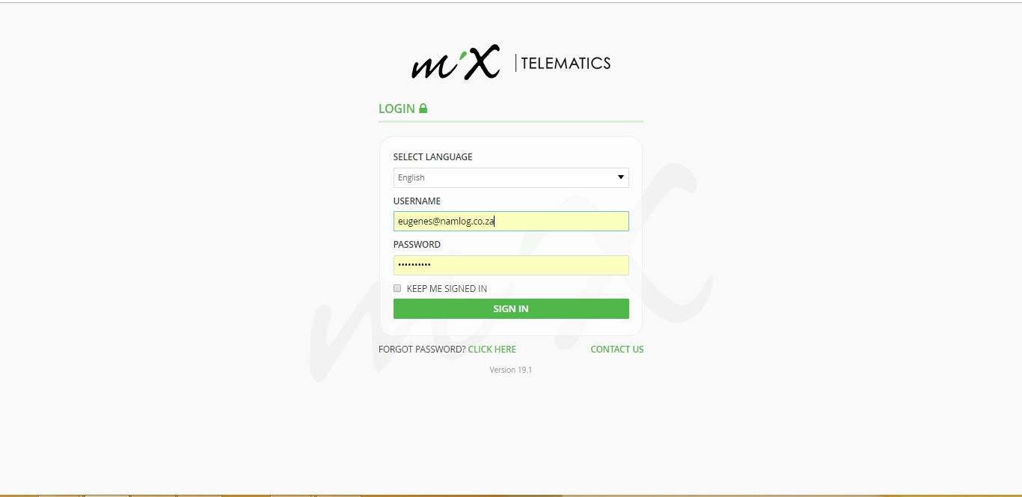

• Once logged in, navigate to “DRIVERS” screen.

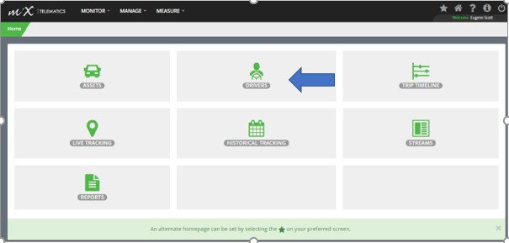

• The User will now have access to all drivers, allocated to his specific business unit.

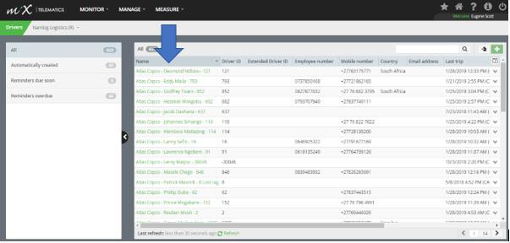

• The user will now need to identify the specific driver by clicking on the driver’s name. The user will be directed to the information page based on the specific driver profile.

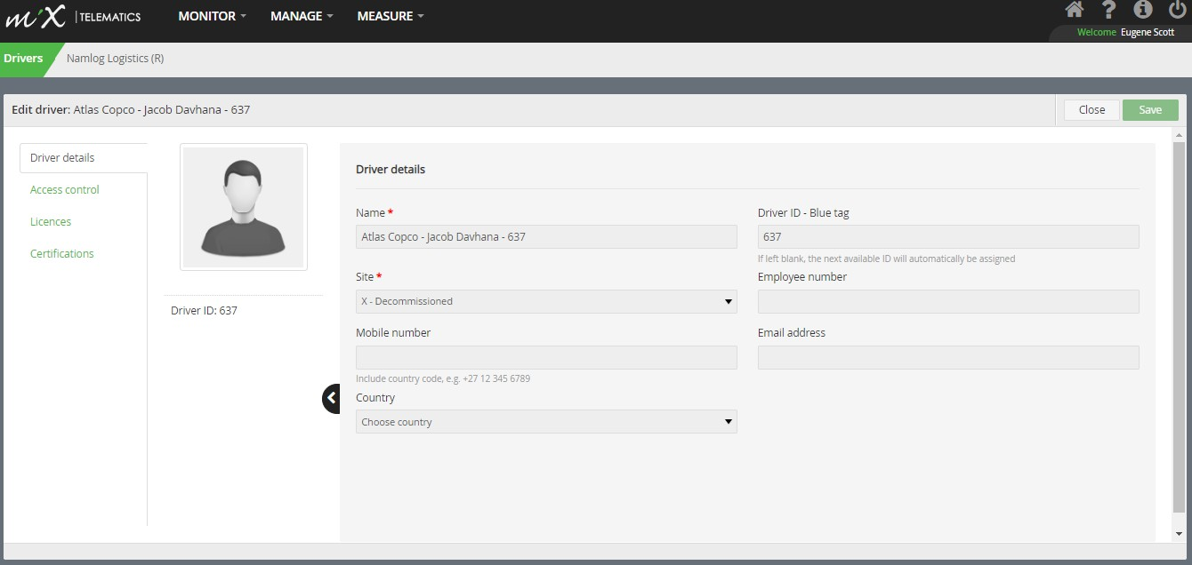

• The user will now need to update the driver’s mobile number in the “MOBILE NUMBER” section as per the below screenshot.
A Secondary number can be entered in “EMPLOYEE NUMBER” Section.

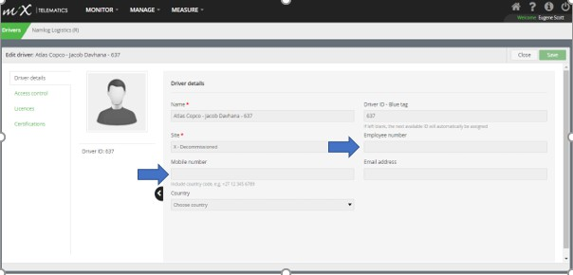
• Once driver details are updated select “SAVE”.
