Namibia: Clearing via Border Vioolsdrift/Noordoewer, Skilpadshek/Poineer’s and Nakop/Ariamsvlei to and from Namibia
PURPOSE
The purpose of the Clearing via Border Vioolsdrift/Noordoewer, Skilpadshek/Poineer’s and Nakop/Ariamsvlei to and from Namibia Standard Operating Procedure (SOP) is to align all Operational and Clearing teams on expectations pertaining to the clearing process of this border. Also, to ensure all operational queries are directed to the correct individual. The SOP must be utilised as a guideline for all Namlog staff. This is to ensure delays are mitigated as far possible and limit any risk of financial loss to the company.
SCOPE
The SOP is applicable to Operational and Clearing teams directly and indirectly involved with the dealing in either cargo, documentation for clearing or any query directed in relation through this border. Clearly defining the process and expectation in which the process flow and dealings must be conducted. The SOP details to the Clearing team in specific, Operational staff verifying the documents, also capturing the information thereof, of the standard to follow.
Process
Border posts : Skilpadshek (Namlog Clearing at Skilpadshek / Easy Clear (In-transit) Clearing Agents at Pioneer’s)
: Mamuno (Easy Clear Clearing Agents / Rumaine Clearing Agents at Buitepos)
: Nakop (Namlog at Nakop / Rumaine Clearing Agents at Ariamsvlei)
Ex-Cape Town
Border posts: Vioolsdrift (CCS Clearing Agents at Vioolsdrift / FFS Clearing Agents at Noordoewer)

Daily operation will be scheduled as stipulated:
- From 08H00, all overflow, and newly inducted cargo should be framed and cleared.
- Loading copies must be signed and issued to the JHB SLI Operations team.
- All Specials and dedicated loads arranged, must be sent to the clearing supervisors and department head.
- All Specials and dedicated loads allocated through these borders must be cleared by Namibia Framing Clerk.
- JHB SLI Linehaul Operations to forward driver and vehicle details to Framing Clerk by 14h00 daily refer to figure 1.

- All Namibia cargo routed to Namibia via the 2 specified border posts must be cleared.
- JHB SLI Operational team loading Namibia Linehaul must submit LMS manifest and all signed loading copies to Namibia Clearing Supervisor.
- All documentation being scanned and sent to the Clearing Agents at the borders must include a Waybill, Delivery note and all other supporting documentation to ensure seamless passing for the vehicle and minimal queries from the Clearing agents to Namlog.
- All load documentation including LMS manifest, and EDI manifest must be sent to respective border Clearing Agents daily.
- Communication and confirmation thereof must be posted on the Rumaine Clearing WhatsApp group daily with the format displayed in figure 2.
Ex-Cape Town
- All overflow, and newly inducted cargo documents should be scanned and sent to CCS for framing and clearing checks to be conducted.
- CPT Linehaul Operations to forward driver and vehicle details to CCS.
- All documentation being scanned and sent to the Clearing Agents (CCS) at the borders must include a Waybill, Delivery note and all other supporting documentation to ensure seamless passing for the vehicle and minimal queries from the Clearing agents to Namlog.
- All load documentation including LMS manifest must be sent to respective border Clearing Agents daily.
- All original load documentation to be handed to the driver when departing from the branch.
- Communication and confirmation thereof must be posted on the CCS and FFS Clearing WhatsApp groups daily with the format displayed in figure 2.

Figure 1
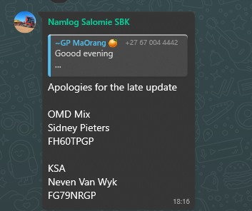

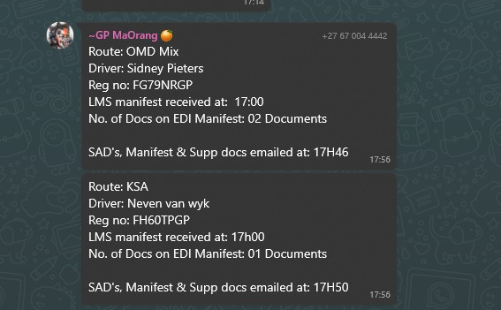
Figure 2

This SOP is implemented to ensure maximum efficiency and ensuring dedication to cut off times as stipulated in Linehaul Operations.

Operational and Clearing Contacts:
- Clearing and Forwarding Manager: 066 286 9987
- Hub and Linehaul Manager: 079 890 6972
- Cape Town Operations: 060 998 7197

