Day to Day Operations- Procedure for ordering New Tyres.

    - Supervisor or Manager reports faults on tyres to the tyre technician.
    - The tyre technician than assesses the vehicle and specifies if tyres need to be replaced or plugged, the tyres are checked with a tyre thread gauge all tyres are removed at 4mm tyre depth.
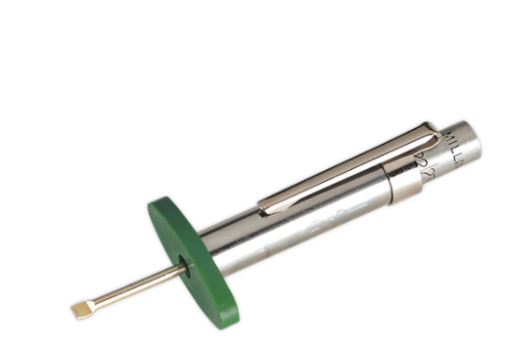

    - A parts requisition is completed indicating all the information of the vehicle for new tyres if required.
    - The parts requisition is handed into the fleet administrator.
    - The fleet administrator will than contact a relevant supplier – Usually already an existing one to receive a quote on the required tyre size and position.

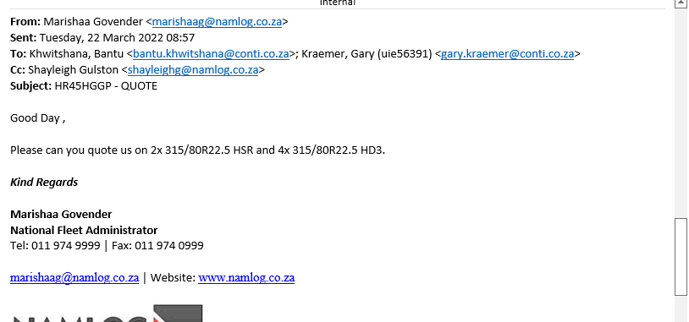

    - Once the quote is received from the supplier the quote is than forwarded to the correct cost centre to be loaded onto Fraxion.
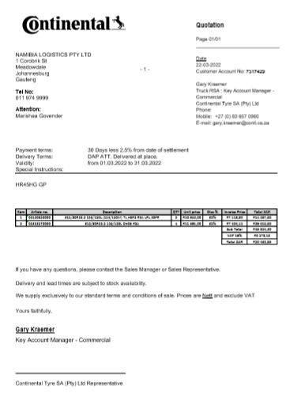

    - Once the quote is loaded on Fraxion the system generates a Namlog Order number after it has been approved by management.

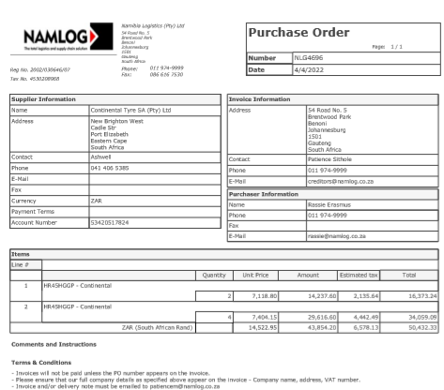

    - The order number is sent to the supplier.
    - The tyres are delivered to Namlog Head Office.
    - The relevant cost centre is informed that their tyres are available.
    - Trucks/Vehicles that are at the Namlog Head Office are fitted with the new tyres, in the case that the old tyres can be reused the tyres are kept aside for rethreading purposes once they are removed .
    - The invoice for the new tyres is received and forwarded to the finance department to arrange payment to the supplier.

