Day to Day Operations- Procedure for ordering retread tyres.

    - Once the new tyres are fitted onto the vehicles the old tyres are assessed by the tyre technician, if they are in a good enough condition to be reused they are kept aside. A casing/retread tyre cannot be used more than two times.

    - Once the tyre technician has tyres ready for rethreading they are branded with a special number (this ensures identification that the tyre belongs to NAMLOG) and than they are recorded into a collection book – This book is usually given to the fleet administrator by the supplier .

    - The tyre technician writes the job number for each tyre from the collection book onto the tyre with chalk.

    - Once the collection slip is completed, tyres are arranged to be collected by supplier.

    - After no more than 7 working days the supplier furnishes Namlog with a proforma invoice .
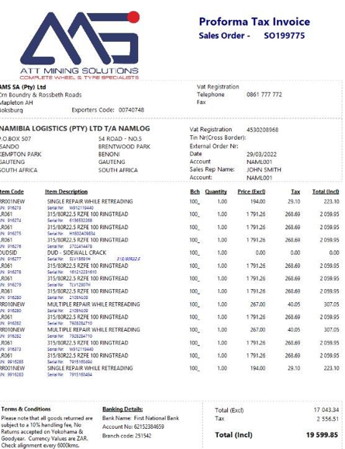
    - This is loaded as stock tyres for the workshop on Fraxion and an order number is generated. Once an order number is generated it sent to the supplier.
    - The rethreaded stock is than delivered to Namibia Logistics Head Office as spare tyres when vehicles require an emergency tyre change.

