PURPOSE
The purpose of the Pallet Mass & Dimensioner Standard Operating Procedure (SOP) is to align all operational teams on expectations pertaining to the operational processes regarding all compatible pallets being received. The SOP must be utilised as a guideline for processing of pallets through the Pallet Mass & Dimensioner.
SCOPE
The SOP is applicable to JHB OPS warehouse staff involved in the Induction & Processing of Inbound cargo specifically pallets compatible with the Pallet Dimensioner.
PROCESS
Cargo offloaded and documents handed over to Data Capturers:
Data Capturers will receive consignment documentation from the debriefer.
Data Capturers will capture the waybill if not captured by Namlog In-houses manned by Namlog staff.
Data Capturers will only print Namlog labels for the consignment if there are no integration labels from the customer.
Data Capturers will then save the waybill.
The Namlog labels will then be handed over to the relevant team leader responsible for Pallet Mass & Dimensioner.
Handover from Data Capturer to Team Leader
The Team Leader will then paste the labels onto the relevant pallets, and process through the specific Induction processing method in this case the Pallet Mass & Dimensioner. Refer to figure 1 below.
Figure 1.
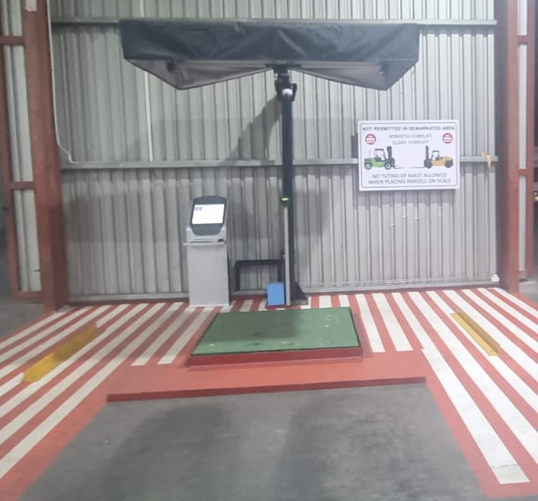
The Pallet Mass & Dimensioner has a dimension and weigh limitation as follows:
- Length: 200cm x Breath: 200cm x Hight 250cm.
- Mass not exceeding 2000 kilograms.
- The Yellow Komatsu Forklift and the Green Clark Forklift must never under any circumstance be used on the Pallet Mass & Dimensioner. Refer to figure 2 below.
Figure 2.
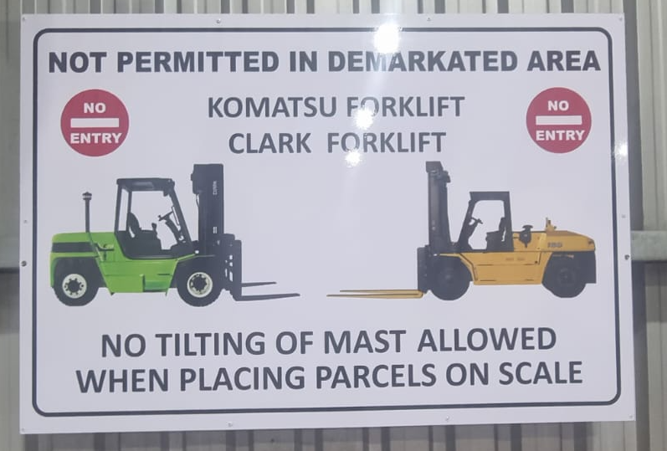
The dedicated Team Leader will instruct the forklift driver on which pallet to fetch from the staging area to the Pallet Mass & Dimensioner. Refer to figure 3 below.
Figure 3.
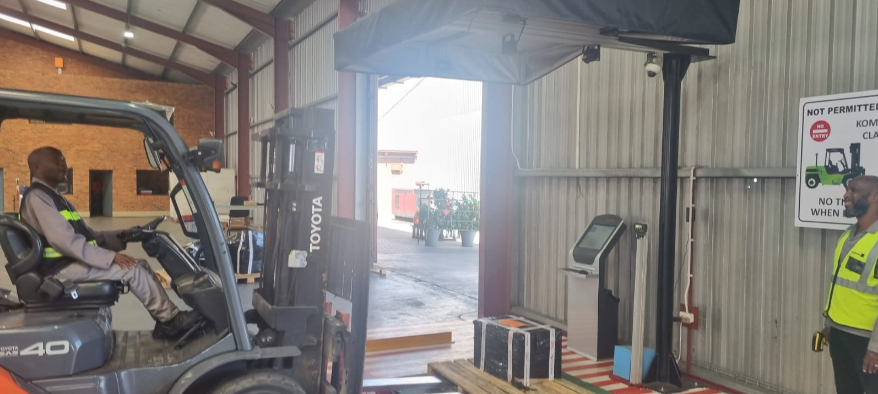
The forklift driver will place the pallet onto the dimensioner’s green platform and then reverse out of the operational area. Refer to figure 4 below.

Figure 4.
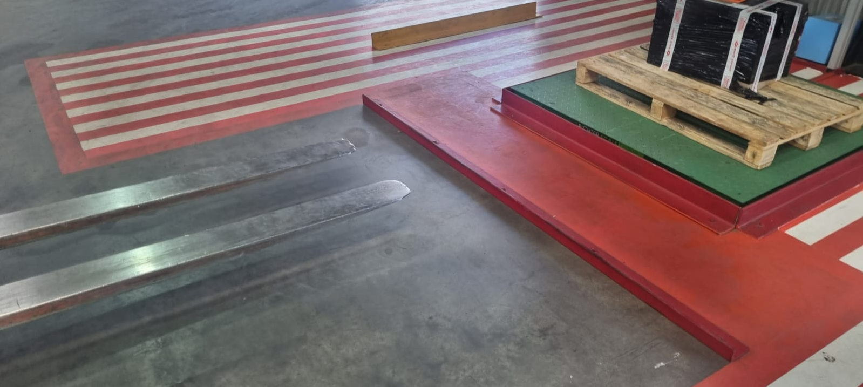
The Dimensioner will register the weight and all dimensions of the pallet.
The Team Leader will scan the Namlog label on the pallet with the cordless scanner. Refer to figure 5 below. Caution: The Operator should take care not to expose his body to the overhead lasers.
Figure 5.
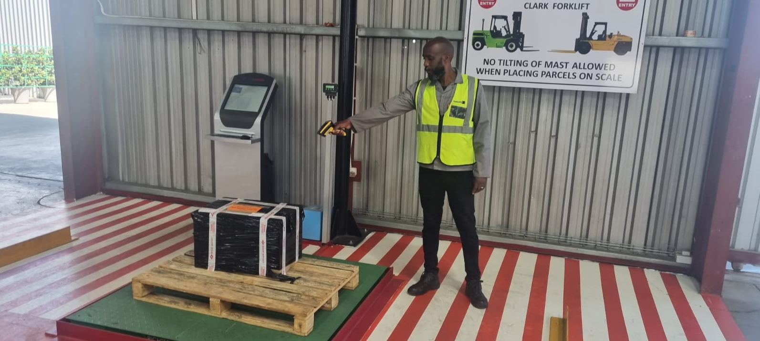
The Team Leader will verify on the screen if the mass and dims have been uploaded, if successfully uploaded, the Team Leader will instruct the forklift driver to remove the pallet and transfer to the designated staging area. Refer to figure 6 below.

Figure 6.
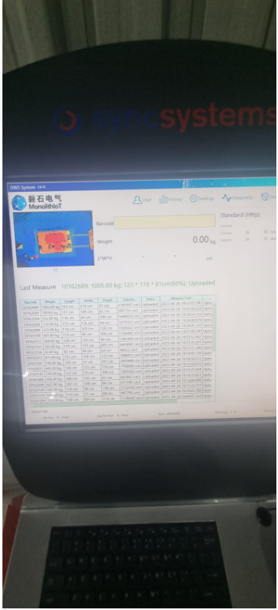
The Team Leader will inform Data Capturers once the entire consignment is mass and dimensioned.
The Data Capturer will then save the waybill in LMS, print the Delivery Note in Portal and handover the documents to the Clearing Department. The Delivery Note contains all the consignment information such as:
- Waybill number
- From customer
- To customer with address
- Mass & Dimensions
- Number of parcels
HANDOVER RESPONSIBILITIES:
- Drivers are responsible to handover documents to the Debriefer.
- Debriefer is responsible to handover debriefed consignment documents to the Data Capturers.
- Data Capturers are responsible to handover labels to Team Leaders and consignment documents with delivery notes to Clearing Department.
- Forklift Drivers are responsible to handover freight to Hub & Linehaul Managers in Warehouse B.
- Warehouse A Operations Manager on shift is Accountable for the above processes.
OPERATIONAL CONTACT:
Operations Manager – 071 259 2257
Shift Supervisor – 071 401 7825
Branch Manager - 082 427 6028
GM Operations – 066 197 7570

