Purpose:
The purpose of this document is to ensure the correct process is followed in the case of a panic activation.

• Once you’ve logged into Mix, ensure you open streams
(Notifications).

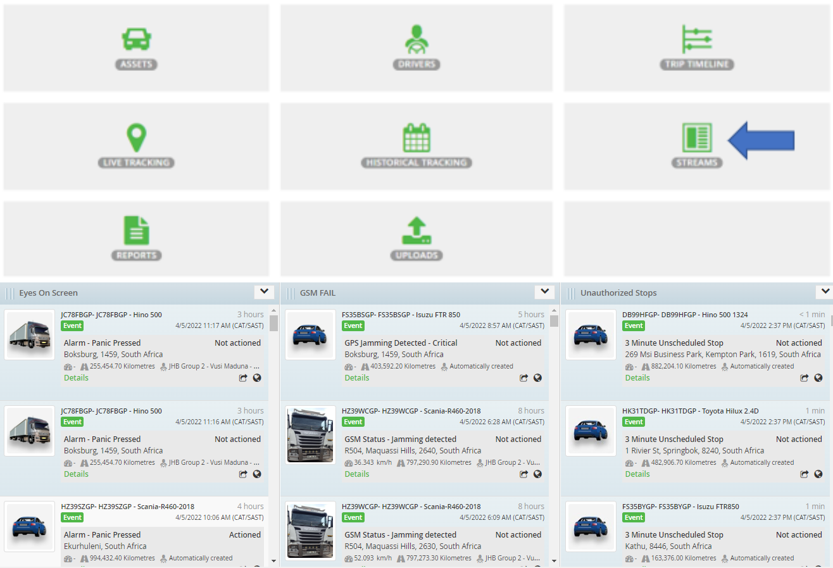

• Panic activations will appear on the screen together with a sound notification that will be generated.

• Mix Telematics will phone the control room to confirm if all is in order.
• Phone driver to confirm situation.
- Pressed by Mistake. (Follow up with 1st contact point if Mix followed up). Send email confirmation to Business unit manager and HO Management as to what incident occurred.

- Accident. (Notify Business unit manager/your direct manager). Follow escalation list and confirm if Mix followed up. Send email confirmation to Namlog.

- Hijacking. Follow SOP below.

• On Mix tracking, lock on asset to get constant location updates.

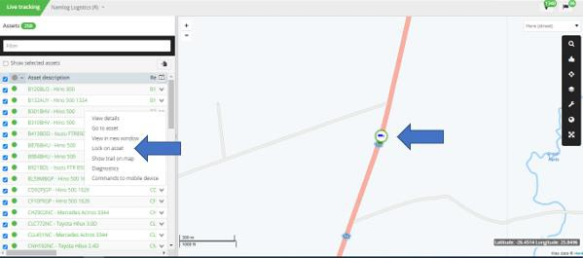

• Phone Mix and report the panic activation/incident. “Deploy recovery team”.

• Activate Beame device.

• Refer to the “SAPS contact details” under the shared control room folder and request assistance from the nearest police station.

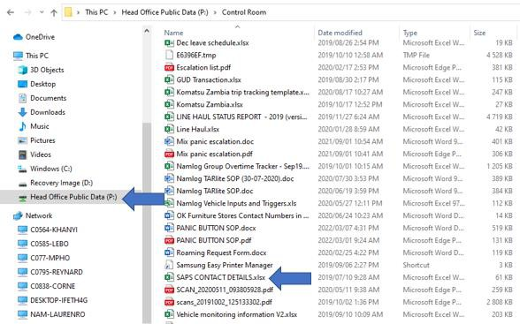

• Provide the officers with the necessary information to dispatch their team.

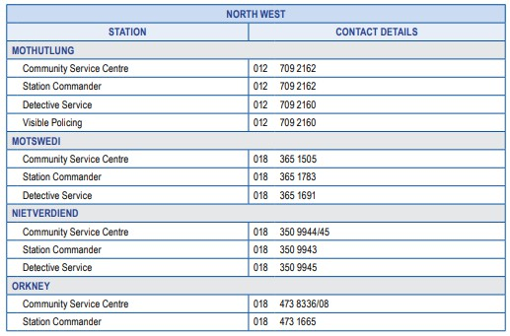
• Escalate matter to both your manager/Business unit manager.

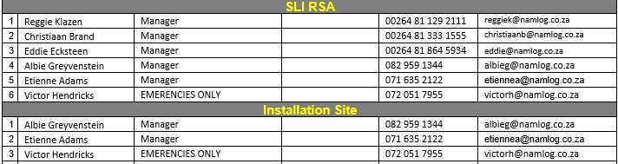
• Ensure constant communication between control and driver

