PURPOSE
The purpose of the Parcel Mass & Dimensioner Standard Operating Procedure (SOP) is to align all operational teams on expectations pertaining to the operational processes regarding all compatible parcels being received. The SOP must be utilised as a guideline for processing of parcels through the Parcel Dimensioner.
SCOPE
The SOP is applicable to JHB OPS warehouse staff involved in the Induction & Processing of Inbound cargo specifically parcels compatible with the Parcel Mass & Dimensioner.
PROCESS
Cargo offloaded and documents handed over to Data Capturers:
Data Capturers will receive consignment documentation from the debriefer.
Data Capturers will capture the waybill if not captured by Namlog In-houses manned by Namlog staff.
Data Capturers will only print Namlog labels for the consignment if there are no integration labels from the customer.
Data Capturers will then save the waybill.
The Namlog labels will then be handed over to the relevant team leader responsible for Parcel Mass & Dimensioner.
Handover from Data Capturer to Team Leader
The Team Leader will then paste the labels onto the relevant items, and process through the specific Induction processing method, in this case the Parcel Mass & Dimensioner.
The parcel must be placed on the rollers with the Namlog label facing the left. Refer to figure 1 below.

Figure 1.
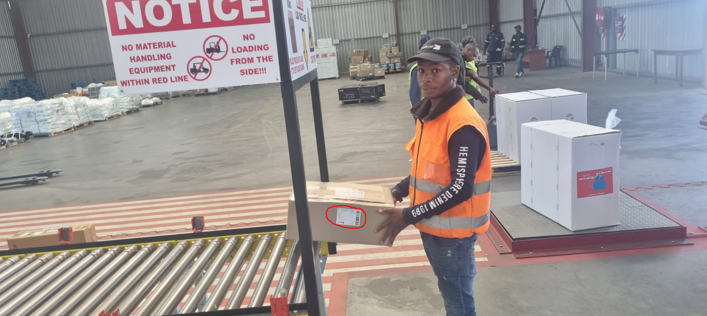
The Parcel Mass & Dimensioner has a dimension and weight limitation as follows: Refer to figure 2 below.
- Length: 90cm x Breath: 60cm x Height 60cm.
- Mass not exceeding 60 kilograms.
- The black frame serves a guide to the maximum dimension per parcel.
Figure 2
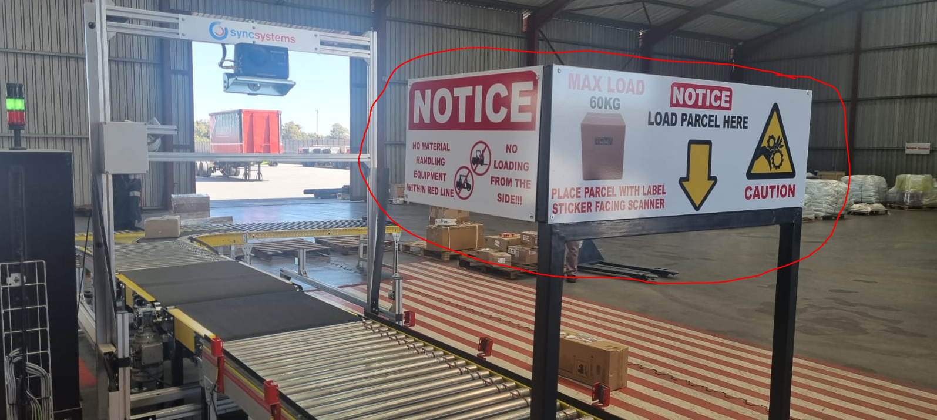

The parcel will flow through on rollers onto the conveyer belts: Refer to figure 3 below.
Figure 3.
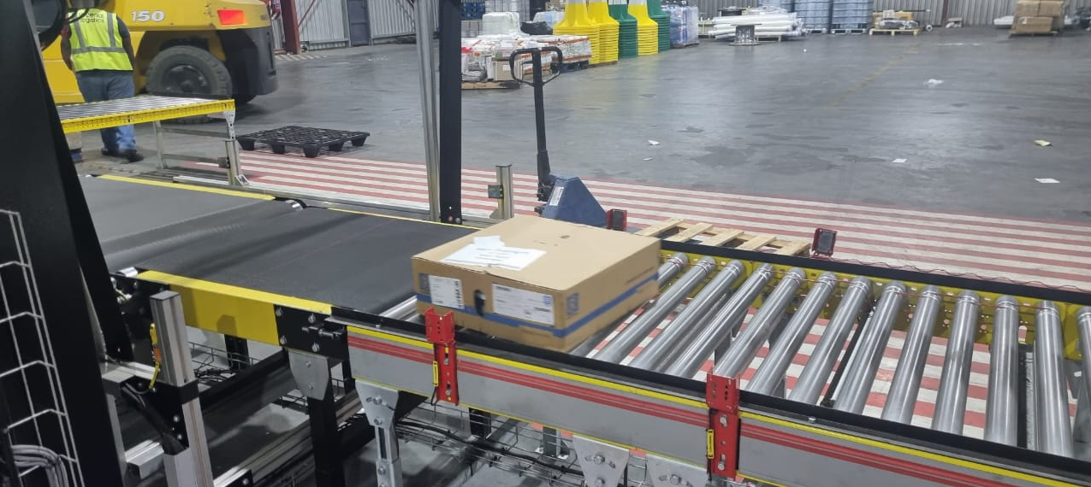
- The first conveyor belt will electronically, via laser scanners, register the dimensions of the parcel.
- The second conveyor belt, which is an electronic scale, will register the weight of the parcel.
The Parcel Mass & Dimensioner Operator will scan the Namlog or integration label while the parcel is on the weight scale: figure 4 & 5 below.
- Green light with a short beep sound, is indication the parcel mass and dims have been recorded successfully.
- Red light with a long beep sound, is indication the parcel has been rejected.
Rejected parcels must be reprocessed, and if still unsuccessful, to be captured manually (refer to SOP for Manual Mass & Dimensioning).

Figure 4.
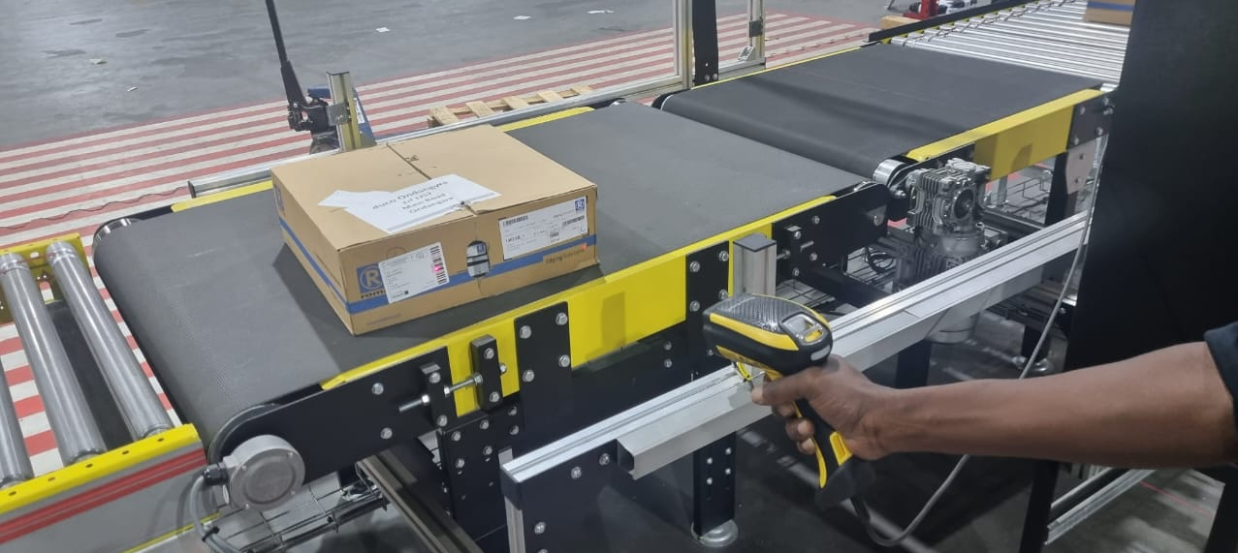
Figure 5.
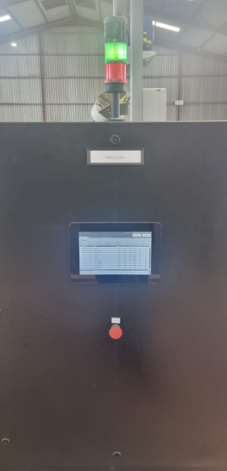
The above screen should be monitored if uncertain if the mass and dimensions were recorded successfully.

The parcel will then flow through on either side of the T junction on rollers: Figure 6 below.
Figure 6.
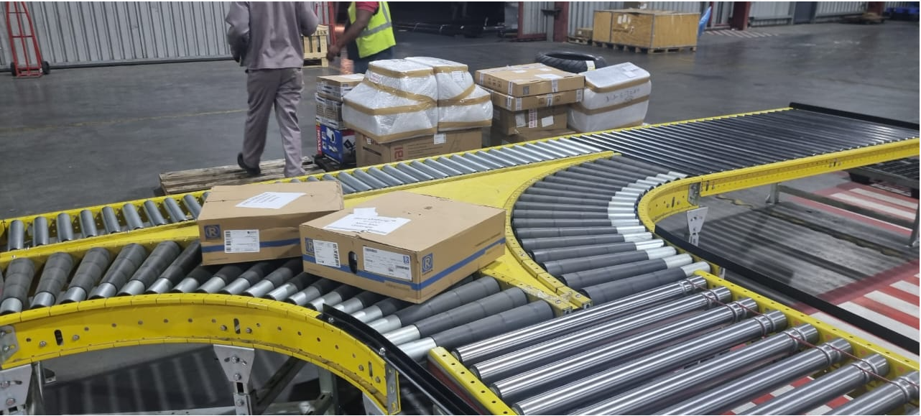
Parcels coming through the Parcel Mass & Dimensioner will then be packed onto pallets allocated to specific branches and or countries.
Once the pallet is full, A forklift driver will transfer the cargo to the designated staging area figure 7 below.
Figure 7.
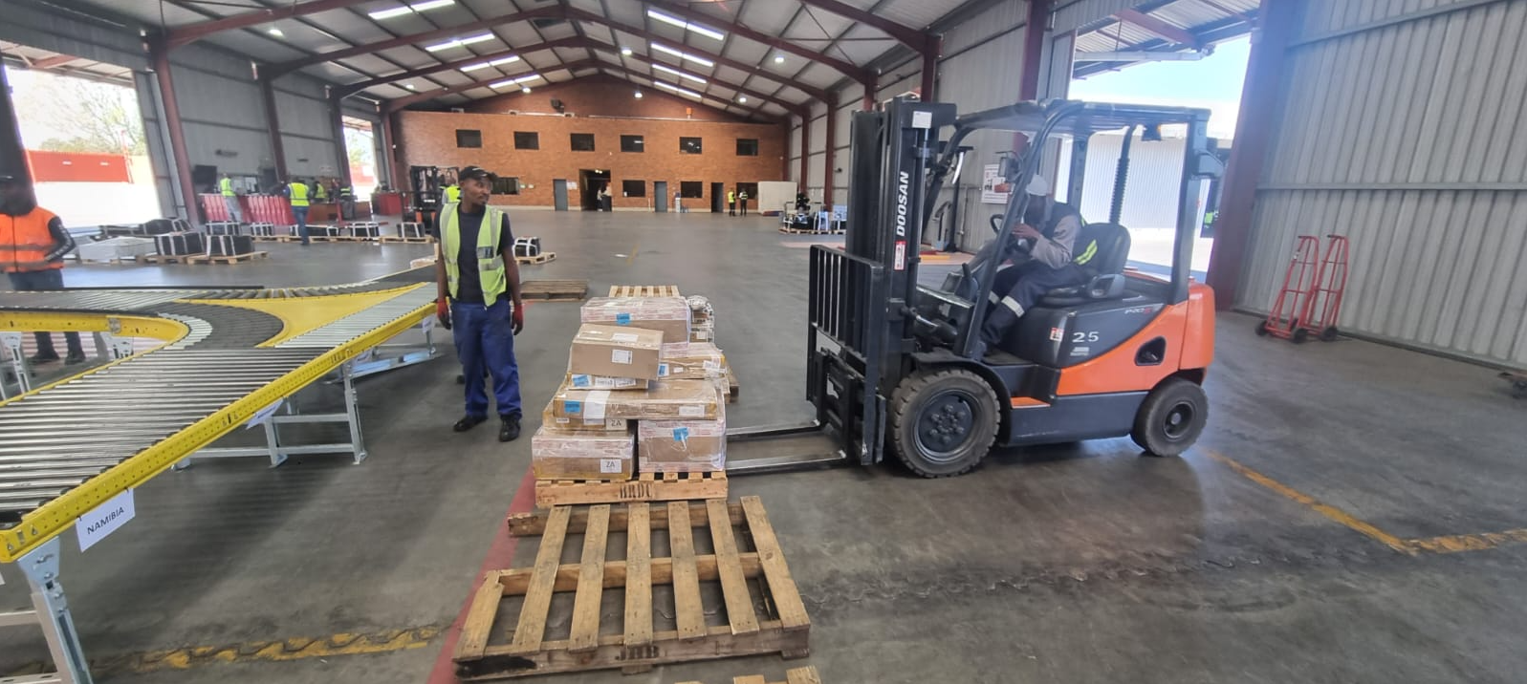
The Team Leader will inform the Data Capturer once the entire consignment is mass and dimensioned.
The Data Capturer will then save the waybill in LMS, print the LMS Delivery Note and handover the documents to the Clearing Department. The Delivery Note contains all the consignment information such as:
- Waybill number
- Sending customer
- Receiving customer with address
- Mass & Dimensions
- Number of parcels
HANDOVER RESPONSIBILITIES:
- Drivers are responsible to handover documents to the Debriefer.
- Debriefer is responsible to handover debriefed consignment documents to the Data Capturers.
- Data Capturers are responsible to handover labels to Team Leaders and consignment documents with delivery notes to Clearing Department.
- Forklift Drivers are responsible to handover freight to Hub & Linehaul Managers in Warehouse B.
- Warehouse A Operations Manager on shift is Accountable for the above processes.
OPERATIONAL CONTACT:
Operations Manager – 071 259 2257
Shift Supervisor – 071 401 7825
Branch Manager - 082 427 6028
GM Operations – 066 197 7570

