- Purpose:
To ensure PODs are dealt with accurately and to meet and adhere to Client POD Requirements timeously.
- Applicability
This internal procedure is applicable to all permanent and / or non-permanent employees, or their managers employed under SMSA/Namibia Logistics (Pty) Ltd or any of its subsidiaries or business units.
3. Procedure
A) General
- POD Administrators to receive original PODs from Relevant branches and Third-Party Agents.
- Original PODs sorted according to Client name and handed to the Relevant POD Administrator.
- PODs are sorted by using the Client POD List.

- Access User Desktop, Click on LMS
- Insert Username and Password
- Click / select Waybills. Click Waybill capture.
- Insert waybill Number and view POD Date/ Time/ Signee and GRV (goods received voucher) number if required. Ensure POD date/Time/Signee correspond with the physical document received.
- POD Administrator to check qty on Waybill and reference qty on GRV /Invoice.
- POD Administrator to check POD Document for any endorsements to update on LMS and email the relevant Key account managers.
- Update the endorsement on LMS under POD (Endorsement Block) provide a brief description.
- Save the POD on your desktop/documents.
- Access email. In the subject line type: Endorsement: Client’s name: waybill number
- In the body of the email a brief description
- Attached the POD.
- Send to the key account exec and the Learner.
- POD Administrator to click on Image and check quality of the Image uploaded.
- 100% Quality- Images clear and visible – including store stamps and signatures.
- 100% Documents on Hand- all Border documents are scanned and printed on hand. If there are missing border documents the Administrator will look at the declarant column and request the missing border document from the clearing Agent who declared the waybill. The request must be done via email to:
- Slabber trading: slabbertmillicent@gmail.com
- All Missing Border documents for Declarant Namlog: must be requested from Group POD Manager and POD Administrator.
- 100% Client Compliant- Ensure Client POD requirements are met and adhered to.
- POD Administrator to report unclear scans and missing documents via email. No branch original PODs must be rescanned unless authorised.
- POD Manager to email poor Quality scans to Operations director and the relevant branch Manager to address.
- Once confirmed that all documents are scanned and on hand the Administrator to Click on POD audit tab/attribute and POD audit the waybills checked. All waybills that are POD audited will indicate to the Invoice team that the waybills are ready to invoice.
- Weekly Outstanding Waybill Activity Report (Outstanding PODs) to be emailed to all Branches and third parties.
Waybills/PODs not audited will result in waybills not paid for deliveries done and disciplinary action will be taken.
- Each waybill number to be put on a excel handover sheet – saved with the date checked and handed over in a Handover workbook that is saved on the desktop of each Administrator. (Electronically).
- POD Administrator to indicate date and Time checked on the handover sheet.
- Handover sheet (2 copies) to be printed and placed on top of the batch of PODs to be handed over to the Invoice Team.
- Invoice Administrator to sign 1 copy of the handover sheet Name and Date Received.
- POD Administrator to File Printed signed Handover sheet and File.
B) POD audit to be Done every afternoon daily by 15h00pm
- POD Administrator to access LMS and Click on Billing – Check Billing
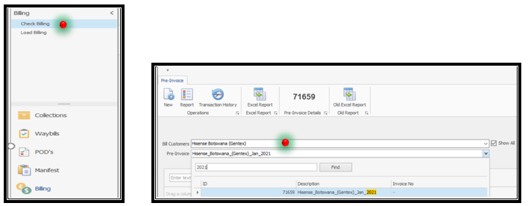
- POD Administrator to Select all – Type in Client Name and select Pre-invoice Month (Tab).
- POD Administrator to Click on each waybill 1 at a time – Right Click and Edit waybill.
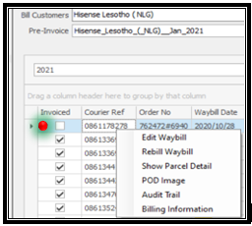

- POD Administrator to Check POD Date / Time / Signee under POD.
- POD Administrator to Check Addocs attribute – Ensure all Border documents are scanned. SAD500-IM4-EDI RELEASE NOTIFICATION-BURS documents.
- POD Administrator to select POD audit Tab and audit the waybill if all is in order.
- POD is clear and visible (Quality).
- All documents are on hand and scanned on LMS (On Hand).
- POD information is correctly captured and (Date-Time-Signee).
- Comply with the Clients POD Requirement.

C) Third Party POD Receiving – Namlog Direct Deliveries
Eliang Couriers Swaziland Loads/ RCJ Express Lesotho Deliveries / Namlog Deliveries (Dedicated )
- Eliang Couriers team sends PODs via email. Indicating waybill number in the subject. Renamed File.
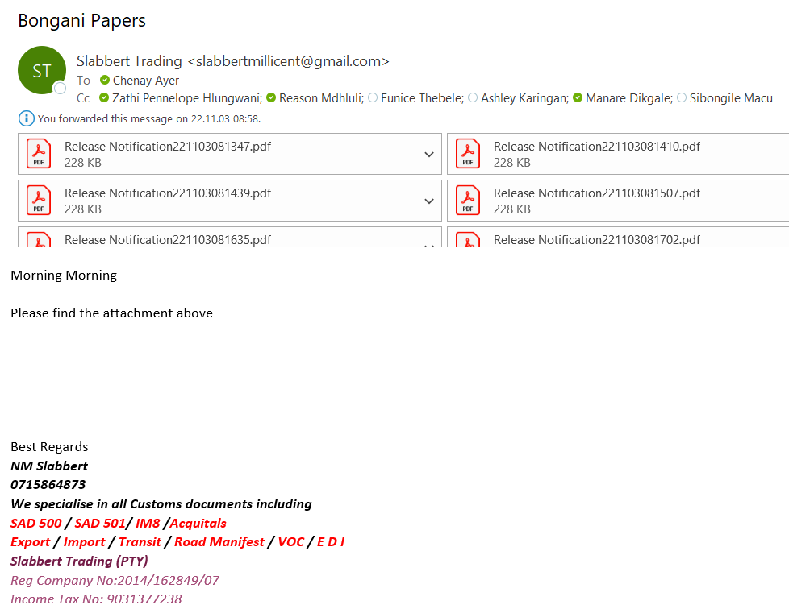
- POD Administrator to Save file on Desktop and rename/Amend in order to Upload the POD on LMS.
- Administrators can also Save the file from Outlook onto LMS via Windows/Scans and Upload.
- POD Administrator inserts waybill number on LMS under waybill capture and view waybill details.
- POD Administrator to capture POD date / time and signed details including store GRV number if required for any chain store deliveries under POD.
- Ensure clear stamps / signatures on all documents.
- Upon receipt of the original POD. The POD Administrator must re-scan the POD and ensure all documents are on hand and scanned on LMS. Rescanning will ensure that we replace the Copy we uploaded that the agent emailed if the Image is not clear.
- Once original POD is received refer to: a) point 1 to point 20.

All Grvs (goods receipt voucher) to Follow will be updated as GRV to FOLLOW for all Chain stores and Requested Via email and telephone form the relevant stores.

D) Third Party POD Downloads
Slabbert trading Border document process: Swaziland
- Driver crosses the border for all Swaziland Deliveries, and the clearing agent emails the border documents.
- Border documents are emailed to the POD Department Team
- Administrator to save ALL documents on their Desktop in a Renamed Folder.
- Administrators to upload the SAD500+EDI on LMS (Logistics Management System)
- Administrator to Open LMS and Insert the waybill number on the SAD500 or EDI Release notification.
- Administrators Save the file from Outlook onto LMS via Windows/Scans and Upload on LMS.

(E) Namlog Lesotho Branch Deliveries
- The Lesotho Branch Manager sends PODs via email with the waybill number included in the subject line. The file is then renamed accordingly.
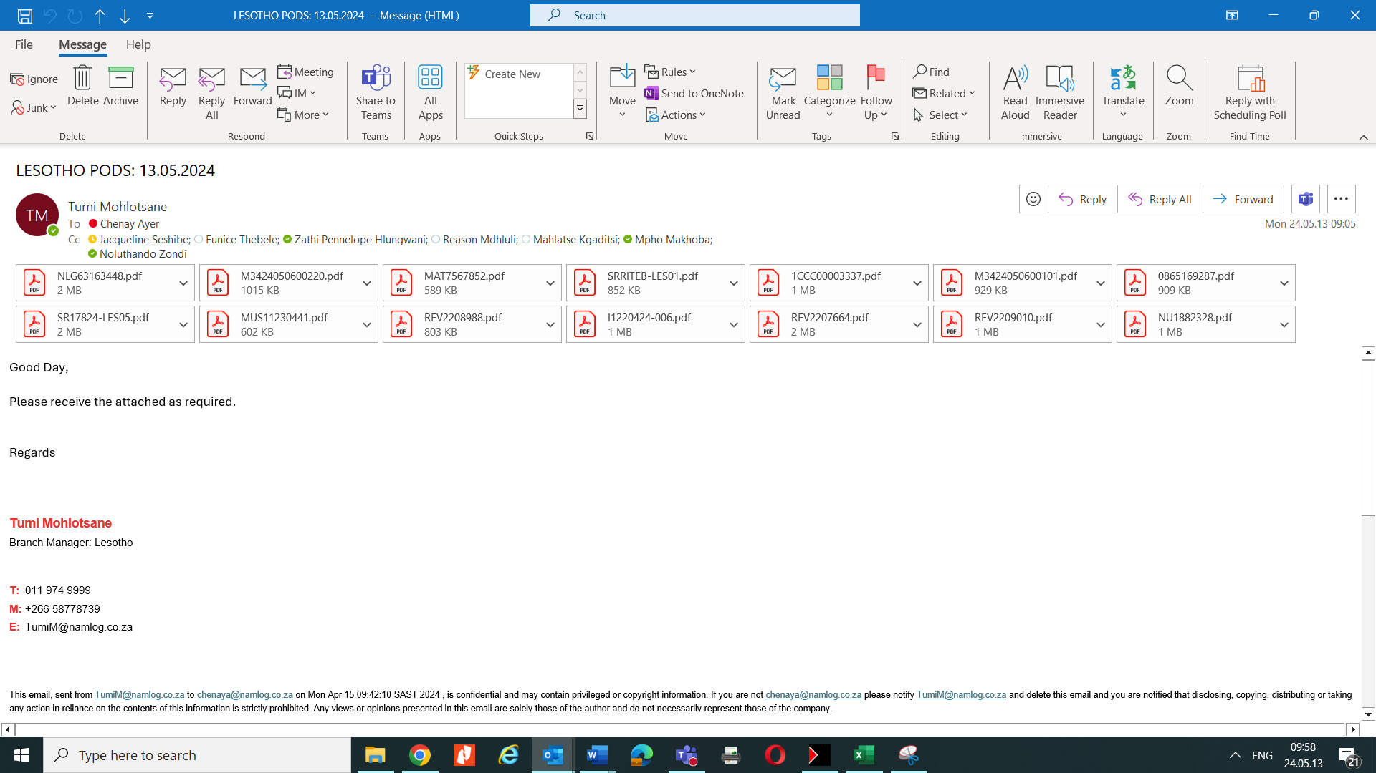
- POD Administrator to Save file on Desktop and rename/Amend in order to Upload the POD on LMS.
- Administrator to Open LMS. Access Waybills / Waybill Capture and Click on Image / POD.
- Administrators can also Save the file from Outlook onto LMS via Windows/Scans and Upload on LMS. Click on Windows/Scans. Go to LMS and Upload
- POD Administrator inserts waybill number on LMS under waybill capture and view waybill details.
- POD Administrator to capture POD date / time and signed details including store GRV number if required for any chain store deliveries under POD. POD Image Uploaded from email to LMS (Point 3)
- Ensure clear stamps / signatures on all documents.
- Upon receipt of the original POD. The POD Administrator must re-scan the POD and ensure all documents are on hand and scanned on LMS. Rescanning will ensure that we replace the Copy we uploaded that the agent emailed if the Image is not clear.
- Once original POD is received refer to: a) point 1 to point 20.

All Grvs (goods receipt voucher) to Follow will be updated as GRV to FOLLOW for all Chain stores and Requested Via email and telephone form the relevant stores.

(F) Petals Express: Cape Town /George
- POD Manager to Generate a waybill activity Report weekly and filter out Cape Town and George areas to download images.
- PODs must be retrieved from their website (parcel Perfect) Daily.
- Username: P776 : Password: P776.
- Images downloaded are saved to Desktop and Converted to PDF
- Waybills number to be inserted on LMS.
- POD image to be copied from the Desktop, to paste in Windows Scans folder and Uploaded on LMS.
- POD date on the Image/POD must be captured on LMS under POD.
- POD administrator to check the quality of the Image/POD.
- POD audit to be done on LMS.
- All outstanding PODs that is not scanned on the third party agents system must be requested according via email
csd@petalsexpress.co.za- Cornelia
dorothea@petalsexpress.co.za-Dorethea
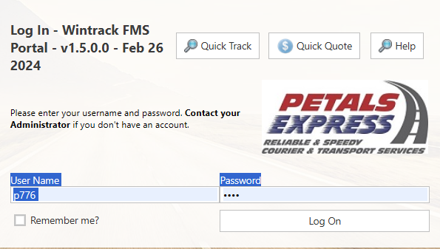
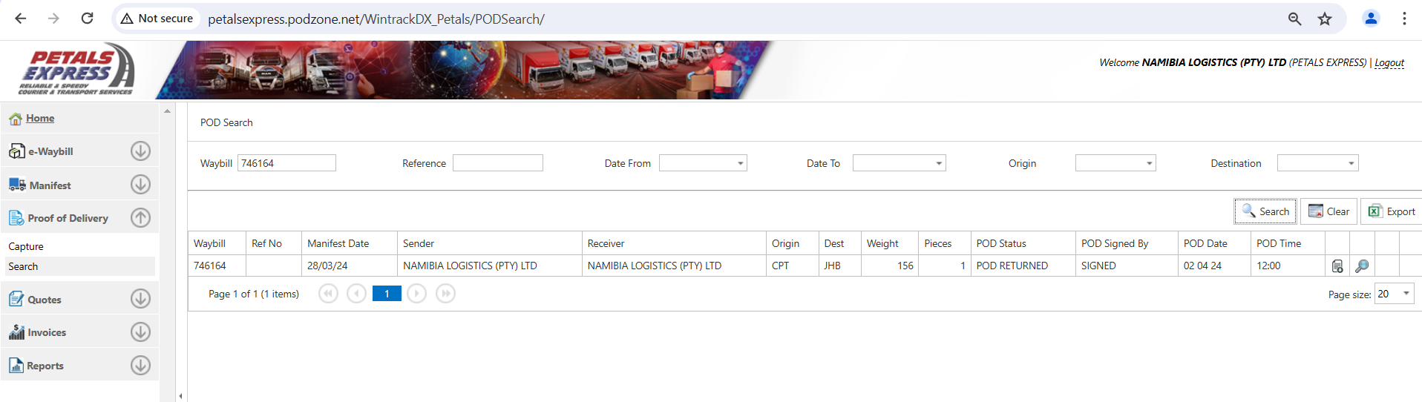

(G) EPX : Wolmaransstad, Steelpoort, Durban, Bloemfontein.
- POD Manager to Generate a waybill activity Report weekly and filter out Cape Town and George areas to download images.
- PODs must be retrieved from their website (parcel Perfect) Daily
- PODs after downloading will be uploaded on the Namlog LMS System.
- Username: chenaya@namlog.co.za: Password: Namlog
- User to Access the EPX Website
- Insert the username and password:
- User to select Login
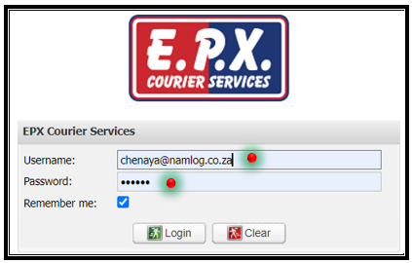
- Notification Block to appear.
- User to select OK
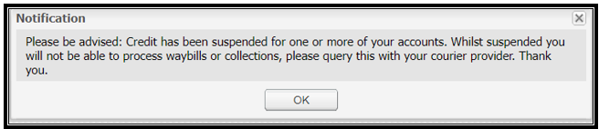
- Warning Block to appear.
- User to select OK
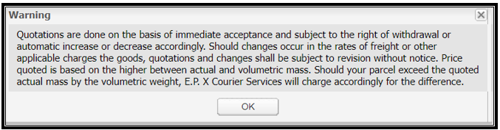
- Images downloaded are saved to Desktop and Converted to PDF
- Waybill number to be inserted on LMS.
- POD image to be copied from the Desktop, to paste in Windows Scans folder and Uploaded on LMS.
- POD date on the Image/POD must be captured on LMS under POD.
- POD administrator to check the quality of the Image/POD.
- POD audit to be done on LMS.
- Images are also uploaded from the EPX website onto LMS.
- EPX POD Notifications sent via email daily.
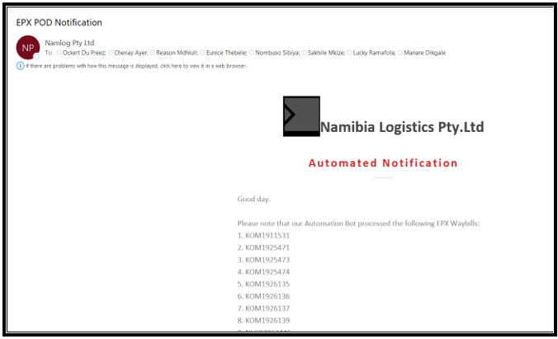
- POD administrator to capture only POD dates for waybills emailed via EPX notification email address for all completed deliveries.
- All outstanding PODs that is not scanned on the third party agents system must be requested according via email
brandondv@epx.co.za- Brandon de Villiers

(H) Outstanding POD Status Report (LMS Waybill Activity Report
- User To access LMS – Operational Reports
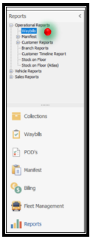
- User To select Waybills and Select Specific from and To Dates
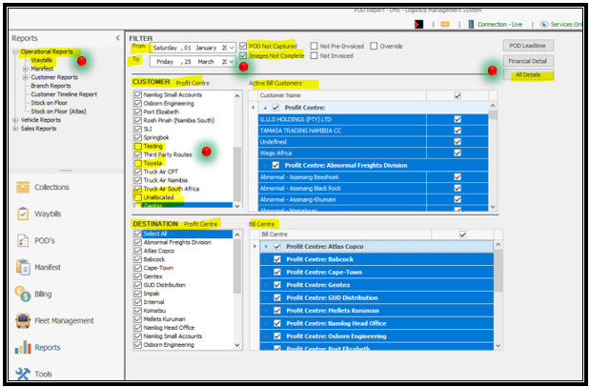
- User to Select All Customers (Profit Centres)
- User to deselect Inter, Impact, Testing, Toyota, Unallocated and Zambia
- User to Select All Destinations (Profit Centre)
- User to Select POD Not Captured and Images Not Complete (Active Bill Customers)
- User to Select to Select All Bill Centre
- User to Select All Details to generate the Outstanding report
The outstanding POD Status report will save on the Desktop with today’s date.
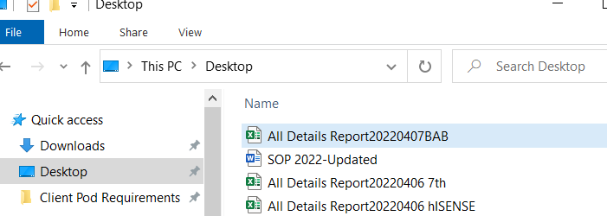
- User to access the Desktop and Open Outstanding POD Report.
- User to open the report and sort waybill captured dates. Oldest to Newest.
- User to clean up the report and delete extra columns.
- User to focus on columns: To Customer, To Bill Centre, To Profit Centre, POD Image, Delivery Lead times.
- Insert a Filter on the Colum’s and focus on the POD Image column.
Image Incomplete, Image Complete and No Image.
To Customer- Receiver Customer
To Bill Centre- Area Namlog is delivering to
To Profit Centre- Delivery branch
Delivery Lead Time-Number of Days from Waybill capture date.

Image Incomplete Indicates. The receiving Branch Received the orders and have scanned in Border documents under the addoc tab on LMS.
No Image Indicates no POD the branch did not receive the Order/Waybill.
Image Complete- indicates POD date not captured.
- User to Select to Profit Centre and select each branch separately.
- User to extract each branch and save on a a new excel sheet.
- User to save the Outstanding POD Report with the Receiving Branch Name and the date.
Example: Gentex – SLI Outstanding POD Status Report 06-04-2022
- User to email the branches regarding outstanding PODs and follow up daily- weekly.

EXAMPLES below:

Gentex:
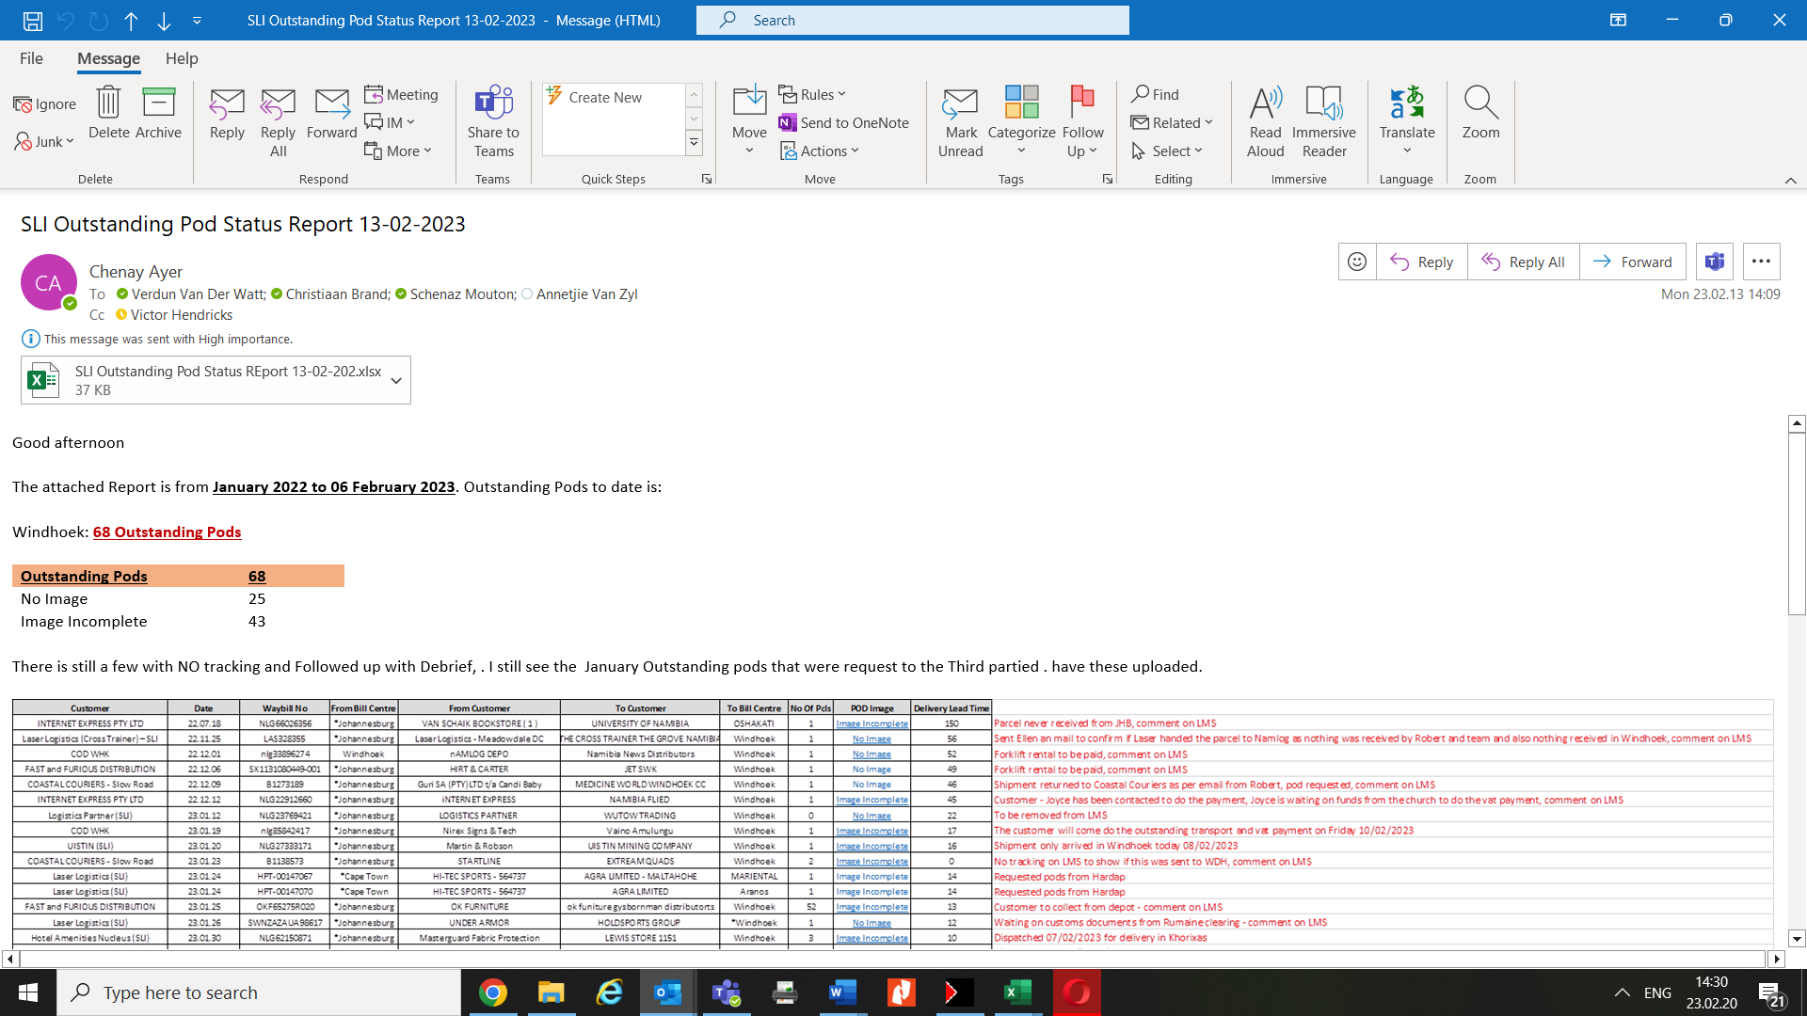

- SLI:

