PURPOSE

The objective of Receiving Linehaul Load Standard Operating Procedure (SOP) is to provide clear guidelines for operational departments within Namlog Group on receiving linehaul load process. This SOP is intended to be used as a reference for all Namlog receiving linehaul load activities.

SCOPE

The SOP is applicable to operational personnel who are responsible for receiving linehaul load.

PROCESS

- Login to LMS to receive linehaul load.
  - Select “Manifest” from main menu.
  - Select “Line Haul Debrief”.
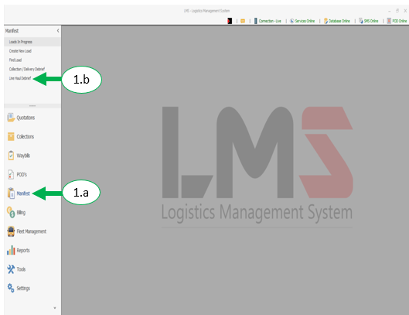
  - Debrief load by confirming the number of parcels on the load.

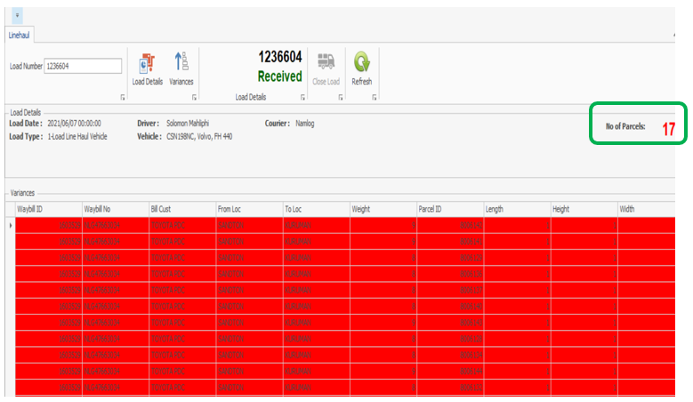

  - Select “Load Details” to receive the load

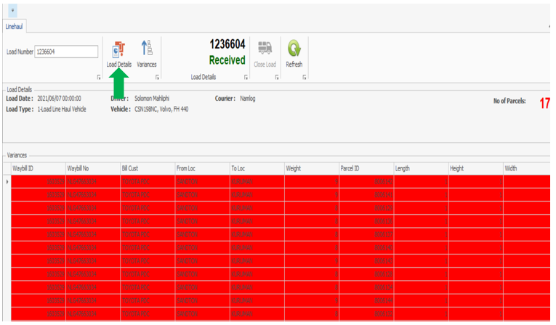

- login to LMS mobile application on the PDA.
  - Enter load number on PDA.

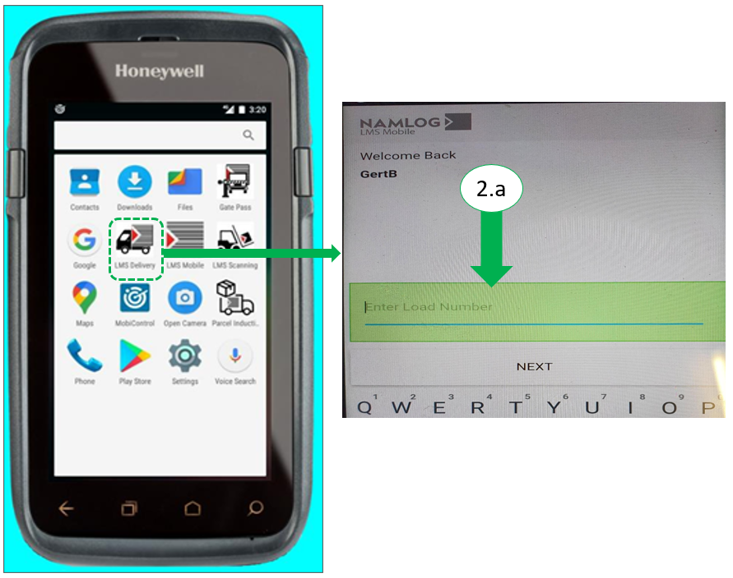

  - Select “OFFLOAD”

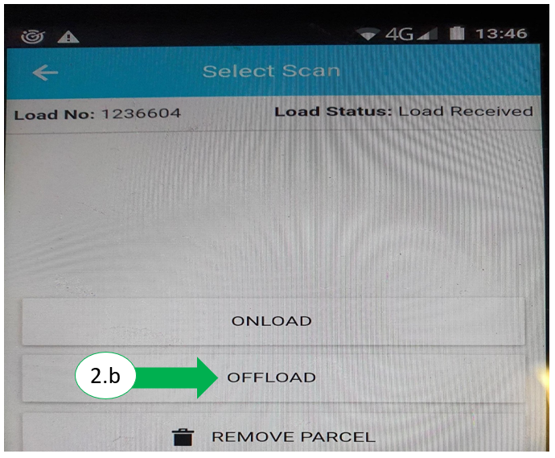

  - Perform onload scanning:
    - Scan Barcode on Parcels. (c.1)
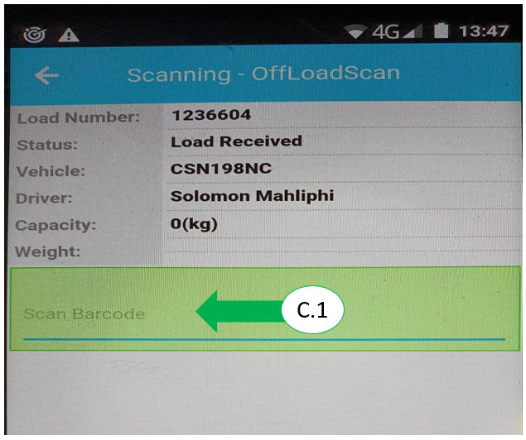

    - PDA will show valid scan. (c.2)

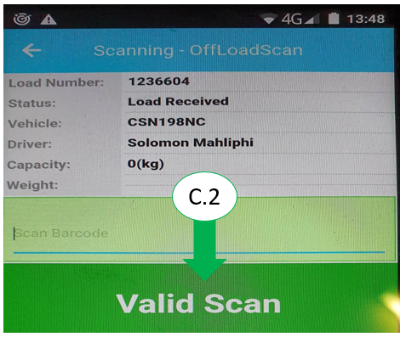

    - Once all parcels are scanned, pull a variance report to check for any miss scans.
    - If there are variances, rescan the parcels

- Once scan is complete, close the load on LMS
  - Click on “Close Load”

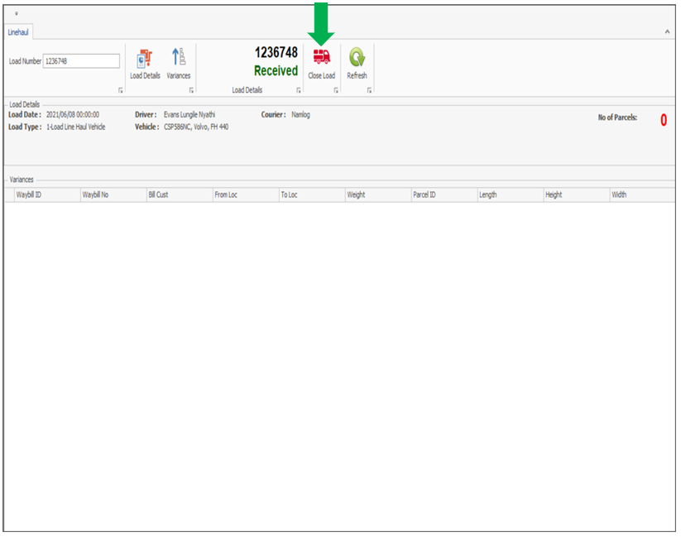

  - The screen will refresh and show “Close Load” pop-up:
    - Enter driver’s name and vehicle closing odometer reading. (b.1)
    - Click “Save”. (b.2)

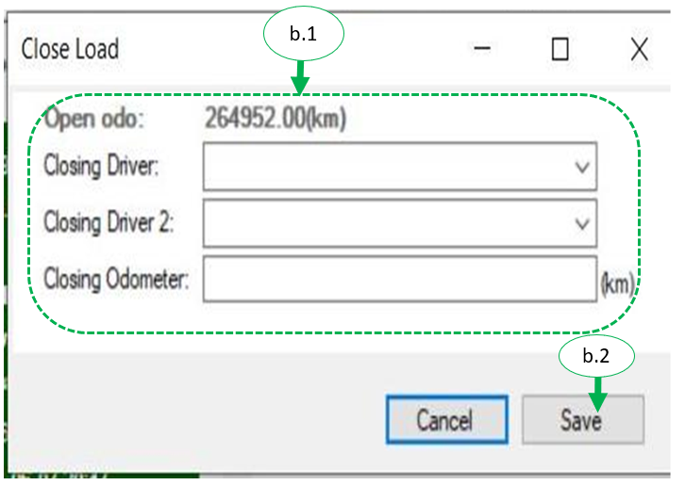

  - Lod will show it has been closed.

