SBK: Clearing via Border Posts Alexander Bay/Oranjemund, Vioolsdrift/Noordoewer and Nakop/Ariamsvlei to and from Namibia
PURPOSE
The purpose of the Springbok Clearing via Border Posts Alexander Bay/Oranjemund, Vioolsdrift/Noordoewer and Nakop/Ariamsvlei Border Posts to and from Namibia Standard Operating Procedure (SOP) is to align all Operational and Clearing teams on expectations pertaining to the clearing process of these borders. Also, to ensure all operational queries are directed to the correct individual. The SOP must be utilised as a guideline for all Namlog staff. This is to ensure delays are mitigated as far possible and limit any risk of financial loss to the company.
SCOPE
The SOP is applicable to Operational and Clearing teams directly and indirectly involved with the dealing in either cargo, documentation for clearing or any query directed in relation through these borders. Clearly defining the process and expectation in which the process flow and dealings must be conducted. The SOP details to the Clearing team in specific, Operational staff verifying the documents, also capturing the information thereof, of the standard to follow.
Process
Identified times: 14h00 – 22h00
Border posts: Vioolsdrift (CCS Clearing Agents at Vioolsdrift / FFS Clearing Agents at Noordoewer)
: Alexander Bay (Namlog Clearing at Alexander Bay / Netty’s Clearing Agent at Oranjemund)
: Nakop (CCS Clearing Agents at Nakop / Rumain Clearing Agents at Ariamvlei)

Daily operation will be scheduled as stipulated:
- From 14h00, all overflow cargo from the previous day should be framed and cleared.
- All Specials arranged prior to 14h00, must be sent to the clearing supervisors and department head.
- All Specials allocated through these borders from 14h00 must be cleared by SBK/OMD Framing Clerk between the shift of 14h00 to 22h00.
- SBK Branch dispatching locally collected over border cargo to these 2 specified border posts cut off time for submitting border documents to Framing Clerk by 16h00 daily.
- SBK Branch to forward driver and vehicle details to Framing Clerk by 17h30 daily refer to figure 1.
- All SBK cargo routed to OMD and RPZC via the 2 specified border posts must be cleared by 18h00.
- JHB Operational team loading SBK Linehaul must submit LMS manifest to SBK/OMD Framing Clerk by 17h00 daily.
- Komatsu cargo and OMD Mix volumes must be sent to SBK Branch by Framing Agent by 17h30 daily, ref to figure 2.
- Komatsu documents must be sent to Netty’s Clearing Agent and OMD Mix documents to Frantic Freight Services.
- All load documentation including LMS manifest, and EDI manifest must be sent to SBK Branch by 18h00 daily.
- Communication and confirmation thereof must be posted on the SBK Clearing WhatsApp group by 18h00 daily with the format displayed in figure 3.
- From 18h00 until 22h00, the Framing agent will continue with framing entries for SLI Linehaul clearing.
Figure 1
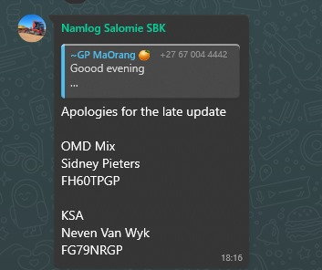

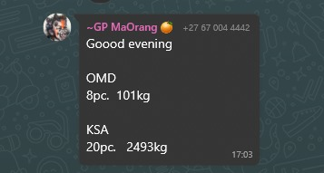
Figure 2

Figure 3
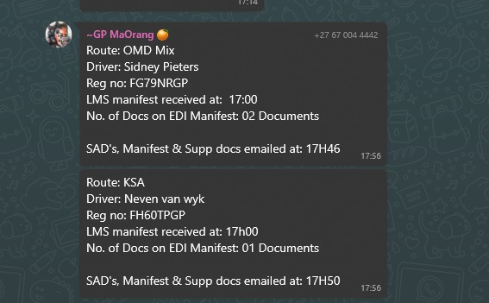

This SOP is implemented to ensure maximum efficiency and ensuring dedication to cut off times as stipulated in Linehaul Operations.

Operational and Clearing Contacts:
- Clearing and Forwarding Manager : 066 286 9987
- General Manager Specials & Abnormal Division: 079 569 9753
- Namlog Springbok Branch Manager: 066 305 2389
- Customs Controller: 060 961 9038

